How do we know what we know about energy?

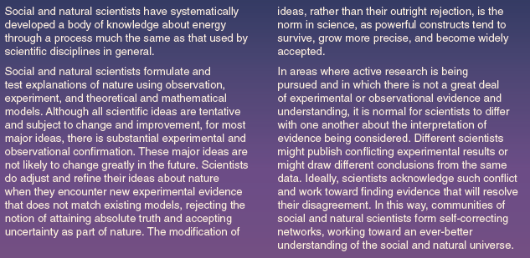

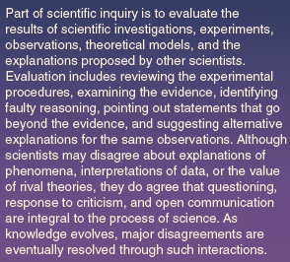

A Brief History of Human Energy Use

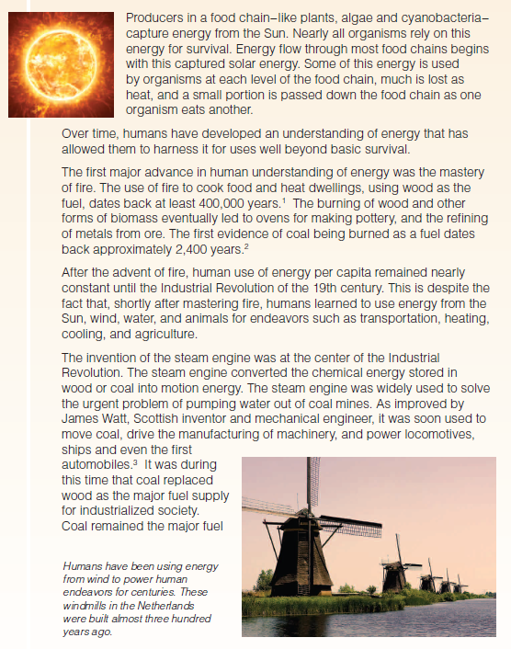

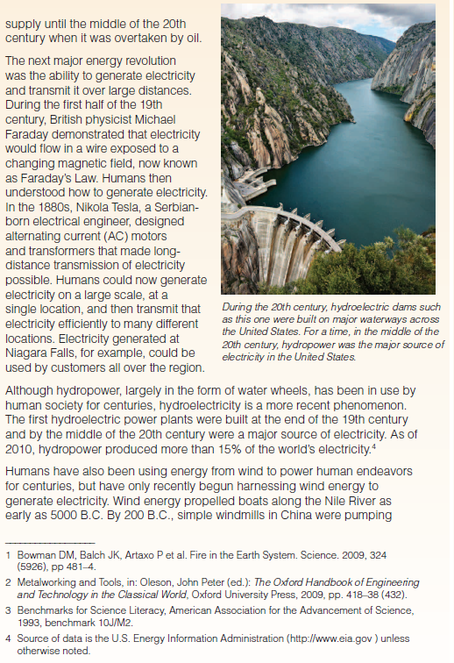

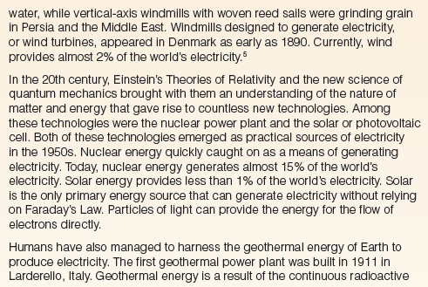

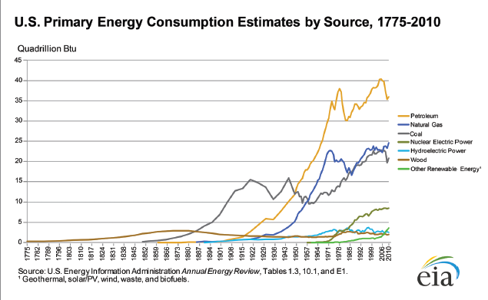

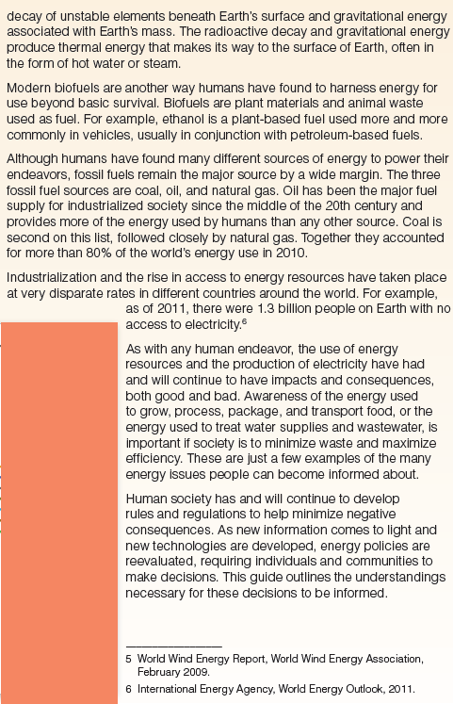

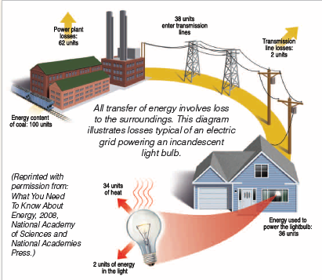

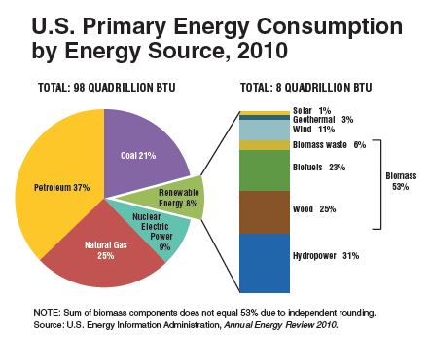

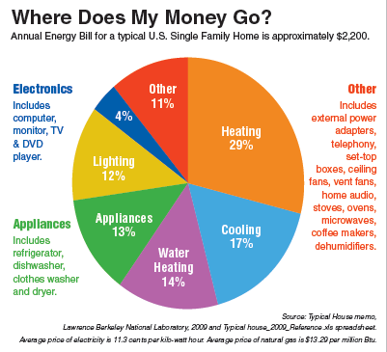

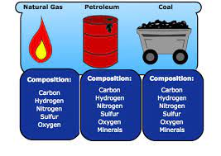

**Fossil Fuels** are currently the world’s primary energy source. Two fossil fuels, coal and oil, provide most of the daily energy that heats our homes, powers our cars, and generates our electricity.

Our fuel needs for transportation and heat drive oil exploration in the harshest corners of the planet. Exploration for oil and gas has moved from land to sea. The oil industry has devised oil rigs, or massive drilling platforms, that stand on the ocean floor and drill deep beneath the sea bed.

Coal produces more than half of our electrical power and accounts for 22% of our overall energy consumption. Coal is the most abundant fossil fuel on earth. Coal mining is vital to the economy of the United States and many other countries.

The use of coal and oil has added billions of tons of carbon dioxide and other pollutants to our atmosphere, yet they remain the most economically efficient sources of energy.

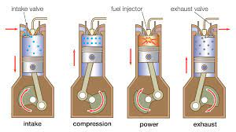

**Internal combustion** engine burns or explodes fuel in an enclosed space. Most of these engines are on automobiles, but they can be adapted to power airplanes, boats, locomotives, even whole factories.

Fuel burns in an enclosed space, and energy from expanding gases is converted into mechanical energy. Inside a four stroke gasoline engine, pistons move four times for every combustion reaction.

An alternative design that generates more power is the two stroke engine. But large amounts of unburned fuel escape through the exhaust port during the up stroke, making two stroke engines inefficient and environmentally hazardous.

Another type of internal combustion engine that does not run on gasoline, and it's one of the most important tools of modern industry, the diesel engine. Some diesel engines are as big as a house. They power entire factories. Diesels also transport the goods produced in factories. Enormous diesel locomotives pull cargo trains. The diesel engine is named for its inventor, Rudolph Diesel, but considerably more powerful and much more efficient.

Mitsubishi is trying to introduce a new breed of internal combustion engine called gasoline direct injection, or gdi. This engine runs on regular gasoline, but operates more like a diesel engine. It runs more efficiently than contemporary gasoline engines.

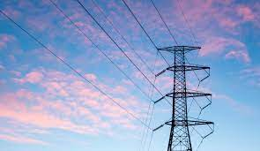

**Electricity:** provides a way to store and distribute energy generated in a variety of ways. We live in an electric world. Electricity may be the most common form of energy we use.

Neutrons have no charge and protons are positively charged. Both stay in the nucleus, the center of an atom. Electrons are negatively charged and they can jump from one atom to another. Electricity is the interaction of electrons and protons.

Electric current is the movement of electrons from atom to atom. Electrons can jump from one negatively charged object to a positively charged one in a discharge, which balances the charges of both objects. Energy builds up as the charges separate. The energy used when the electrons move during the discharge is the voltage, or potential difference, and is measured in volts.

An energy source, such as fossil fuel, moving water, or wind, is harnessed to spin a turbine and the turbine spins a magnet near a coil of metal wire. The movement of the magnet near the coil of wire causes electrons to move through the wire. This current flows through power lines to the outlets of electric power customers. When the direction of the current is changed several times a second, as it is in the lines of power plants, the electricity is called alternating current, or ac electricity.

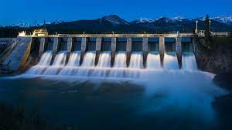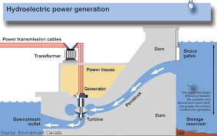

**Hydroelectric:**

Water rushes through giant turbines to generate massive amounts of electricity, enough to power all of the surrounding area. Hydroelectric power converts the energy of water flowing in streams and rivers into mechanical energy. Hydroelectric dams today are designed to produce much more electricity. A modern dam usually blocks a river with a concrete wall several hundred feet high. This floods the area around the dam and creates an artificial lake. The water held behind a dam has a tremendous amount of potential energy, which can be converted to kinetic energy, or the energy of an object in motion.

In a hydroelectric dam, the force of gravity pulls water down through large tubes called penstocks. In this way, the potential energy of the lake water becomes kinetic energy as it begins to move. As the water flows through the penstocks, it spins turbines, which power electric generators, which spin magnets in metal coils. This produces an electric current that is distributed on a power grid. The water current produces a current of electricity.

Hoover dam is one of the world’s most famous hydroelectric dams. It is an excellent example of how to harness efficient, renewable and clean hydroelectric energy. However, the energy produced by the three gorges dam comes with a heavy price. Building the dam created a body of water nearly 600 feet deep and as long as Lake Superior. This artificial lake destroyed 13 major cities, as well as hundreds of towns and villages.

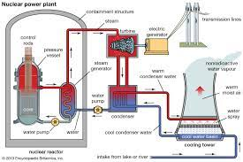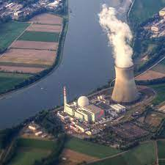

**Nuclear Power:**

One of the most efficient forms of energy comes from the splitting or fusing of atoms in what is known as nuclear power. Physicists recognized that atoms contain substantial energy. An enormous amount of energy could be obtained from a small amount of matter.

During the process of nuclear fusion, the nuclei of atoms are joined together under extremely hot temperatures. This is when the atoms release large amounts of energy. Typically, hydrogen atoms combine to form helium atoms.

Nuclear energy can also be generated by splitting atoms. The process of splitting atoms and releasing energy is called fission. Nuclear fission of uranium is the most common method of producing nuclear power. Neutrons are shot at the uranium which splits the uranium nuclei and releases more neutrons. The neutrons split other uranium nuclei in a chain reaction. If enough uranium is used, a self-sustaining or continuous chain reaction will cause the release of large amounts of heat that can generate electricity. One ton of uranium produced as much energy as more than a million tons of coal or a million barrels of oil, but, splitting atoms creates hazardous radioactive particles that may cause cancer and genetic mutations.

Today, more than 400 nuclear power plants account for about 17% of the world’s electricity. More than 100 such power plants are operating today in the United States.

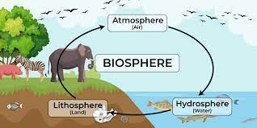

**Biosphere: Irene Curie** conducted research into radioactive elements that paved the way for nuclear power plants. But Irene’s research took a toll on her health, just as it had on her mother’s (Marie). She died of leukemia in 1956, the victim of her pioneering experiments in radioactive elements. But her work lives on. Scientists continue to find uses for artificial radioactive isotopes in energy production and medicine.

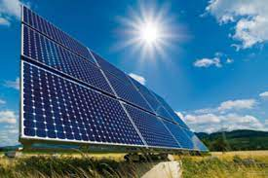

**Solar Power:**

The energy of the sun can generate electricity and provide heat. Solar power is available everywhere; it’s renewable and clean. Solar panels generate electricity based on the photovoltaic effect. Photovoltaic panels convert the sun’s energy into electricity, which we then use in the home.

Most systems will store the electricity in batteries.

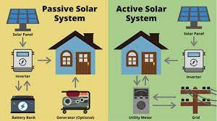

**Student Inventor:**

A solar-powered house that uses active and passive solar power to make the most efficient house that’s architecturally sound.

Active solar power is just photovoltaic cells that absorb the sunlight and then produce all of the energy that’s needed in the house.

Passive solar power: In the northern hemisphere, sunlight comes from the south. So, putting panels on the southern side of the house maximizes exposure to sunlight.

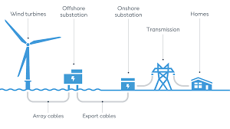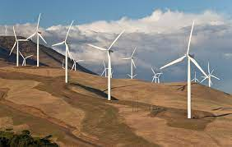

**Wind power:** captures energy in the air. The air that surrounds our planet is in motion. Wind is caused by differences in air pressure. High pressure air moves toward low pressure air to balance the pressures. Anything that moves has energy.

New models of wind turbines are spinning their way toward clean electricity around the world. Some turbines have a fan diameter over 100 meters long, roughly the length of a football field. As air flows across the blades, it causes the fan to rotate, which powers an electrical generator. A single wind turbine can generate as much as 3.6 megawatts, enough electricity for hundreds, even thousands of homes.

Clusters of wind turbines are called wind farms.

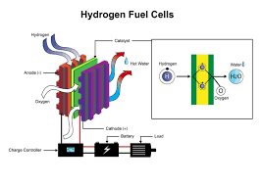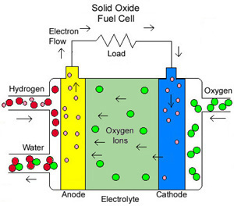

**Hydrogen fuel cells**

Hydrogen. the most abundant element in the universe and the energy source of stars, is a colorless, odorless flammable gas at room temperature, but it can power an internal combustion engine. Hydrogen fuel can also generate electricity in a fuel cell, a device that converts chemical energy into electric energy. A series of chemical reactions splits hydrogen into protons and a current of electrons, and then combines them with oxygen, which produces water. The flow of electrons is electric current. A fuel cell will produce an electric current by stripping the electrons from hydrogen, passing them through a wire, and producing water molecules.

**Before you know it:** Name some emerging energy inventions.

Windmills, solar cars, fuel cells