Heading

Title

**Introduction**

**Purpose** To develop the techniques and skills in measuring structures using a microscope.

**Discussion**

Microscopic measurements are frequently of great importance to the biologist. How long is a bacterial cell? Or what is the diameter of a particular kind of white corpuscle? The smallest unit of macroscopic metric measurement is one millimeter (mm) or about 1/25th of an inch. However, this is an extremely large unit for microscopic observation and measurement. For measuring microscopic materials, the biologist uses a unit known as a MICRON (μm), which is one millionth of a meter or 0.000001 m or 0.001 mm.

**Hypothesis**

If the magnification of a specimen is known, then the size of the microscopic field of vision can be calculated as well as the diameter of specimen.

**Materials** Plastic metric ruler

# Procedures and Calculations and Data

1. Determine the magnification of the ocular: _______

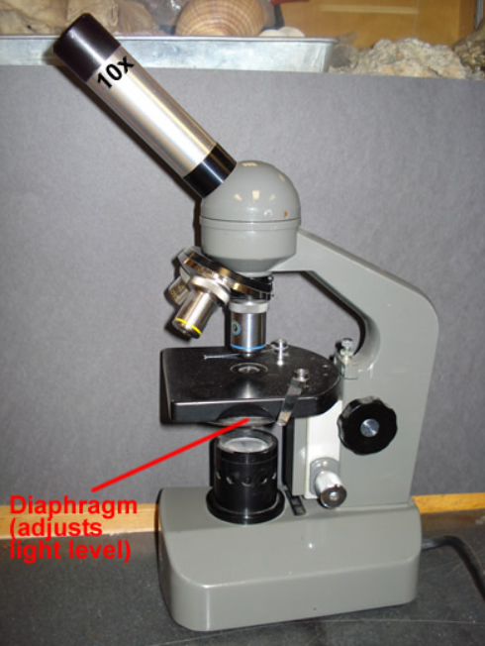

2. Record the magnifications of the objectives shown:

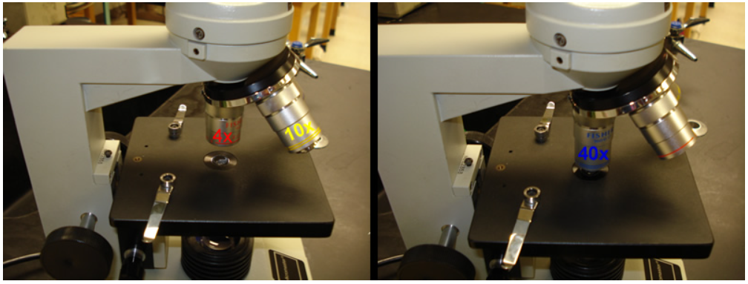

a. The magnification written on the objectives ranges from _____ low power (scanning) to high power _____ and _____.

b. Determine the microscope’s magnification for each objective.

**Low power scanning magnification**

**4X objective** 🡪

**High power magnification**

**10X objective 🡪**

**40X objective 🡪**

c. What is the purpose of the scanning objective (4X)?

3. The letter “e” is placed on a slide and on the stage of the microscope and viewed by a student (as shown below).

Microscopic View the letter “e”.

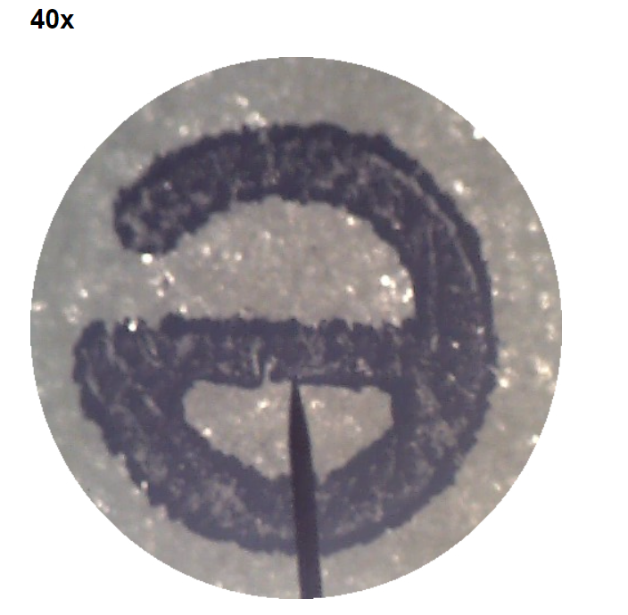 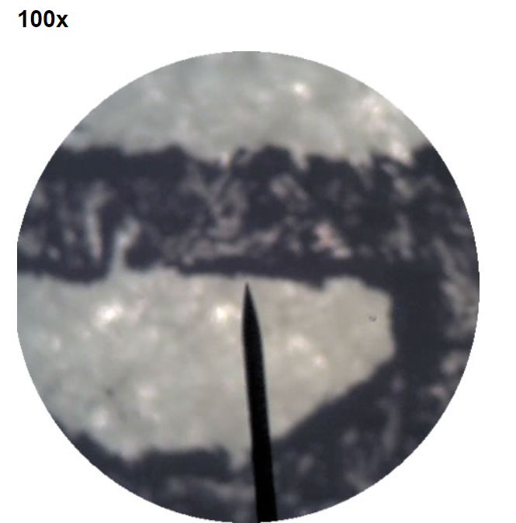

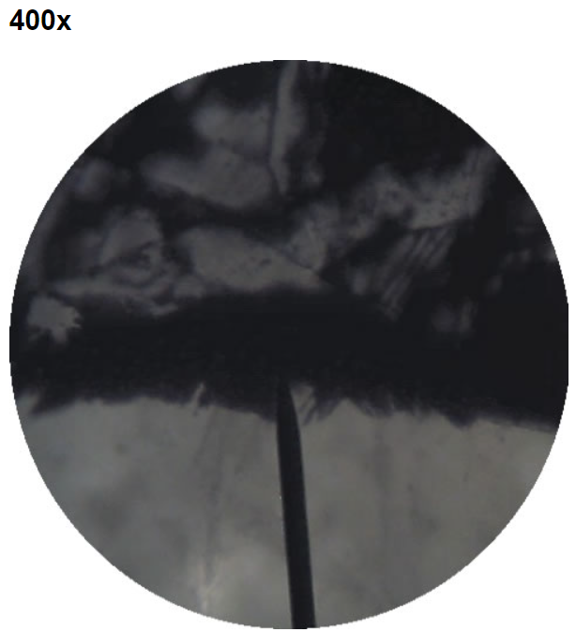

a. What happens to the image in the microscopic field?

b. What happens to the microscopic field of view as magnification increases?

3. A metric ruler is laid across the stage of the microscope, clipping it in with the stage clips. The ruler lines were brought into focus first using the coarse adjustment knob, then the fine adjustment. Determine the diameter of the microscopic field:

**Magnification**

Ocular: **_____**

Low power objective: **_____**

Microscope: **_____**

**Diameter of microscopic field**: **_____**

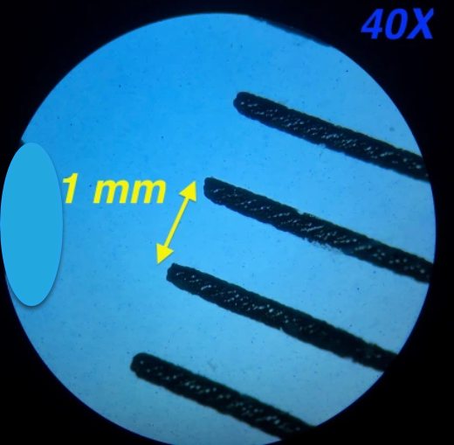

4. The ruler is moved within the microscopic field so that one of the vertical lines dividing the ruler into millimeters is just visible at the left edge of the field under low power.

* The distance between the first and second vertical lines is 1.0 mm. Since a third vertical line does not appear, you know that the diameter of the low-power field shown below is less than 2 mm.
* It is necessary, therefore, to estimate the distance between the second line and the right edge of the field.

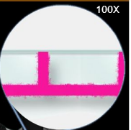

1 mm

**Magnification**

Ocular: **_____**

Low power objective: **_____**

Microscope: **_____**

**Diameter of microscopic field**: **_____**

5. Now, the metric ruler is moved again within the low-power field so that one of the vertical lines is centered in the field. Slowly and carefully the microscope objectives are rotated in order to place the microscope under high power (the 40X objective). The image of the ruler in the high-power field is shown on the next page.

Estimate the diameter of the high power microscopic field:

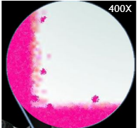

**Magnification**

Ocular: **_____**

High power objective: **_____**

Microscope: **_____**

**Diameter of microscopic field**: **_____**

6. Confirm the high-power microscopic field diameter estimate:

a. Use your estimate of the low-power field diameter (> 1.0 mm and < 2.0 mm).

b. Divide by the relative increase in magnification from low-power to high-power (e.g. 4.0). If your low-power objective magnified 10 times and the high-power magnifies 40 times, then the increase in magnification would be 10X divided by 40X, yielding a factor of 4.0.

c. Divide the estimated measurement of your low-power field (>1.0 <2.0 mm) by the magnification increase factor (e.g. 4.0). This is the estimated diameter of your high-power field.

7. A human blood smear slide is placed on the stage (Shown below). Estimate the diameter of a single human red blood cell using the calculations already made and counting the number of human blood cells going across the microscopic field.

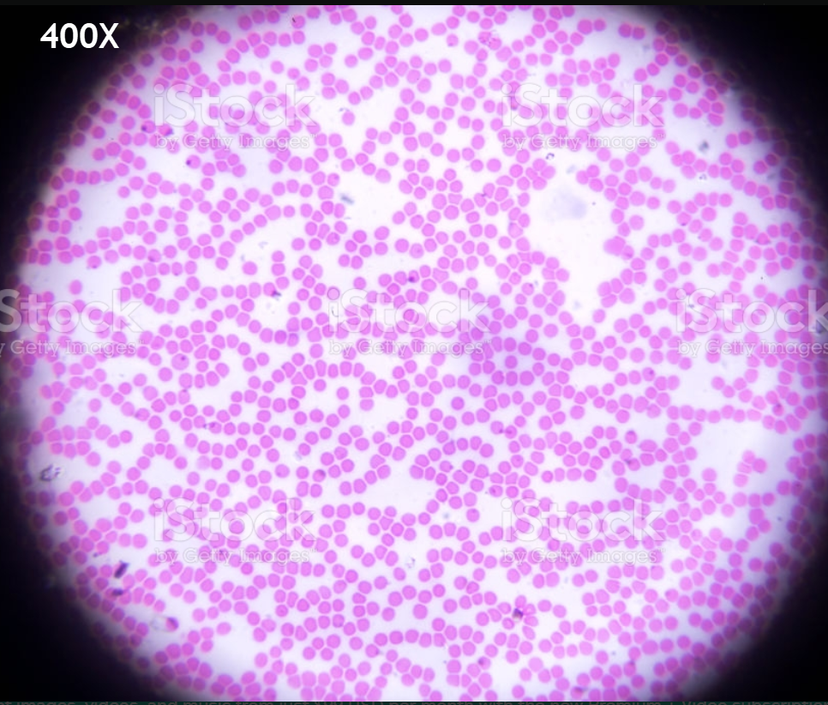

**Magnification** High power **400X**

Count how many red blood cells go across the center of the microscopic field: **_____**

Divide the total number of cells you counted going across the microscopic field INTO the diameter of the high-power field.

[e.g. diameter in mm / # RBC’s = **_____** mm]

**Diameter of ONE red blood cell**: **_____**

8. Go back to the top of page 1 and write the proper heading:

# *Name (upper left) Biology (upper right)*

*Date Teacher, section*

9. Place the title of the lab at the top center below your heading.

**Conclusions**

**Address Hypothesis** (*Was the hypothesis confirmed or incorrect? Give evidence*.)

**Analysis** (*Repeat content from the discussion with evidence from the lab*.)

For measuring microscopic materials, the biologist uses a unit known as a MICRON (μm), which is one millionth of a meter or 0.000001 m or 0.001 mm. In this lab, the red blood cell diameter was ? mm or ? microns. [1 mm = 1000 μm. ? mm / 1000 μm/mm = ? μm]

**Questions** (*Use complete sentences that convey a complete thought to answer each question*.)

1. What happens to the microscopic field view as the magnification increases? Give evidence to support your answer.

2. What is the estimated diameter of ONE human red blood in microns? SHOW WORK for your calculations. [1 mm = 1000 μm … # mm / 1000 μm/mm = ? μm]

**Errors**

The diameters of the microscopic fields and red blood cells were an estimate, leaving room for some inaccuracy of measurement.

Calculations may not be correct when converting units from millimeters to microns.

**Resources/Bibliography**

Microscopic Field. *Lab Worksheet*. Biology Course Site, Week 2. Learning CTR Online, n.d. Web. 16 Sept. 2022. <[www.learningctronline.com](http://www.learningctronline.com)/biology-course-site-s1>.

Metric Ruler under Low Power. Homeschoolsciencegeek. n.d. Web. 6 Sept. 2018. <https://homeschoolsciencegeek.wordpress.com/2018/09/06/high-school-biology-02/> .

Human Blood Smear under High Power. Newton North High School. n.d. Web. 17 March. 2020. [http://nnhsbergbio.pbworks.com/](http://nnhsbergbio.pbworks.com/w/file/fetch/114279419/NOTES.h_Microscopes%20Info.pdf) .