Cellular Respiration - Krebs Cycle



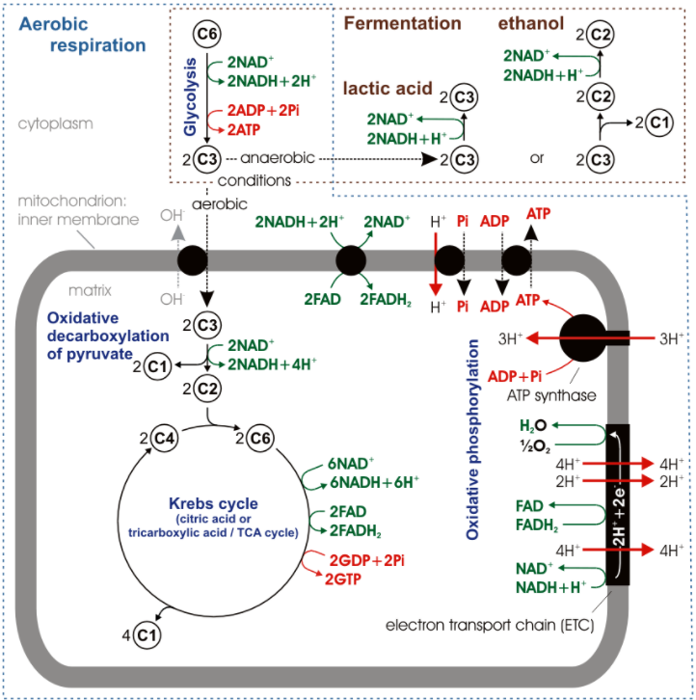

**See** [**https://www.learningctronline.com/courses**](https://www.learningctronline.com/courses) **for Materials and Resources.**

**Topics:**

1. Cellular Respiration – Krebs Cycle

**Objectives:**

1. Understand how energy is acquired by organisms.
2. Investigate the biological processes of Cell Respiration.
3. Analyze the steps of Cellular Respiration: Glycolysis, Transition Reaction, the Krebs Cycle, and the Electron Transport Chain.
4. Distinguish aerobic from anaerobic respiration.

TAKE NOTE

1. Notes/Study Guide
2. Homework from Text
3. Lab Cell Respiration Simulation
4. Honors 🡪 Know the names of molecules in cellular respiration.
5. Chapter 8 Test … Cell Respiration
6. Week 10 Devotional (<https://www.learningctronline.com/devotional>)

**Text**: Chapter 8: Cellular Respiration pp. 134-150

Read the assigned pages in the text.

**Class Notes: PowerPoint or PDF**

**Notes/Study Guide:** Fill in the Chapter 8 Study Guide worksheet to understand the class notes.

**Homework**:

* Study Questions (end of the chapter in the text) #1-3, 6-15 (explain true/false), 17-22
* Use a Word document format as follows:
  + Start on a new page of your document
  + Heading: Your name, Chapter in Text, Study Questions
  + Number the appropriate questions you are to answer
  + Write the answer in a complete sentence use the question as the template (do not copy the question, but reword it into a statement that answers the question).
* Use the same document each week by starting a new “Study Question” for a different chapter on the next page.
* Assignments will be “spot checked” during class or submitted via email.

**Lab**: Cell Respiration Simulation

* Complete the "Cell Respiration Simulation Lab" using the lab worksheet and videos provided.
* After completing the Lab worksheet, email it to [learningctronline@gmail.com](mailto:learningctronline@gmail.com) for grading.
* Save document into your LAB folder in the Biology folder on your desktop.

**TEST:** Cellular Respiration

1) the academic integrity policy

* Tests must be completed **WITHOUT** referring to books, notes, the internet, people, or any outside resources.
* A guardian should be proctoring the test as per Learning CTR Online policy: <https://www.learningctronline.com/test-proctor-policy>

2) This test is composed of 30 multiple choice and 2 essay questions.

* The **test must be taken "in one sitting"**, meaning that once you start the test, you must complete it without interruption.
* Take a short break (5 minutes) during the test.

3) There is a **60-minute time limit** on this test. Please have the proctor write the time taken at the top of your answer sheet with their signature or initials.

4) Honors students have an additional 20 minutes to answer the additional questions.

5) Proctors should NOT be reading the test or engaging students during the test.

5) Do NOT use RED font. Black font is best.

6) Students may use notes for 10 minutes at the end of the test … do NOT exceed the 60- minute time limit.

Supplemental Resources (Optional)

1. Cellular Respiration Vocabulary Crossword

<http://somup.com/c3fnYeOhzk> (4:44) **Glycolysis**

<http://somup.com/c3fnYiOhzG> (1:07) **Link (Transition) Reaction**

<http://somup.com/c3fnYlOhzL> (2:53) **The Krebs Cycle**

<http://somup.com/c3fnYDOhA1> (4:28) **The Electron Transport Chain (ETC)**

<https://youtu.be/eJ9Zjc-jdys> (8:47) The Amoeba Sisters Channel – **Cellular Respiration**

<https://youtu.be/YbdkbCU20_M> (8:34) The Amoeba Sisters Channel – **Fermentation**