Solid Waste Reference Material: Water Treatment

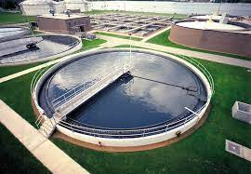

If most of us are honest, when someone would mention “solid waste” we thought they referred to human excrement (Webster: waste matter discharged from the body). Well, it includes that, but as we have already seen, solid waste is a huge, much-encompassing issue. In this reference material we will consider solid waste regarding sewage and therefore, regarding water quality.

For instance, how do we know that the water we drink is safe? After all, some towns issue a warning on all of their water bills: “This water is not safe for consumption.” Have you ever thought of what happens to our sewage when we flush it down? Realizing the mud-slinging we could encounter, let’s discuss this crappy subject. By the way one of the men who invented the toilet was named Thomas Crapper.

Water quality is defined by many factors. Most of which would bore you to death. So let’s include them all! (That was a joke if you didn’t catch it.) The most important factor in regard to water quality is DISSOLVED OXYGEN level. Dissolved oxygen simply means the amount of oxygen that is found in a body of water. Eighty percent of all oxygen is dissolved in the atmosphere so we (and plants) can breath it, while twenty percent of all the oxygen on earth is found in water for fish and plants to “breath.”

The amount of oxygen in a specific environment determines the type and amount of life there. For instance, trout need a relatively high amount of oxygen to survive, while carp or “suckers” can survive in places of low oxygen. This is why trout are found in fast moving streams that have a lot of rapids that mix oxygen into the water. Slow, small streams or bodies of water contain much less oxygen.

Water tests: pH and Hardness

There are several water quality tests that laboratories perform to determine if water is safe to drink. We won’t go into great depth in this water issue, but I do want to mention “pH” and “water hardness.” The highest water quality exists when pH is near 7 and hardness is around 80 parts per million.

Water hardiness is caused by calcium and magnesium ions and other heavy metal ions in water. Hardness is an important quality because “soft” water is corrosive (corrodes lead pipes) while “hard” water leaves scum and white, flaky stuff all over. The following chart categorizes water hardness by the amount of metal ions in the water:

|  |  |  |
| --- | --- | --- |
| 0-60 ppm |  | Soft |
| 61-120 ppm |  | Moderately hard |
| 121-180 ppm |  | Hard |
| Over 180 ppm |  | Very hard |

Hard water absorbs great amounts of detergents and soaps and therefore, forms scums. This is a problem when processing food products, beverages and rubber products. It is also a problem when taking a shower because you feel slimy and dirtier than before you took the shower. Soft water irritates eyes and skin. Limesoda softens “hard” water while an alkaline (higher pH) agent hardens “soft” water.

pH is another factor of water quality. There are many substances on earth called acids and bases. Acids contain high concentrations of [H+] ions and bases contain high concentrations of [OH-] ions. [H+] ions and [OH-] ions are the major constituents of [OH-] ions. [H+] ions and [OH-] ions are the major constituents of water as seen by this oversimplified mathematical equation:

water = #[H+] ions + #[OH-] ions

Below is a chart of approximate pH values of some common substances, including the pH range for most natural water supplies. Bases tend to be bitter while acids tend to be sour. Both are slippery to the touch because they “eat” away skin layers.

|  |  |  |
| --- | --- | --- |
|  | pH scale |  |
| Extremely alkaline | 14.0 | Household lyle |
| (basic) | 13.0 |  |
|  | 12.0 | Bleach |
| Strongly alkaline | 11.0 | Ammonia |
|  | 10.0 | Milk of magnesia |
| Moderately alkaline | 9.0 | Borax |
| Slightly alkaline | 8.0 | Baking soda, sea water |
| Neutral | 7.0 | Blood, distilled water ,milk |
| Slightly acidic | 6.0 | Corn |
|  | 5.0 | Boric acid (ear treatment) |
| Moderately acidic | 4.0 | Orange juice, citrus |
| Strongly acidic | 3.0 | Vinegar |
| Extremely acidic | 2.0 | Lemon juice |
|  | 1.0 | Battery acid |

Strong acids or strong bases are dangerous, requiring much care when being handled. As you can see, many substances are acids or bases; some even strong, yet we eat them or let them touch our body. This is because a diluted acid or base, even if very strong is much less harmful than when highly concentrated. Lemon juice is a good example. Pure lemon juice would burn our mouth, but diluted down it makes a great drink. After all, when life gives you lemons…make lemonade!

**Water treatment**

To consider “Wastewater (sewage) treatment”, we first need to talk about what happens without sewage treatment plants. What would happen if we didn’t have toilets? Can you imagine the mud slide in the streets? Before you are too “grossed out,” this is the condition for much of the underdeveloped, third world countries. Thank God for toilet paper and bathrooms!

**Natural sewage treatment**

The main problem of sewage in the environment is pathogenic bacteria (coliform bacteria). When humans excrete waste (scientific term for going to the bathroom), the bacteria in the feces (yet, another term for bodily discharge through the anus) is picked up in the ground water. Where there are chicken, pig, cow, sheep, etc farms and/ or concentrated human populations, there will be a lot of…waste. This sewage can be broken down in nature. Believe it or not, there are micro-organisms that feed on our defecation (did you realize there was so many ways to tell about discharging feces through the anus). The problem is that nature cannot handle such great amounts of sewage, excrement, feces, defecation, manure…and the like.

**Self Purification**

In the old days when people lived out in the sticks by themselves or even when communities developed the “River” sewage systems, nature handled the problem. Yes, the raw sewage was channeled into the rivers. Man, I used to swim in the river! The sewage formed a ZONE OF DEGRADATION, which flowed downstream. In this “zone of degradation” you can see visible solids, there is low dissolved oxygen in the water and therefore, only scavenger fish like carp or sturgeon could survive.

But things get worse further downstream in the ZONE OF DECOMPOSITION. In the “zone of decomposition” there is little to no dissolved oxygen in the water, the water smells and is darkly colored. There is not much suspended solids, the water is just like a chocolate milk drink. This zone cannot support any fish life, but bloodworms (leeches) are able to survive.

As you proceed further downstream, one would encounter a ZONE OF RECOVERY. This zone of recovery shows an increase in the dissolved oxygen level of the water. The carp, sturgeon and even catfish are abundant. One would probably not be grossed out by this zone.

Finally, in times past there were ZONES OF CLEAN WATER. In reality, there are many rivers that do not contain zones of clean water anymore. All sewage is completely removed, the water is clean, the dissolved oxygen supports trout, bass, pike and many fishfood-insects.

The reality of dumping raw sewage into our rivers still occurs today. The ocean is a favorite dumping ground. The good news is that the city that dumps the sewage doesn’t see the disgusting results. The bad news is that there are many cities downstream! These downstream sites suffer from diseases and impurities in their drinking water. Definitely a crappy situation to be in.

**Lentic Communities.**

Other places where sewage may be dumped are found in lentic communities. This is usually the type of thing you can “dive” into. “Lentic” refers to the study of bodies of water: oceans, lakes, rivers, streams, etc. I would like to list and define some common bodies of water.

Lakes: a standing body of water greater than ten acres (1 acre = 202 X 202 feet) capable of preventing plants from giving root, but allowing animal life anywhere.

Ponds: a smaller, quiet body of water (less than ten acres) capable of supporting plants all across its diameter.

Swamp: wet lowland area that can support woody vegetation (small trees).

Marsh: broad, wet area that cannot support woody vegetation, but does support grasses and sedges/cattails.

Bog: An area of water that accumulates floating organic matter on the surface. Vegetation forms an unstable mat that does not support trees or rooted plants. The water is usually “acidic” and “soft” with a base of fine sediment up to several feet deep.

**Sewage/Wastewater Treatment**

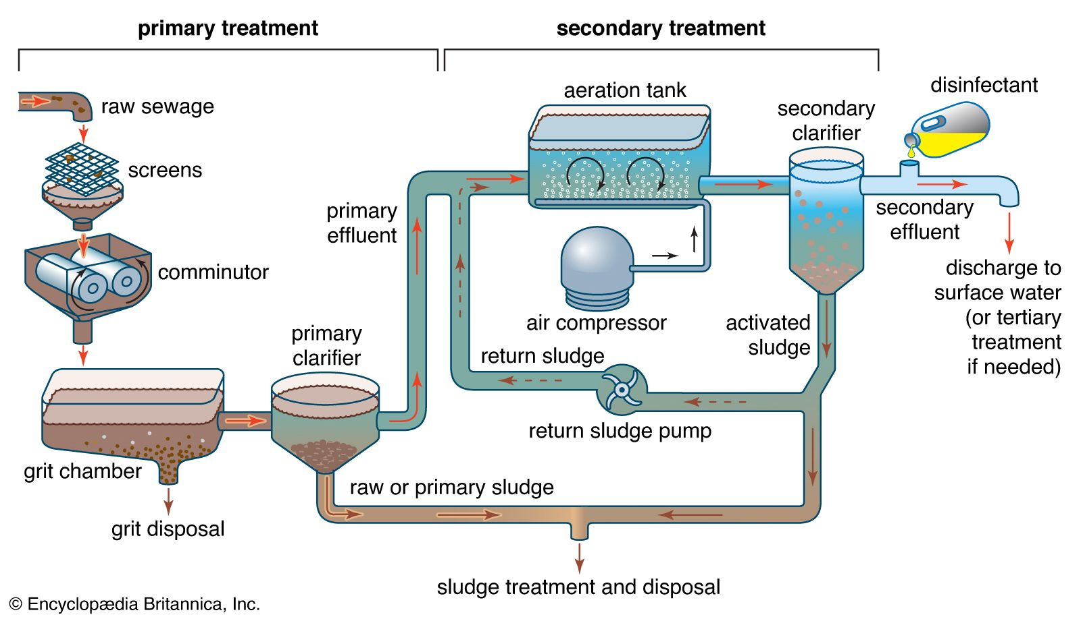

Wastewater treatment is generally divided into three phases of treatment: primary treatment, secondary treatment and tertiary treatment.

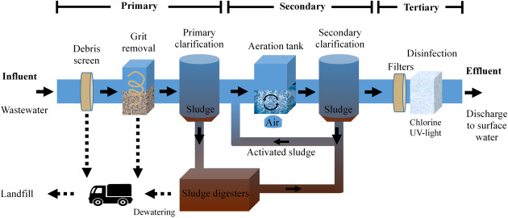

1. Primary treatment removes suspended solids through the “physical” means of screens and settling out of heavier materials. PHYSICAL REACTION.

2. Secondary treatment bacteria to decompose or break down the sewage so it can be further treated. BIOLOGICAL REACTION.

3. Tertiary treatment involves the following CHEMICAL REACTIONS: (a) add oxygen to the aeration tank, (b) add chemicals to help solids come together, therefore, becoming heavier and settling out, (c) absorb gases, minerals and dangerous liquids, and (d) kill off harmful bacteria before the waste water re-enters the river water (chlorination).

To start the whole process sewage treatment, wastes flow to a Wastewater Treatment Plant by gravity, and then it’s all downhill from there. The following sketch is a simplified graphic of the processes and mechanisms used to treat sewage.

(A) Heavy solids, grit, sand, cinders, etc., settle out in the grit removal process. This involves materials passing through screens or larger solids being lifted by CONVEYOR BELT to be taken to a landfill.

(B) The remaining large pieces of material in waste – paper, fibre, leaves, etc., are ground up in a special GRINDER.

(C) The “affluent” (part going in) mixture of ground up waste and smaller suspended solids pass into the PRIMARY SETTLING TANK. Here, bits of organic materials settle out, and are pumped to the digester (G).

(D) The lighter waste waters flow to an AERATION TANK where they are mixed with live cultures of bacteria and mixed violently. This stirring speeds the biological decomposition of the waste because the bacteria feed on sewage and oxygen. Mixing increases oxygen.

(E) The “effluent” (part coming out of) mixture of waste and bacteria flows to a final SETTLING CHAMBER where the bacteria falls to the bottom and the clear treated waste water flows in to chlorination tank.

(F) At the CHLORINATION TANK, any residual amounts of bacteria are killed by the “disinfecting” chlorine (just as in a swimming pool). The final “effluent” enters the nearby river.

(G) The DIGESTER receives the majority of settled out material: bacteria from the final settling chamber (E) and the sludge from the primary settling tank (C). This waste is dehydrated or de-watered in the digester so it can be landfilled or possibly used to produce fuel gas.