Organic Chemistry

I. Carbon Containing Molecules

## A. The study of substances containing carbon in combination with hydrogen and sometimes other non-metals [O, N, S]

## B. Organic molecules are more common than all other compounds combined

## C. Fats, proteins, carbohydrates, vitamins are all organic

## D. Medical Treatment: sulfa drugs, hormones (pills, steroids), cortisone, tranquillizers, anti-inflammatants, adrenaline (epinephrine), etc.

II. Nature of Organic Molecules

## A. Bonding

1. Based on the carbon atom (each has 4 covalent bonds)

2. Structural formulas are 3-D (3 dimensional)

3. Single, double, triple covalent bonds between carbon atoms … also hybridization (sp, sp2, sp3, etc.)

a) carbon bonds strongly with non-metallic atoms

C – H 99 kcal/mole

C – O 84 kcal/mole

C – Cl 79 kcal/mole

C – N 70 kcal/mole

b) carbon bonds strongly with itself

C – C 83 kcal/mole

C = C 143 kcal/mole



196 kcal/mole

c) other atoms in the same family (group IV) like Si, Ge have relatively weak bonds with themselves

Si – Si Ge – Ge ~42 kcal/mole

B. Characteristics

1. insoluble in water

2. usually non-electrolytes

3. low melting point

4. react slower than inorganic compounds (smaller)

5. often require high activation energies for the reaction to begin

#### C. Formulas

1. Molecular Formula C2H6

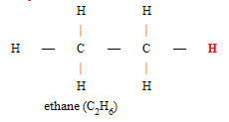

2. Structural Formula



3. Skeletal Formula ▬ (ethane) (propane)

[assume C and H atoms]

4. Empirical Formula (CH) 2

5. Isomers

* Same molecular formula, but different structural formulas

#### Galactose Glucose isomers of Pentane

C6H12O6 C6H12O6 C5H12

#### 

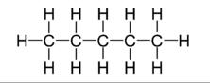

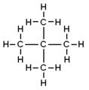

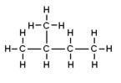

*milk sugar* *blood sugar*

##### III. Hydrocarbons

###### A. Molecules that contain ONLY carbon and hydrogen atoms

* The largest group of organic molecules.

###### B. Homologous Series

1. Saturated Hydrocarbons (“ALKANES”)

a. Contain only single covalent bonds between carbon atoms

b. sp3 hybrid orbitals around the carbon atoms (*tetrahedral geometry*)

 pentane

*skeletal formula*

* Because of electron pair repulsion, carbon chains are actually “bent” so there is less atom to atom interference

c. Alkane Series (**CnH2n+2**)

|  |  |  |  |  |  |  |
| --- | --- | --- | --- | --- | --- | --- |
| **Alkane** | **# of Carbons** | **Formula** |  | **Alkane** | **# of Carbons** | **Formula** |
| Methane | n = 1 | CH4 |  | Octane | n = 8 | C8H18 |
| Ethane | n = 2 | C2H6 |  | Nonane | n = 9 | C9H20 |
| Propane | n = 3 | C3H8 |  | Decane | n = 10 | C10H22 |
| Butane | n = 4 | C4H10 |  | Undecane | n = 11 | C11H24 |
| Pentane | n = 5 | C5H12 |  | Dodecane | n = 12 | C12H26 |
| Hexane | n = 6 | C6H14 |  |  |  |  |
| Heptane | n = 7 | C7H16 |  | Triacontane | n = 30 | C30H62 |

d. Alkyl Groups (CnH2n+1)

* Organic molecules are classified and named according to the carbon chain and also by alkyl groups
* For instance, butane (C4H10) can also be isopropane which is **methyl** propane (same molecular formula)

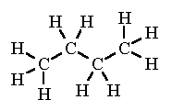 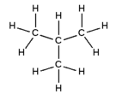

Butane methyl propane

|  |  |  |  |  |  |  |
| --- | --- | --- | --- | --- | --- | --- |
| **# of Carbons** | **Alkyl Group** | **Formula** |  | **# of Carbons** | **Alkane** | **Formula** |
| n = 1 | Methyl | -CH3 |  | n = 8 | Octyl | -C8H17 |
| n = 2 | Ethyl | -C2H5 |  | n = 9 | Nonyl | -C9H19 |
| n = 3 | Propyl | -C3H7 |  | n = 10 | Decyl | -C10H21 |
| n = 4 | Butyl | -C4H9 |  | n = 11 | Undecyl | -C11H23 |
| n = 5 | Pentyl | -C5H11 |  | n = 12 | Dodecyl | -C12H25 |
| n = 6 | Hexyl | -C6H13 |  |  |  |  |
| n = 7 | Heptyl | -C7H15 |  | n = 30 | Triacontyl | -C30H61 |

e. Alkanes are commonly used for combustion reactions

CH4 + 2 O2 (g) 🡪 CO2 (g) + H2O

hydrocarbon + oxygen 🡪 carbon dioxide + water.

f. Cyclo alkanes (CnH2n)

|  |  |  |  |  |  |  |
| --- | --- | --- | --- | --- | --- | --- |
| **Name** | **Cyclopropane** | **Cyclobutane** | **Cyclopentane** | **Cyclohexane** | **Cycloheptane** | **Cycloalkane** |
| **Molecular Formula** | C3H6 | C4H8 | C5H10 | C6H12 | C7H14 | CnH2n |
| **Structural Formula** |  |  |  |  |  | (CH2)n |
| **Line Formula** |  |  |  |  |  |  |

* Cyclo-alkanes have 2 less hydrogens per molecule
* The most common cyclo-alkanes have 5-6 carbon rings because they are more stable.

##### III. Hydrocarbons

###### B. Homologous Series

2. Unsaturated Hydrocarbons (“ALKENES” & “ALKYNES”)

a. Contain at least one double or triple covalent bond between carbon atoms

1) alkenes are also called the ethylene series (CnH2n) and/or “olefins,” containing at least one double covalent bond between carbon atoms

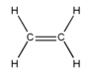

Ethene or Ethylene

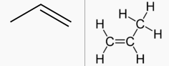

Propene or propylene

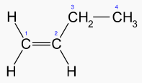

1-butene or butylene

a) sp2 hybrid orbitals

b) unsaturated hydrocarbons are more reactive than the saturated hydrocarbons (alkanes) because the double or triple bond is less stable.

c) unsaturated hydrocarbons are often saturated by H2, HBr, Br2, HCl and Cl2

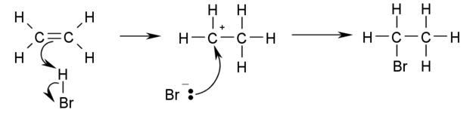

*Saturation of ethylene with HBr*

2) alkynes are also called the acetylene series (CnH2n-2) containing at least one triple covalent bond between carbon atoms



a) sp hybrid orbitals

b) The most reactive of the hydrocarbons

c) Acetylene is used in welding and cutting metals (high temperature flame)

b. Made by the process of CRACKING 🡪 long chain paraffins are heated in the presence of a catalyst so the -C–C- bonds rupture and allow double or triple bonds to form in their place.

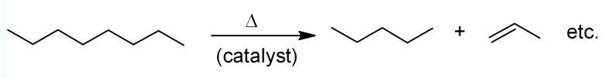

*octane* *pentane propene*

c. Unsaturated hydrocarbons are more reactive than the saturated hydrocarbons (alkanes) because the double or triple bond is less stable.

3. Aromatic Hydrocarbons (“BENZENE” Series)

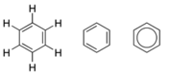

a. Strong odors

b. Based on benzene (6 carbon ring)

1) A liquid which boils ~80 C

2) less reactive than alkynes/acetylenes

3) doesn’t hydrogenate (add hydrogen to unsaturated bonds) as readily as ethylenes or alkynes

c. General Formula: CnH2n-6

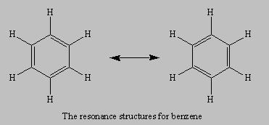

d. Resonance Structures

1) planar molecules

2) regular hexagonal pattern

3) the actual C to C bond has the same length (not “double” or “single” but in between) so the only way to represent it is via resonance structures (e.g. NO3- ion or SO2 molecule)

e. Benzene Structures

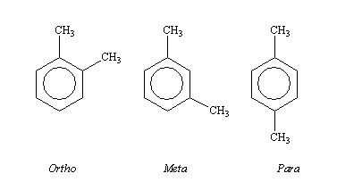

Common benzene configurations: ortho, meta, para

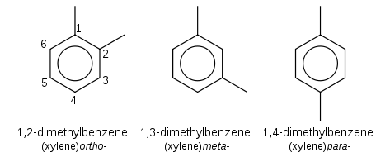

Benzene derivatives are used in gasoline and other petroleum products, cleaning agents, and many industrial intermediates

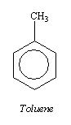 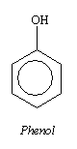 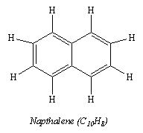

Napthalene is a constituent in mothballs and polymers found in car enamels

###### 

###### C. Polymerization

1. Polymers are molecules which consist of a large number of small molecular units combined together chemically

a. The nature of polymers depends on the “monomer” (the repeating unit within the polymer)

b. Examples

cellulose cotton

blood skin

rubber plastics

silk synthetics (Dacron, nylon, silicone)

leather wood

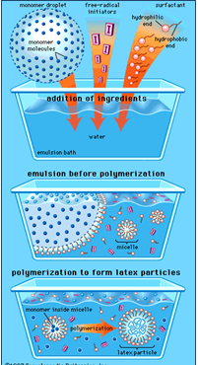

|  |  |  |  |  |
| --- | --- | --- | --- | --- |
| **Name(s)** | **Formula** | **Monomer** | **Properties** | **Uses** |
| **Polyethylene** low density (LDPE) | –(CH2-CH2)n– | ethylene CH2=CH2 | soft, waxy solid | film wrap, plastic bags |
| **Polyethylene** high density (HDPE) | –(CH2-CH2)n– | ethylene CH2=CH2 | rigid, translucent solid | electrical insulation bottles, toys |
| **Polypropylene** (PP) different grades | –[CH2-CH(CH3)]n– | propylene CH2=CHCH3 | atactic: soft, elastic solid isotactic: hard, strong solid | similar to LDPE carpet, upholstery |
| **Poly(vinyl chloride)** (PVC) | –(CH2-CHCl)n– | vinyl chloride CH2=CHCl | strong rigid solid | pipes, siding, flooring |
| **Poly(vinylidene chloride)** (Saran A) | –(CH2-CCl2)n– | vinylidene chloride CH2=CCl2 | dense, high-melting solid | seat covers, films |
| **Polystyrene** (PS) | –[CH2-CH(C6H5)]n– | styrene CH2=CHC6H5 | hard, rigid, clear solid soluble in organic solvents | toys, cabinets packaging (foamed) |
| **Polyacrylonitrile** (PAN, Orlon, Acrilan) | –(CH2-CHCN)n– | acrylonitrile CH2=CHCN | high-melting solid soluble in organic solvents | rugs, blankets clothing |
| **Polytetrafluoroethylene** (PTFE, Teflon) | –(CF2-CF2)n– | tetrafluoroethylene CF2=CF2 | resistant, smooth solid | non-stick surfaces electrical insulation |
| **Poly (methyl metha) crylate** (PMMA, Lucite, Plexiglas) | –[CH2-C(CH3)CO2CH3]n– | methyl methacrylate CH2=C(CH3)CO2CH3 | hard, transparent solid | lighting covers, signs skylights |
| **Poly(vinyl acetate)** (PVAc) | –(CH2-CHOCOCH3)n– | vinyl acetate CH2=CHOCOCH3 | soft, sticky solid | latex paints, adhesives |
| **cis-Polyisoprene** natural rubber | –[CH2-CH=C(CH3)-CH2]n– | isoprene CH2=CH-C(CH3)=CH2 | soft, sticky solid | requires vulcanization for practical use |
| **Polychloroprene** (cis + trans) (Neoprene) | –[CH2-CH=CCl-CH2]n– | chloroprene CH2=CH-CCl=CH2 | tough, rubbery solid | synthetic rubber oil resistant |

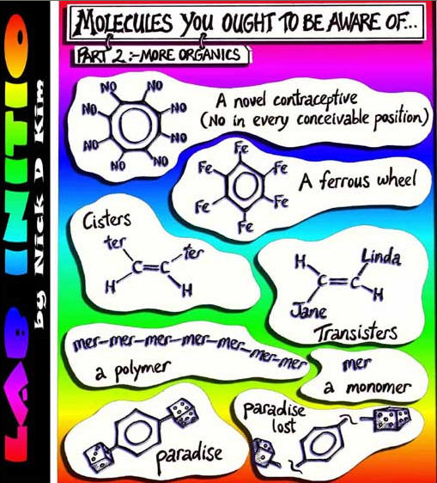IV. IUPAC Naming

###### A. Identify the Carbon Chain

1. Number the carbon atoms sequentially to represent the longest chain or largest “ring” – this is called the “parent” chain

* Numbering does NOT have to be horizontally arranged
* meth- (1 carbon atom), eth- (2 carbon atoms), prop- (3 carbon atoms) …

2. Determine whether the molecule has ONLY single covalent bonds between the carbon atoms.

a. All single bond(s) 🡪 alkane series 🡪 “-**an**”

b. Double bond(s) 🡪 alkene/ethylene series 🡪 “-**en**”

c. Triple bond(s) 🡪 alkyne/acetylene series 🡪 “**-yn**”

3. Name the parent chain – this becomes the base of the molecules’ name.

###### B. Name the “Alkyl Groups” along the parent chain

1. Determine what alkyl groups are present and how many of each.

* A single alkyl group is named as is: methyl, ethyl, propyl, etc.
* TWO of any alkyl group uses the prefix: “**di-**“ … dimethyl, diethyl, etc.
* “**tri-**” refers to three of the same alkyl group, “**tetra-**” refers to four of the same alkyl group, “**penta-**” refers to five of the same alkyl group, etc.

2. Each alkyl group will have a NUMBER corresponding to the carbon atom of the parent chain.

“**2-methyl**” indicates a **methyl** group on the **number 2** carbon atom.

3. If the same alkyl group exists, label the numbers separated by a comma and then name the alkyl group.

* “**2,3-dimethyl**” indicates a **methyl** group on the **number 2** and **number 3** carbon atoms.
* “**2-methyl, 4-ethyl**” indicates a **methyl** group on the **number 2** carbon atom and an **ethyl** group on the **number 4** carbon atom.

*Examples are provided on the next few pages:*

***Example 1:*** Write the structural formula for **2-methyl pentane**.

Start decoding the name from by counting the number of carbon atoms in the longest chain; in this case: “- ***pent”*** [*5 carbons*].

Determine if there are any carbon-carbon double or triple bonds? That would mean the name has an “-ene” or “-yne” in it. In this case: “- ***an”*** tells you there are not any.

Draw the carbon skeleton: [*pentane*]

-1C–2C–3C–4C–5C-

Put a “**methyl”** group on the “**number 2**” carbon atom: [*2-methyl*]



It does NOT matter which end you start counting from. Counting from the other end yields the same structural formula as the first one, except that it has been flipped.



Finally, put in the correct number of hydrogen atoms on each carbon so that each carbon is forming four bonds.



***If you had to name this yourself:***

* Count the longest chain of carbons that you can find. The longest carbon chain does NOT have to be drawn horizontally. 5 carbons means “- ***pent***.**”**

OR

 

* Are there any carbon-carbon double bonds? No. Therefore, “- an” 🡪 ***pentane***.
* Identify the ***methyl*** group (-CH3) on the number 2 carbon.

This organic molecule is named: ***2-methyl pentane***.

* By convention, number the alkyl groups from the end which produces the LOWEST number in the name. In this case: **2-methyl** rather than 4-methyl.

***Example 2:*** Write the structural formula for **2,3-dimethyl butane**.

Draw the carbon backbone which is based on (***but-***) with 4 carbons in the longest chain and (- ***an***) with no carbon-carbon double or triple bonds.

-1C–2C–3C–4C-

The prefix (***di-***) indicates two **methyl** groups and the numbers **2,3** indicate that the methyl group (-CH3) is located on the number 2 and number 3 carbon atoms:

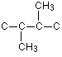

Complete the formula by filling in the hydrogen atoms as shown:

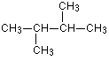

**Note:** It does not matter whether you draw the two methyl groups one up and one down, or both up, or both down



***If you had to name this yourself:***

* Count the longest chain of carbons that you can find. The longest carbon chain does NOT have to be drawn horizontally. **4** carbons means “- ***but***.**”**



OR

* Are there any carbon-carbon double bonds? No. Therefore, “- an” 🡪 ***butane***.
* Identify the ***methyl*** groups (-CH3) on the number 2 and number 3 carbon atoms.
* Since there are TWO methyl groups, we add the prefix “**di-**” to indicate that.

This organic molecule is named: **2,3-dimethyl butane**.

***Example 3:*** Write the structural formula for **2,2-dimethyl butane**.

This is exactly like the last example, except that both methyl groups are on the same carbon atom. Notice that the name shows this by using ***2,2-*** as well as ***di***. The structure is worked out as before:

-1C–2C–3C–4C-

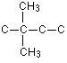 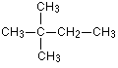

*with all the hydrogen atoms* 🡪

***Example 4:*** Write the structural formula for **2-methyl 3-ethyl hexane**.

*“****hexane****”* indicates a 6-carbon chain with no carbon-carbon double/triple bonds.

-1C–2C–3C–4C–5C–6C-

This time there are two **different** alkyl groups attached:

* + and a **methyl** group (-CH3) on **number 2** carbon atom.
  + an **ethyl** group (-CH2CH3) on the **number 3** carbon atom

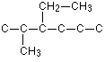

Fill in the hydrogen atoms:

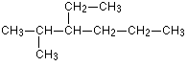

**Note:** Normally, the name of an organic molecule lists the LOWEST numbered alkyl group first and then goes sequentially. Some naming systems alphabetize the name by alkyl group (i.e. 3-ethyl 2-methyl hexane).

V. Oxygen Containing Organic Molecules

* The next most abundant organic molecules after hydrocarbons
* Often named after their hydrocarbon “roots”
* Functional Groups

1. A particular arrangement of a few atoms which give characteristic properties to an organic molecule

2. Organic molecules can often be considered as being composed of 1 or more “FUNCTIONAL GROUPS” attached to a hydrocarbon backbone or radical.

3. “R” will represent a carbon-based unit.

###### A. Alcohols

1. Functional Group: R—OH

2. Characteristics

a. not “bases” … even though it contains an “OH” (hydroxyl) group … does NOT dissociate in an aqueous solution

b. non-electrolytes

c. does exhibit Hydrogen bonding (strengthens inTERmolecular bonds)

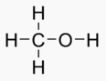 

*methanol ethanol*

3. Classes of Alcohols

a. Primary / Terminal



1) the –OH is attached to the end/terminal carbon atom

2) **Naming** depends on the number of carbon atoms … change the ending to “**-ol**”

Methanol, ethanol, propanol, butanol, pentanol, etc.

b. Secondary

1) the –OH is attached to a non-terminal carbon atom

2) **Naming** depends on the position of the “-OH” group, the number of the carbon atom, and changing the ending to “**-ol**”

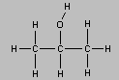

2-propanol

c. Tertiary

1) the –OH is attached to a carbon atom that is bonded to TWO other carbon atoms (three carbon atoms total … “**tert**”)



2) **Naming** depends on the position of the “-OH” group, the number of the carbon atom, and changing the ending to “**-ol**”

* The following alcohol can be named more than one way:

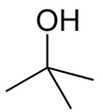 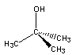

Tert Butanol 2-methyl 2-propanol

*antifreeze*

d. Diols and Triols

1) Alcohols often contain more than one –OH group is attached to a carbon atom that is bonded to TWO other carbon atoms (three carbon atoms total … “**tert**”)

2) **Naming** depends on the position of the “-OH” group, the number of the carbon atom, and changing the ending to “**-ol**”

* The following alcohol can be named more than one way:

 

Ethane 1,2 di-ol 1,2,3-propan tri-ol

(Glycerol)

###### 

###### B. Ethers

1. Functional Group: R—O— R’

2. Characteristics

a. exhibit little to no Hydrogen bonding



b. every ether has one isomeric alcohol

c. they are common linkages in carbohydrates and lignin; formerly used as *anesthetics*

3. Naming Ethers

a. recognize the ether functional group

b. name the alkyl group on each side of the oxygen atom

CH3-O-CH3 di-methyl ether

 di-ethyl ether

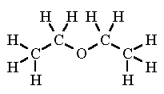

###### 

Ether or sweet oil was discovered by Spanish chemist, *Raymundus Lullius* in 1275.

In 1540 German Scientist, Valerius Cordus described how to synthesize it and Swiss physician, Paracelsus discovered the medicinal uses of ether.

MTBE gasoline additive

**Methyl *tert*-butyl ether**



###### C. Aldehydes

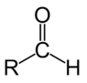

1. Functional Group:

2. Characteristics

a. -C=O is highly polar … *relatively unstable molecules*

b. Aldehydes are used in preservatives, perfumes, and resins (fabric)

c. the aldehyde functional group is moderately reactive and can be further oxidized to form a carboxyl group (no hydrogen atom).

d. Aldehydes are produced from terminal alcohols.

3. Naming Aldehydes

a. Write it as -CHO - ***never*** as -COH, because that looks like an alcohol

b. The names of aldehydes end in “***al***.”

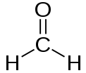 methanal (formaldehyde)

 propanal

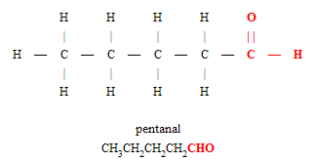

Formaldehyde was commonly used to preserve animals, plants, etc. Eventually it was found to be carcinogenic.

###### D. Organic Acids

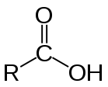

1. Functional Group:

2. Characteristics

a. Do NOT ionize in water (non-electrolytes)

b. Aldehydes easily oxidize to form the carboxylic acid group

c. Used in making plastics, wood glue, synthetic fibers and fabrics, descaling agents

d. Organic acids (along with esters) are main ingredients in aspirin, soaps, detergents. They tend to have strong, rancid odors.

3. Naming Organic Acids

a. Organic acids usually are given a common name because they are abundantly used in industry

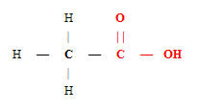

ethanoic acid (vinegar)

acetic acid

b. The IUPAC naming system identifies the carbon chain

c. The names of organic acids end in ***–oic acid***.

|  |  |  |  |  |
| --- | --- | --- | --- | --- |
| **# of Carbons** | **Common Name** | **IUPAC name** | **Chemical Formula** | **Common Location or use** |
| 1 | Formic Acid | Methanoic Acid | HCOOH | Insect stings |
| 2 | Acetic Acid | Ethanoic Acid | CH3COOH | Vinegar |
| 3 | Propionic Acid | Propanoic Acid | CH3CH2COOH | Preservative |
| 4 | Butyric Acid | Butanoic Acid | CH3(CH2)2COOH | Rancid Butter |
| 6 | Caproic Acid | Hexanoic Acid | CH3(CH2)4COOH | Goat Fat |
| 8 | Caprylic Acid | Octanoic Acid | CH3(CH2)6COOH | Coconuts & breast milk |
| 12 | Lauric Acid | Dodecanoic Acid | CH3(CH2)10COOH | Coconut oil & hand soaps |
| 14 | Myristic Acid | Tetradecanoic Acid | CH3(CH2)12COOH | Nutmeg |
| 16 | Palmitic Acid | Hexadecanoic Acid | CH3(CH2)14COOH | Palm oil |
| 18 | Stearic Acid | Octadecanoic Acid | CH3(CH2)16COOH | Chocolate, waxes, soaps, & oils |
| 20 | Arachidic Acid | Eicosanoic Acid | CH3(CH2)18COOH | Peanut oil |

###### E. Ketones

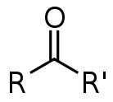

1. Functional Group:

* a type of molecule that features one carbonyl group (C=O) bonded to two other carbon atom

2. Characteristics

a. Non-terminal alcohols (-OH) are oxidized to form ketones

b. Every ketone has at least one isomeric aldehyde

c. Produced on massive scales in industry as solvents, polymer precursors, and pharmaceuticals.

d. The brain, in particular, relies heavily on ketone bodies as a substrate for [lipid](http://en.wikipedia.org/wiki/Lipid) synthesis and for energy during times of reduced food intake.

3. Naming Ketones

a. The IUPAC naming system identifies the carbon chain. Ketones are named by changing the suffix *-e* of the parent alkane to *-one*.

b. For the most important ketones, however, traditional nonsystematic names are used virtually exclusively, e.g. **acetone** and **benzophenone**.

c. The position of the carbonyl group is usually denoted by a number.

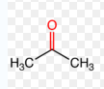

Dimethyl ketone (acetone) CH3C(O)CH3

Common solvent for cleaning purposes in the laboratory. active ingredient in nail polish remover and as paint thinner and sanitary cleaner/nail polish remover base.

2 butanone or methyl ethyl ketone CH3C(O)CH2CH3

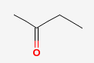

Solvent, found in coatings and in vinyl films use in the manufacture of plastics, textiles, in the production of paraffin wax, and in household products such as laquer, varnishes, paint remover, a denaturing agent for denatured alcohol, glues, and as a cleaning agent. Butanone is also used in dry erase markers as the solvent of the erasable dye.

###### F. Esters

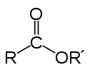

1. Functional Group:

* the product of the reaction between an organic acid and an alcohol

acetic acid (vinegar) + ethanol 🡪 ethyl acetate (or ethyl ethanoate) + water

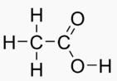  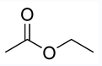

2. Characteristics

a. General formula written as: **R-COO-R’**

b. Pleasant odors, less soluble in water than alcohols or organic acids

c. Industrial solvents; also used in manufacturing plastics (plexiglas, dacron)

d. Commonly used in fragrances and artificial flavoring in foods. Found in “essential oils” (An oil is "essential" in the sense that it carries a distinctive scent, or essence, of the plant.) and pheromones.

e. Esters (along with organic acids) are main ingredients in aspirin, soaps, detergents.

f. Many common fragrances contain multiple esters (pineapple, cherry, pear, grape, banana, apple).

3. Naming Esters

a. Ester names are derived from the names of the parent alcohol and the carboxylic acid followed by the suffix *-oate*.

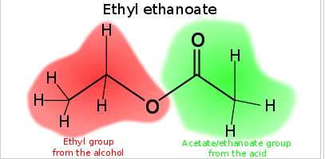

###### G. Soaps / amino acids / Nitriles / … etc.

Table of Common Esters and their Derivations

|  |  |  |  |  |
| --- | --- | --- | --- | --- |
| Ester | Structure | Odor | Alcohol | Acid |
| Benzyl acetate |  | **Peaches**  Pear  Strawberry | Benzyl alcohol | Acetic acid (vinegar) |
| Butyl butyrate |  | **Pineapple** | Butanol | Butyric acid |
| Ethyl butyrate |  | **Pineapple**  Banana  Strawberry | Ethanol | Butyric acid |
| Isoamyl acetate |  | Banana  Pear | Isoamyl alcohol (pentanol) | Acetic acid (vinegar) |
| Octyl ethanoate  (Octyl acetate) |  | **Orange** | Octanol | Acetic acid (vinegar) |
| Methyl anthranilate |  | Grape  Jasmine | Methanol | 2-aminoben-zoic acid |
| Methyl butyrate |  | Apple  Pineapple  Strawberry | Methanol | Butyric acid |
| Metyl salicylate |  | **Wintergreen** | Methanol | Salicylic acid |
| Propyl ethanoate  (propyl acetate) |  | **Pear** | Propanol | Acetic acid (vinegar) |

VI. Organic Processes

###### A. Substitution

1. One element replaces another. Often, organic substitution occurs with halogens.

2. With the exception of iodine, all of the halogens are more electronegative than carbon.

a. The halogen has a negative polarity while the carbon-based chain has a positive polarity.

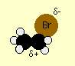

b. Normally, the H of a saturated hydrocarbon is replaced by the halogen

c. This process is called “Halogenation” or halogen substitution.

CH4 + Cl2  🡪 CH3Cl + HCl

###### B. Addition

1. Adding one or more elements to an unsaturated hydrocarbon (alkenes or alkynes).

2. Hydrogenation

a. Hydrogen is often the element that replaces the double or triple bond of the organic molecule.



Ethene Hydrogen Ethane

b. Some margarine is made by hydrogenating carbon-carbon double bonds in animal or vegetable fats and oils. You can recognize the presence of this in foods because the ingredients list will include words showing that it contains "*hydrogenated vegetable oils*" or "*hydrogenated fats*".

3. There are some probable health risks from eating hydrogenated fats or oils.

3. There are some probable health risks from eating hydrogenated fats or oils.

a. The relatively high temperatures used in the hydrogenation process tend to flip some of the carbon-carbon double bonds into the "trans" form.

b. If these particular bonds aren't hydrogenated during the process, they will still be present in the final margarine in molecules of ***trans fats***.

c. The consumption of trans fats has been shown to increase cholesterol levels (particularly of the more harmful LDL form) - leading to an increased risk of heart disease.

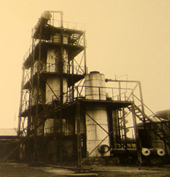

###### C. Cracking

1. "Cracking" breaks larger molecules into smaller ones. This can be done with a thermic or catalytic method.

2. Cracking processes allow the production of liquified petroleum gas (LPG), gasoline products, jet fuel, and diesel fuels.

a. exhibit little to no Hydrogen bonding

b. every ether has one isomeric alcohol

c. they are common linkages in carbohydrates and lignin; formerly used as anesthetics

3. Another application of “cracking” is the break down complex “paraffins” (long chain alkanes/waxes) to smaller “olefins” (possess a double bond … alkenes)

###### D. Fermentation

1. Conversion of carbohydrates or organic acids

2. Anaerobic Respiration is biochemical fermentation

Glucose → Energy (ATP) + Ethanol + Carbon dioxide (CO2)  
  
Glucose → Energy (ATP) + Lactic acid

a. production of energy

b. The process of anaerobic respiration yields less energy than aerobic respiration.

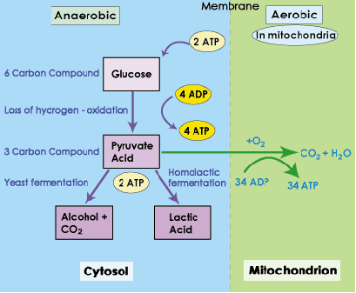

3. A metabolic process whereby electrons released (oxidation) from nutrients are ultimately transferred to molecules obtained from the breakdown of those same nutrients.

a. cider, winemaking, brewing beer (alcohol based)

b. flavoring in foods and tea leaves (lactic acid based) … sauerkraut, dry sausages, kimchi, yogurt or vinegar for use in pickling foods.

4. In industry, fermentation is the breakdown and re-assembly of biochemicals for industry. There are 5 major groups of commercially important fermentation reactions:

1. [Microbial](http://en.wikipedia.org/wiki/Microbial) [cells](http://en.wikipedia.org/wiki/Cell_(biology)) or [biomass](http://en.wikipedia.org/wiki/Biomass) as the product, e.g. [single cell protein](http://en.wikipedia.org/wiki/Single_cell_protein), [bakers yeast](http://en.wikipedia.org/wiki/Bakers_yeast), [lactobacillus](http://en.wikipedia.org/wiki/Lactobacillus), [E. coli](http://en.wikipedia.org/wiki/E._coli), etc.
2. Microbial [enzymes](http://en.wikipedia.org/wiki/Enzyme): [catalase](http://en.wikipedia.org/wiki/Catalase), [amylase](http://en.wikipedia.org/wiki/Amylase), [protease](http://en.wikipedia.org/wiki/Protease), [pectinase](http://en.wikipedia.org/wiki/Pectinase), [glucose isomerase](http://en.wikipedia.org/wiki/Glucose_isomerase), [cellulase](http://en.wikipedia.org/wiki/Cellulase), [hemicellulase](http://en.wikipedia.org/wiki/Hemicellulase), [lipase](http://en.wikipedia.org/wiki/Lipase), [lactase](http://en.wikipedia.org/wiki/Lactase), [streptokinase](http://en.wikipedia.org/wiki/Streptokinase), etc.
3. Microbial [metabolites](http://en.wikipedia.org/wiki/Metabolite) :
4. Primary metabolites – [ethanol](http://en.wikipedia.org/wiki/Ethanol), [citric acid](http://en.wikipedia.org/wiki/Citric_acid), [glutamic acid](http://en.wikipedia.org/wiki/Glutamic_acid), [lysine](http://en.wikipedia.org/wiki/Lysine), [vitamins](http://en.wikipedia.org/wiki/Vitamin), [polysaccharides](http://en.wikipedia.org/wiki/Polysaccharide) etc.
5. Secondary metabolites: all [antibiotic](http://en.wikipedia.org/wiki/Antibiotic) fermentation
6. Recombinant products: [insulin](http://en.wikipedia.org/wiki/Insulin), [HBV](http://en.wikipedia.org/wiki/HBV), [interferon](http://en.wikipedia.org/wiki/Interferon), [GCSF](http://en.wikipedia.org/wiki/GCSF), [streptokinase](http://en.wikipedia.org/wiki/Streptokinase)
7. Biotransformations: [phenyl acetyl carbinol](http://en.wikipedia.org/w/index.php?title=Phenyl_acetyl_carbinol&action=edit&redlink=1), [steroid](http://en.wikipedia.org/wiki/Steroid) [biotransformation](http://en.wikipedia.org/wiki/Biotransformation), etc.

###### E. Combustion

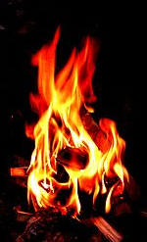

1. Exothermic chemical reaction between a fuel and an oxidant (oxidizing element)

2. Organic combustion usually works with a hydrocarbon. The general form of a combustion reaction is:

CH4 + 2 O2 🡪 CO2 + H2O +

hydrocarbon + oxygen 🡪 carbon dioxide + water + HEAT

3. Common hydrocarbons used in combustion

a. methane (“natural gas”), ethane, propane (grills), butane (lighters), octane (gasolines)

b. cyclic hydrocarbons yield a lot of energy (heat) … 485 kcal/mole (cyclopropane) to 1400 kcal/mole (cyclodecane)

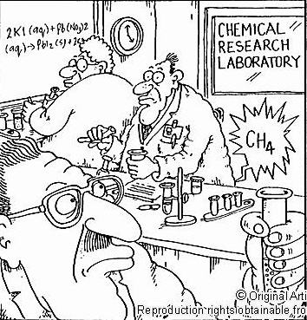

###### F. Esterification

1. Production of esters from an alcohol and organic acid

2. See “Esters” in previous section (*oxygen containing organic molecules*)

###### G. Saponification

1. **Saponification** (“soap making”) is the [hydrolysis](http://en.wikipedia.org/wiki/Hydrolysis) of an [ester](http://en.wikipedia.org/wiki/Ester) under [basic](http://en.wikipedia.org/wiki/Base_(chemistry)) conditions to form an [alcohol](http://en.wikipedia.org/wiki/Alcohol) and the salt of a [carboxylic acid](http://en.wikipedia.org/wiki/Carboxylic_acid) ([carboxylates](http://en.wikipedia.org/wiki/Carboxylate)).

2. Commonly used to refer to the reaction of a metallic alkali ([base](http://en.wikipedia.org/wiki/Base_(chemistry))) with a [fat](http://en.wikipedia.org/wiki/Fat) or [oil](http://en.wikipedia.org/wiki/Oil) to form [soap](http://en.wikipedia.org/wiki/Soap). [*When a vegetable oil or animal fat is mixed with a strong alkali. The products of the reaction are two: soap and glycerin.*]

a. Natural soaps are sodium or potassium salts of fatty acids, originally made by boiling lard or other animal fat together with lye or potash (potassium hydroxide).

b. Hydrolysis of the fats and oils occurs, yielding glycerol and crude soap.

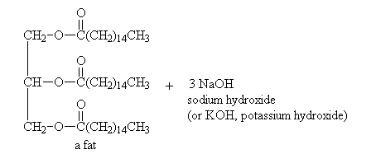 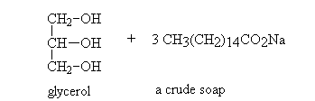

3. A curious fact about modern soap is that most common soap found in the grocery store made in mass-produced factories does have a small amount of excess alkali in it. Also, it has had all of its naturally-occurring glycerin (moisturizer) removed so it can be sold as a separate commodity. Why? Greater profit.

