**QUICK LAB: Sublimation [Textbook p. 437]**

Laboratory Record Sheet Use with Section 13.4

**PURPOSE**

To observe the sublimation of air freshener.

**MATERIALS**

* small pieces of solid air freshener
* small, shallow container
* 2 clear 8-oz plastic cups
* hot tap water
* ice
* 3 thick cardboard strips

**PROCEDURE**

**1.** Place a few pieces of air freshener in one of the cups. **CAUTION:** *Work in a well-ventilated room.*

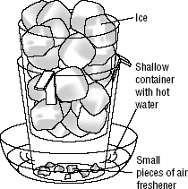**2.** Bend the cardboard strips and place them over the rim of the cup that has the air freshener pieces.

**3.** Place the second cup inside the first. The base of the second cup should not touch the air freshener. Adjust the cardboard as necessary. This assembly is your sublimator.

**4.** Fill the top cup with ice. Do not get any ice or water in the bottom cup.

**5.** Fill the shallow container about one-third full with hot tap water.

**6.** Carefully place your sublimator in the hot water. Observe what happens.

**7. If you do NOT have the materials necessary, watch the video:** [**http://somup.com/cFQ6XCVSht**](http://somup.com/cFQ6XCVSht)

**ANALYSES AND CONCLUSIONS**

(*Use complete sentences that convey a complete thought. Also, include evidence to back up your answers*.)

**1.** Define *sublimation*.

**2. PREDICT** what would happen when the water in the shallow container is at room temperature compared to when the water is boiling.

**3.** Explain the heat transfer or flow when sublimation takes place. Consider the substance that sublimes and the surrounding air or substances in your answer.

**4.** Show a general equation of sublimation and deposition using solid, vapor and arrows. Explain the heat transfer for each process.

5. Label the heat transfer for each state of matter in the diagram.

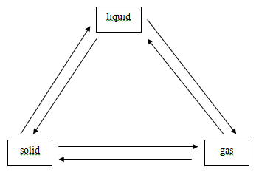

**ANALYSES AND CONCLUSIONS**

*ANSWERS are provided for guidance. You may use them AS LONG AS YOU REWORD your answers in YOUR OWN WORDS versus copying and pasting.*

*1. Sublimation is the change of a substance from a solid to a gas without passing through the liquid stage. In this lab the air freshener went from solid to gas because it was placed in hot water, causing it to sublime.*

*2. At room temperature, we predict less sublimation than at the boiling point because of the heat or temperature difference of the water. Sublimation requires heat added to a system so a solid can sublime to a gas.*

*3. A substance sublimes because heat is absorbed or added (endothermic) to the system causing the solid to become a gas while the surrounding air or substances lose or give off heat (exothermic). The air freshener in this lab goes from solid to gas because heat is lost from the water into the air freshener. Another common example of sublimation is with dry ice (solid carbon dioxide) which sublimes at room temperature because the dry ice absorbs heat from the surrounding air (which loses heat). Dry ice is often used to keep substances cool. In other words, substances give off their heat to the dry ice.*

*4.  Sublimation is an endothermic process, meaning that the solid gains heat to become vapor. Deposition is an exothermic process, meaning that the vapor loses heat to become solid.*

*5. State of Matter diagram:*

