**Electricity / Vehicles**

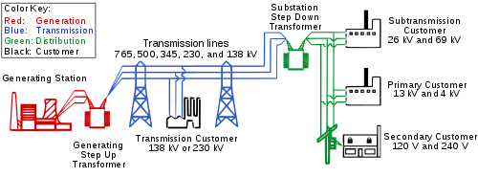

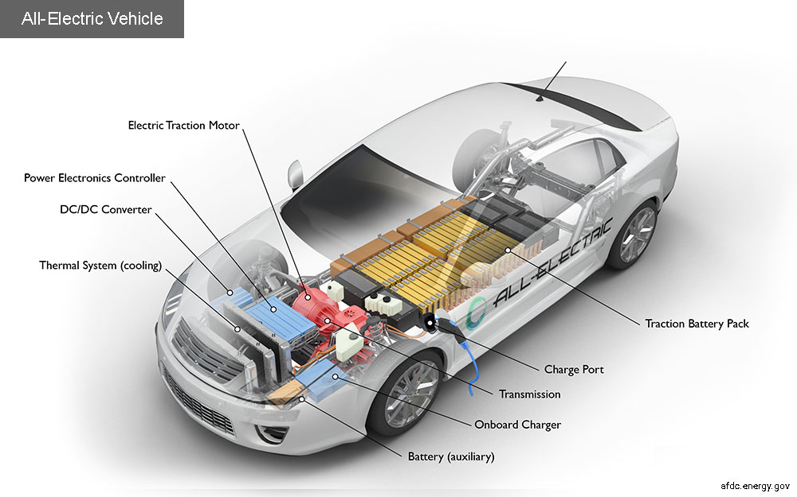

**See** [**https://www.learningctronline.com/courses**](https://www.learningctronline.com/courses) **for Materials and Resources.**

**Topics:**

1. Electricity Vehicles

**Objectives:**

* + Explain basic components of electricity (electrons, circuits, conductors, insulators, magnetic induction).
  + Identify and define components of electrical power plants (Magnetic induction, turbine, generator, alternating/direct current, step up/step down transformation).
  + Summarize energy resources (sources of energy, types of renewable and non-renewable energy sources, energy units, cost, usage/consumption, production).

TAKE NOTE [1 week]

1. Review Alternative Energy (Go Green Project; Solar/Wind Labs; Fracking)
2. Electricity & Transmission Pre-test
3. Electricity & Transmission PowerPoint Worksheet
4. Energy Summary Reference Material Worksheet
5. Electric Vehicles Worksheet
6. Film Review “Edison the Man” [1940, Spencer Tracy, 1h 47 m]
7. Quiz Electricity & Energy Summary
8. Week 24 Devotional (<https://www.learningctronline.com/devotional>)

**Text**:

**Reference Material: PowerPoint & Reference Material**

**Homework**:

* Electricity & Transmission PowerPoint Worksheet
* Energy Summary Reference Material Worksheet

**Lab**: Electrical Vehicles Worksheet

* Complete the Electrical Vehicles worksheet by summarizing at the end.
* Save the document into your LAB folder in the Projects in Science folder on your desktop.

**Lab**: Film Review

* Obtain the movie “Edison, the Man” [1940, Spencer Tracy) [1h 47m].
  + Complete the **Edison, the Man** film review provided.
* Save the document into your LAB folder in the Projects in Science folder on your desktop.

**TEST:** Electricity & Energy Summary Quiz

1) the academic integrity policy

* Tests must be completed **WITHOUT** referring to books, notes, the internet, people, or any outside resources.
* Students **MAY** use the approved Periodic Tables, approved Reference Tables, or approved equation (formula) sheet (provided by the teacher) along with calculators and scratch paper.
* A guardian should be proctoring the test. Proctoring means to monitor the following:

2) Take the **"in one sitting"**, meaning that once you start the test, you must complete it without interruption.

3) There is a **30-minute time limit** on this test. Please have the proctor write the time taken at the top of your answer sheet with their signature or initials.

4) Proctors should NOT be reading the test or engaging students during the test.

5) Do NOT use RED font. Black font is best.

Supplemental Resources (Optional)