*What are You Longing For?*

Have you ever considered what constitutes a human being? I am not referring to one’s chemical composition, but to one’s person.

**Humans are Made of Three Parts**

Every human has a physical **body** which contacts the physical world through physical senses (taste, touch, hearing, sight, smell, pain, pressure). No one denies the existence of the human body because one can see it, touch it, and interact with the physical world around us. Yet, two deeper, inward parts of a person, the soul and the spirit, cannot be seen physically.

The **soul** contacts the psychological world, allowing people to think, feel, choose, and interact on a philosophical and psychological level. The soul is the immaterial aspect or essence that confers individuality and humanity (love, joy, peace, kindness, and other virtues) and is often synonymous with the self or the mindset of a person. Since the soul is contained within the body, it cannot be observed directly using our physical senses. Yet, the fact that everyone thinks, feels, and chooses proves that we have a mind, emotion, and will … all of which constitute our “inward” soul or person that is deeper than our physical body.

The deepest, most hidden, and unknown part of a human being is the **spirit** with its leading aspects of conscience and intuition and with its major function to contact and receive God. The vast majority of people believe in the existence of the supernatural; possibly a creator, spirits, gods of some kind, etc. all of which are beyond ourselves. Even atheists may pray when facing fear, death or tragedy. Why? Because God has put eternity into the heart of every person (Ecclesiastes 3:11). There is an inner longing to know the meaning of life (if we pay attention), to know how we got here (origins), and to know what life will be after this physical and soulish existence ends.

People may suppress the longing within them, but God is calling out to each of us through our human spirit. Do we respond by seeking Him in return? In order to contact God, we must exercise our spirit, not our mind, not our will, not our emotion, not some physical position or activity. To receive God’s life into our spirit we have to respond to the eternity stirring deep within us. This is not a religion, a ritual, or anything contrived by us, but an acknowledgment that God is calling out to us deep within. We act on this calling by seeking God, and believing that it is God Who is coming to us personally and intimately. Once we contact God, we receive Him without reference to our body and soul initially.

The diagram shows a simple view of a person’s constitution. Note that the spirit is hidden deep within the soul, and the soul is contained within the body. God created human kind with these three parts. Most humans realize the need to properly care for their bodies and even their souls, but few pay attention to or properly understand their spirit.

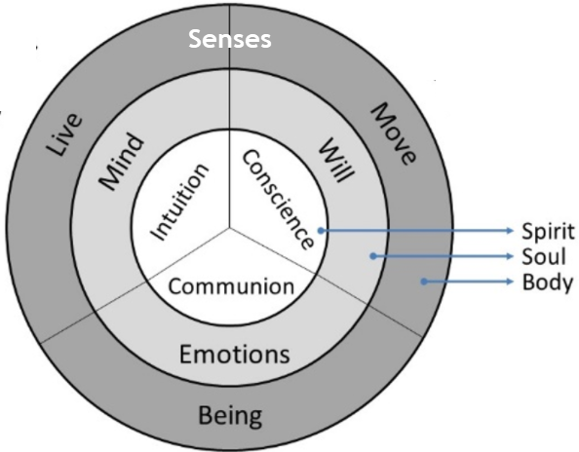

How do we recognize our spirit? The spirit causes a hunger within that neither money, nor education, nor religion, nor pleasure, nor fame, nor power, nor status, nor success, nor outward peace, etc. can fully satisfy. The spirit also drives us to know the meaning of our existence rather than just pursuing “YOLO” (you only live once).

God wants us to use our spirit in the way He intended when He created us. Apart from this, we will always sense a void, an emptiness, a lack, something is missing, or “Is this all there is?” God created us with a soul to excel and to strive to fulfill our potential on a human level, which may include high attainments and bright hopes. But ask yourself why we pursue a life of “better” possessions, “greater” challenges, “higher” excitement, “optimum stimulation”, etc. On one hand, this is good and healthy to some degree. On the other hand, when will we truly feel satisfied? After God created the universe and especially mankind, He was satisfied because He rested (Genesis 2:2-3). He didn’t need physical rest, but wanted to dwell in the satisfaction of His creation with the potential of having an intimate, personal relationship with people!

The most motivated person may accomplish great achievements, but once they reach the “top” (and some do), there is the feeling, “Is this it? Why do I feel there is more to life?” There is! God! God put a spiritual organ within each of us to call to us and cause us to long for something higher than anything we can attain or obtain in the human realm. Ultimately, nothing will permanently satisfy the deep inner longing except God Himself.

For many, the thought of God is existential, surreal, and intangible. But the Creator of the universe wants us to know Him, to love Him, and to worship Him in reality. To respond to the inner calling of God and the inner longing for something more is true worship and this involves intimacy and communion with almighty God Himself through Jesus Christ. Unfortunately, the term “worship” has been distorted by religion to imply some ritual, some outward practice, some methodology, some meditation or transcendence, or some supernatural phenomenon that is mystical or unattainable. But God said that true worship is in spirit and truth (John 4:24), which simply means to contact God Himself via our human spirit. When we touch God, we touch truth. He is truth. He is available. He is loving, kind, approachable, and desires us to know Him personally and intimately.

Most people worship via their bodies (performing outward rituals) or via their souls (feelings, intellect, decisive behavior modification), acknowledging a supreme being, but do they miss the intimate communion with God Himself? If so, then their worship is vain. Proper and true worship begins deep within us and is initiated by God Himself. God calls us. We do not call Him first. God chooses us. We do not choose Him first. How we respond to God’s call and choosing means everything. Do we seek Him? Do we allow ourselves to deny our former manner of life and chose to join in with God?

It is interesting to note, that before we know God, our world began mainly interacting via our physical body with the development of our soul or person. God operates deep within us and we are mainly unaware or unwilling to focus on our spirit because it is like a foreign agent. Once, however, we come to know God, believe in God, receive God, and trust God, He works to sanctify our entire being: body, soul, and spirit (1 Thessalonians 5:23). The entire process of interacting with our new world in Jesus Christ is to allow God within our spirit to infiltrate our soul and eventually even our bodies.

CTR