**Mirrors & Lenses (Week 2)**

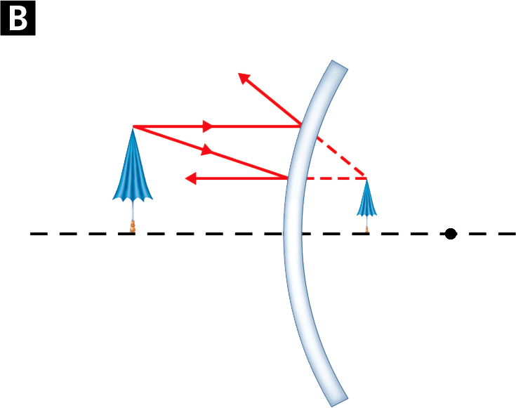

Focal point

Convex mirror

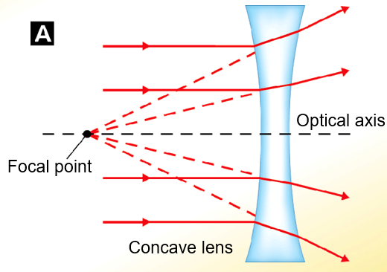

**See** [**https://www.learningctronline.com/courses**](https://www.learningctronline.com/courses) **for Materials and Resources.**

**Topics:**

1. Mirrors and Lenses (week 2 of 3)

**Objectives:**

* Name the three major types of mirrors and describe & draw how light is transmitted through them.
* Name the two major types of lenses and describe & draw how light is transmitted through them.
* Calculate focal points, object and image distances and shapes related to each type of mirror and lens.
* Define polarization and give real life examples of its use.

TAKE NOTE

1. Reading (Hewitt Text)

2. Lab: Reflection & Refraction LAB REPORT due this week (Friday)

3. Notes Mirrors and Lenses (read)

4. Problem Set 1: Reflection & Refraction (due next week)

5. Problem Set 2: Mirrors and Lenses (due before Test)

6. Ray Diagrams Worksheet (1 week)

7. Lab: Flat & Spherical Mirrors (1 week)

8. Lab: Lenses (1 week)

9. Quiz Mirrors (open notes) … due after next week’s class (midnight).

10. Class Song: If I Had Reality

11. Consider Final Project topic (weeks 31-32)

12. Week 29 Devotional (<https://www.learningctronline.com/devotional>)

**Text**: Chapters 30 Lenses; 29.3 Mirrors (Hewitt)

**Class Notes: Use the Document provided**

**Homework**:

* Ray Diagrams Worksheet
* Problem Set 1 Reflection & Refraction
* Problem Set 2 Mirrors and Lenses (2 weeks)

**Lab**: Flat & Spherical Mirrors

* Perform the lab as directed using the worksheet provided.
* Complete all calculations and data, showing work whenever appropriate.
* Conclusions should be answered in complete sentences that convey a complete thought.
* Save the documents into your LAB folder in the Physics folder on your desktop.

**Lab**: Lenses

* Perform the lab as directed using the worksheet provided.
* Complete all calculations and data, showing work whenever appropriate.
* Conclusions should be answered in complete sentences that convey a complete thought.
* Save the documents into your LAB folder in the Physics folder on your desktop.

**TEST:** Quiz Mirrors and Lenses

There is a **20-minute time limit** on the quizzes.

You MAY use notes on this quiz.

Supplemental Resources (Optional)

**<http://somup.com/c0f3oL44Mm> Converging (Convex) Lenses** (2:08)

[**http://somup.com/cFf0FsV5Gl**](http://somup.com/cFf0FsV5Gl)(1:37) Diverging (Concave) Lenses

[**https://somup.com/c3QVD2UDdG**](https://somup.com/c3QVD2UDdG) **(5:15) Metaphysic on America’s Got Talent**