Inheritance Patterns

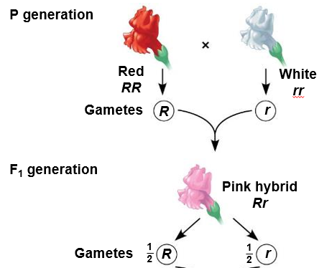

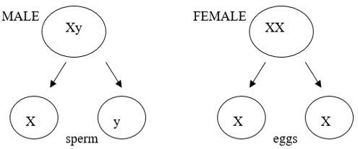



**See** [**https://www.learningctronline.com/courses**](https://www.learningctronline.com/courses) **for Materials and Resources.**

**Topics:**

1. Inheritance Patterns

**Objectives:**

1. Describe, define and give examples for Incomplete Dominance (intermediate dominance, co-dominance, blending).
2. Explain inheritance by Multiple Alleles, including human blood typing (antigens, antibodies, Rh factor, recipients, donors).
3. Understand how sex is determined for individuals and in offspring.
4. Describe, define and give examples sex-linked traits.
5. Define Polygenic Inheritance (Continuous Variation) and give examples.
6. Explain Epistasis (modifier genes).

TAKE NOTE

1. Notes/Study Guide Inheritance Patterns (1 week)
2. Homework from Text Chapter 13 (1 week)
3. Lab Build a Body
4. Lab Human Blood Typing
5. Worksheet: Intermediate Dominance, Dihybrid Traits, Multiple Alleles (Q1-2, 4-6, 8, 10-12 minimum).
6. Honors
   1. Must draw the “Build a Body” in the lab (#3).
   2. Complete all questions on the homework worksheet (#5).
   3. Create Notes Study Guide using objectives, major, minor points.
7. Chapter 12-13 Test … Genetics & Inheritance Patterns (due within ONE week). Submit Test for grading and feedback BEFORE taking the semester exam.
8. Semester Exam (Chapters 1-8, 10-16) … due within 10 days … review test corrections.
9. Week 16 Devotional (<https://www.learningctronline.com/devotional>)

**Text**: Chapter 13: Inheritance Patterns pp. 230-243

Read the assigned pages in the text.

**Class Notes: PowerPoint or PDF**

**Notes/Study Guide:** Fill in the Chapter 8 Study Guide worksheet to understand the class notes.

**Homework**: (1 week)

* Study Questions (end of the chapter in the text) #1-7
* Use a Word document format as follows:
  + Start on a new page of your document
  + Heading: Your name, Chapter in Text, Study Questions
  + Number the appropriate questions you are to answer
  + Write the answer in a complete sentence use the question as the template (do not copy the question, but reword it into a statement that answers the question).
* Use the same document each week by starting a new “Study Question” for a different chapter on the next page.
* Assignments will be “spot checked” during class or submitted via email.

**Lab**: Build a Body

* Complete the "Build a Body" using the lab worksheet provided.
* Honors students or those desiring bonus points must draw, sketch, make an image of the Body based on the traits “inherited”.
* After completing the Lab worksheet, email it to [learningctronline@gmail.com](mailto:learningctronline@gmail.com) for grading.
* Save document into your LAB folder in the Biology folder on your desktop.

**Lab**: Human Blood Typing

* Complete the "Human Blood Typing" using the lab worksheet provided.
* Use the following link: <https://accessdl.state.al.us/AventaCourses/access_courses/virtuallabs_ua_v21/01_unit/01-01/01-01_learn.htm>
* After completing the Lab worksheet, email it to [learningctronline@gmail.com](mailto:learningctronline@gmail.com) for grading.
* Save document into your LAB folder in the Biology folder on your desktop.

**TEST:** Genetics & Inheritance Patterns

1) the academic integrity policy

* Tests must be completed **WITHOUT** referring to books, notes, the internet, people, or any outside resources.
* A guardian should be proctoring the test as per Learning CTR Online policy: <https://www.learningctronline.com/test-proctor-policy>

2) This test is composed of 25 multiple choice and 3 essay questions.

* The **test must be taken "in one sitting"**, meaning that once you start the test, you must complete it without interruption.
* Take a short break (5 minutes) during the test.

3) There is a **60-minute time limit** on this test. Please have the proctor write the time taken at the top of your answer sheet with their signature or initials.

4) Honors students have an additional 15 minutes to answer the additional questions.

5) Proctors should NOT be reading the test or engaging students during the test.

5) Do NOT use RED font. Black font is best.

Supplemental Resources (Optional)

1. Inheritance Patterns Vocabulary Crossword

<https://youtu.be/YJHGfbW55l0> (7:11) The Amoeba Sisters Channel – **Incomplete Dominance, Codominance, Polygenic Traits, Epistasis**

<https://youtu.be/9O5JQqlngFY> (7:04) The Amoeba Sisters Channel – **Multiple Alleles (ABO Blood Types) & Punnett Squares**

<https://youtu.be/h2xufrHWG3E> (6:11) The Amoeba Sisters Channel – **Punnett Squares & Sex-Linked Traits**

TEST: Semester Exam

1. **A guardian should be proctoring your test.** Proctoring means to monitor the following:  
     
   1) the academic integrity policy,  
   2) taking the entire test "in one sitting", and  
   3) keeping the time limit of 90 minutes.  
     
   Proctors should NOT be reading the test or engaging students during the test.
2. For the semester exam you **MAY** use the review study guide during the exam according to the exam strategy shown below. **Do NOT use the study guide until you have gone through the exam twice as directed below.**
3. The test must be completed **WITHOUT** referring to the textbook, the class notes, the internet, people, or any other outside resources on this test.
4. Students **MAY** use the approved Periodic Tables, approved Reference Tables, or approved equation (formula) sheet (provided by the teacher) along with calculators and scratch paper throughout the exam.
5. The semester exam must be taken in one sitting, meaning that once you open the test, you must complete it without interruption. There is NO written portion for this exam, only automated (multiple choice).
6. You have **90 minutes** **maximum** to complete the semester exam. You will be penalized for going over the time limit, even 1 minute. Students who have an accommodation should email the teacher regarding the time limit.

**STRATEGY: Take the test "three times".**

1. Go through all the questions and answer the "easier" ones for you first ... to build confidence.
2. Then, go back and carefully consider the ones you did not answer initially. Skip the ones you feel are too hard, you don't understand, or you will look up using the review study guide.
3. Lastly, go to the questions you skipped and make them make sense based on your knowledge of Biology. Look up some answers using study guides if you have time.

If you take more than 90 minutes, your score will be reduced UNLESS you have a documented, pre-approved accommodation.

**The semester exam has 50 multiple choice questions with NO written portion.**