Heading

Title

**Introduction**

**Purpose** To observe anaerobic respiration using yeast fermentation in sugar.

**Discussion**

All living cells, including the cells in your body and the cells in yeast, need energy for cellular processes such as pumping molecules into or out of the cell or synthesizing needed molecules. **ATP** is a special molecule which provides energy in a form that cells can use for cellular processes. Each cell in our body and each yeast cell can use the energy stored in organic molecules in food to make ATP.

**When O2 is available**, cells use **aerobic** **cellular respiration** to transfer energy from the organic molecules in food to ATP. As shown in the figure, aerobic cellular respiration is a complex process that begins with **glycolysis**, followed by the **Krebs cycle** and the **electron transport chain**. Aerobic cellular respiration can make up to 36 molecules of ATP per molecule of glucose. Most of this ATP is produced by the electron transport chain which can only function if O2 is available.

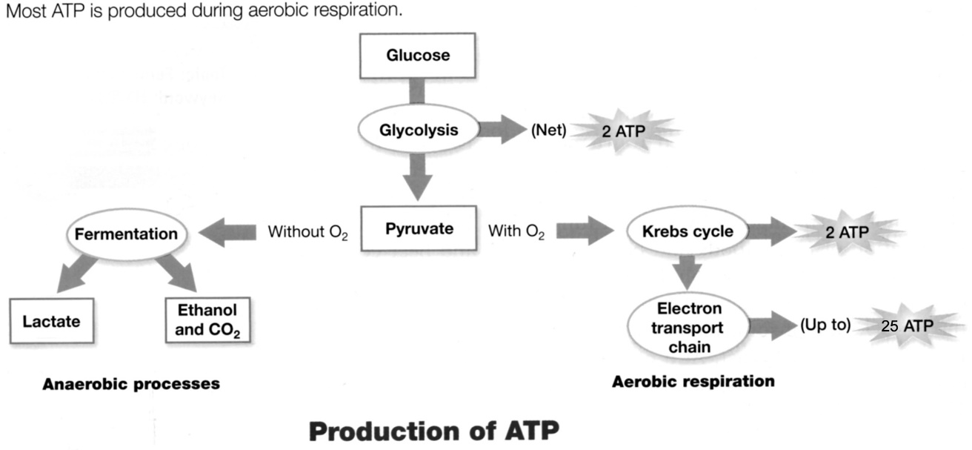

**36**

**ATP**

**When O2 is not available**, cells can make ATP using glycolysis followed by **fermentation**. Glycolysis produces 2 ATP and fermentation restores molecules needed for glycolysis to continue. Glycolysis followed by fermentation produces much less ATP than aerobic cellular respiration, but fermentation is useful when O2 is not available. In the figure, fermentation is referred to as **anaerobic** processes. The "an" in front of aerobic means "not” aerobic (no oxygen). There are two types of anaerobic fermentation:

1. **lactate** **fermentation** (e.g. in muscles when an animal exercises hard)
2. **alcoholic fermentation** (e.g. in yeast, which can be used to make wine or beer)

To measure the rate of fermentation in yeast, you can measure the amount of carbon dioxide (CO2) gas the yeast produces. CO2 production can be measured by measuring the circumference of balloons, which get bigger as they catch the CO2 produced by the yeast.

**Hypothesis**

If different amounts of sugar are added to the same amount of yeast in four bottles, then the reaction with the most sugar will have the yield the most fermentation.

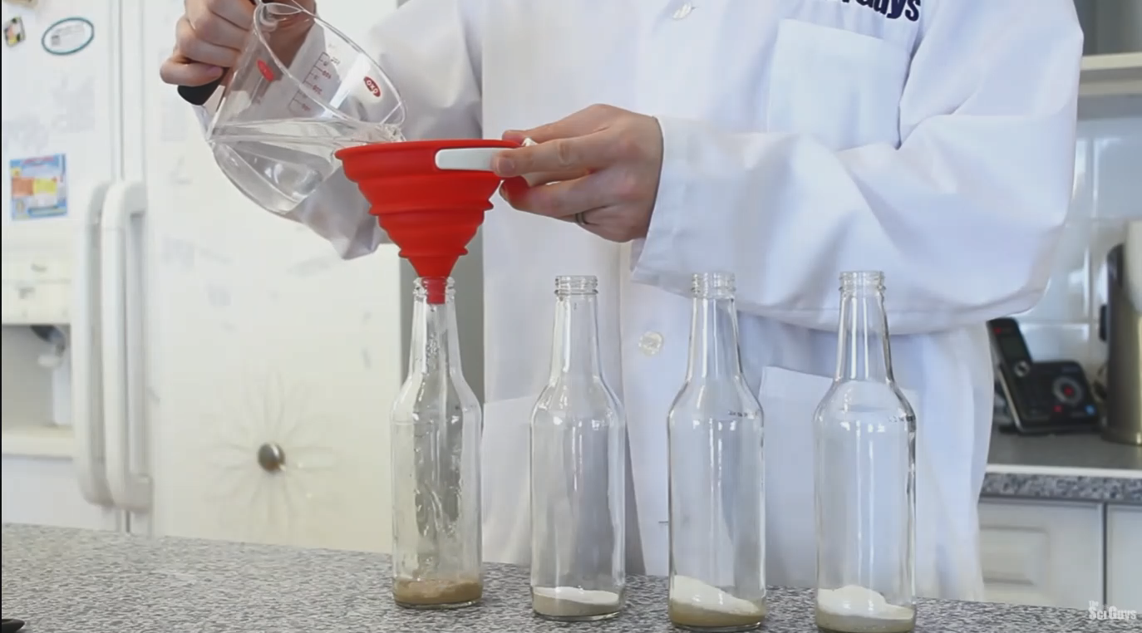

**Materials**

<http://somup.com/c3ewYoOeIW> (2:58)

* + 4 12-ounce bottles (see image)
  + 4 packets of Active Dry Yeast (bread maker yeast) (2 ¼ teaspoons) (*Make sure that the yeast has not reached its expiration date*)
  + Thermometer (⁰ C)
  + Funnel (*if needed, make your own out of a coffee filter by cutting a small hole.*)
  + Water Balloons that fit snugly on your test tubes (4)
  + Metric Ruler and String
  + 6 teaspoons of sugar (sucrose)
  + Hot plate or stove
  + 250 ml Warm Tap Water for each bottle (1 L total)

**Procedures**

1. Watch the video and follow the instruction given.

2. Add 1 package (2 ¼ tsp) of yeast to each bottle using the funnel.

3. Add sugar to each bottle as shown in the chart (none, 1 tsp, 2 tsp, 3 tsp respectively).

4. Heat over 1 Liter of water to ~50⁰ C. Add 250 ml of warm water to each bottle.

5. Cover (with thumb or cover) and shake each bottle gently to mix the ingredients.

6. Place a balloon over the opening of each bottle (see image above).

7. Allow the reaction to proceed until the reaction has stopped (possibly a few hours). Record the time it took for the reaction to finish.

8. Wrap a string around the “fattest” part of the balloon (the circumference). The string length should represent the largest diameter of each balloon while on the bottle.

9. Use the metric ruler to measure how long each string is.

10. Clean up and put everything away.

**Calculations and Data**

A. Time for reaction to finish: _________

|  |  |
| --- | --- |
| **Sucrose Added** | **Balloon Circumference (mm)** |
| 0% (plain water) |  |
| 1 tsp sucrose |  |
| 2 tsp sucrose |  |
| 3 tsp sucrose |  |

* Double click the bar graph below and edit the data to match your experimental data.

1. Title the Bar Graph “Balloon Circumference” (*double click in text box*)
2. Label each axis properly with a title and units. (*double click in text box*)
3. Inside the chart, click “Edit Data” and “Edit Data in Excel” to change the circumference data. Change the circumferences and then close the Excel document.

B. Write the chemical equation for the fermentation of yeast. Name each molecule.

HONORS (Include pictures of the lab with explanations)

**Conclusions**

**Address Hypothesis** *(Was the hypothesis confirmed or disproved?)*

**Analysis** *(Discussion content plus evidence from the lab.)*

**Questions**

*(Keep the numbers, but replace questions with statements that convey a complete thought.)*

1. What is the main advantage of aerobic respiration?

2. What is the main advantage of anaerobic fermentation for humans?

3. What was the control for this experiment?

4. What do Yeast need ATP for?

5. What evidence existed in the experiment that carbon dioxide was produced?

**Errors**

**Bibliography**

*Effects of Sucrose Concentration on the Rate of Alcoholic Fermentation in Yeast.*Adapted from “*Alcoholic Fermentation in Yeast Investigation*” in the School District of Philadelphia Biology Core Curriculum. © 2011 by Drs. Jennifer Doherty and Ingrid Waldron, University of Pennsylvania Biology Department.

Cellular Respiration. Class Notes. Biology Course Site, Week 9. Learning CTR Online, n.d. Web. 18 Nov. 2022. <[www.learningctronline.com](http://www.learningctronline.com)/biology-course-site-s1>.

Fermentation of Yeast Lab. *Lab Worksheet*. Biology Course Site, Week 9. Learning CTR Online, n.d. Web. 18 Nov. 2022. <[www.learningctronline.com](http://www.learningctronline.com)/biology-course-site-s1>.

Fermentation of Yeast Lab Video. *Week 9* *Overview*. Biology Course Site, Week 9. Learning CTR Online, n.d. Web. 18 Nov. 2022. <<http://somup.com/c3eQYTTyJx>>.