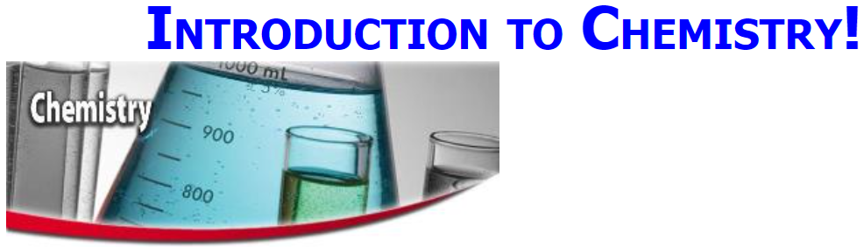



**See** [**https://www.learningctronline.com/courses**](https://www.learningctronline.com/courses) **for Materials and Resources.**

**Topics:**

1. Chemistry Introduction

**Objectives:**

1. Have a great start to Chemistry!
2. Go over practical and technical issues to navigating course related issues.
3. Show that many great scientists were believers in Jesus. Science and the Bible are compatible.
4. Give examples of inquiry-based learning throughout the lesson.
5. Define Chemistry and understand its place in science.
6. Present steps of the scientific method and be able to distinguish each.
7. Understand basic graphing protocols (independent and dependent variables) as part of experimentation and data collection.
8. Learn a problem-solving strategy: "AGES" for use throughout the course.

TAKE NOTE

1. Review Policies
   1. Late Policy
   2. Grading & Pedagogy – expect to spend 8-10 hrs/week on Chemistry; Honors: 10-12 hrs/wk
   3. Test Corrections
2. Create a Chemistry folder on your Desktop with the following SUBfolders:
   1. Class Notes
   2. Homework
   3. Lab
   4. Test
   5. Reference Tables / Resource
      1. Periodic Tables
      2. Equation / Formula Sheet
      3. Reference Tables
3. Technology
   1. Zoom
   2. Tablet
   3. Lab Supplies
   4. Microsoft Word, PowerPoint, Excel compatibility (especially MAC users)
   5. Text
4. Review Conduct, Integrity, Plagiarism policy (<https://www.learningctronline.com/policies-conduct-integrity-plagiari>)
5. Lesson Check/Sample problems from TEXT
6. Lab Quiz (Simple Graphing)
7. Introduction to Chemistry (Scientific Method) Test
8. Class Song: “Do Your Best” (<https://www.learningctronline.com/class-songs>)
9. Week 1 Devotional (<https://www.learningctronline.com/devotional>)

**Text**: Chapter 1: Introduction to Chemistry pp. 1-31

Read the assigned pages in the text.

**Class Notes: PowerPoint or PDF**

**Notes/Study Guide:** Fill in the Chapter 1 study guide to understand the class notes.

**Homework**:

(1) Answer the KEYED **"Lesson Check"** questions at the end of sections 1.1, 1.2, and 1.3 as well as question 30 at the end of section 1.4.

(2) Answer the **"Sample problems"** found in the "Sample Problem" boxes throughout the chapter. For Chapter 1 do "Sample Problems" # 25 - 26. An answer KEY is provided for you to use to self-correct your homework problems.

* Put your answers into complete thoughts in a Word document. Do NOT just put the answer, but write a phrase or sentence that you can study from for your tests. Save your work in a WORD document and SAVE into your HOMEWORK folder in the Chemistry folder on the desktop.
* Assignments will be “spot checked” during class or submitted via email.

**Lab**: Simple Graphing

* Perform the "Simple Graphing Lab" experiment using the lab worksheet provided.
* There is a video as part of the lab included on the worksheet.  
    
  [Simple Graphing Lab](http://somup.com/cqQrIpe5Fj) (0:31)
* After completing the Simple Graphing Lab worksheet, you will take a **Lab Quiz** worth 10 points (2 points per question).
* You may **NOT** use the worksheet on the quiz or any other resources.

**TEST:** Introduction to Chemistry (Scientific Method)

1) the academic integrity policy

* Tests must be completed **WITHOUT** referring to books, notes, the internet, people, or any outside resources.
* Students **MAY** use the approved Periodic Tables, approved Reference Tables, or approved equation (formula) sheet (provided by the teacher) along with calculators and scratch paper.
* A guardian should be proctoring the test. Proctoring means to monitor the following:

2) Take the multiple-choice test “in one sitting.” (no break)

* The **multiple-choice test must be taken "in one sitting"**, meaning that once you start the test, you must complete it without interruption.

Chapter 1 only has a multiple-choice portion of 10 questions.

3) There is a **25-minute time limit** on this test. Please have the proctor write the time taken at the top of your answer sheet with their signature or initials.

4) Proctors should NOT be reading the test or engaging students during the test.

5) Do NOT use RED font. Black font is best.

Supplemental Resources (Optional)  
  
[Make an Observation](http://somup.com/cF6erAnVCp) (0:04)  
  
[Acoustic Observation (Sheep)](http://somup.com/cqjOXxetNJ) (0:06)

AGES (Problem Solving Method) <http://somup.com/crnlDND2dj> (5:45)