# Sound Waves Lab

# Introduction

# Purpose To investigate various aspects of sound waves and their wave properties.

<http://somup.com/crnDrkDrtb> Single & Double-Point Source Ripple Tank (0:49)

<http://somup.com/criibpYiqf> Sound Tubes (1:39)

<http://somup.com/crnDrxDrOk> Resonance Boxes with Tuning Forks (1:41)

<http://somup.com/criiFBYi00> C Scale & Single Tuning Fork Demonstration (0:42)

<https://screencast-o-matic.com/watch/cYf3F9AoR3> Standing Waves & Resonance (1:50)

# Materials

# Video link of Single & Double-Point Source Ripple Tank

2 Large Tuning Forks on Resonance Boxes with ~same frequency & wavelength

8 Small Tuning Forks (representing the C major scale) – kit

2-3 Fork striking tools

1 Tuning Fork

2 Long, Thin Springs (thin slinkies)

Sound Tubes (plastic)

# Procedures

STATION ONE — Single & Double-Point Source Ripple Tank

<http://somup.com/crnDrkDrtb> (0:49) Single & Double-Point Source Ripple Tank

1. Observe Single Point Source Ripple.

2. Draw a picture of what you see for a single wave.

3. What general shape did the single point source “ripple” tank produce?

4. Observe Double Point Source Ripple wave action and the “lines” of interference that are produced. Make a drawing (or take a screen shot).

5. Label the following on your drawing: one wavelength, interference lines.

6. What wave phenomenon did double point source “ripple” tank demonstrate?

STATION TWO — Plastic Sound Tubes … swing the tubes and play a song.

<http://somup.com/criibpYiqf> Sound Tubes (1:39)

1. Swing the tubes are different speeds, varying the size of the swinging circle. Record your observations.

2. What created different tones (notes) in the sound tubes? Explain using wave properties.

3. What is the source of sound waves? Give evidence to prove this.

STATION THREE — Two Large Tuning Forks on Resonance Boxes

<http://somup.com/crnDrxDrOk> (1:41) Resonance Boxes with Tuning Forks

1. Place the resonance boxes close together so that the open ends face each other, but are not touching.

a. Using the tuning fork ball, hit one of the tuning forks HARD to produce a clear sound.

b. Place your ear next to the fork that was NOT struck or firmly grab the fork you did strike so that it stops making sound. Record your observations.

2. Explain why the tuning fork that you did NOT strike produced a sound using the following terms: vibration, wave particles and transfer of energy.

3. Explain using wave properties why the first tuning fork sounded louder than the second?

4. What wave phenomenon is this?

5. Place a metal clamp on one of the tuning forks. Strike each tuning fork (of the two resonance boxes) separately and listen. Record your observations.

STATION FOUR — “C” Scale Tuning Forks

1. Complete the data table below using tuning forks or the video:

<http://somup.com/criiFBYi00> C Scale & Single Tuning Fork Demonstration (0 to 0:42)

2. Play the musical scale IN ORDER from the lowest note to the highest by striking the tuning forks one at a time and holding each one next to your ear.

3. NOTICE the number imprinted on the tuning forks. This number represents its frequency in Hertz. Record these on the chart on your data sheet.

|  |  |  |  |  |  |  |  |  |
| --- | --- | --- | --- | --- | --- | --- | --- | --- |
|  | Low C | D | E | F | G | A | B | High C |
| f |  |  |  |  |  |  |  |  |
| λ |  |  |  |  |  |  |  |  |

4. What happens to the frequency as you proceed UP the musical scale from C to G?

5. Calculate the wavelength for each note of the musical scale to the nearest hundredth of a meter. Record your results in the table. Show work for one calculation.

6. Compare the “C” with the “G” in terms of frequency (f) and wavelength (λ).

7. The wavelength (λ) of a tuning fork is 0.64 meters and the speed of sound is 330 meters per second, what is its frequency (f)? SHOW WORK. Which note on the musical scale is this (*hint: it will be a multiple of one of the previous frequencies*)?

STATION FIVE — Single Tuning Fork (“D”)

<http://somup.com/criiFBYi00> C Scale & Single Tuning Fork Demonstration (0:42 to 1:02)

1. Hold the end of the tuning fork opposite the forks. Strike the tuning fork and hold it about 6-12 inches from your ear.

2. Move the struck tuning fork away from you as far as possible and then directly towards you. Continue this back-and-forth movement. Describe the pitch (higher or lower) as it is near you verses farther away from you.

3. What wave phenomenon is this? Explain.

STATION SIX — Standing Waves Using a Long Spring (*one and two loops*)

<https://screencast-o-matic.com/watch/cYf3F9AoR3> Standing Waves & Resonance (1:50)

1. Stretch the spring about 15 feet & create a standing TRANSVERSE wave with two loops. Draw a picture and label the wavelength, crest, trough, amplitude.

2. Create a standing TRANSVERSE wave with THREE (3) loops in it. Draw a picture and label the wavelength, crest, trough, amplitude.

3. Compare the wavelength and amplitude between the “two” loop standing wave and the “three” loop standing wave.

4. If there’s time, try to produce as many standing waves as possible.

5. When using the long springs, what relationship exists between the number of standing waves you produced and the amount of energy needed to produce them?

STATION SEVEN — Resonance in a Glass

<https://screencast-o-matic.com/watch/cYf3F9AoR3> Standing Waves & Resonance (1:50)

1. Watch the end of the video, starting at 1:32. Define resonance.

2. What is a defining characteristic of resonance?

**Conclusions and Questions**

1. Explain the main idea of diffraction related to the double point source ripple tank.

2. What is the relationship between the frequency and wavelength of a wave if speed is held constant?

3. What is the source of the sound waves?

4. What is the scientific term for “pitch” or musical tone?

5. What wave properties are involved when a tuning fork is heard while moving from farther away to up close and farther away again?

HONORS

A. For Station Three: Draw a picture of the two tuning forks and the LONGITUDINAL wave particles to represent what happened in this exercise.

B. For Station Four: What musical note has a wavelength (λ) of 0.43 meters? Explain your answer. Determine that notes frequency. SHOW WORK

C. Determine the actual wavelengths for the standing waves using ½ wavelength, 1 wavelength, 1 ½ wavelengths, 2 wavelengths, etc. Explain your answers.

1. Wavelength … with one loop?

2. Wavelength … with two loops?

3. Wavelength … with three loops?

4. Wavelength … with four loops?

**ANSWERS**

STATION ONE — Single & Double-Point Source Ripple Tank

<http://somup.com/crnDrkDrtb> Single & Double-Point Source Ripple Tank (0:49)

1. Observe Single Point Source Ripple.

2. Draw a picture of what you see for a single wave.

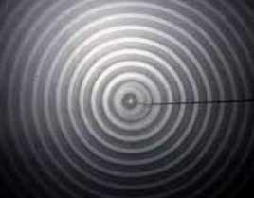

3. What general shape did the single point source “ripple” tank produce?

**Circular, concentric circles**

4. Observe Double Point Source Ripple wave action and the “lines” of interference that are produced.

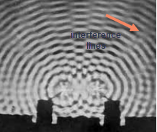 One λ exists between any two dark (or light) lines.

5. Label the following on your drawing: one wavelength, interference lines.

6. What wave phenomenon did double point source “ripple” tank demonstrate?

**Diffraction (transverse interference)**

STATION TWO — Plastic Sound Tubes … swing the tubes and play a song.

<http://somup.com/criibpYiqf> Sound Tubes (1:39)

1. Swing the tubes are different speeds, varying the size of the swinging circle. Record your observations.

**Swinging the sound tubes at different speeds and in different sized loops caused the different tones (frequencies).**

2. What created different tones (notes) in the sound tubes? Explain using wave properties.

**The corrugation of the tubes allows resonance. Swinging the sound tubes at different speeds and in different sized loops caused the different tones (frequencies). This is because faster swinging allows more particles into the tube which collide, creating higher frequencies, and slower swinging allowed less particles in the tube, creating lower tones (frequencies).**

3. What is the source of sound waves? Give evidence to prove this.

**Air (with particles) is the sound of sound waves. The sound tubes did not work when one end was covered with a plastic bag, preventing air particles from entering.**

STATION THREE — Two Large Tuning Forks on Resonance Boxes

<http://somup.com/crnDrxDrOk> (1:41) Resonance Boxes with Tuning Forks

1. Place the resonance boxes close together so that the open ends face each other, but are not touching.

a. Using the tuning fork ball, hit one of the tuning forks HARD to produce a clear sound.

b. Place your ear next to the fork that was NOT struck or firmly grab the fork you did strike so that it stops making sound. Record your observations.

**The tuning fork that was not struck makes the same sound as the fork that was struck.**

2. Explain why the tuning fork that you did NOT strike produced a sound using the following terms: vibration, wave particles and transfer of energy.

**The sound was produced by the vibration of the tuning forks. Particles vibrating from the struck tuning fork transferred energy through the air by colliding with other particles. The energy was strong enough to create vibration in the non-struck tuning fork.**

3. Explain using wave properties why the first tuning fork sounded louder than the second?

**More energy was applied to it so its amplitude (loudness) was higher.**

4. What wave phenomenon is this? **Resonance**

5. Place a metal clamp on one of the tuning forks. Strike each tuning fork (of the two resonance boxes) separately and listen. Record your observations.

**“Beats” (sound interference) were produced by the two frequencies that were close, but not the same. It is like a warbling sound.**

STATION FOUR — “C” Scale Tuning Forks

1. Complete the data table below using tuning forks or the video:

<http://somup.com/criiFBYi00> C Scale & Single Tuning Fork Demonstration (0 to 0:42)

2. Play the musical scale IN ORDER from the lowest note to the highest by striking the tuning forks one at a time and holding each one next to your ear.

3. NOTICE the number imprinted on the tuning forks. This number represents its frequency in Hertz. Record these on the chart on your data sheet.

|  |  |  |  |  |  |  |  |  |
| --- | --- | --- | --- | --- | --- | --- | --- | --- |
|  | Low C | D | E | F | G | A | B | High C |
| f | **523** | **587** | **659** | **698** | **783** | **440** | **494** | **523** |
| λ | **0.63** | **0.56** | **0.5** | **0.47** | **0.42** | **0.75** | **0.67** | **0.63** |

**λ = speed / f**

4. What happens to the frequency as you proceed UP the musical scale from C to G?

**As the musical note increases from C to G, the frequency (pitch) increases as well.**

5. Calculate the wavelength for each note of the musical scale to the nearest hundredth of a meter. Record your results in the table. Show work for one calculation.

**speed = f λ λ = 330 m/s / f in each case**

6. Compare the “C” with the “G” in terms of frequency (f) and wavelength (λ).

**Frequency increases from C to G, while wavelength decreases.**

7. The wavelength (λ) of a tuning fork is 0.64 meters and the speed of sound is 330 meters per second, what is its frequency (f)? SHOW WORK. Which note on the musical scale is this (*hint: it will be a multiple of one of the previous frequencies*)?

**speed = f λ 330 m/s = f (0.64 m) f = 512 Hz**

**High C (low C is 256 Hz which is ½ the frequency).**

STATION FIVE — Single Tuning Fork (“D”)

<http://somup.com/criiFBYi00> C Scale & Single Tuning Fork Demonstration (0:42 to 1:02)

1. Hold the end of the tuning fork opposite the forks. Strike the tuning fork and hold it about 6-12 inches from your ear.

2. Move the struck tuning fork away from you as far as possible and then directly towards you. Continue this back-and-forth movement. Describe the pitch (higher or lower) as it is near you verses farther away from you.

**When the tuning fork approaches the frequency is higher (compressions); when the tuning fork is farther away the frequency goes lower (rarefactions).**

3. What wave phenomenon is this? Explain.

**The Doppler Effect occurs because of the relative motion of sound. When sound approaches the listener, the frequency increases, creating a higher pitch because the sound waves are compressed together. When sound moves away from the listener, the frequency decreases (lower pitch) because the sound waves are spreading out (rarefactions).**

STATION SIX — Standing Waves Using a Long Spring (*one and two loops*)

<https://screencast-o-matic.com/watch/cYf3F9AoR3> Standing Waves & Resonance (1:50)

1. Stretch the spring about 15 feet & create a standing TRANSVERSE wave with two loops. Draw a picture and label the wavelength, crest, trough, amplitude.

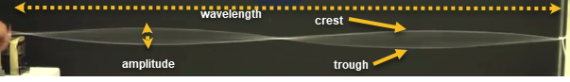

2. Create a standing TRANSVERSE wave with THREE (3) loops in it. Draw a picture and label the wavelength, crest, trough, amplitude.

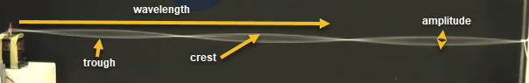

3. Compare the wavelength and amplitude between the “two” loop standing wave and the “three” loop standing wave.

**The two-loop standing wave had a larger amplitude and longer wavelength than the three-loop standing wave.**

4. If there’s time, try to produce as many standing waves as possible.

5. When using the long springs, what relationship exists between the number of standing waves you produced and the amount of energy needed to produce them?

**To produce more standing waves, one must exert or apply MORE energy.**

STATION SEVEN — Resonance in a Glass

<https://screencast-o-matic.com/watch/cYf3F9AoR3> Standing Waves & Resonance (1:50)

1. Watch the end of the video, starting at 1:32. Define resonance.

**Resonance occurs when the sound frequency matches the natural frequency of the glass (material).**

2. What is a defining characteristic of resonance?

**Resonance causes the material (glass in this case) to vibrate.**

**Conclusions and Questions**

1. Explain the main idea of diffraction related to the double point source ripple tank.

**Diffraction is the interference of waves. When interference is “constructive” the light / white waves are observed. When interference is “destructive” the dark / black waves are observed.**

2. What is the relationship between the frequency and wavelength of a wave if speed is held constant?

**Frequency and wavelength of waves are inversely proportional when speed is held constant. When the wavelength is smaller (sound tubes waved in small circles very fast), the frequency (pitch) was higher and when the wavelength is longer (sound tubes waved in large circles very slow), the frequency (pitch) was lower.**

3. What is the source of the sound waves?

**Particles vibrate to produce sound waves.**

4. What is the scientific term for “pitch” or musical tone? **Frequency**

5. What wave properties are involved when a tuning fork is heard while moving from farther away to up close and farther away again?

**Sound waves are moving when the Doppler Effect occurs, meaning that the speed of sound (movement) is involved as well as frequency (pitch).**

HONORS

A. For Station Three: Draw a picture of the two tuning forks and the LONGITUDINAL wave particles to represent what happened in this exercise.

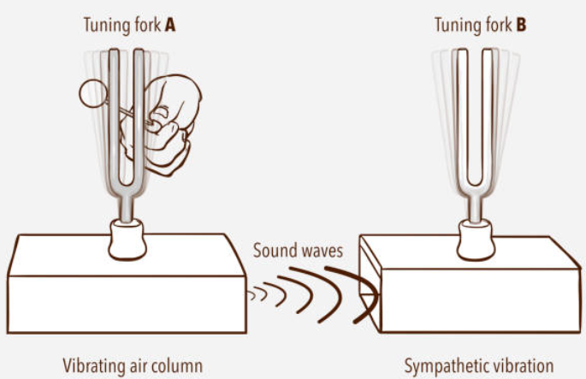

B. For Station Four: What musical note has a wavelength (λ) of 0.43 meters? Explain your answer. Determine that notes frequency. SHOW WORK

**The musical note would be “G” above the middle G. The reason is that 0.43 is half of the wavelength for middle G (0.86). Wavelengths of the same note but different octaves are factors of each other.**

**speed = f λ 330 m/s = f (0.43 m) f = 767 Hz**

C. Determine the actual wavelengths for the standing waves using ½ wavelength, 1 wavelength, 1 ½ wavelengths, 2 wavelengths, etc. Explain your answers.

1. Wavelength … with one loop?

½ wavelength because one loop only constitutes a crest or trough. A wavelength is made up of a crest and a trough put together.

2. Wavelength … with two loops?

1 wavelength because two loops contain a crest and a trough. A wavelength is made up of a crest and a trough put together.

3. Wavelength … with three loops?

1 1/2 wavelengths because three loops a crest and a trough plus another crest OR trough. A wavelength is made up of a crest and a trough put together.

4. Wavelength … with four loops?

2 wavelengths because four loops contain two full crests and two full troughs. Each wavelength is made up of a crest and a trough put together.