# PHET Simulator: Sound & Waves

Water Simulation

Click on the following link: <https://phet.colorado.edu/en/simulation/waves-intro> .

* Download the simulation.
* The first simulation is water, the second is sound, and the third is light.

a. At the bottom, click on the Water icon.

b. Set the “Frequency” and “Amplitude” to the middle settings (upper right).

c. Click on “Top View” (lower left) and “Normal” (lower middle).

d. Click on the green button of the faucet. Allow several drops before continuing.

1. What general shape do you observe with a single drop at a time? Make a diagram.

2. Notice the white bands and the dark/black bands. Assume that 1 white band + 1 dark band = 1 wavelength. Pause the simulation. Count the number of wavelengths on the screen. Use the tape measure (upper right) to measure the wavelength.

3. Change the frequency setting to “max” and allow the drops to fall for 10 seconds. Pause the simulation.

a. Count the number of wavelengths on the screen. Use the tape measure (upper right) to measure the wavelength.

b. Did the wavelengths get longer or shorter as the frequency was increased to maximum?

4. Hit the reset button. Set the frequency to the middle setting and allow the drops to fall for 10 seconds. Listen carefully and observe the light and dark bands.

a. Click the pause button. Set the “Amplitude” to the “max” setting and allow the drops to fall for 10 seconds more. Listen carefully and observe the light and dark bands.

b. Describe the difference(s) when you adjusted the amplitude?

5. Make a diagram. Label the wavelength and frequency.

Sound Simulation

a. At the bottom, click on the Sound icon.

b. Set the “Frequency” and “Amplitude” to the middle settings (upper right) and click on the “Particles” circle.

c. Click on “Top View” (lower left) and “Normal” (lower middle).

d. Click on the green button of the speaker. Allow several drops before continuing.

1. Describe the pattern of the particles as the speaker plays.

2. Make a drawing of the “waves” based on the particles. Include the components of a sound wave (rarefaction, compression, wavelength).

Waves on a String Simulation

Click on the following link: <https://phet.colorado.edu/en/simulation/wave-on-a-string> .

a) Download the simulation.

b) The first simulation is water, the second is sound, and the third is light.

<http://somup.com/cbeD3zRBj> PHET Simulation Frequency & Wavelength (1:24)

a. At the top, click on “oscillate”. At the upper right, click on “Fixed End”. At the bottom, click on “Slow Motion.”

b. Set the “Frequency” and “Amplitude” to 0.75 cm and 0.75 Hz (at the bottom).

c. Click on “Rulers” (lower right).

d. Click on the “Play/Pause” button. Stop the simulation when the green bead on the oscillator is exactly on the orange dashed line. (It may take a few trials.)

1. What general shape do you observe in the simulation? Make a diagram, labelling crest/peak, trough, wavelength, amplitude.

2. Hit the reset button (bottom right). Click the “Pulse” setting (upper left) and change the “Tension” to “Low” (at the bottom). Hit the green button on the pulse mechanism once.

a) Describe what happens when the wave hits the “fixed end”? Distinguish the incident wave from the reflected wave.

b) Adjust the TENSION to the highest setting. Hit the green button on the pulse mechanism five times in a row. Record how this affects the speed of the waves.

c) Adjust the TENSION to the lowest setting. Hit the green button on the pulse mechanism five times in a row. Compare how long it takes the wave to die out when on the lower tension setting from the high-tension setting.

3. Hit the reset button. Select OSCILLATE (upper left) to make a machine create the waves. Set the Tension to High. Select NO END to let the waves travel out the door (*meaning they never reflect back*).

a) Set the DAMPING to “none” (bottom center). Adjust the AMPLITUDE from 0 cm to 0.20 cm to 0.40 cm to 0.60 cm to 0.80 cm, and to 1.00 cm using the “slider” or the black arrow buttons. What changed on the waves at different amplitudes?

b) Set the AMPLITUDE to 1.00 cm. Adjust the frequency to 1.00 Hz. Click on “Timer” (bottom right) and click the play icon (triangle). Then, click the “Play/Pause” button to start the simulation. Measure the amount of time it takes for the pulse generator to complete 15 full cycles (all the way up + all the way down = 1 cycle)

**f “1.00 Hz”: 15 cycles in ____ s**

c) Now set the frequency to 2.00 Hz. Reset the timer and measure the amount of time it takes to complete 15 full cycles. Then, 3.00 Hz.

**f “2.00 Hz”: 15 cycles in ____ s f “3.00 Hz”: 15 cycles in ____ s**

d) What is the relationship between frequency of the wave and the time it takes the wave to travel?

e) Calculate the actual frequency in Hertz for each of the frequency settings by dividing 15 cycles by the time it took the waves to travel. *Cycles or waves per second equals Hertz*.

**f “1.00 Hz”: f = __ Hz f “2.00 Hz”: f = __ Hz f “3.00 Hz”: f = __ Hz**

*15 / ?s 15 / ?s 15 / ?s*

f) Calculate the PERIOD of the waves at each frequency in seconds (**T =** **1 / f** ).

**f “1.00 Hz”: T = __ s f “2.00 Hz”: T = __ s f “3.00 Hz”: T = __ s**

*1 / f 1 / f 1 / f*

g) Based on the results, define “period” of a wave.

4. Click the “Ruler” box (bottom right). Click “Slow Motion” (center towards bottom). Run the animation for a few seconds at amplitude 1.00 cm and frequency 1.00 Hz, and pause the animation when the green bead aligns with the orange dashed line.

a) Measure one WAVELENGTH from a crest to another crest, or from a trough to another trough, of from any two matching wave points. Convert into meters.

**f “1.00 Hz”:** λ **= __ cm = __ m**

1. Make a drawing of one full wave showing how you measured that wavelength. Label the wavelength, the amplitude, crest and trough.

c) Measure the WAVELENGTH for the frequencies **2.00 Hz** and **3.00 Hz** next.

**f “2.00 Hz”:** λ **= __ cm = __ m**

**f “3.00 Hz”:** λ **= __ cm = __ m**

d) What is the relationship between frequency of the wave and its wavelength? Give evidence to support your answer.

5. Calculate the VELOCITY of the waves, for each frequency setting. (**v = f λ**) SHOW WORK.

a) *Use “****f****” in Hz and use “****λ****” in m.*

**f “1.00 Hz”: v = __ m/s**

**f “2.00 Hz”: v = __ m/s**

**f “3.00 Hz”: v = __ m/s**

b) What can you say about the velocity of the sound waves over each frequency?

**Conclusions and Questions**

1. What wave properties were observed and/or calculated in this lab?

2. What relationship of two wave properties was observed in this lab? What does it mean?

3. Match the description in the right column to the wave property in the left column:

Amplitude a. waves per second

Frequency b. intensity or loudness

Period c. crest to crest or trough to trough

Velocity d. m/s

Wavelength e. 1/frequency

f. λ

g. height above or below the principal axis

h. time it takes for one wavelength

ANSWERS

Water Simulation

1. What general shape do you observe with a single drop at a time? Make a diagram.

**Concentric circles** 

2. Notice the white bands and the dark/black bands. Assume that 1 white band + 1 dark band = 1 wavelength. Pause the simulation. Count the number of wavelengths on the screen. Use the tape measure (upper right) to measure the wavelength.

**4 λ (wavelengths). 2.5 cm/ λ**

3. Change the frequency setting to “max” and allow the drops to fall for 10 seconds. Pause the simulation.

a. Count the number of wavelengths on the screen. Use the tape measure (upper right) to measure the wavelength.

**6 λ (wavelengths). 1.5 cm/ λ**

b. Did the wavelengths get longer or shorter as the frequency was increased to maximum?

**The wavelength became shorter (2.5 cm to 1.5 cm)**

4. Hit the reset button. Set the frequency to the middle setting and allow the drops to fall for 10 seconds. Listen carefully and observe the light and dark bands.

a. Click the pause button. Set the “Amplitude” to the “max” setting and allow the drops to fall for 10 seconds more. Listen carefully and observe the light and dark bands.

b. Describe the difference(s) when you adjusted the amplitude?

**The higher amplitude was louder and the image is much clearer.**

 

Amplitude “Middle” Amplitude “Maximum”

5. Make a diagram. Label the wavelength and frequency.

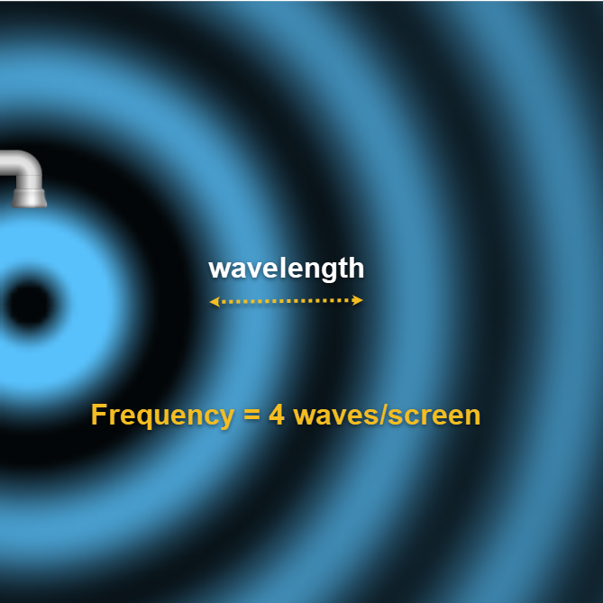

Sound Simulation

1. Describe the pattern of the particles as the speaker plays.

**The particles compress and expand in “bands” or regions.** 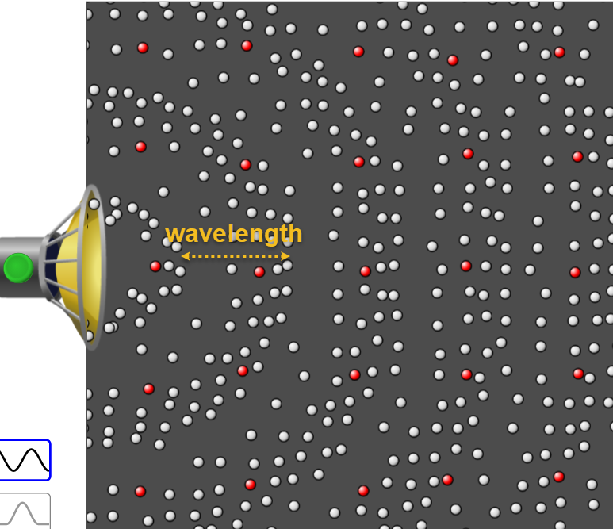

2. Make a drawing of the “waves” based on the particles. Include the components of a sound wave (rarefaction, compression, wavelength).

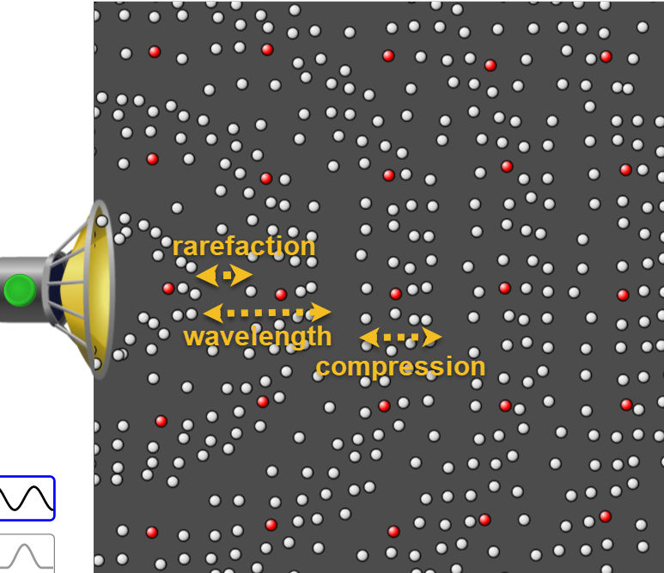

Waves on a String Simulation

<http://somup.com/cbeD3zRBj> PHET Simulation Frequency & Wavelength (1:24)

1. What general shape do you observe in the simulation? Make a diagram, labelling crest/peak, trough, wavelength, amplitude.

**The shape is a transverse wave (sin curve).**

2. Hit the reset button (bottom right). Click the “Pulse” setting (upper left) and change the “Tension” to “Low” (at the bottom). Hit the green button on the pulse mechanism once.

a) Describe what happens when the wave hits the “fixed end”? Distinguish the incident wave from the reflected wave.

**The wave reflected (bounced) back towards the origination point. The reflected wave was smaller than the incident wave.**

b) Adjust the TENSION to the highest setting. Hit the green button on the pulse mechanism five times in a row. Record how this affects the speed of the waves.

**The wave travelled much faster than at a lower tension.**

c) Adjust the TENSION to the lowest setting. Hit the green button on the pulse mechanism five times in a row. Compare how long it takes the wave to die out when on the lower tension setting from the high-tension setting.

**The wave travelled back and forth longer at the lower tension.**

3. Hit the reset button. Select OSCILLATE (upper left) to make a machine create the waves. Set the Tension to High. Select NO END to let the waves travel out the door (*meaning they never reflect back*).

a) Set the DAMPING to “none” (bottom center). Adjust the AMPLITUDE from 0 cm to 0.20 cm to 0.40 cm to 0.60 cm to 0.80 cm, and to 1.00 cm using the “slider” or the black arrow buttons. What changed on the waves at different amplitudes?

**The height of the wave above and below the orange dashed line increased as amplitude was increased.**

b) Set the AMPLITUDE to 1.00 cm. Adjust the frequency to 1.00 Hz. Click on “Timer” (bottom right) and click the play icon (triangle). Then, click the “Play/Pause” button to start the simulation. Measure the amount of time it takes for the pulse generator to complete 15 full cycles (all the way up + all the way down = 1 cycle)

**f “1.00 Hz”: 15 cycles in 15 s**

c) Now set the frequency to 2.00 Hz. Reset the timer and measure the amount of time it takes to complete 15 full cycles. Then, 3.00 Hz.

**f “2.00 Hz”: 15 cycles in 7.5 s f “3.00 Hz”: 15 cycles in 5 s**

d) What is the relationship between frequency of the wave and the time it takes the wave to travel?

**The higher the frequency of the wave, the less time it took for the waves to travel. This is an inverse relationship.**

e) Calculate the actual frequency in Hertz for each of the frequency settings by dividing 15 cycles by the time it took the waves to travel. *Cycles or waves per second equals Hertz*.

**f “1.00 Hz”: f =1 Hz f “2.00 Hz”: f = 2 Hz f “3.00 Hz”: f = 3 Hz**

*15 / ?s 15 / ?s 15 / ?s*

f) Calculate the PERIOD of the waves at each frequency in seconds (**T =** **1 / f** ).

**f “1.00 Hz”: T = 1 s f “2.00 Hz”: T = 0.5 s f “3.00 Hz”: T = 0.33 s**

*1 / f 1 / f 1 / f*

g) Based on the results, define “period” of a wave.

**The period is the reciprocal of frequency. Frequency is the number of waves in one second and period is the time it takes for one wave to travel one wavelength.**

4. Click the “Ruler” box (bottom right). Click “Slow Motion” (center towards bottom). Run the animation for a few seconds at amplitude 1.00 cm and frequency 1.00 Hz, and pause the animation when the green bead aligns with the orange dashed line.

a) Measure one WAVELENGTH from a crest to another crest, or from a trough to another trough, of from any two matching wave points. Convert into meters.

**f “1.00 Hz”:** λ **= 6 cm = 0.06 m**

1. Make a drawing of one full wave showing how you measured that wavelength. Label the wavelength, the amplitude, crest and trough.

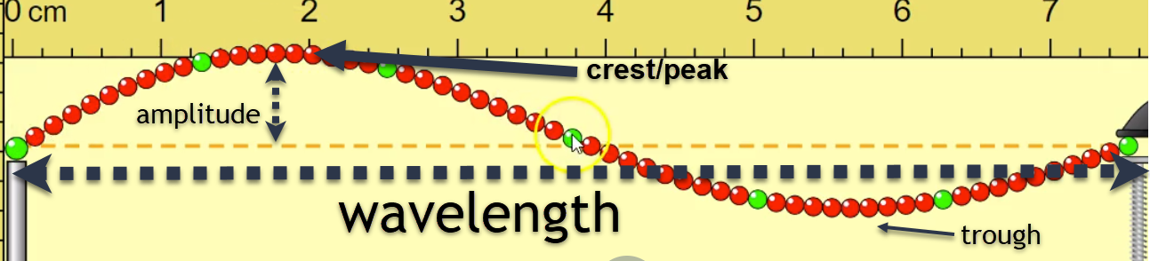

c) Measure the WAVELENGTH for the frequencies **2.00 Hz** and **3.00 Hz** next.

**f “2.00 Hz”:** λ **= 3 cm = 0.03 m**

**f “3.00 Hz”:** λ **= 2.1 cm = 0.021 m**

d) What is the relationship between frequency of the wave and its wavelength? Give evidence to support your answer.

**The higher the frequency of the wave, the shorter the wavelength. When the frequency was 1 Hz, the wavelength was 6 cm, but when frequency increased to 3 Hz, the wavelength decreased to 2.1 cm.**

5. Calculate the VELOCITY of the waves, for each frequency setting. (**v = f λ**) SHOW WORK.

a) *Use “****f****” in Hz and use “****λ****” in m.*

**f “1.00 Hz”: v = 0.06 m/s** *v = 1 Hz x 0.06 m*

**f “2.00 Hz”: v = 0.06 m/s** *v = 2 Hz x 0.03 m*

**f “3.00 Hz”: v = 0.06 m/s** *v = 3 Hz x 0.021 m*

b) What can you say about the velocity of the sound waves over each frequency?

**The speed of the sound waves was constant for all frequencies.**

**Conclusions and Questions**

1. What wave properties were observed and/or calculated in this lab?

**Frequency, amplitude, wavelength, period, velocity**

2. What relationship of two wave properties was observed in this lab? What does it mean?

**Frequency and wavelength are inversely proportional at constant velocity. As frequency increase, wavelength decreases and as frequency decreases, wavelength increases.**

3. Match the description in the right column to the wave property in the left column:

Amplitude **b, g** a. waves per second

Frequency **a** b. intensity or loudness

Period **e, h** c. crest to crest or trough to trough

Velocity **d** d. m/s

Wavelength **c, f** e. 1/frequency

f. λ

g. height above or below the principal axis

h. time it takes for one wavelength