Activity: Ionization Energy

**Purpose** To illustrate periodic trends in ionization energy for elements of the Periodic Table.

**Materials** Graph paper 6 Color - Colored Pencils (ROYGBV) Pen & Pencil

# Procedure // Calculations & Data

1. Plot a graph of ionization energy versus atomic number using the table of elements below. The actual graph should take up most of the graph paper. Adjust your numbers accordingly.

Ionization Energy (Kj/mole)

|  |  |  |  |  |  |  |  |
| --- | --- | --- | --- | --- | --- | --- | --- |
| First Ionization Energies (Kilojoules per mole) | | | | | | | |
| H  1312 |  |  |  |  |  |  | He  2372 |
| Li  520 | Be  900 | B  801 | C  1087 | N  1402 | O  1314 | F  1681 | Ne  2081 |
| Na  Atomic Number 1 - 36  496 | Mg  738 | Al  576 | Si  787 | P  1012 | S  1000 | Cl  1256 | Ar  1521 |
| K  419 | Ca  590 | Ga  579 | Ge  761 | As  947 | Se  941 | Br  1140 | Kr  1351 |

1. Label each point on the graph with the element’s symbol.
2. Draw a point to point line using a straight edge or ruler to connect each element in order of atomic number (*from H to He to Li and so forth*).
3. Use a **normal pencil** to connect the He, Ne, and Ar peaks.
4. Use a **red** colored pencil to connect the F, Cl and Br peaks.
5. Use a **blue** colored pencil to connect the N, P and As peaks.
6. Use an **orange** colored pencil to connect the O, S and Se peaks.
7. Use a **violet** colored pencil to connect the C, Si and Ge peaks.
8. Use a **yellow** colored pencil to connect the Be, Mg, and Ca peaks.
9. Use a **green** colored pencil to connect the B, Al and Ga peaks.
10. Use a **pen** to connect the Li, Na, and K peaks.
11. Rotate your graph until the “peak” lines are somewhat horizontal.

# Conclusions and Questions

1. What do all the colored pencil lines represent in terms of the Periodic Table of Elements?
2. What is ionization energy in terms of an atom and electrons?
3. Which group has the highest ionization energy for its period?
4. Which group has the lowest ionization energy for its period?
5. Why doesn’t your graph show a straight line between periods or down all the groups (*What chemical phenomenon would explain this*?)
6. Distinguish between ionization energy and electron affinity.

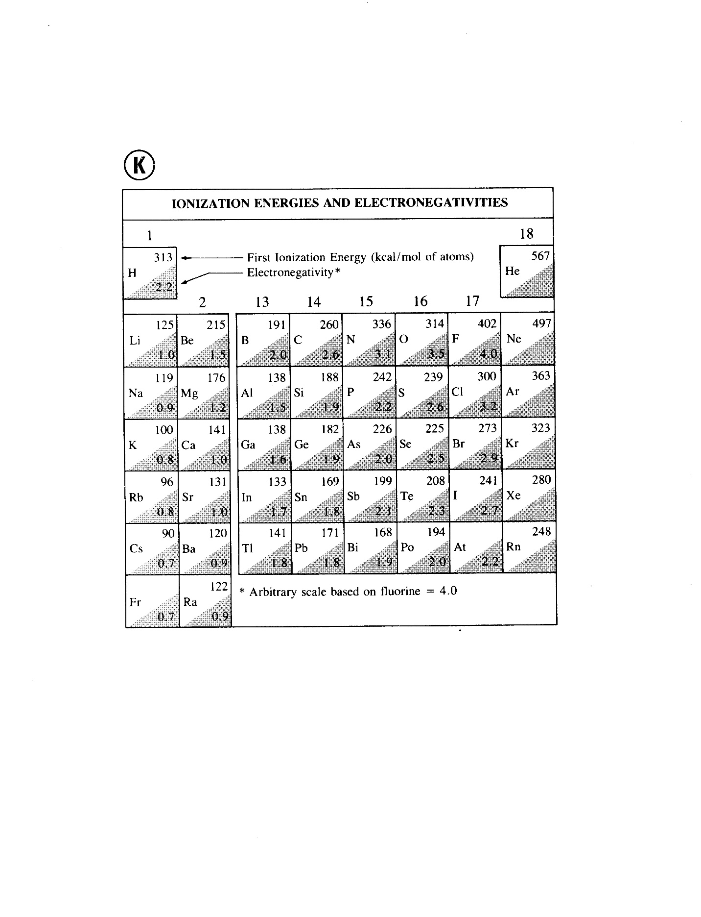

Ionization Energy by Periods



# Conclusions and Questions

1. What do all the colored pencil lines represent in terms of the Periodic Table of Elements?

***Energy levels (rows) of the Periodic Table***

2. What is ionization energy in terms of an atom and electrons?

***Ionization energy is the energy needed to release the most loosely bound electron from an atom’s valence. The “first ionization energy” is the energy to remove the first electron. The “second ionization energy” is the energy to remove the second electron. And so forth.***

3. Which group has the highest ionization energy for its period?

***The noble gases (inert gases), Group VIIIA or 18, have the highest ionization energy. This is because they are stable and do not want to lose or gain electrons.***

4. Which group has the lowest ionization energy for its period?

***The Alkali metals, Group IA or 1, have the lowest ionization energy. This is because they are unstable with one valence electron and will easily give up or lose an electron.***

5. Why doesn’t your graph show a straight line between periods or down all the groups (*What chemical phenomenon would explain this*?)

***This activity shows “periodicity.” This means that there is a relationship among elements or atoms that changes along periods. Any given period does NOT show a straight line because of the electrons changing orbitals within a sublevel. For instance, as an atom gains electrons in the 2p sublevel, there are 3 orbitals for the electrons to enter. Each orbital represents equal energy as long as there is only one electron in each. When the fourth electron enters the 2p sublevel, there is an energy change.***

6. Distinguish between ionization energy and electron affinity.

***Ionization energy relates to losing electrons. Electron affinity is an atom’s attraction for electrons. The Halogens (F, Cl, Br, I) and Chalcogens (O, S, Se, Te) have the highest electron affinity and will gain electrons the easiest.***