Name _____________

Complete the chart on the three chemical difference between DNA and RNA

|  |  |  |
| --- | --- | --- |
| Structure | DNA | RNA |
| 1. Strand of nucleotides |  |  |
| 2. Sugar |  |  |
| 3. Nitrogen bases |  |  |

4. Proteins are made up of _____.

5. There are 20 different types of _____.

6. The message of the DNA code is information for building _____.

7. Each set of three nitrogen bases that codes for an amino acid is known as a _____.

8. The amino acid _____ is represented by the mRNA codon ACA.

9. _____ and _____ are mRNA codons for phenylalanine.

10. There can be more than one _____ for the same amino aicd.

11. For any one codon, there can be only one _____.

12. The genetic code is said to be universal because a codon represents the same _____ in almost all organisms.

13. _____, _____, and _____ are stop codons.

14. _____ and _____ are amino acids that are each represented by only one codon.

15. Proteins are made in the cytoplasm of a cell, whereas DNA is found only in the _____.

16. The process of making RNA from DNA is called _____.

17. The process of transcription is similar to the process of DNA _____.

18. _____ carries infromation from the DNA in the nucleus out into the cytoplasm of the cell.

19. mRNA carries the information for making proteins to the _____.

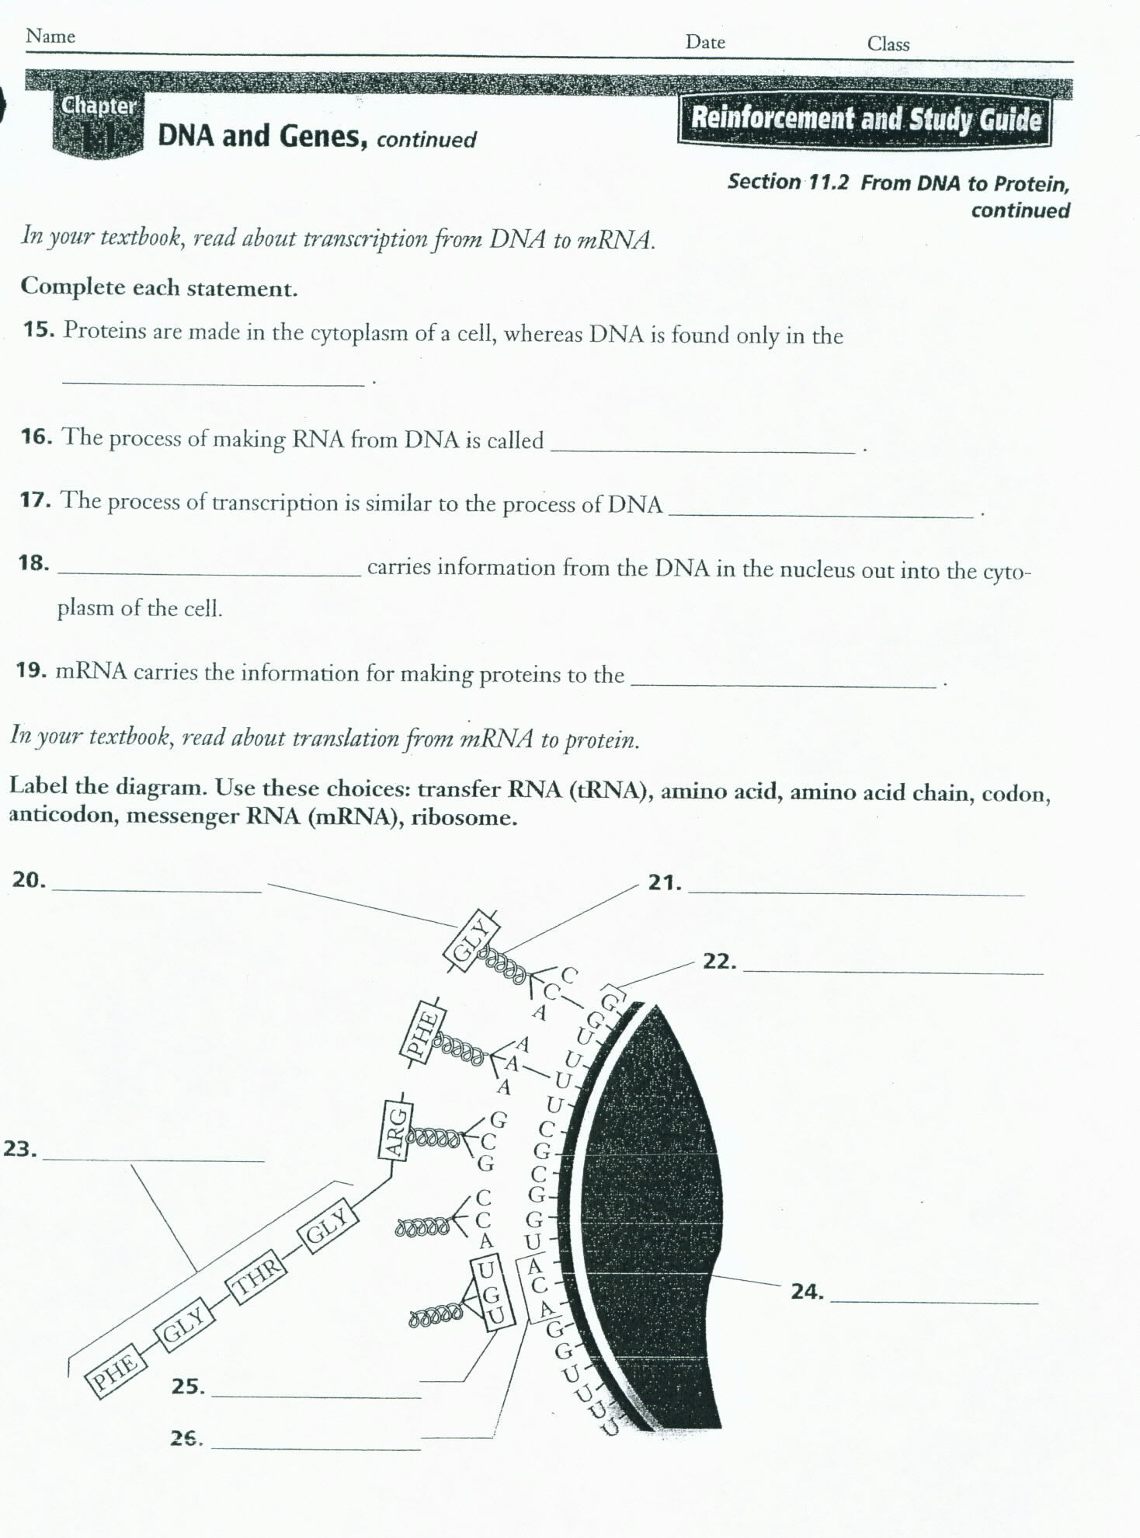

20. _____

21. _____

22. _____

23. _____

24. _____

25. _____

26. _____

