**Static Electricity & Magnetism (Week 3/3)**

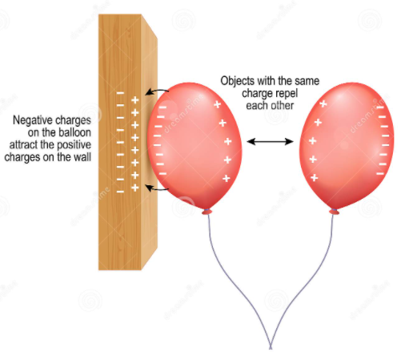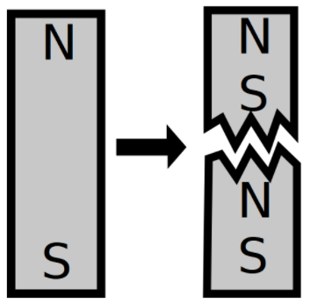

**See** [**https://www.learningctronline.com/courses**](https://www.learningctronline.com/courses) **for Materials and Resources.**

**Topics:**

1. Static Electricity & Magnetism (week 3 of 3)

**Objectives:**

* *Which particle is involved in transfer of charge between objects?*
* *Compare and contrast Static Electricity and Magnetism (similarities, differences).*
* *Explain the source of electrostatics and how objects are affected by it.*
* *Identify properties of magnetic objects.*
* *Distinguish and draw electric field lines around charges and magnetic field lines around magnets, labelling the charges and the poles.*
* *Identify properties of electrified objects and magnetic objects (retention, strength).*
* *Understand how magnets are formed and sustained.*
* Define and understand insulators and conductors.
* Describe the transfer of charge, which particle is most involved.
* Understand magnetic strength related to magnet size and composition.
* Explain friction, induction and conduction related to electrostatics and magnetism.

TAKE NOTE

1. Reading (Hewitt Text)

2. Quiz Static Electricity & Magnetism due tomorrow by noon EST (open notes).

3. Notes Static Electricity & Magnetism & Big Ideas

4. Lab Static Electricity Insulators & Conductors

5. Lab Static Electricity Electron Movement & Transfer

6. Lab Magnetism Size & Strength

7. Lab Static Electricity Movement of Charges

8. Problem Set 2: Static Electricity

9. Elicitation Follow Up StaticElectricity & Magnetism

10. Test – Static Electricity & Magnetism

11. Class Song: Let’s Get Down to Business

12. Week 23 Devotional (<https://www.learningctronline.com/devotional>)

**Text**: Chapters 32 – 33, 36 Static Electricity & Magnetism (Hewitt)

**Class Notes: Use the Documents provided & Big Ideas**

**Homework**:

* Problem Set 2 Static Electricity
* Study Big Ideas
* Study Follow Up Elicitation Reference

**Lab**: Static Electricity – Transfer of Charge, Insulators & Conductors

* Perform the lab as directed using the worksheet provided.
* Complete all calculations and data, showing work whenever appropriate.
* Conclusions should be answered in complete sentences that convey a complete thought.
* Save the documents into your LAB folder in the Physics folder on your desktop.

**Lab**: Static Electricity – Electron Movement & Transfer

* Perform the lab as directed using the worksheet provided.
* Complete all calculations and data, showing work whenever appropriate.
* Conclusions should be answered in complete sentences that convey a complete thought.
* Save the documents into your LAB folder in the Physics folder on your desktop.

**Lab**: Magnetism – Size & Strength

* Perform the lab as directed using the worksheet provided.
* Complete all calculations and data, showing work whenever appropriate.
* Conclusions should be answered in complete sentences that convey a complete thought.
* Save the documents into your LAB folder in the Physics folder on your desktop.

**Lab**: Static Electricity – Movement of Charges

* Perform the lab as directed using the worksheet provided.
* Complete all calculations and data, showing work whenever appropriate.
* Conclusions should be answered in complete sentences that convey a complete thought.
* Save the documents into your LAB folder in the Physics folder on your desktop.

**TEST:** Static Electricity & Magnetism

1) the academic integrity policy

* Tests must be completed **WITHOUT** referring to books, notes, the internet, people, or any outside resources.
* Students **MAY** use the approved Periodic Tables, approved Reference Tables, or approved equation (formula) sheet (provided by the teacher) along with calculators and scratch paper.
* A guardian should be proctoring the test. Proctoring means to monitor the following:

2) The test is composed of multiple-choice questions and problems.

3) There is a **60-minute time limit** on this test. Please have the proctor write the time taken at the top of your answer sheet with their signature or initials.

4) Proctors should NOT be reading the test or engaging students during the test.

5) Do NOT use RED font. Black font is best.

Supplemental Resources (Optional)

<http://somup.com/cY1QFtQlBS> Components of Static Electricity (5:31)

<http://somup.com/cr10omqs6t> Charging an Insulator (Styrofoam) (1:12)

<http://somup.com/cr10oOqsjp> Transfer of Charge & Charge by Induction (1:44)

<http://somup.com/cr10DGqso6> Acrylic & Metal Transferring Charge (1:08)

<http://somup.com/cr10DAqs2H> Franklin’s Bells - Induction & Conduction (2:30)

<http://somup.com/cZn2YXprgV> Particle Transfer in Electricity (2:11)