System: _____

|  |  |  |
| --- | --- | --- |
| Organ or Hormone | Location in Body | Description |
|  | | |
| Adrenal Cortex |  |  |
| Adrenal Medulla |  |  |
| Hypothalamus |  |  |
| Ovary |  |  |
| Pancreas |  |  |
| Parathyroid Gland |  |  |
| Pineal Gland |  |  |
| Pituitary Gland |  |  |
| Testis |  |  |
| Thymus Gland |  |  |
| Thyroid Gland |  |  |

**Cut and paste the proper items below into the chart above.**

|  |  |
| --- | --- |
| Location in Body | Description |
|  | |
| Brain | Steroids, Sex hormones, Cortisol (stress) |
| Brain | Adrenalin, norepinephrine; Epinephrine; stress reactions |
| Brain | Controls blood calcium levels (nerves/muscles). |
| Chest | Estrogen 🡪 egg development; secondary sex characteristics (female)  Progesterone 🡪 uterine health. |
| Groin | Homeostasis; Controls pituitary; “master gland”; regulates body temperature, blood pressure; affects hunger, mood, sex drive, sleep. |
| Groin | Insulin, glucagon, regulates glucose levels in the blood. |
| On top of kidney | Produces Thyroxine, regulating metabolism. |
| On top of kidney | Releases melatonin, regulates rhythmic activities (sleep cycles). |
| Stomach / kidneys | Secretes hormones which make other endocrine glands secrete hormones, “releasing hormones”; Releases FSH (menstrual cycle), LH (ovulation), ACTH (metabolism), TSH (thyroid), GH (growth) |
| Throat | Stimulates Tcell development (immunity wbc’s) as a child. |
| Throat | Testosterone 🡪 sperm production, secondary sex characteristics (male). |

System: _____

Use the text boxes to label the image:

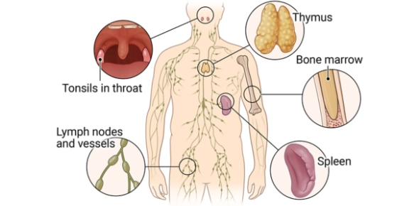

1. Leukocytes are

A. White blood cells B. Red blood cells C. Platelets D. Capillaries

2. A function of lymph nodes is to

A. Secrete thymosin C. Cleanse lymph of foreign debris

B. Serve as a holding station for red blood cells D. All of these

3. Which of the following performs specific immune responses?

A. phagocytosis B. T-cells & B-cells C. granulocytes D. macrophages

4. Nonspecific immune system response

A. provides the first line of defense against foreign substances in the body.

B. occurs in a nonspecific order.

C. has the ability to create a type of memory that confers immunity.

D. protects against specific immune responses that threaten the body.

5. The major function of the immune system is

A. to help the respiratory system.

B. to help circulated blood throughout the body.

C. to fight disease.

6. B and T cells are

A. tonsils B. lymphocytes C. lymph nodes D. antibodies

System: _____ **Label the items below the image AND know their function.**

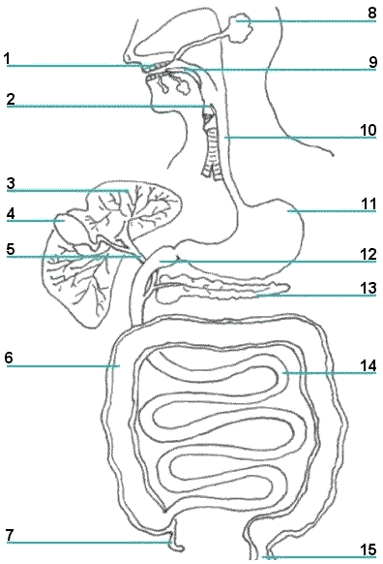

1. _____ 2. _____ 3. _____

4. _____ 5. _____ 6. _____

7. _____ 8. _____ 9. _____

10. _____ 11. _____ 12. _____

13. _____ 14. _____ 15. _____

System: ____

Use the text boxes to label the image:

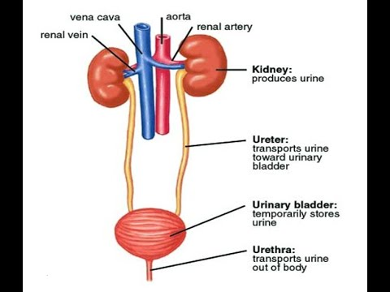

1. What is the smallest functional component of the human excretory system?

A. bladder B. kidney C. nephron

2. Which are the tubes that carry urine from the kidney to the bladder?

A. adrenal tubes B. ureters C. kidneys D. urethras

3. The ___ is/are responsible for urine storage.

A. bladder B. ureter C. kidneys D. urethras

4. What is the main function of the excretory system?

A. to secrete saliva C. break down food

B. get rid of waste products from the cells D. circulate oxygen

5. The ___ filters cellular wastes from the blood.

A. liver B. lymph nodes C. kidneys D. adrenal glands

6. When does the skin take part in excretion?

A. all the time B. never C. when a person sweats D. when a person sleeps