Series Circuits Lab

## Introduction

## Purpose To investigate basic components of series circuits.

**Discussion**

When resistors or other electrical devices are connected in a series circuit, all current travels through each resistor. It moves through one resistor after the other.

Consider the flow of water in a river as a model of an electric current. At the river’s source, the gravitational potential of the water is highest. Rapids are like resistors. A river having one rapid after another is like a series connection. All the water in the river passes through each of the rapids but loses some potential energy at each one. Likewise, current passing through a series circuit flows through all the components of that circuit (*e.g., generator (battery or source), an ammeter, a voltmeter, and each resistor in a circuit*).

The current is the same in each device. However, the total potential difference across the resistors in series is the sum of the potential drops across each individual resistor (*assuming no resistance loss to the ammeter and voltmeter*). The resistance in each resistor adds up to produce the total resistance in the circuit as well. We can represent these statements mathematically as follows for a series circuit:

V total = V1 + V2 + V3

R total = R1 + R2 + R3

### I = V / R

**Materials** 3 Resistors (~Ohms) 1-10 A Ammeter 12 V batteries Alligator Clips/Wires

**OR**

**PHET Simulation**: <https://phet.colorado.edu/en/simulation/legacy/circuit-construction-kit-ac>

<http://somup.com/cr1vqiqWtE> Series Circuit Lab (5:43)

Part 1 3 Resistors of Equal Resistance

1. Obtain or use 3 resistors of different Ohm capacities, a battery, an ammeter, some wire and one pair of alligator clips or use the PHET Simulation.

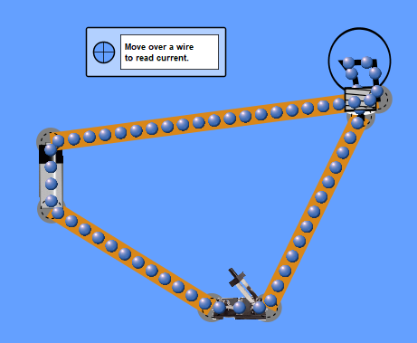

“non-contact” ammeter

12 V Battery

switch

Resistor (bulb)

Use the “non-contact” ammeter in the PHET simulator.

Set the battery to 12 V.

Read the resistance on the bulb (right click in simulation).

2. Set up a simple series circuit using a battery, ONE of the resistors, a switch, and the ammeter.

3. Use the voltage of the battery and the resistance of the resistor to calculate the theoretical current in amps. Record this in the calculations and data chart for “resistor 1” (*first row*).

4. Record the actual ammeter reading (*current amperage*) using the non-contact ammeter. Multiply that reading times the resistance and compare that with the voltage for the battery.

5. Record the actual voltage reading (*potential volts*) at the resistor using the voltmeter.

6. Add another resistor of equal resistance in series to the circuit. Use the voltage of the battery and the resistance of the two resistors to calculate the theoretical current in amps. Record this in the calculations and data chart for “resistor 2” (*second row*).

7. Record the actual ammeter reading (current amperage) using the non-contact ammeter. Multiply that reading times the resistance and compare that with the voltage for the battery.

8. Record the actual voltage reading (*potential volts*) at the resistor using the voltmeter.

9. Add the third resistor of equal resistance in series to the circuit. Use the voltage of the battery and the resistance of the three resistors to calculate the theoretical current in amps. Record this in the calculations and data chart for “resistor 3” (*third row*).

10. Record the actual ammeter reading (current amperage) using the non-contact ammeter. Multiply that reading times the resistance and compare that with the voltage for the battery.

11. Record the actual voltage reading (*potential volts*) at the resistor using the voltmeter.

Part 2 3 Resistors of Different Resistance

1. Use the 3 resistors in the series circuit, but this time change the resistance so that the resistors are 10 Ω, 20 Ω, and 30 Ω respectively.

“non-contact” ammeter

12 V Battery

switch

Resistor (bulb)

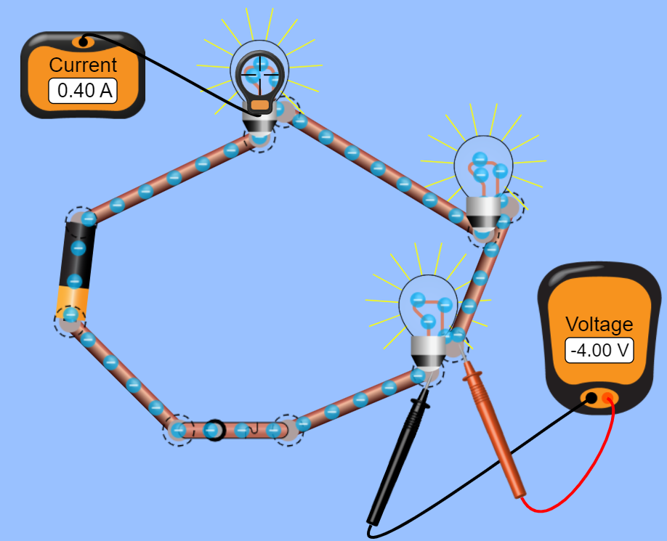

Use the “non-contact” ammeter in the PHET simulator.

Set the battery to 12 V.

Read the resistance on the bulb (right click in simulation).

**Calculations and Data**

**Part 1** 3 Series Circuits (equal resistors). Complete the chart below with all your results.

|  |  |  |  |  |  |  |
| --- | --- | --- | --- | --- | --- | --- |
| Resistance in Ohms  of the resistors | Total Resistance of Circuit (*ohms*) | Battery Voltage (*volts*) | Expected Current in amps (*calculated*) | Actual Ammeter reading (*amps*) | Voltage based on Actual Amperage (*volts*) | Measured Voltage (*volts*) across each resistor |
| 1 |  |  |  |  |  |  |
| 2 |  |  |  |  |  |  |
| 3 |  |  |  |  |  |  |

* Sketch each of the three series circuits you created (one resistor, two resistors, three resistors) with appropriate symbols, labeling voltage across the batteries, current and resistance over each resistor.

**Part 2** 1 Series Circuit (different resistors). Complete the chart below with all your results.

|  |  |  |  |  |  |  |
| --- | --- | --- | --- | --- | --- | --- |
| Resistance in Ohms  of the resistors | Total Resistance of Circuit (*ohms*) | Battery Voltage (*volts*) | Expected Current in amps (*calculated*) | Actual Ammeter reading (*amps*) | Voltage based on Actual Amperage (*volts*) | Measured Voltage (*volts*) across each resistor |
| 1 |  |  |  |  |  |  |
| 2 |  |  |  |  |
| 3 |  |  |  |  |

* Sketch the series circuit with three different resistors with appropriate symbols, labeling voltage across the batteries, current and resistance over each resistor.

**Conclusions and Questions**

1. What element(s) in a series circuit remains constant over every component? Explain your answer.

2. What element(s) in a series circuit are variables? Explain your answer.

3. A 10 Ω resistor, a 15 Ω resistor, and a 5 Ω resistor are connected in series across a 90 V battery. What is the effective resistance of the circuit? What is the current in the circuit?

**Calculations and Data**

**Part 1** 3 Series Circuits (equal resistors). Complete the chart below with all your results.

|  |  |  |  |  |  |  |
| --- | --- | --- | --- | --- | --- | --- |
| Resistance in Ohms  of the resistors | Total Resistance of Circuit (*ohms*) | Battery Voltage (*volts*) | Expected Current in amps (*calculated*) | Actual Ammeter reading (*amps*) | Voltage based on Actual Amperage (*volts*) | Measured Voltage (*volts*) across each resistor |
| 1 10 Ω | 10 Ω | 12 V | 1.2 A | 1.2 A | 12 V | 12 V |
| 2 10 Ω | 20 Ω | 12 V | 0.6 A | 0.6 A | 12 V | 6 V |
| 3 10 Ω | 30 Ω | 12 V | 0.4 A | 0.4 A | 12 V | 4 V |

* Sketch each of the three series circuits you created (one resistor, two resistors, three resistors) with appropriate symbols, labeling voltage across the batteries, current and resistance over each resistor.

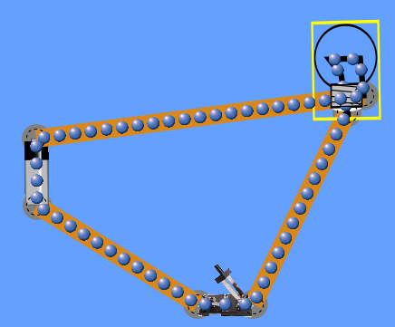 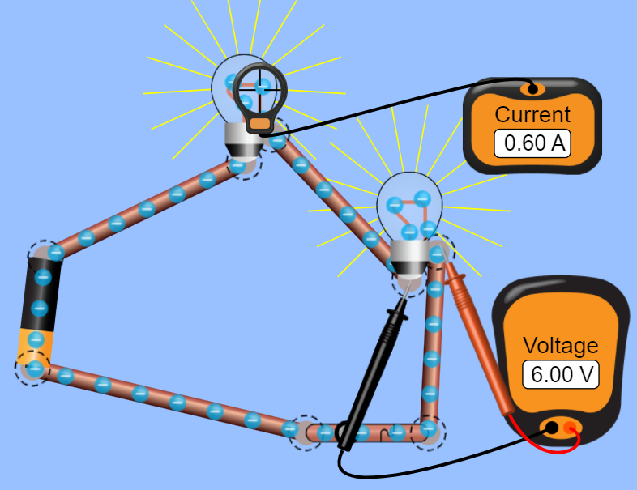

6 V

10 Ω

6 V

10 Ω

0.6 A

0.6 A

0.6 A

12 V

10 Ω

1.2 A

1.2 A

1.2 A



4 V

10 Ω

4 V

10 Ω

0.4 A

0.4 A

0.4 A

4 V

10 Ω

0.4 A

0.4 A

**Part 2** 1 Series Circuit (different resistors). Complete the chart below with all your results.

|  |  |  |  |  |  |  |
| --- | --- | --- | --- | --- | --- | --- |
| Resistance in Ohms  of the resistors | Total Resistance of Circuit (*ohms*) | Battery Voltage (*volts*) | Expected Current in amps (*calculated*) | Actual Ammeter reading (*amps*) | Voltage based on Actual Amperage (*volts*) | Measured Voltage (*volts*) across each resistor |
| 1 10 Ω | 30 Ω | 12 V |  | 0.2 A |  | 2 V |
| 2 20 Ω |  | 0.2 A |  | 4 V |
| 3 30 Ω |  | 0.2 A |  | 6 V |

* Sketch the series circuit with three different resistors with appropriate symbols, labeling voltage across the batteries, current and resistance over each resistor.

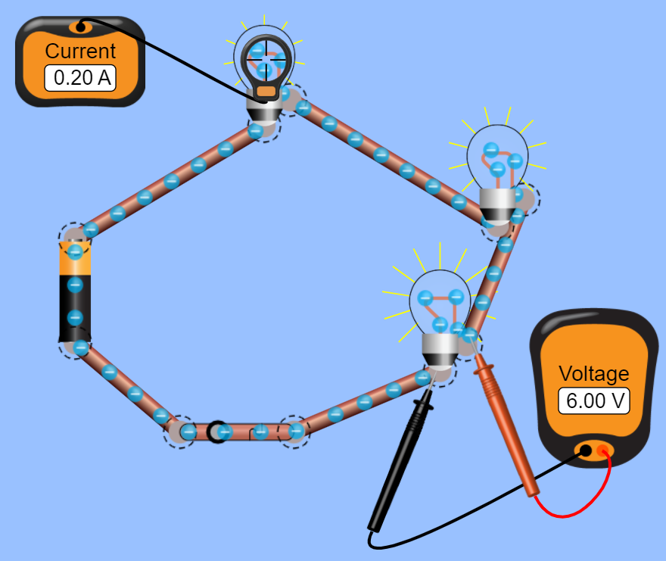

2 V

10 Ω

6 V

30 Ω

0.2 A

0.2 A

0.2 A

4 V

20 Ω

0.2 A

**Conclusions and Questions**

1. What element(s) in a series circuit remains constant over every component? Explain your answer.

**Current (I) in amps (A) remains constant in a series circuit because there is only one loop of current flow.**

2. What element(s) in a series circuit are variables? Explain your answer.

**Voltage in volts (V) and resistance in ohms (Ω) are variables in a series circuit. Since there is only one loop of current flow,** V total = V1 + V2 + V3 and R total = R1 + R2 + R3**.**

3. A 10 Ω resistor, a 15 Ω resistor, and a 5 Ω resistor are connected in series across a 90 V battery. What is the effective resistance of the circuit? What is the current in the circuit?

**R total = R1 + R2 + R3 R total = 10 Ω + 15 Ω + 5 Ω = 30 Ω**

**V = I R … I = V / R = 90 V / 30 Ω = 3.0 A**