The M_____ System

Metric System Versus the English System

* S_____
  + The metric system uses _____ unit for each category of measurement
  + _____ (mass), _____ (volume), _____ (distance)
  + The English system utilizes _____ different names for each major measurement (*units of mass, volume, distance*)
    - * + DISTANCE: Rod, furlong, hand, foot, yard, mile, nautical mile
        + VOLUME: Pinch, gill, teaspoon, tablespoon, ounce, cup, pint, quart, gallon, peck, bushel
        + MASS/WEIGHT: Penny, grain, ounce, pound, short ton, standard ton
* C_____
  + All metric units are _____ of _____ or utilize _____ placement
  + The English system has _____ consistency between units

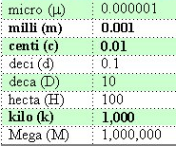

Metric & English Common Units

* Vehicle Odometer:
  + ___ km = ___ mile or 1 km = 0.625 miles
* Temperature:
  + ºF = ___ ºC + ___ or ºC = ___ (ºF - 32)
* Distance:
  + 1 inch = 2.54 cm or 0.39 inches = 1 cm

Metric _____

* Metric prefixes mean the same thing regardless of the quantity being measured; i.e., mass, volume, distance, time.
  + 1 _____ _____, 1 cc = 1 _____, 1 ml
  + _____ milliliters = ___ liter
  + 1 cubic decimeter = 1 liter

Factor labeling … see videos

Mathematics in Science

S_____ Notation or E_____ Notation

* The system of scientific notation was invented to express very _____ or very _____ numbers in a very compact and easy-to-calculate way.
* It is also sometimes referred to as "_____ of ten" or “exponential notation”, because it takes advantage of the _____ nature of our number system.
* Scientific notation always involves raising 10 to some exponential power (“powers of ___”).

Scientific Notation Conventions

sci not decimals

* use a _____ from ___ to ___
* _____ (power) of _____

e.g. 3,600,000,000,000

* + - * assume the decimal follows the last zero & the exponent is 10__ … 3,600,000,000,000. x 100 
        + … You need a _____ between __ & ___ … so move the decimal to the _____ 12 places
      * 3.6 x 1012 … Since the _____ decreased, you must _____ the exponent the same amount of places

sci not decimals 2

e.g. 0.0000000000436

* + - * assume the decimal follows the last zero & the exponent is 100 … 0.0000000000436 x 100 
        + … You need a _____ between 1 & 9 … so move the decimal to the _____ 11 places
      * 4.36 x 10-11 … Since the number _____, you must _____ the exponent the same amount of places

Scientific Notation (standard notation to exponential notation)

* Notice when the number _____, the exponent _____
* Notice when the _____ increases, the _____ decreases

Scientific Notation

* Inter-converting exponents to decimals
* scientific notation to standard notation

e.g. 6.7 x 104 = _____

* + You must decrease the _____, and therefore, increase the _____,
  + 10__ decreases to 10__
  + _____ increases to _____

e.g. 3.82 x 10-3 = _____

* + You must increase the _____, and therefore, _____ the number
  + 10__ increases to 10__
  + _____ decreases to _____
* “Thumb _____ / Thumb _____” RULE

Mathematical Operations

* When adding, subtracting, multiplying or dividing, one must deal with numbers and exponents separately … this means you cannot add a number to an exponent and vice versa.

Addition 65 x 10-1 + 8.3 x 101

* Convert numbers to a _____ exponent (choose the _____ exponent)
* The _____ of the exponents must be the _____ to add or subtract numbers

0.65 x 101 + 8.3 x 101

* Add _____ to _____ … add 0.65 + 8.3 = 8.95 8.95 x 101

Subtraction 47 x 10-1 - 7.1 x 101

* Convert numbers to a _____ exponent (choose the larger exponent)
* The superscripts of the exponents must be the same to add or subtract numbers

0.47 x 101 - 7.1 x 101

* Subtract _____ from _____ … subtract 0.47 - 7.1 = -6.63 -6.63 x 101

Multiplication 12 x 10-2 x 3 x 104

* Multiply _____ by _____ 12 x 3 = 36
* _____ the superscripts of the _____ 10-2 x 104 … add (-2) + 4 = 2 … = 102

36 x 102 … 3.6 x 103

Division 9 x 104 / 3 x 10-2

* Divide _____ by _____ 9 / 3 = 3
* _____ the superscripts of the _____ 104 x 10-2 … subtract … 4 - (-2) = 6 … = 106 🡪 3 x 106

Uncertainty in Measurement

* Uncertainty in measurement depends on the _____ and _____ of the _____ and the limitations of the _____
* We certainly want our dentists, doctors, mechanics, pharmacists, nurses, chefs, and other service providers to be _____ and _____ in their care

Accuracy, Precision, and Error

* Darts on a dartboard illustrate the difference between accuracy and precision.
* Label each target related to accuracy and precision:

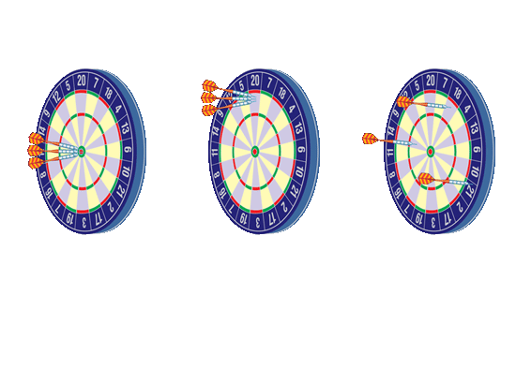

* The _____ of a dart to the bull’s-eye corresponds to the degree of _____. The closeness of several darts to one _____ corresponds to the degree of _____.
  + Example: TroubleShooting and Q & A’s
* _____ is the identification or diagnosis of "trouble" in a system based on a lack of accuracy and/or precision.

_____: deals with ‘common’ errors or failures (experienced _____); “_____”.

* + *E.g. Students forgot to put units on their measurements, lowering the average grade on the test.*

_____: deals with “_____” in the system.

* + *E.g. A student misread the question and got it incorrect.*

Precision

* + Usually refers to _____
  + Indicates the _____, reproducibility or consistency of a measurement.

Examples

* + The following measurements on a thermometer [91.9 C, 92.0 C, 92.0 C, 91.9 C] show _____ and high _____ and, therefore, the thermometer readings are considered _____.

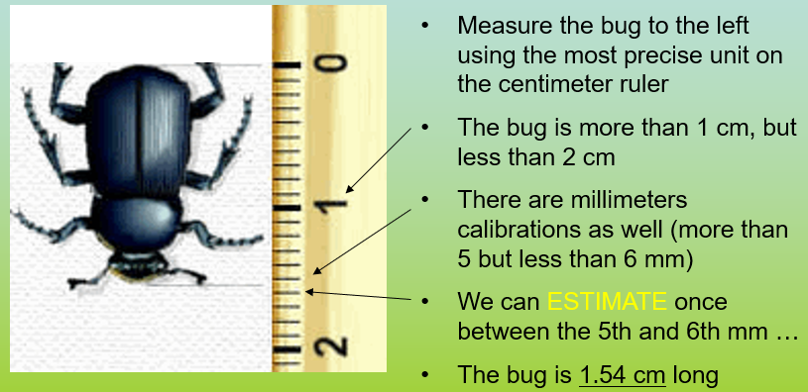

A_____

* + Usually refers to people and inaccurate measuring OR to an instrument that may be measuring precisely, but is not accurate
  + Indicates how _____ a measurement is to the _____ value

Example

* + The values of temperature [91.9 C, 92.0 C, 92.0 C, 91.9 C] for the boiling point of water are _____ … the accepted value at sea level is 100.0 C (student probably used an *“immersion thermometer” rather than non-immersion thermometer*)

How do we designate precision and accuracy in measurements?

* + We use _____ figures … also called significant _____ … which are numbers that are significant in the _____.
  + A scientist uses significant figures for several reasons
    - to _____ the amount of numbers used
    - to indicate the _____ of measurements obtained
    - to indicate the _____ of the measuring tool used

Significant Figures

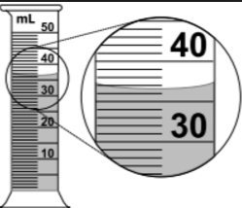

* The bottom line …
  + significant figures are used to show that _____ are both accurate and precise
  + accurate based on the _____ measuring and the instrument is _____ to _____ standards
  + precise based on the measuring _____ used
* A precise measurement could be _____ ml
* All _____ digits are significant as part of the measurement.

Significant Figures when _____ …

* You are allowed _____ estimate

RULES for determining which numbers in a measurement are significant.

* The _____ significant figure or digit in a measurement can be an _____.
* Unless instructed otherwise, one should use all the precision possible on a measuring device plus _____ estimate (*one decimal place*).
* All of measurement numbers are considered _____ (*including the ONE* _____).

RULES for determining which numbers in a measurement are significant.

* All digits (*INTEGERS*) except zero are _____ considered to be _____ in a measurement
  + 433 🡪 ___ sig figs .1746 🡪 ___ sig figs
* Zeros are significant if they:
  + exist _____ two integers
    - 502 🡪 ___ sig figs .12304 🡪 ___ sig figs
  + _____ a number containing a _____
    - 20. 🡪 ___ sig figs .7000 🡪 ___ sig figs

Mathematical Operations 🡪 Addition & Subtraction

* Use the number of significant figures in the _____ precise measurement for the total.
* 1520 + 0.1 - 0.001 = 1520.099
* Which of our values is **least precise**? 1520, which has its last significant digit in the _____ place. Thus, our answer must be rounded to the tens place: _____.

Mathematical Operations 🡪 Multiplication & Division

* When multiplying or dividing two or more numbers, count the significant figures in each of the original numbers.
* Take the smallest of the numbers of significant figures.
* The product or quotient will have that minimum number of significant figures.
* 0.048 m × 32.97 m = 1.58256 m2
  + Round to two significant figures because 0.048 has two: **1.6 m2** .
* 14570 kg ÷ 5.81 L = 0.19719 kg/L
  + Round to three significant figures because 5.81 has three. **0.197 kg/L**

How do we assess precision and accuracy in measurements?

We use _____ error

Percent error is a mathematical way of showing _____ and _____

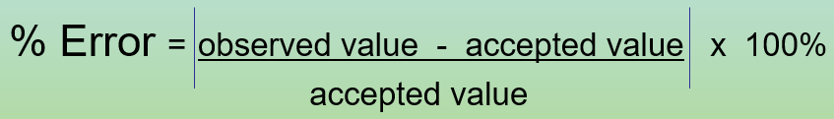

3B Units of Measurement

V_____

* Volume is the amount of _____ a substance occupies.
* ___3 is used to find the volume of a _____ shaped solid
* _____
  + 1 L = 1000 ml
  + ↓ ↑ liters are the _____ unit and have a smaller _____
  + ↑ ↓ milliliters are the smaller _____ and have a _____ number
* W_____ d_____ can be used to find volume of _____ shaped objects.

Name three ways to measure volume

* _____ shaped objects … ___3
* _____ … ___
* _____ shaped objects … water _____ (___)

M_____

* The mass of an object is the amount of _____ an object contains. A typical classroom uses a _____ beam _____ to measure mass in _____.
* 1 _____ (kg) is the basic SI unit of mass.

E_____

* The capacity to do _____ or to produce _____ is called energy.
* The SI unit of energy is the _____ (J)
* One _____ (cal) is the quantity of heat that raises the temperature of 1 g of pure water by 1°C.
* Conversions between joules and calories can be carried out using the following relationships.
  + 1 J = 0.2390 cal [see reference table 1]
  + 1 cal = 4.184 J
  + 1 _____ (KJ) = _____ joules
  + 1 kilocalorie (Kcal) = 1000 calories … “food calorie”

T_____

* A measure of the _____ _____ energy (_____) of molecules in a substance.
* Most people equate temperature with how “hot” or “cold” an object is. *But an Alaskan or an Egyptian would define hot and cold differently than you and I.*
* Most substances _____ with an _____ in temperature and _____ as the temperature _____. (e.g. sidewalks in winter versus summer).
* This explains how thermometers work (*the liquid inside expands & contracts*).

The SI (Metric) unit of temperature is the _____ scale, K, also known as the _____ temperature scale because it begins at _____ … equal to –273.15°C.

CONVERSIONS: ___ = º___ + _____ º___ = ___ - 273.15

º___ = ___ º___ + ___ ºC = 5/9(ºF-32)

D_____

* A measure of how tightly _____ matter is;
* Defined as an object's mass divided by its volume.

ρ = _____ 🡪 “d” is also fine

* Density and volume are _____ proportional: ↑ ↓
* If one keeps the mass the same, as the density _____, the volume the substance occupies _____.
* Density is an _____ property that depends only on the composition of a substance, not the size of the sample.
* The most dense substance (sinks/floats).



Calculating Density

***_***

_

*_*

p =

m =

V =

You have been using dimensional analysis or f_____ l_____.

* We are constantly converting measurements according to units.
  + 1 U.S. dollars = 0.89 euros. For money we call it “exchange rate”.
* To convert units, we need to _____ out the unit we do not want, and leave the desired unit.

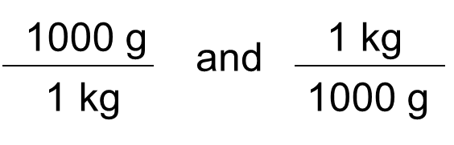

* We begin with _____. E.g. _____ g = ___ kg
* Create _____ Factors.

Conversion Factors

* Allow us to convert units
* Use equalities as a _____ of equivalent measurements
* The measurement in the numerator is _____ to the measurement in the denominator.
* Are _____ by “_____”

*Convert 2.4 kg to g*

2.4 ~~kg~~ x 103 g/~~1 kg~~ = 2.4 x 103 g