Heading

Title

**Introduction**

**Purpose**

To identify anatomy and describe characteristics of a typical vertebrate.

**Discussion**

At some time in their life, a chordate has the following 4 characteristics:

1. Dorsal Notochord - All chordates start with a soft, flexible notochord, which in many is replaced with the vertebral column. Also known as the Backbone (Vertebral Column) in vertebrates.
2. Dorsal, Tubular Nerve Cord - Also called the Spinal Cord. Runs down the back and helps the brain communicate with the rest of the body. Often protected by the Vertebral Column or Notochord.
3. Pharyngeal Pouches - Seen only during embryonic development in most vertebrates. In invertebrate chordates, fishes, & some amphibian larvae, these become functioning gills. In terrestrial vertebrates that breathe with lungs, the pouches are modified for various purposes.
4. Tail - Extends beyond the anus in all chordate embryos.

All Chordates have bilateral symmetry, are triploblastic (endoderm [organs], mesoderm [muscles], and ectoderm [skin & skeleton]), coelomates (body cavity between digestive tract and body wall), deuterostomes (anus first development), and mostly reproduce sexually.

Frogs are amphibians (water to land animals) that are vertebrates along with reptiles, birds, mammals, and most fish. Many organs and organs systems are similar within these organisms. Therefore, the frog is a simple organism to dissect.

**Materials** PowerPoint “Vertebrate Overview Frog Dissection” Frog Dissection Kit

**Procedures**

1. HONORS students and those who desire to perform the actual frog dissection, must obtain the frog dissection kit.

a. Do NOT use an unpreserved specimen because it may have parasites.

b. Follow the PowerPoint Presentation and take pictures of each dissection section, labelling the appropriate organs.

c. Complete this lab worksheet, filling in all blanks in the paragraphs.

d. Images must include labelled organs.

2. Those who choose to do the “virtual” frog dissection:

a. Follow the PowerPoint Presentation and label all worksheets of each dissection section.

b. Do the initial simulated cut out to expose the body cavity. Include image in the lab.

c. Complete this lab worksheet, filling in all blanks in the paragraphs, and labelling organs.

**Calculations and Data**

1. Fill in the paragraphs based on the PowerPoint presentation.

Frogs are vertebrates in a class called _____, living in _____ and on _____. Frogs have similar body systems (like the digestive and circulatory systems) to other vertebrates like humans, making them a nice specimen for comparative anatomy. Along with toads, they make up the largest group of Amphibians.

Characteristics of Frogs

* + Atypical Amphibian because they lack a _____; in a group called Anurans (without tail).
  + Unlike other _____ (4 limbed) vertebrates, Amphibians have _____, _____, scaleless _____ which is used for _____ (also have lungs).
  + Modified, extended back legs for jumping.
  + _____ (_____-blooded).

2a. Students doing the VIRTUAL dissection should print out the next page and do the simulated dissection (make the appropriate cuts in the abdomen of the frog), and insert an image below when done.

2b. Students doing the ACTUAL dissection make the appropriate cuts in the abdomen of the frog and insert an image below when done.

**Open Body Cavity of the Frog (Image)**

**Virtual Dissection “CUTS to Expose the Body Cavity” (Image)**

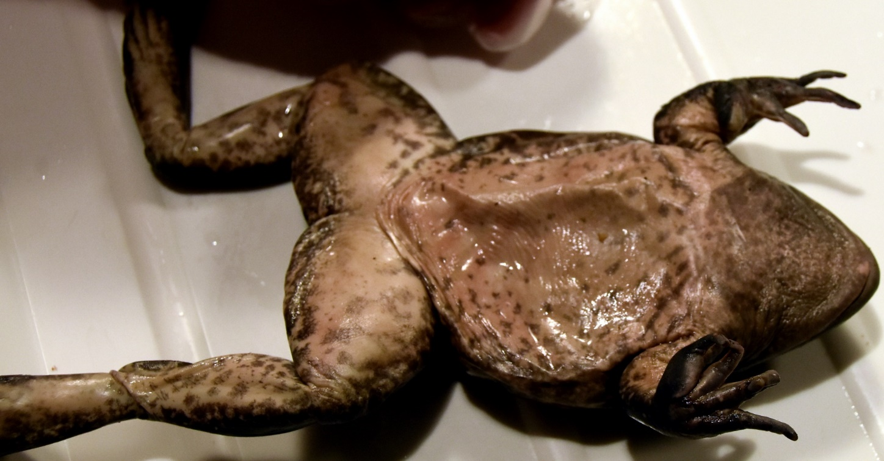

**Male Female**

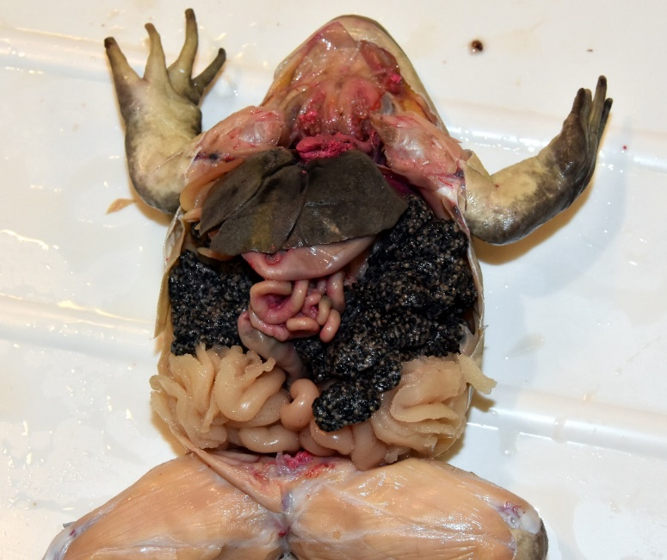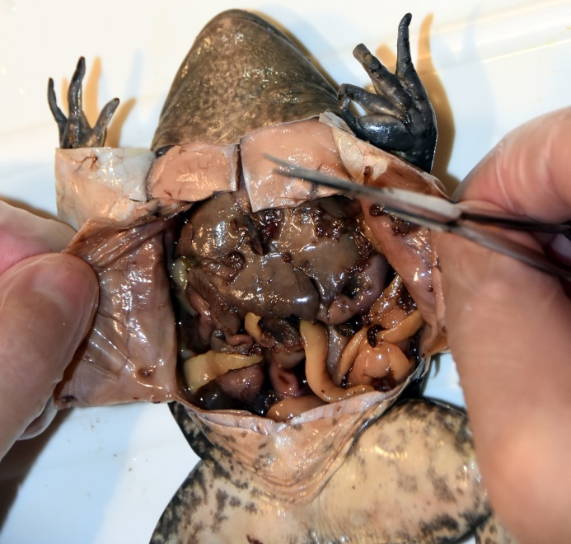

**Use the text boxes to label the fat bodies, ovaries, oviducts, and liver.**

Liver

Oviducts

Ovaries

Fat bodies

The frog on the left is a mature male; the frog on the right is a female.

A mature female is easy to identify because of the large paired _____ and extensive _____.

Also note the difference between the oviducts and fat bodies. _____ bodies are fingerlike and found in both male and female frogs; oviducts are long tube-like structures.

The _____ has many functions including _____ blood, _____ of fats for energy, and the production of _____ for fat digestion in the small intestine.

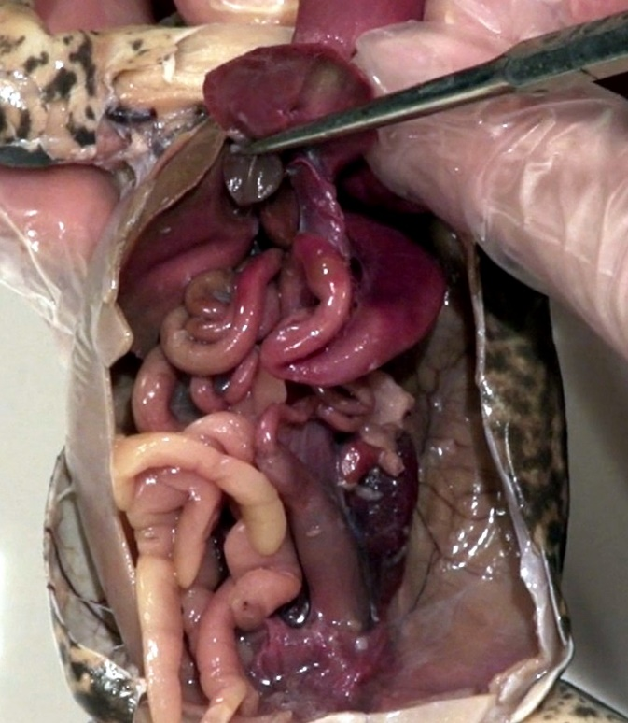

The organ which the probe is touching (to the left) is the _____ _____.

Function: Stores _____ produced by liver for _____ digestion; enters small intestine.

The liver lobes needed to be removed or pulled back.

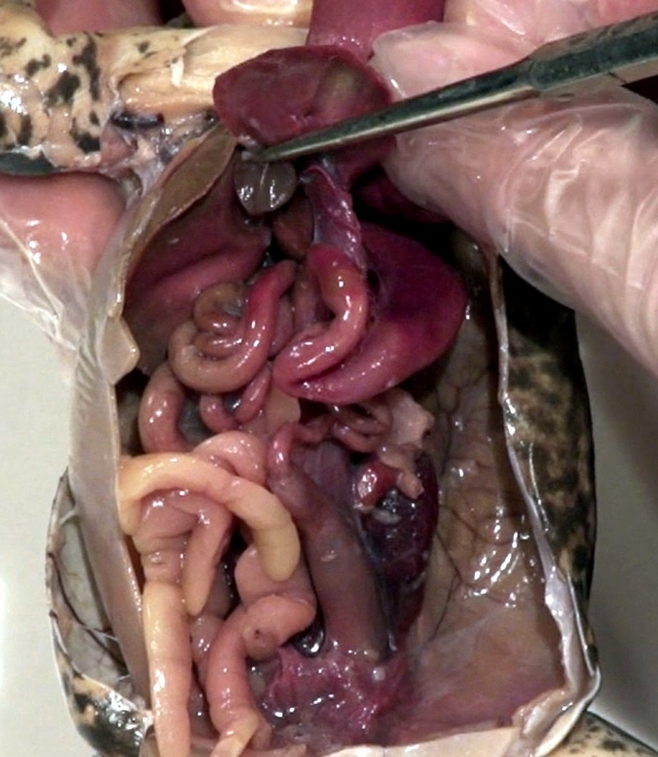

**Use the text boxes to label the stomach, small & large intestines, and urinary bladder.**

Urinary Bladder

Large Intestine

Small Intestine

Stomach

_____ – Large j-shaped structure; food storage and _____; complete digestive system.

_____ intestine – Long tube-like structure (increased surface area); digestion and nutrient _____.

_____ intestine (colon) - _____ absorption; forms feces, excreted through cloaca.

_____ _____ – Thin walled; urine _____.

_____ – Located at the start of the small intestine; _____ producing structure for digestion (pancreatic juices); _____ production, like insulin used for blood _____ regulation.

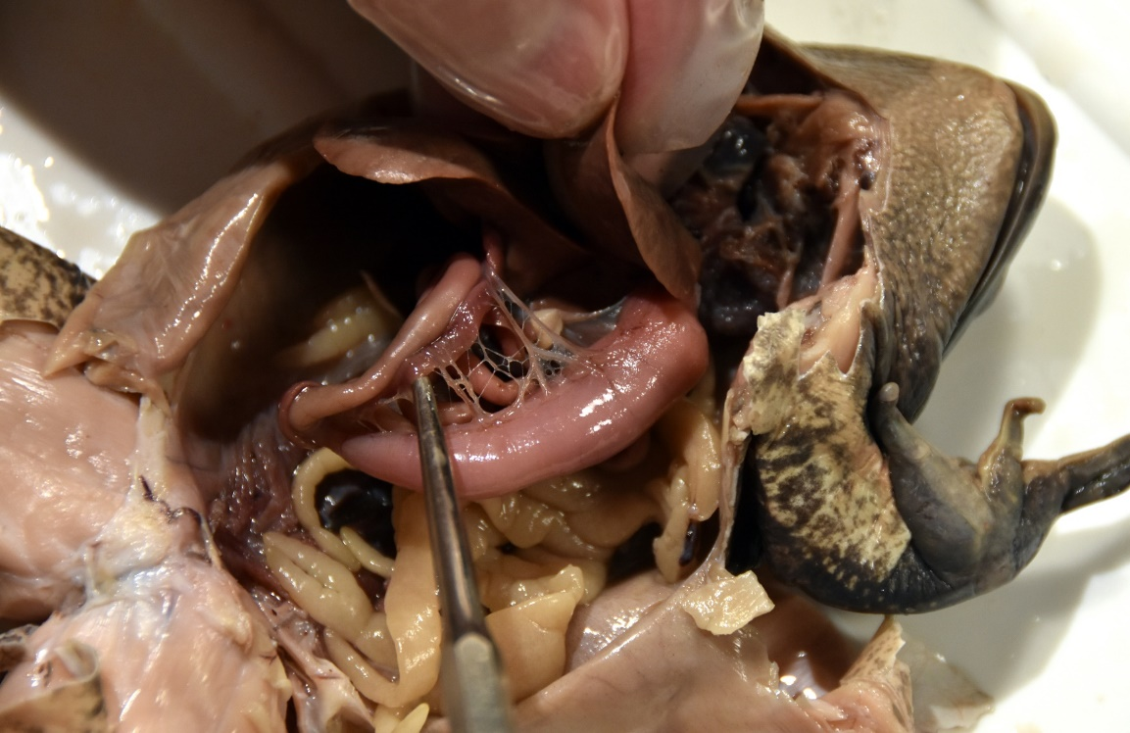

**Use the text boxes to label the stomach, small intestine, and pancrease (above).**

Small Intestine

Pancreas

Stomach

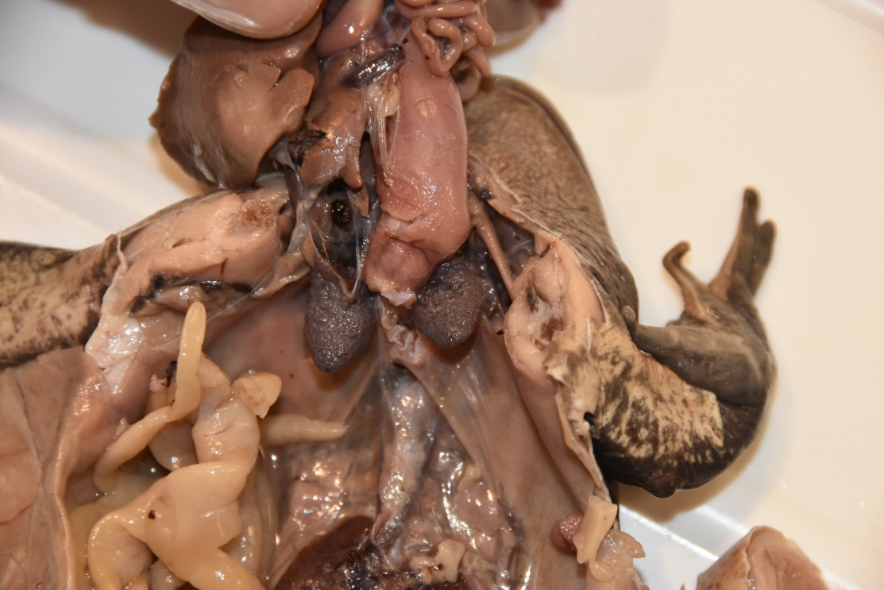

Mesentery, Digestive System and Liver Moved Upward.

_____ (paired) – Deflated; not as complex as the human lung, have some compartmentalization but no alveoli; _____ exchange for respiration, also gas exchange through skin/mouth.

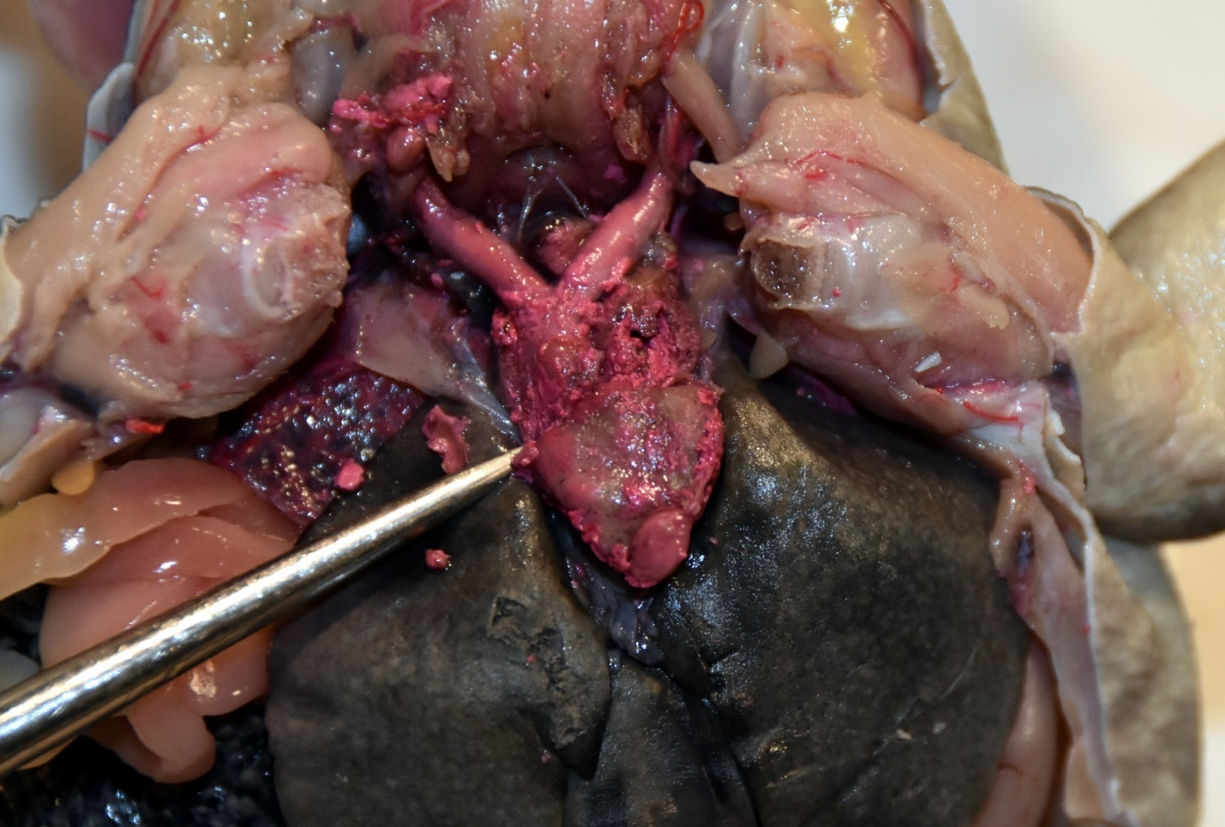

**Use the text boxes to label the left and right atria, and ventricle (above).**

Left Atrium

Right Atrium

Ventricle

H_____

* _____ system; _____ blood (from the body) and oxygenated blood (from the skin) enters the _____ atrium;
* _____ blood (from the lungs) enters the _____ atrium.
* Blood is then pumped from both atria to the _____.
* The ventricle then pumps the blood through the conus arteriosus.
* Oxygen-poor blood is pushed to the _____; oxygen-rich blood is shunted to the rest of the body. The process then repeats.

**Accessory Organs:**

_____ – _____ (white blood cell production); filters and stores blood; found in mesentery; dark here, many times fleshy color.

_____ – _____ waste from the blood, produce _____; large, paired, dark organs found against the dorsal body wall.

**Conclusion Questions**

1. Define “triploblastic” and explain each tissue layer in terms of development in an adult.

2. Define “deuterostome”. What is significant about this?

3. Which developmental characteristic of chordates is missing in adult frogs?

4. Define “ectotherm” and give its relevance.

**Bibliography**

South Dakota Public Broadcasting. 2022 PBS & GBH Educational Foundation. <https://dptv.pbslearningmedia.org/collection/dissection-videos-for-classroom-use/>