Name _____ Date ______

1. Sketch an approximate scale model of the earth. Include the four main layers, as well as the two different types of crust (showing their relative thickness). Also identify the lithosphere and the asthenosphere.

2. Describe the principle of refraction, and how it applies to our understanding of the earth’s interior.

3. Create a side view sketch of the three types of convergent plate boundaries and label each diagram completely (*lithosphere, asthenosphere, what formation is produced*).

4. Explain why earthquakes occur. Include plates & energy in your answer.

5. Explain the process of energy transformation in the build-up and release of stress in an earthquake.

6. List the four-point plate tectonics definition.

7. List three pieces of evidence for the theory of continental drift. [*enrichment*]

8. List three pieces of evidence for seafloor spreading. [*enrichment*]

9. Name and describe the three different types of faults, the stress associated with each fault type and the type of boundary that each fault is likely to form at.

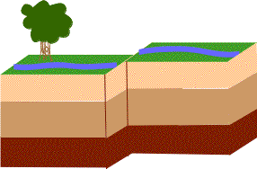 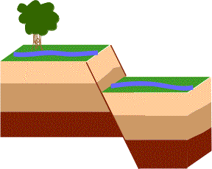 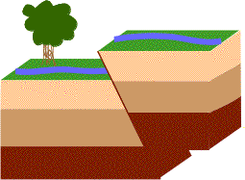

10. Describe the difference between the different types of seismic waves.

11. How is an earthquake located, and how is the Richter magnitude of an earthquake determined?

12. What are the factors that can affect how destructive an earthquake is?

13. What type of boundaries will have deep focus earthquakes?

____ are defined as movements of the ground that are caused by a sudden release of ____ when rocks along a ____ move. Earthquakes usually occur when rocks under stress suddenly shift along a fault. A fault is a break in a body of rock along which one block _____ relative to another.

Label Figure 1: _____

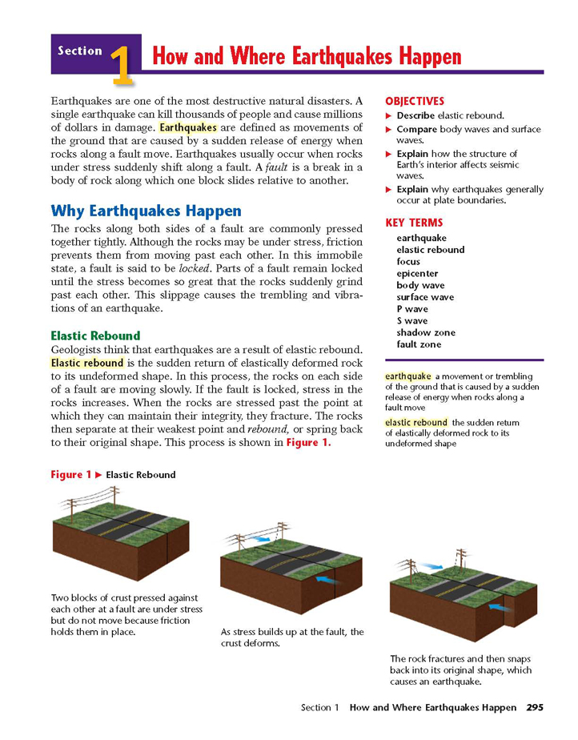

Label Figure 2: _______________________

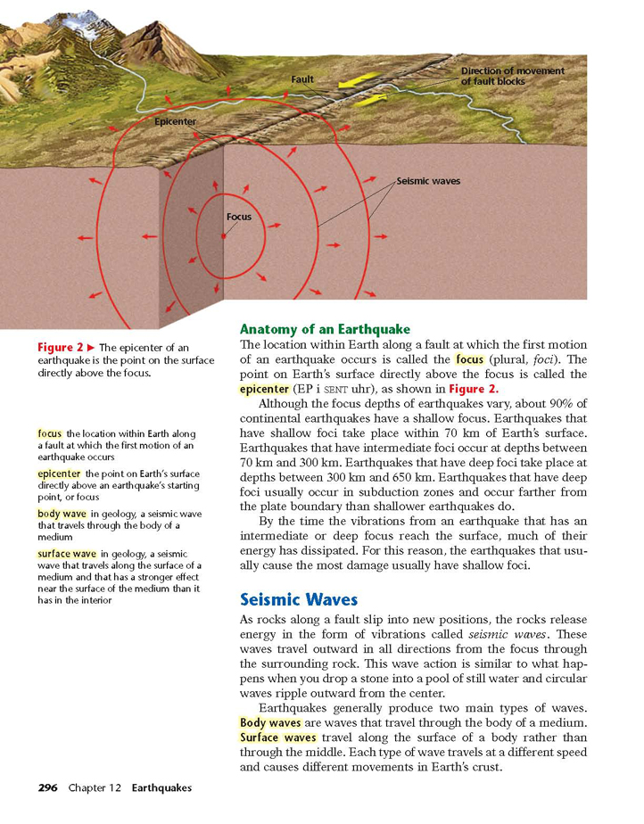

The location within Earth along a fault at which the first motion of an earthquake occurs is called the ________.

The point on Earth’s surface directly above the focus is called the _______________.

As rocks along a fault slip into new positions, the rocks release energy in the form of vibrations called _____ waves.

Seismic (earthquake waves) can be placed into two main categories: ___ waves and ___ waves.

P waves, called ____ waves or compression waves, are the ____ seismic waves, always the first waves of an earthquake to be detected.

P waves move rocks ____ & ____ ____ to the direction of wave travel. They move through solids, liquids, and gases.

S waves, ____ or shear waves, are the second-fastest waves. S waves move rock particles move side to side ____ to the direction of wave travel. S waves can only travel through ____.

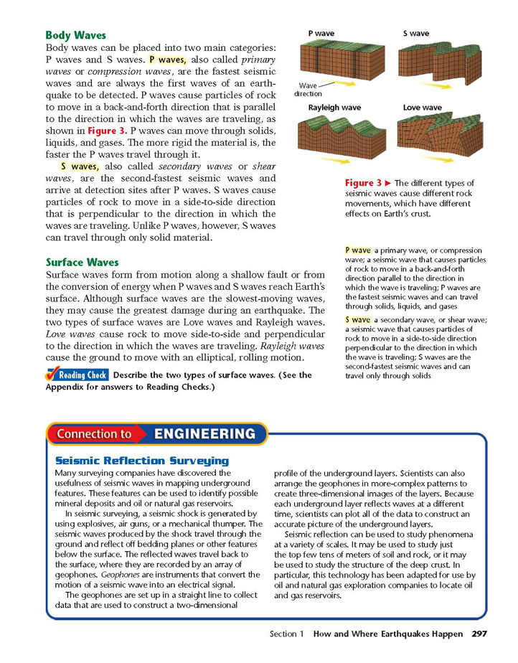

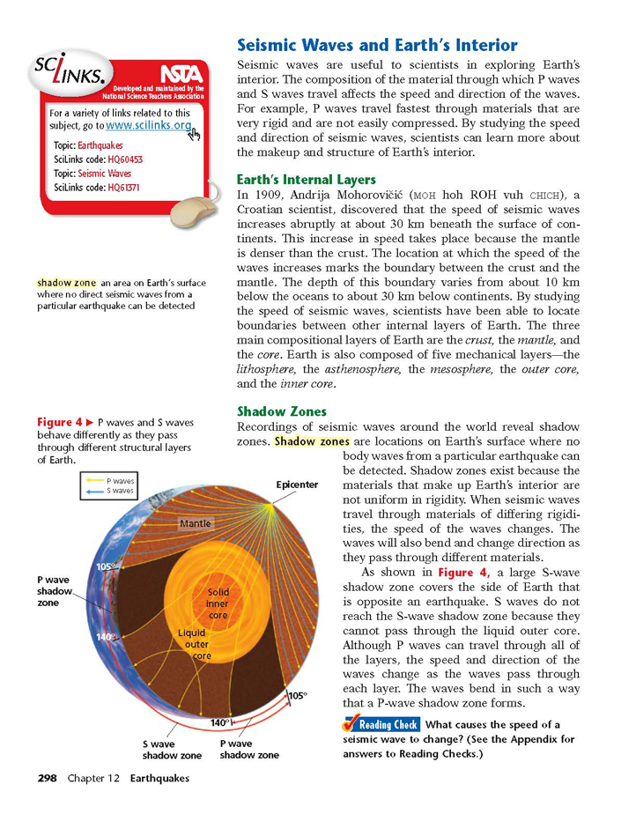

Based on Figure 4 to the left

Because particular earthquake waves can be detected throughout the earth, we know that the three main compositional layers of Earth are the ____, the _____, and the _____.

The outer core is m_____ (liquid) because the ___ wave does not penetrate it, and these waves only pass through solids.

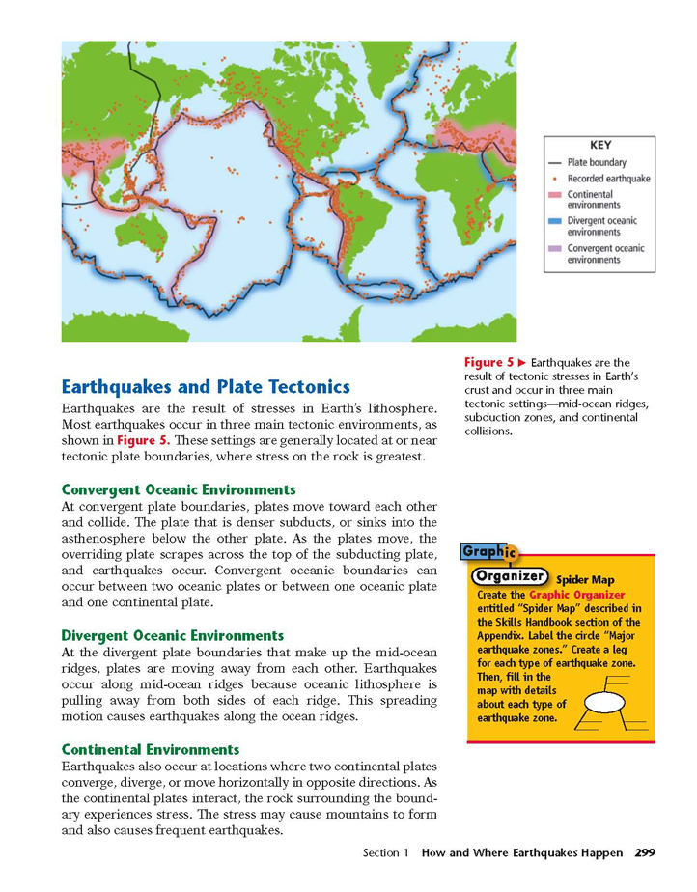

Earthquakes are the result of tectonic ____ in Earth’s crust.

Four types of mountains formed near plate boundaries are:

1

2

3

4

Earthquakes form at ______, which are at plate boundaries because of the intense ____ that results when plates ______, ______, or slide past each other.

Vibrations in the ground can be detected and recorded by using an instrument called a ____. To determine the ____ of an earthquake, scientists use information from _____ seismic stations, and use the difference in ____ time between the ___ and ___ wave arrival.

The measure of the strength of an earthquake is called ____. Seismologists express magnitude by using a magnitude scale, such as the _____ scale.

A _____ is a wave generated by an off shore earthquake. This produces a very large ocean _____.

14. Draw THREE diagrams or the 3 types of volcanoes. Name them, and describe the difference between them.

15. Explain what is meant by viscosity. What type of magma has higher viscosity? Which type has lower viscosity? What is the relationship between viscosity and explosiveness?

16. Explain the difference between pyroclastic material and lava.

17. What is a hot spot? Draw a diagram showing how a hot spot could create an island chain (like Hawaii) over time.

18. Why are subduction boundary volcanoes more explosive?

19. What is the “Ring of Fire”?

20. Explain the relationship between plate tectonics, earthquakes and volcanoes.

21. The Juan De Fuca plate is subducting below the North American plate at a rate of 6 cm/yr, building the Cascade Mountain range. The Cascade Range has is about 7, 000,000 y ears old. How much of the Juan De Fuca plate has subducted over that time? (Give answer in Km) Use 4 step method to solve.

ANSWERS

1. Sketch an approximate scale model of the earth. Include the four main layers, as well as the two different types of crust (showing their relative thickness). Also identify the lithosphere and the asthenosphere.



2. Describe the principle of refraction, and how it applies to our understanding of the earth’s interior.

As earthquake waves travel from one material to a different material (each with differing densities), they refract. Refraction is the changing of wave speed (and therefore, direction) as it goes from one material to the next.

3. Create a side view sketch of the three types of convergent plate boundaries and label each diagram completely.

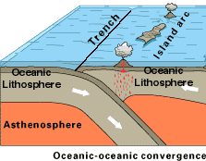

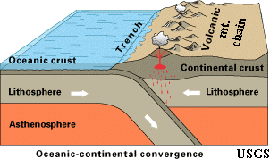

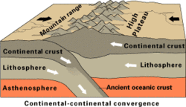

4. Explain why earthquakes occur. Include plates & energy in your answer.

Earthquakes occur as plates *move into*/ *move away from* / *slide past* one another. As these plates move, a huge amount of energy is released (in the form of an earthquake).

5. Explain the process of energy transformation in the build-up and release of stress in an earthquake.

Faults build up energy (as plates are attempting to move relative to one another). Because these plates area so massive, this movement does not come easy. Finally, enough pressure builds up and the plates finally slide relative to one another. This movement releases the energy (pressure) that built up prior to the plate movement.

6. List the four-point plate tectonics definition.

a. Earth’s crust is divided into plates

b. Plates move because of convection in the asthenosphere and slab pull.

c. New crust is created at ridges.

d. Old crust is destroyed at trenches.

7. List three pieces of evidence for the theory of continental drift. [*enrichment*]

* Fit of continents
* Fossil evidence
* Glossopteris – pre-historic fern
* Mesosaurus – alligator like creature
* Glacial evidence – Southern continents had experienced a glaciation.
* Coal beds – found in N. America and Europe
* Mountain ranges – match in Europe and N. America
* Rock beds – similar on different continents
* Present day organism’s distribution.

8. List three pieces of evidence for seafloor spreading. [*enrichment*]

Age - youngest material found closest to ridge.

Temperature – warmest water near mid-ocean ridge

Depth – depth contours reveal middle of ridge called the rift valley (deeper section where lava comes out)

Magnetic Orientation – alternating strips of normal and reverse polarity.

9. Describe the three different types of faults, the stress associated with each fault type and the type of boundary that each fault is likely to form at.



Fault= strike-slip

Stress= shearing

Boundary type= Transform



Fault= normal

Stress= tensional

Boundary type= Divergent



Fault= thrust (reverse)

Stress= compressional

Boundary type= Convergent

10. Describe the difference between the different types of seismic waves.

Body Waves

Primary waves – fastest, travel through any type of material. (longitudinal)

Secondary waves – slower, can’t travel through liquid. (transverse)

Surface waves

Rayleigh waves– Up and down motion.

Love waves- side to side, whip like motion.

11. How is an earthquake located, and how is the Richter magnitude of an earthquake determined?

To find the location of an earthquake, one must determine the S-P Interval for the earthquake at a particular seismic station (the S-P interval determines the distance to the quake from that seismic station); 3 stations TOTAL are needed to determine the exact location.

Richter magnitude is determined by finding the amplitude (highest point on seismogram).

12. What are the factors that can affect how destructive an earthquake is?

Intensity (how strong the earthquake is)

Duration of vibration (how long the earthquake lasts for)

Type of material (ground material)

Structure design (structure of buildings/houses)

13. What type of boundaries will have deep focus earthquakes?

Convergent. Due to subduction.



Earthquakes are defined as movements of the ground that are caused by a sudden release of energy when rocks along a fault move. Earthquakes usually occur when rocks under stress suddenly shift along a fault. A fault is a break in a body of rock along which one block slides relative to another.

Label Figure 1: Elastic Rebound



Label Figure 2: Epicenter of an Earthquake



The location within Earth along a fault at which the first motion of an earthquake occurs is called the focus.

The point on Earth’s surface directly above the focus is called the epicenter.

As rocks along a fault slip into new positions, the rocks release energy in the form of vibrations called seismic waves.

Seismic (earthquake waves) can be placed into two main categories: P waves and S waves.

P waves, called primary waves or compression waves, are the fastest seismic waves, always the first waves of an earthquake to be detected.

P waves move rocks back & forth parallel to the direction of wave travel. They move through solids, liquids, and gases.

S waves, secondary or shear waves, are the second-fastest waves. S waves move rock particles move side to side perpendicular to the direction of wave travel. S waves can only travel through solids.





Based on Figure 4 to the left

Because particular earthquake waves can be detected throughout the earth, we know that the three main compositional layers of Earth are the crust, the mantle, and the core.

The outer core is molten (liquid) because the S wave does not penetrate it, and S waves only pass through solids.



Earthquakes are the result of tectonic stress in the earth’s crust.

Four types of mountains formed near plate boundaries are:

Fault block

Folded

Volcanic

Dome

Earthquakes form at faults, which are at plate boundaries because of the intense stress that results when plates separate, collide, or slide past each other.

Vibrations in the ground can be detected and recorded by using an instrument called a seismograph. To determine the location of an earthquake, scientists use information from three seismic stations, and use the difference in lag time between the p and s wave arrival.

The measure of the strength of an earthquake is called magnitude. Seismologists express magnitude by using a magnitude scale, such as the Richter scale.

A Tsunami is a wave generated by an off shore earthquake. This produces a very large ocean wave.

14. Draw a diagram and describe the difference between the three different types of volcanoes.



* Composite (stratovolcano) cone – A volcano that consists of alternating layers of lava and ash. High viscosity magma. Most violent (I.e. Mt. St. Helens)
* Cinder cone – Small, steep sided, composed mostly of ash. Medium to High Viscosity. (I.e. Paracutin (Mexico), Sunset Crater (Arizona))
* Shield – large, gentle slope. Relatively quiet eruptions. Low viscosity magma

(I.e. Mauna Loa, Olympus Mons (Mars))

15. Explain what is meant by viscosity. What type of magma has higher viscosity? Which type has lower viscosity? What is the relationship between viscosity and explosiveness?

Viscosity is magmas resistance to flow (high viscosity 🡪 flows slower; low viscosity 🡪 flows faster). A high viscosity magma is stickier whereas a low viscosity magma is runnier.

Mafic magma has a lower viscosity and felsic magma has a higher viscosity.

Magma that has a higher viscosity will produce a more explosive eruption, whereas magma with a lower viscosity will produce a less explosive eruption.

16. Explain the difference between pyroclastic material and lava.

Lava is simply magma that has erupted from the earth (it is now above ground).

Pyroclastic material is broken down into the following three categories:

* Volcanic Ash – fine grained particles blown out of a volcano from an explosive eruption.
* Volcanic Blocks - A volcanic block is a solid rock fragment greater than 64 mm in diameter that was ejected from a volcano during an explosive eruption
* Volcanic Bombs - Volcanic bombs are lava fragments that were ejected while viscous (partially molten) and smaller than 64 mm in diameter

17. What is a hot spot? Draw a diagram showing how a hot spot could create an island chain (like Hawaii) over time.

A hot spot is an area of persistent volcanic activity. Hot spots originate at unusually hot areas of the mantle-core boundary. Overlying mantle melts forming plumes of magma that rise and penetrate the crust forming volcanoes.



18. Why are subduction boundary volcanoes more explosive?

Magma that exists in subduction zone has higher amount of silica and that leads to more viscous magma which leads to more explosive eruptions.

19. What is the “Ring of Fire”?

As a result of subduction, the area around the Pacific Ocean is known as the “Ring of Fire” for the volcanoes that result there.



20. Explain the relationship between plate tectonics, earthquakes and volcanoes.

Volcanoes and earthquakes are seemingly very different geological events, yet they are actually closely related — both result from movements of Earth's crust. Earth's crust — the lithosphere — is composed of several major plates and many minor plates that change shape and position. Over time, these tectonic plates move, interact with each other, and are responsible for the formation of ocean basins, mountain ranges, islands, volcanoes, and earthquakes.

21. The Juan De Fuca plate is subducting below the North American plate at a rate of 6 cm/yr, building the Cascade Mountain range. The Cascade Range has is about 7, 000,000 y ears old. How much of the Juan De Fuca plate has subducted over that time? (Give answer in Km) Use 4 step method to solve.

1. Rate = 6cm/yr 2) D=RT 3) D=RT

Time = 7,000,000 years 7,000,000 years x .00006km

Distance = ? 420

4) D=420Km