Taking Notes In Science Class

<https://screencast-o-matic.com/watch/cqjVFdOGBg>

**Purpose Retention / Learning with** UNDERSTANDING

**Principle Big Ideas Supported by Small Ideas**

**Process Your Part / Role**

**Preparation Concentration / Focus**

**Pattern What method works for you?**

**1. Verbatim – during class**

**2. Cornell Method – during class**

**3. Outline Method – after class**

**4. Mapping Method – after class**

**5. Charting Method – after class**

**Scientific Method (A Process) … Objective**

**1. Observation … Major Point**

* 1. **Uses the senses … Minor Point**
  2. **Ask questions, collect & organize data. … Minor Point**

**2. Hypothesis … Major Point**

**a. Possible solution … Minor Point**

**b. Based on accurate observation … Minor Point**

**3. Experimentation … Major Point**

**a. Test the proposed solution … Minor Point**

**b. Control & Experimental groups (variables) … Minor Point**

**c. Conclusions … Minor Point**

**4. Theory … Major Point**

**a. Gives explanation … Minor Point**

**b. Repeatable, recognizable pattern … Minor Point**

**5. Scientific Law … Major Point**

**a. Describes nature … Minor Point**

**b. No known exceptions … Minor Point**

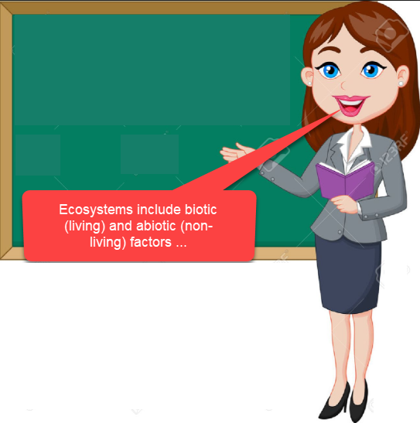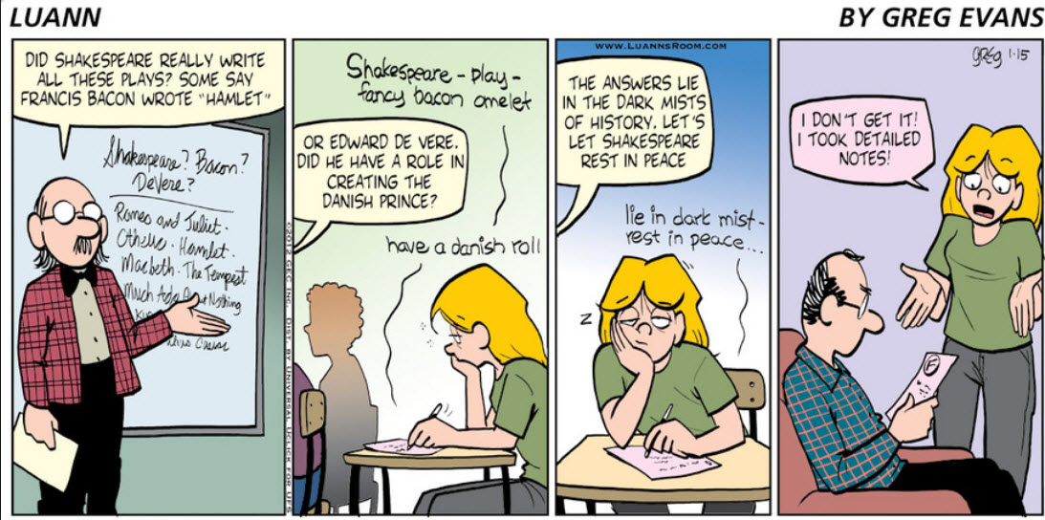

Ecology uses robotics …



**Note Taking 101**

