**Ice Age Theory & Climate Change**

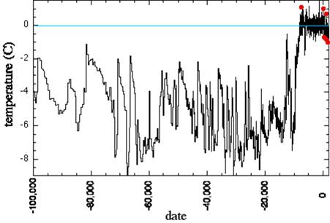

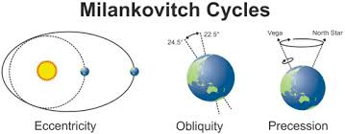

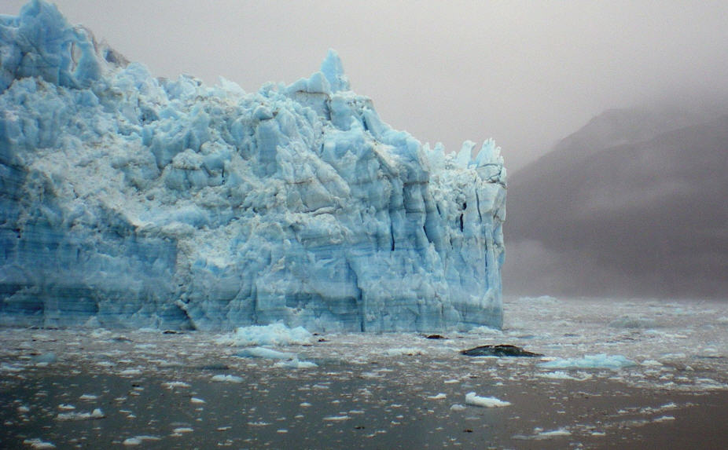

**See** [**https://www.learningctronline.com/courses**](https://www.learningctronline.com/courses) **for Materials and Resources.**

**Topics:**

1. Ice Age Theory & Climate Change

**Objectives:**

1. Describe the Pleistocene extinction and possible causes.

2. Define what ice ages are and distinguish glacial and interglacial periods throughout Earth’s history.

3. Explain Milankovitch’s ice age theory components.

4. Define paleoclimatology and explain how scientists monitor Earth’s climate throughout history.

5. Describe glaciers and glaciation, giving the types of glaciers and how glaciers are formed.

6. Understand how glaciers are identified using topographic maps.

7. Explain the formation of the Great Lakes.

8. Describe isostatic rebound.

9. Practical apply paleoclimatology in reading various graphs about ice age.

TAKE NOTE (All assignments are due by next week’s class.)

1. Ice Age Theory PowerPoint Worksheet
2. Worksheet: Great Lakes Formation & Ice Ages
3. Climate Change Socratic Seminar
4. Jeopardy Review: Earth’s History & Climate
5. Test Earth’s History & Climate (open notes)
6. Week 28 Devotional (<https://www.learningctronline.com/devotional>)

**Text**:

**Reference Material: Ice Age Theory PowerPoint**

**Homework**:

* Ice Age Theory PPT Worksheet
* Jeopardy Review: Earth’s History & Climate

**Lab**: Climate Change Socratic Seminar

* + Complete the worksheet provided.
  + There is a **class presentation** for this assignment.
* Save the document into your LAB folder in the Projects in Science folder on your desktop.

**TEST:** Earth History & Climate

1) This test is OPEN NOTES, but you must keep the time limit.

2) Take the **"in one sitting"**, meaning that once you start the test, you must complete it without interruption.

3) There is a **45-minute time limit** on this test. Please have the proctor write the time taken at the top of your answer sheet with their signature or initials.

4) Proctors should NOT be reading the test or engaging students during the test.

5) Do NOT use RED font. Black font is best.

Supplemental Resources (Optional)

Precession <http://somup.com/cZnhq5pi2n> (1:42)

Global Warming Fear Factor <https://screenpal.com/watch/cq6VIEu6JC> (2:24)

Glacial Calving <https://screenpal.com/watch/cFQUqVYiHX> (3:46)

Glacier Formation <https://screenpal.com/watch/cFQUFsYimH> (4:39)

Formation of the Great Lakes <http://somup.com/cZn12epj5B> (5:33)