**Properties of Magnetic Objects**

**Materials**: 3 “cut” nails Plastic lid for a float (fast food drink lid)

Aluminum pie tin Bar magnet or cow magnet

Glass beaker Water

**NAIL RESPONSE PROCEDURES**:

1. “**De**magnetize” the cut nails by whatever methods works best for you. Demagnetizing Objects (1:50). Keep them off to the side away from the magnet.
2. Because this is a very sensitive “testing” arrangement, check to see that there are no metallic objects near, around, underneath or directly above the pie tin.
3. Obtain an aluminum pie tin and add water to the pie tin (using the glass beaker) until it is a little less than ½ filled.
4. Lay the plastic lid on the water and place the “demagnetized” nail on the lid as shown in the picture on the right.

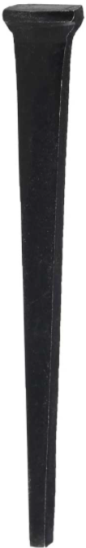 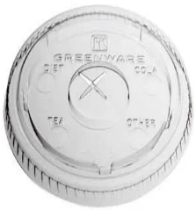 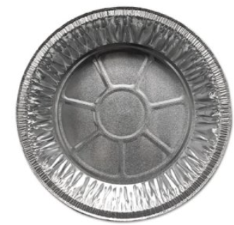 

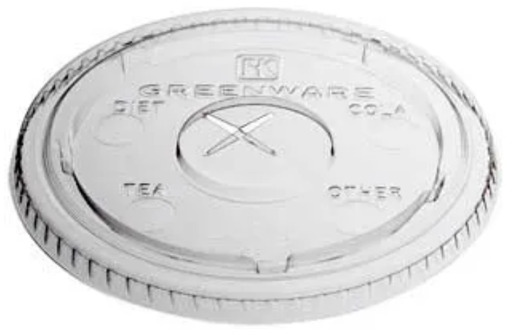



**PREDICTIONS**:

1. What do you predict would happen if you held another “**de**magnetized” nail horizontally and at right angles to the floating “**de**magnetized” nail, bringing the pointed end of the nail you are holding near the pointed end of the floating nail? [*Record your prediction*]
2. What do you predict would happen if you held a “magnetized” nail horizontally and at right angles to the floating “**de**magnetized” nail, bringing the pointed end of the nail you are holding near the both ends of the floating nail? [*Record your predictions*]

* What ideas, experiences or evidence did you use to make your predictions?

1. What do you predict would happen if you floated a “magnetized” nail and held another “magnetized” nail horizontally and at right angles to the floating “magnetized” nail, bringing the pointed end of the nail you are holding near both ends of the floating nail? *[Record your predictions*]

* What ideas, experiences or evidence did you use to make your predictions?

**EXPERIMENT**: You will test all of your predictions now beginning with #1 of the procedures. Record all your observations on the Calculations and Data Sheet.

1. What do you actually observe to happen when you float a “**de**magnetized” nail and bring a “**de**magnetized” nail near both ends of it?
2. What do you actually observe to happen when you float a “**de**magnetized” nail and bring a “magnetized” nail near both ends of it?

* **To magnetize the nail**, you must hold another “**de**magnetized” nail on one end and rub a cow magnet (strong) from that end to the other end. Rub only in one direction for 5-6 strokes.
* Then bring one end of the “magnetized” nail near each end of the floating “**de**magnetized” nail.

1. What do you actually observe to happen when you float a “magnetized” nail and bring a “magnetized” nail near both ends of it?

* Take the “**de**magnetized” nail off the float in the pie tin and replace it with the “magnetized” nail.
* Obtain another “**de**magnetized” nail and magnetize it. [*To magnetize the nail, you must hold a “demagnetized” nail on one end and rub a magnet from that end to the other end. Rub only in one direction for 5-6 strokes*.]

**NAIL ORIENTATION PROCEDURES**:

1. At this point, you should have a “magnetized” nail on the float. Spin the float gently and observe the position it points to when it stops spinning.

* BE SURE THERE IS NO MAGNET OR OTHER METAL OBJECTS NEAR THE PIE TIN as this may throw off the results.
* Describe your observation in terms of where the nail points when the float stops spinning.

1. Repeat procedure #1 two or three more times and make your observations.
2. Now turn the float so that the pointed end of the nail faces a specific direction and then let go. Which direction does the pointed end of the nail face once the float comes to a stop again? REPEAT THIS PROCEDURE TWO MORE TIMES and record your observations.
3. Compare your observations with that of three other groups. What did you observe the same (if anything)? What was different (if anything)?

Back of room

Front of room

1. Make a drawing or sketch in the circle within the box to the right showing the orientation of the magnetized nail once it stopped floating. Be sure to indicate the pointed end of the nail verses the “flat” head of the nail.

**CONCLUSIONS AND QUESTIONS** *(Complete this section in short phrases)*

1. Explain your observations about the orientation of the nail after spinning the float. What do you think could be causing this behavior?
2. Can you think of a device that works like the floating nail? If so, describe it and explain why you think it is similar.
3. Do you think you can use static electricity properties to explain what happened in this lab? Give specific reasons why you chose “yes” or “no.” In other words, what did you observe that was the same (if anything)? What was different (if anything)?

**ANSWERS**

**EXPERIMENTATION OBSERVATIONS**:

1. What do you actually observe to happen when you float a “**de**magnetized” nail and bring a “**de**magnetized” nail near both ends of it?

**Nothing happens**

2. What do you actually observe to happen when you float a “**de**magnetized” nail and bring a “magnetized” nail near both ends of it?

**The nail is attracted to the magnet**

3. What do you actually observe to happen when you float a “magnetized” nail and bring a “magnetized” nail near both ends of it?

**One end is attracted. The other end is repelled**.

**Nail Orientation Procedure OBSERVATIONS:**

1. At this point, you should have a “magnetized” nail on the float. Spin the float gently and watch the position it comes to when it stops spinning. What happens?

**The nail points in a specific direction.**

2. Repeat procedure #1 two or three more times and make your observations.

**The nail points in the same direction each time.**

3. Now turn the float so that the pointed end of the nail faces a specific direction and then let go. Which direction does the pointed end of the nail face once the float comes to a stop again? REPEAT THIS PROCEDURE TWO MORE TIMES and record your observations.

**The nail rotates back to the same position as in procedure 2.**

4. Compare your observations with that of three other groups. What did you observe the same (if anything)? What was different (if anything)?

5. Make a drawing or sketch in the circle within the box to the right showing the orientation of the magnetized nail once it stopped floating. Be sure to indicate the pointed end of the nail verses the “flat” head of the nail.

**The nail will point in a particular direction because of polarity.**

**CONCLUSIONS AND QUESTIONS** *(Complete this section in short phrases)*

1. Explain your observations about the orientation of the nail after spinning the float. What do you think could be causing this behavior?

**When the nail was unmagnetized, it was not oriented in any particular direction. However, after the nail became magnetized and the ends were affected by the earth’s magnetism.**

2. Can you think of a device that works like the floating nail? If so, describe it and explain why you think it is similar.

**The nail is behaving like a compass with N and S poles.**

3. Do you think you can use static electricity properties to explain what happened in this lab? Give specific reasons why you chose “yes” or “no.” In other words, what did you observe that was the same (if anything)? What was different (if anything)?

**Magnetism has similarities and differences compared to static electricity. Both exhibit attraction and repulsion as well as realignment of charge (static electricity) and domains (magnetism). With static electricity objects are attracted to other charged objects. Magnetism also shows objects attracting to “poles” of the magnet or earth.**