**Hydropower**

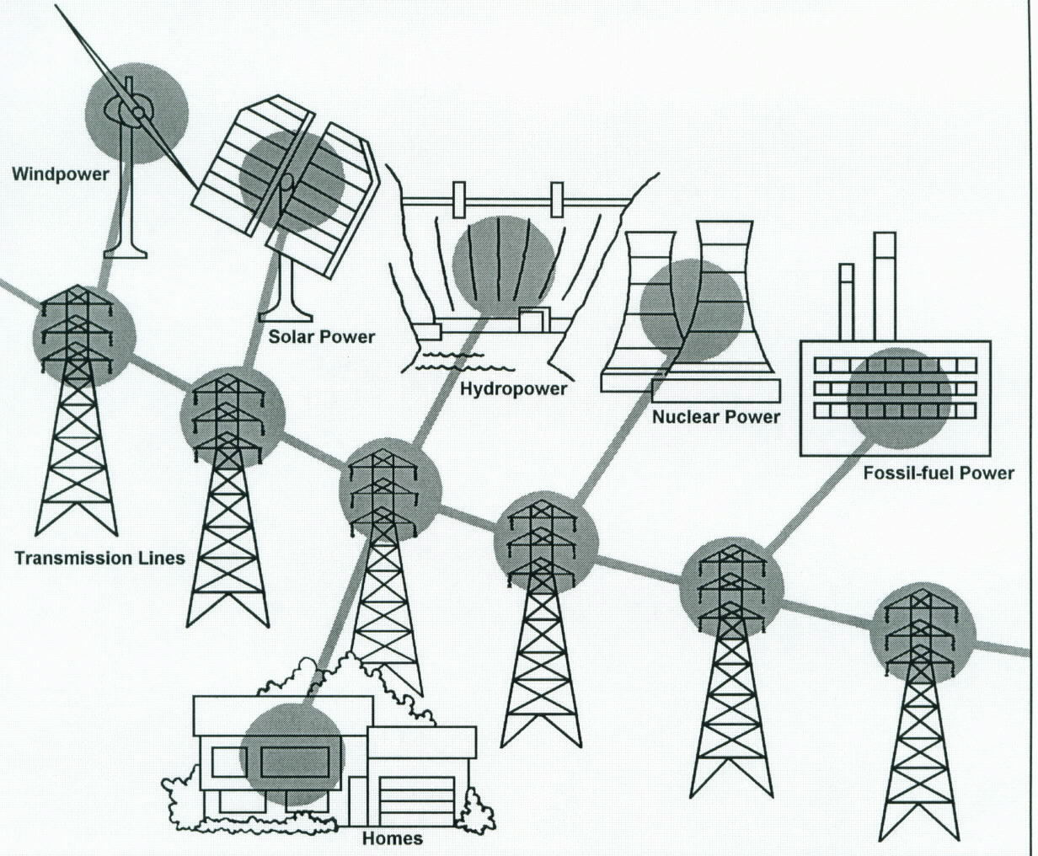

Grid System

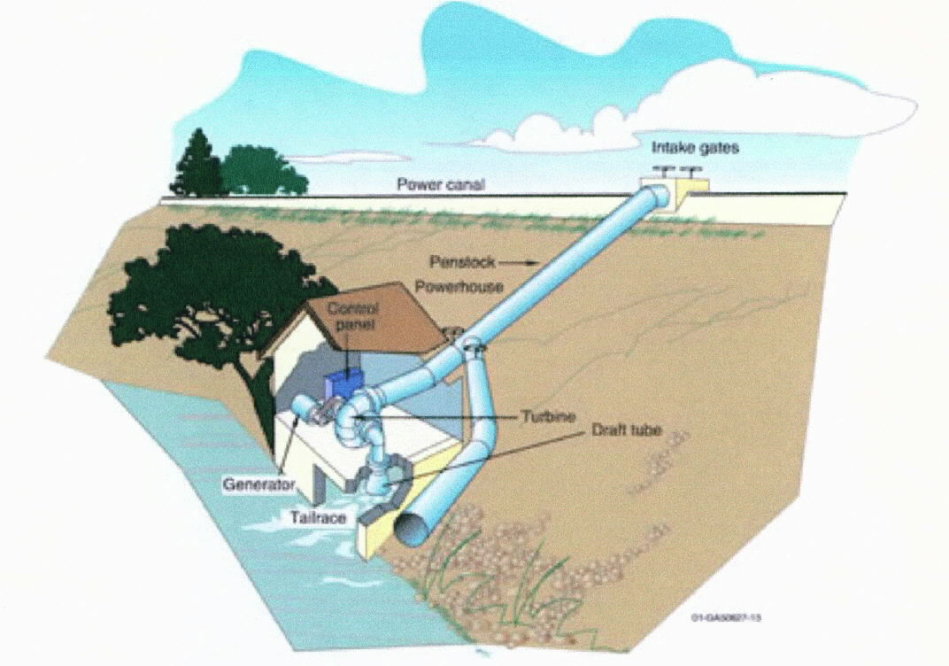

Micro Hydropower

**See** [**https://www.learningctronline.com/courses**](https://www.learningctronline.com/courses) **for Materials and Resources.**

**Topics:**

1. Hydropower

**Objectives:**

* + Gain a general knowledge of energy, energy resources, and energy conservation.
  + Understand and define the terminology associated with hydropower and electrical production.
  + Draw and label the water cycle.
  + Understand the source, advantages and disadvantages of hydropower as a renewable resource.
  + Draw and label components of a hydroelectric power plant (dam) whether large scale or small scale.
  + Explain practical application of hydropower especially related to electrical production and usage.

TAKE NOTE [1 week]

1. Energy Survey
2. Hydropower Worksheet from Reference Material
3. Grid System Worksheet from PowerPoint
4. Lab: Electrical Generation
5. Film Review “Building Hoover Dam”
6. Quiz Hydropower
7. Week 22 Devotional (<https://www.learningctronline.com/devotional>)

**Text**:

**Reference Material: Grid System PowerPoint & Reference Material**

**Homework**:

* Energy Survey
* Hydropower Reference Material Worksheet
* Grid System Worksheet from PowerPoint

**Lab**: Electrical Generation

* Complete the Electrical Generation worksheet provided.
* Save the document into your LAB folder in the Projects in Science folder on your desktop.

**Lab**: Film Review

* Watch the movie “The Building of Hoover Dam” using the video link:

The Building of Hoover Dam <http://somup.com/c0lt3CkDSO> (29:36)

* + Complete the **“Building of Hoover Dam”** film review provided.
* Save the document into your LAB folder in the Projects in Science folder on your desktop.

**TEST:** Hydropower Quiz

1) the academic integrity policy

* Tests must be completed **WITHOUT** referring to books, notes, the internet, people, or any outside resources.
* Students **MAY** use the approved Periodic Tables, approved Reference Tables, or approved equation (formula) sheet (provided by the teacher) along with calculators and scratch paper.
* A guardian should be proctoring the test. Proctoring means to monitor the following:

2) Take the **"in one sitting"**, meaning that once you start the test, you must complete it without interruption.

3) There is a **30-minute time limit** on this test. Please have the proctor write the time taken at the top of your answer sheet with their signature or initials.

4) Proctors should NOT be reading the test or engaging students during the test.

5) Do NOT use RED font. Black font is best.

Supplemental Resources (Optional)

1. Vocabulary Crossword Hydropower

The Building of Hoover Dam <http://somup.com/c0lt3CkDSO> (29:36)