**Electric Utility Net Generation of Electricity  
(Based on year 2000 total kilowatt-hours generation)**

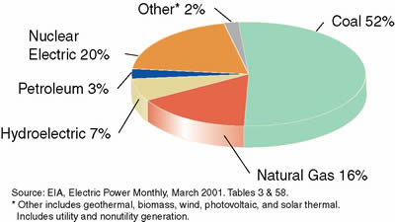

**Electric Utility Net Generation by Renewables  
(Based on year 2000 total kilowatt-hours generation)**

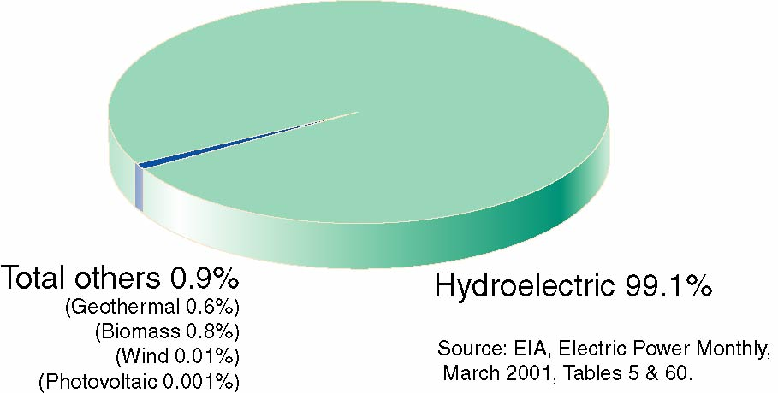

Time Line for Hydroelectric Power

**B.C. ,** Used by the Greeks to turn water wheels for grinding wheat into flour, more than 2,000 years ago.

**1775,** U.S. Army Corps of Engineers founded, with establishment of Chief Engineer for the Continental Army.

**1880,** Michigan's Grand Rapids Electric Light and Power Company, generating electricity by dynamo, belted to a water turbine at the Wolverine Chair Factory, lit up 16 brush-arc lamps.

**1881,**  Niagara Falls, city street lamps powered by hydropower.

**1886,** about 45 water-powered electric plants in the U.S. and Canada.

**1887,** San Bernardino, Ca., first hydroelectric plant in the west.

**1889,** 200 electric plants in the U.S. use waterpower for some or all generation.

**1901,** first Federal Water Power Act.

**1902,** Bureau of Reclamation established.

**1907,** 15% of electric generating capacity in U.S. was provided by hydropower.

**By 1920,** 25% of U.S. electrical generation was by hydropower. **1920,** Federal Power Act establishes Federal Power Commission authority to issue licenses for hydrodevelopment on public lands.

**1933,** Tennessee Valley Authority established.

**1935,** Federal Power Commission authority extended to all hydroelectric projects built by utilities engaged in interstate commerce.

**1937,** Bonneville Dam, first Federal dam, begins operation on the Columbia River.

**1937,** Bonneville Power Administration established.

**By 1940,** 40% of electrical generation was hydropower.

**Between 1921 and 1940,** conventional capacity in the U.S. tripled; almost tripled again between 1940 and 1980.

**Currently,** about 7% of U.S. electricity comes from hydropower. Today, there is about 80,000 MW of conventional capacity and 18,000 MW of pumped storage.

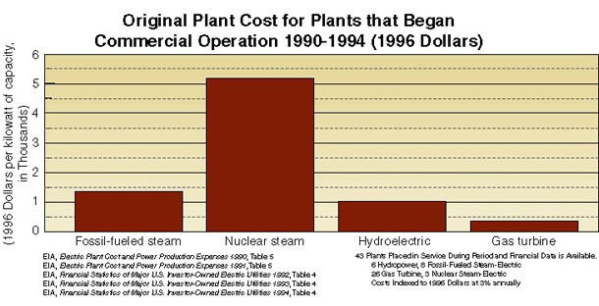

**Production Expenses Graph**

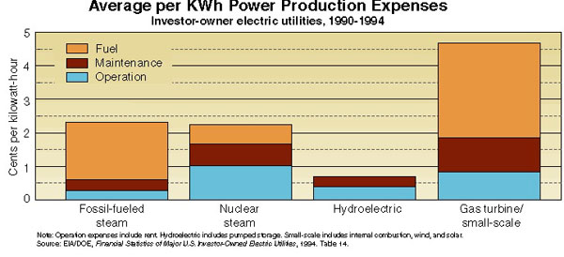

**U.S. Technology**

**Capital cost $/kW:**  $1700-2300/kW cap. **Operating life:** 50+ years

**Operation cost/kWh:** 4.05 mills (0.4¢) **Capacity factor:** 40-50%

**Maintenance cost/kWh:** 2.62 mills(0.3¢) **Average size:** 31 MW

**Total cost/kWh:** 23.57 mills (2.4¢)

**Impoundment Hydropower -** uses a dam to store water.Water may be released either to meet changing electricity needs or to maintain a constant water level.

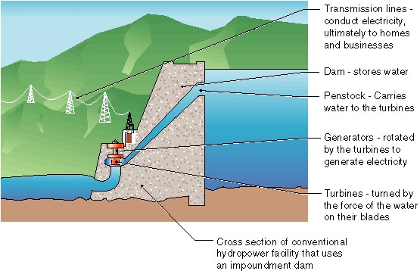

**Run-of-River Projects -** utilize the flow of water within the natural range of the river, requiring little or no impoundment. Run-of-river plants can be designed using large flow rates with low head or small flow rates with high head. In the following photo, the run-of-river structure at Idaho Falls, Idaho is visible behind the foliage. It features a large flow rate with a low head (low height of diversion structure).

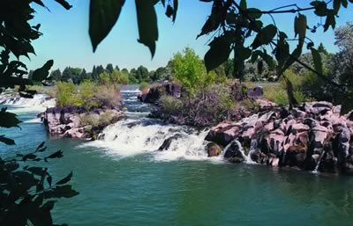

**Micro-hydropower Projects -** produce 100 kilowatts (kW) or less. Micro-hydro plants can utilize low heads or high heads.

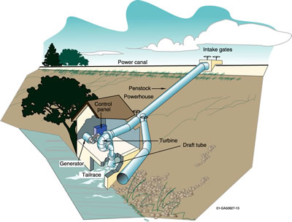

**Diversion Hydropower -** channels a portion of the river through a canal or penstock, but may require a dam. The project below, The [Tazimina project](http://hydropower.inel.gov/indian/indian.htm#taz) (Alaska), did not require a dam.

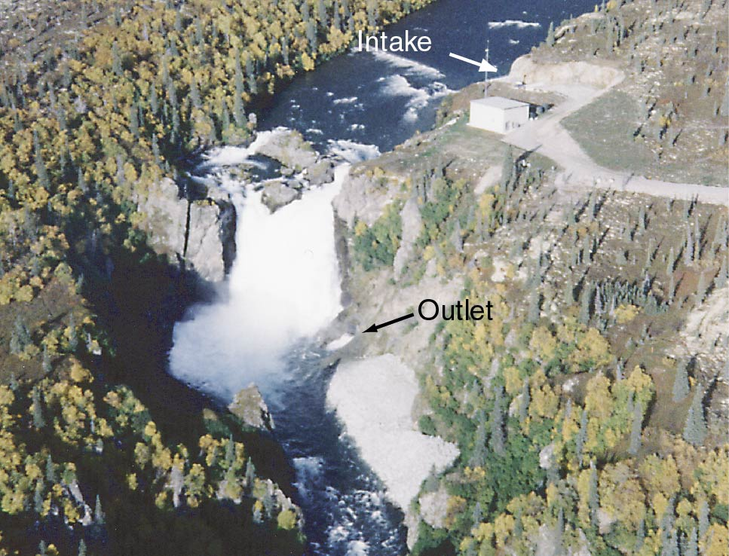

|  |
| --- |
| Primary Purpose or Benefit of U.S. Dams |

|  |  |
| --- | --- |
|  |  |
|  |

|  |  |
| --- | --- |
| How Hydropower Works **The hydrologic cycle:** Water constantly moves through a vast global cycle, in which it evaporates from lakes and oceans, forms clouds, precipitates as rain or snow, then flows back to the ocean. The energy of this water cycle, which is driven by the sun, is tapped most efficiently with hydropower. |  |
| **Description of the Technology**  Hydropower plants capture the kinetic energy of falling water to generate electricity. A turbine and a generator convert the energy from the water to mechanical and then electrical energy. The turbines and generators are installed either in or adjacent to dams, or use pipelines (penstocks) to carry the pressured water below the dam or diversion structure to the powerhouse. Hydropower projects are generally operated in a run-of-river, peaking, or storage mode.  Run-of-river projects use the natural flow of the river and produce relatively little change in the stream channel and stream flow. A peaking project impounds and releases water when the energy is needed. A storage project extensively impounds and stores water during high-flow periods to augment the water available during low-flow periods, allowing the flow releases and power production to be more constant. Many projects combine the modes. The power capacity of a hydropower plant is primarily the function of two variables: (1) flow rate expressed in cubic feet per second (ft3/s), and (2) the hydraulic head, which is the elevation difference the water falls in passing through the plant. Project design may concentrate on either of these variables or both. | |

**Most conventional hydropower plants include six major components (see graphic below):**

1. Dam. Controls the flow of water and increases the elevation to create the head. The reservoir that is formed is, in effect, stored energy.

2. Penstock. Carries water from the reservoir to the turbine in a power plant.

3. Turbine. Turned by the force of water pushing against its blades.

4. Generator. Connects to the turbine and rotates to produce the electrical energy.

5. Transformer. Converts electricity from the generator to usable voltage levels.

6. Transmission lines. Conduct electricity from the hydropower plant to the electric distribution system.



The principal **advantages** of using hydropower are its large renewable domestic resource base, the absence of polluting emissions during operation, its capability in some cases to respond quickly to utility load demands, and its very low operating costs. **Disadvantages** can include high initial capital cost and potential site-specific and cumulative environmental impacts. Potential environmental impacts of hydropower projects include altered flow regimes below storage reservoirs or within diverted stream reaches, water quality degradation, mortality of fish that pass through hydroelectric turbines, blockage of upstream fish migration, and flooding of terrestrial ecosystems by new impoundments. However, in many cases, proper design and operation of hydropower projects can mitigate these impacts. Hydroelectric projects also include beneficial effects such as recreation in reservoirs or in tail waters below dams.

Hydropower technology can be categorized into two types: **conventional** and **pumped storage**. **Conventional hydropower plants** use the available water energy from a river, stream, canal system, or reservoir to produce electrical energy. In conventional multipurpose reservoirs and run-of-river systems, hydropower production is just one of many competing purposes for which the water resources may be used. Competing water uses include irrigation, flood control, navigation, and municipal and industrial water supply. **Pumped storage plants** pump the water resource, usually through a reversible turbine, from a lower reservoir to an upper reservoir. While pumped storage facilities are net energy consumers, they are valued by a utility because they can be rapidly brought on-line to operate in a peak power production mode. The pumping to replenish the upper reservoir is performed during off-peak hours when electricity costs are lowest. This process benefits the utility by increasing the load factor and reducing the cycling of its base load units. In most cases, pumped storage plants run a full cycle every 24 hours.

**Applications and Uses of the Technology**

The major application for **hydropower** energy is in the bulk power market, where it **accounts for** about 77,000 MW conventional capacity and 18,000 MW of pumped storage capacity, or **about 10% of the electric generating capacity in the United States**. Plants are owned by Federal and state agencies, cities, metropolitan water districts, irrigation companies, and public and independent utilities. Individual persons also own small plants at remote sites for their own energy needs and for sale to utilities under the Public Regulatory Policies Act (PURPA). Hydropower is an essential contributor in the national power grid because of its ability to respond in seconds to large and rapidly varying loads, which other base load plants with steam systems powered by combustion or nuclear processes cannot accommodate.

**There are several favorable features of hydropower**

Anywhere rain falls, there will be rivers. If a particular section of river has the right terrain to form a reservoir, it may be suitable for dam construction. No fossil fuels are required to produce the electricity, and the earth's hydrologic cycle naturally replenishes the "fuel" supply. Therefore no pollution is released into the atmosphere and no waste that requires special containment is produced. Since "water is a naturally recurring domestic product and is not subject to the whims of foreign suppliers," there is no worry of unstable prices, transportation issues, production strikes, or other national security issues.

**Hydropower is very convenient** because it can respond quickly to fluctuations in demand. A dam's gates can be opened or closed on command, depending on daily use or gradual economic growth in the community. The production of hydroelectricity is often slowed in the nighttime when people use less energy. When a facility is functioning, no water is wasted or released in an altered state; it simply returns unharmed to continue the hydrologic cycle. The reservoir of water resulting from dam construction, which is essentially stored energy, can support fisheries and preserves, and provide various forms of water-based recreation for locals and tourists. Land owned by the hydroelectric company is often open to the public for hiking, hunting, and skiing. Therefore, "hydropower reservoirs contribute to local economies. A study of one medium-sized hydropower project in Wisconsin showed that the recreational value to residents and visitors exceeded $6.5 million annually." Not to mention the economic stimulation provided by employment.

**Hydroelectric power is also very efficient and inexpensive**

**Hydropower may be better on the environment than fossil-fuel sources, but its future is so uncertain that we may need to focus on other alternatives.**

"Modern hydro turbines can convert as much as 90% of the available energy into electricity. The best fossil fuel plants are only about 50% efficient. In the US, hydropower is produced for an average of 0.7 cents per kilowatt-hour (kWh). This is about one-third the cost of using fossil fuel or nuclear and one-sixth the cost of using natural gas," as long as the costs for removing the dam and the silt it traps are not included. Efficiency could be further increased by refurbishing hydroelectric equipment. An improvement of only 1% would supply electricity to an additional 300,000 households.

**Hydropower has become the leading source of renewable energy**

It provides more than 97% of all electricity generated by renewable sources worldwide. Other sources including solar, geothermal, wind, and biomass account for less than 3% of renewable electricity production." In the US, 81% of the electricity produced by renewable sources comes from hydropower. "Worldwide, about 20% of all electricity is generated by hydropower." Some regions depend on it more than others. For example, 75% of the electricity produced in New Zealand and over 99% of the electricity produced in Norway come from hydropower.

**The use of hydropower** "**prevents** the burning of 22 billion gallons of oil or 120 million tons of coal each year." In other words, "the carbon emissions avoided by the nation's hydroelectric industry are the equivalent of an additional 67 million passenger cars on the road—50 percent more than there are currently." The advantages of hydropower are therefore convincing, but there are some serious drawbacks that are causing people to reconsider its overall benefit.

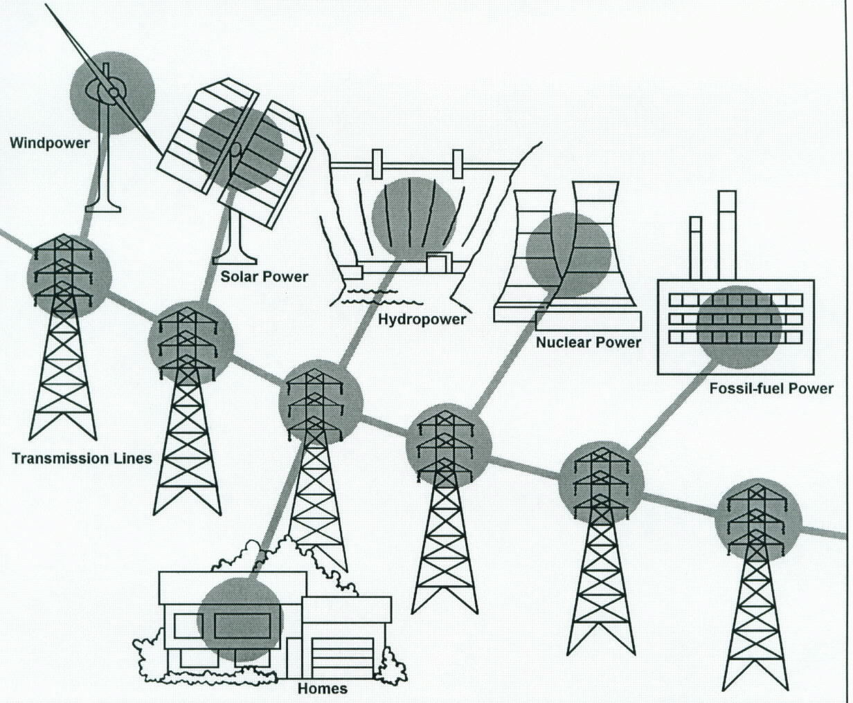

The area where you live and its energy resources are prime factors in determining what kind of power you use. For example, in Washington State hydroelectric power plants provided approximately 80 percent of the electrical power during 1996. In contrast, in Ohio during the same year, 90 percent of the electrical power came from coal-fired power plants due to the area’s ample supply of coal.

Electrical utilities range from large systems serving broad regional areas to small power companies serving individual communities. Most electric utilities are investor-owned (private) power companies. Others are owned by towns, cities, and rural electric associations. Surplus power produced at facilities owned by the Federal Government is marketed to preference power customers (A customer given preference by law in the purchase of federally generated electrical energy which is generally an entity which is nonprofit and publicly financed.) by the Department of Energy through its power marketing administrations.

**Peaking with Hydropower**

Demands for power vary greatly during the day and night. These demands vary considerably from season to season, as well. For example, the highest peaks are usually found during the summer daylight hours when air conditioners are running.

Nuclear and fossil fuel plants are not efficient for producing power for the short periods of increased demand during peak periods. Their operational requirements and their long startup times make them more efficient for meeting baseload needs.

Since hydroelectric generators can be started or stopped almost instantly, hydropower is more responsive than most other energy sources for meeting peak demands. Water can be stored overnight in a reservoir until needed during the day, and then released through turbines to generate power to help supply the peakload demand. This mixing of power sources offers a utility company the flexibility to operate steam plants most efficiently as base plants while meeting peak needs with the help of hydropower. This technique can help ensure reliable supplies and may help eliminate brownouts and blackouts caused by partial or total power failures.

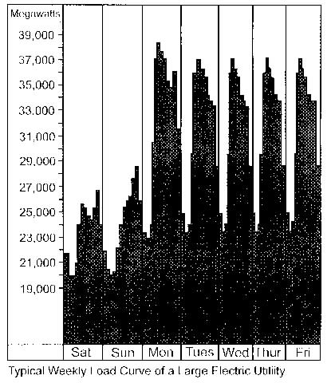

Today, may of Reclamation’s 58 power plants are used to meet peak electrical energy demands, rather than operating around the clock to meet the total daily demand. Increasing use of other energy-producing power plants in the future will not make hydroelectric power plants obsolete or unnecessary. On the contrary, hydropower can be even more important. While nuclear or fossil-fuel power plants can provide baseloads, hydroelectric power plants can deal more economically with varying peakload demands. This is a job they are well suited for.

**Pumped Storage**

During the Night, water is pumped from the base of the dam to the reservoir or storage pool as “stored” energy.



Like peaking, pumped storage is a method of keeping water in reserve for peak period power demands. Pumped storage is water pumped to a storage pool above the power plant at a time when customer demand for energy is low, such as during the middle of the night. The water is then allowed to flow back through the turbine-generators at times when demand is high and a heavy load is placed on the system.

During the day, water is allowed to flow from the reservoir or storage pool through the penstock, turbine and generator to produce electricity/energy.



The reservoir acts much like a battery, storing power in the form of water when demands are low and producing maximum power during daily and seasonal peak periods. An advantage of pumped storage is that hydroelectric generating units are able to start up quickly and make rapid adjustments in output. They operate efficiently when used for one hour or several hours.

Because pumped storage reservoirs are relatively small, construction costs are generally low compared with conventional hydropower facilities.

Pumped Storage

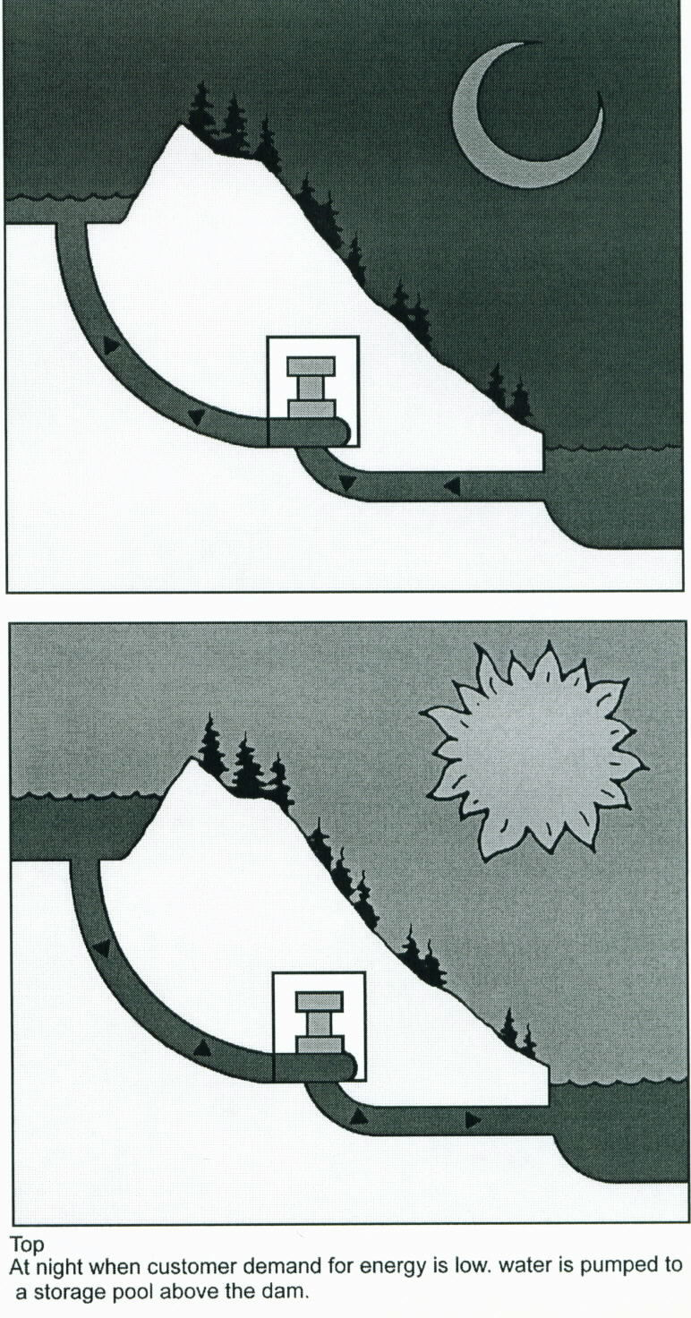

Vast networks of transmission lines and facilities are used to bring electricity to us in a form we can use. All the electricity made at a power plant comes first through transformers which raise the voltage so it can travel long distances through power lines. (Voltage is the pressure that forces an electric current through a wire.) At local substations, transformers reduce the voltage so electricity can be divided up and directed throughout an area.

Transformers on poles (or buried underground, in some neighborhoods) further reduce the electric power to the right voltage for appliances and use in the home. When electricity gets to our homes, we buy it by the kilowatt-hour, and a meter measures how much we use.

While hydroelectric power plants are one source of electricity, other sources include power plants that burn fossil fuels or split atoms to create steam, which in turn is used to generate power. Gas-turbine, solar, geothermal, and wind-powered systems are other sources. All these power plants may use the same system of transmission lines and stations in an area to bring power to you. By use of this “**power grid**,” electricity can be interchanged among several utility systems to meet varying demands. So the electricity lighting your reading lamp now may be from a hydroelectric power plant, a wind generator, a nuclear facility, or a coal, gas, or oil-fired power plant …. Or a combination of these.

