Heading

Title

**Introduction**

**Purpose** To investigate the process of seed germination.

**Discussion**

Seeds are a unique structure in many plants. After fertilization occurs, the ovary (female reproductive structure) develops into a Fruit, and the ovule becomes a Seed. A Seed is an embryo of a plant that is encased in a Seed Coat (protective covering) and surrounded by Endosperm (food supply). An Embryo is an organism in its early stage of development.

Fruit is the mature ovary that contains the seeds. Many different kinds of fruit. Its purpose is to help spread seeds.

In order for germination to occur, plants need: proper moisture, proper temperature, and proper oxygen. Most seeds do not require light for germination. Once proper environmental conditions have been met, the following general steps happen:

1. Water must soften the seed coat and penetrate into the seed.
2. Water hydrates the embryo and enzymes are activated that make the endosperm nutrients available to the growing embryo.
3. Seed grows a root to access water and nutrients underground.
4. Seed grows shoots that grow towards the sun.
5. Seed leaves (Cotyledons) emerge from the seed and begin to perform photosynthesis.

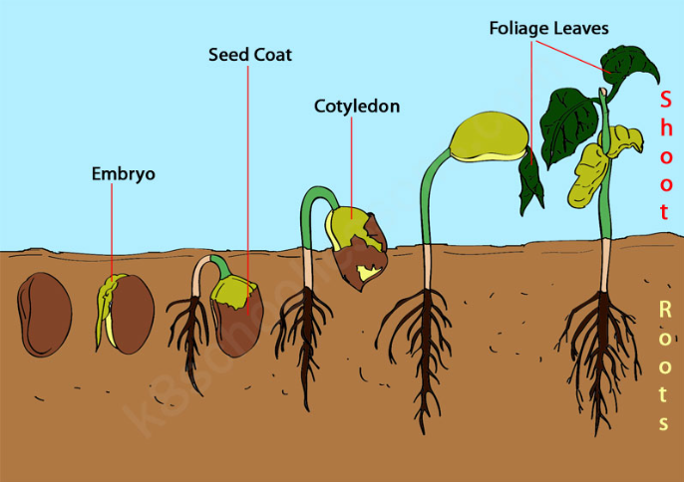

**Hypothesis**

If a seed is given proper sunlight, moisture, temperature and oxygen, then, it will germinate into a plant and the stages of germination can be observed sequentially.

**Materials** Egg carton Lettuce or Turnip Seeds Potting Soil

**Procedures & Calculations and Data**

1. Obtain an egg carton (normally 12 eggs would have been in the carton) without any eggs. Remove the top half and keep the bottom half (that holds the eggs).

2. Add potting soil to each “egg cup” in the egg carton to about ¾ level.

3. Add one to a few seeds to each sub-container. Ideally, one seed is best, but they tend to be small so it is okay to add a few seeds.

4. CAREFULLY, add a sprinkle of water to 10 of the 12 “egg cups”. Do NOT over water.

5. Place the egg carton on a window sill that receives sunlight.

6. Each day you will observe the seed growth in TWO bays (out of the 10 watered bays) of the egg carton until the seed has fully germinated. Leave the 2 unwatered bays until the end. Discard that soil and plant once you take a picture.

7. The goal is to observe each stage of germination as presented in the discussion section. Taking a picture of each stage.

8. Gently water every day at the same time. Do NOT water the two bays that were not watered before.

**Calculations and Data**

1. Complete the table, indicating what day each stage of germination was observed.

|  |  |  |  |  |  |
| --- | --- | --- | --- | --- | --- |
|  | Embryo | Root | Shoot | Cotyledon | Leaves |
| DAY |  |  |  |  |  |

2. Insert images for each of the germination stages. Be sure to label the DAY (*time elapsed since planting the seed*) and the stage of germination (*see chart above*).

**Conclusions and Questions**

1. Based on your results, was temperature an issue related to seed germination? Explain.

2. What conditions are important to seed germination?

3. Was there any difference in germination in the two bays that were not watered? How many stages of germination were observed?