Early Models of the Atom

D_____

* Greek philosopher (460 – 370 BC) Coined the term “Atom”
* “Matter consists of discrete, _____ particles”.
* Democritus held a very general theory with _____ experimental evidence.
* Democritus’ ideas were rejected by Plato & Aristotle (*fathers of philosophy and ancient “scientific thinking”*) … & therefore, set aside.

D_____’s Atomic Theory (1808)

1. All _____ are composed of extremely small, _____ particles called "_____."

2. All atoms of the same element have the same _____ properties. Atoms of different elements have different properties.

3. In the course of an ordinary chemical reaction, no atom of one element disappears or is changed into an atom of another element.

4. _____ are formed when atoms are joined together in simple, _____ -number _____ (*Law of “Multiple Proportions”)*.

Dalton’s Work - Forming Tin oxides

* Discovered that tin reacts with a _____ _____ of oxygen
* 100 g tin reacts with 27 g (SnO) or 13.5 g oxygen (SnO2) … [definite proportions]
* Oxygen is always consumed in a 1:2 ratio _____ the compounds (multiple proportions).
* Each tin atom can combine with one or two oxygen atoms. The atoms _____ combine in any other ratios.

The Law of _____ Of _____

* _____ cannot be created nor destroyed.
* There is _____ detectable change in _____ in an ordinary chemical reaction.
* All compounds/elements that react are just _____ their atoms.

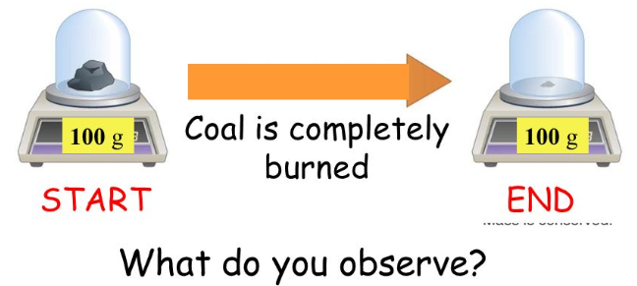

Acrylic Tape (2 charges exist)

* In the first case you should have noticed “_____”
* In the second case, “_____”

Historical Overview

Benjamin Franklin

* Learned from experiments with thunderstorms, that lightning is a flow of _____ energy through the atmosphere.
* He arbitrarily decided that there must be “_____” … and called them charge “A” and charge “B”

E_____

* A _____ ray can also be deflected by a magnet.
* In 1897, JJ Thomson got the same result as _____ with any gas he used, which _____ Dalton’s assumption that all atoms are indivisible.
* He theorized the existence of a particle common to all atoms 🡪 using the charged plates on either side of the tube, he showed the particle was _____ charged.

The _____ _____ Model

* Thomson's _____ led to the proposal of a new atomic model, the plum pudding model.
* _____ floating in a _____ of positive charges
* Modification of Dalton’s model of a solid, _____ sphere
* Recognition of the existence of _____ and the _____ of the whole atom

_____’s Oil Drop Experiment

* Millikan repeatedly measured _____ between the _____ and _____ charged plates and found that they were always a multiple of 1.60 x 10-19 coulomb.
* Millikan called this the _____ on the electron.

Millikan’s Oil Drop Experiment

* Measured rate of fall of charged oil droplets
* Determined the _____ on an _____

Thomson’s experiment: mass-to-charge ratio for an electron

Together, Millikan’s and Thomson’s results allowed for the determination of the _____ and _____ of the _____.

Testing the Plum Pudding Model

* Ernest _____ developed an experiment to test the plum pudding model of JJ Thomson.
  + He shot _____ particles (+) at a thin sheet of gold foil.
  + _____ particles are detected at various angles.
* Rutherford’s Results: Discovery of the _____
  + _____ particles pass straight through gold foil (99%)
  + A _____ particles _____ at very large angles ???

Conclusions:

* Atom: mostly _____ space
* _____ charge is concentrated in small, _____ region (_____)
* Volume of nucleus: _____; mass: l_____ arge

Led to the Initial *Planetary* Model of the Atom 🡪 Dense, _____ nucleus of atom _____ by _____.

P_____

* In 1886, Eugen _____ (1850–1930) observed a cathode-ray tube to discover a new particle.
* Protons were originally called “_____ rays” in the CRT, electrons were called “cathode rays”
* “Canal Rays” responded _____ to the “cathode rays” (electrons) indicating an opposite _____.

N_____

* Physicist James _____ (1891–1974) confirmed the existence of yet another subatomic particle: the neutron.
  + Chadwick bombarded Beryllium with alpha particles and found a new particle was released
  + _____ charge (*did not deflect under electric or magnetic field influence*)
  + Essentially the same _____ as the _____
  + Highly penetrable particle (*could penetrate 10-20 cm into lead*)

A_____ M_____ Unit

* The atomic mass unit is the unit used to express the _____ of an _____.
* One-twelfth the mass of a _____ atom
* Corresponds to 1.660538921 × 10−24 g

The Atom

* Atom is the _____ particle of an _____ that has the same _____ as the element.
* The atom can be divided into two parts:
  + _____: _____ portion of the atom
  + _____: Regions _____ the nucleus
* The atom is made of _____ particles: _____, _____, and _____.
  + Protons are _____ charged.
  + Electrons are _____ charged.
  + Neutrons are _____ charged.

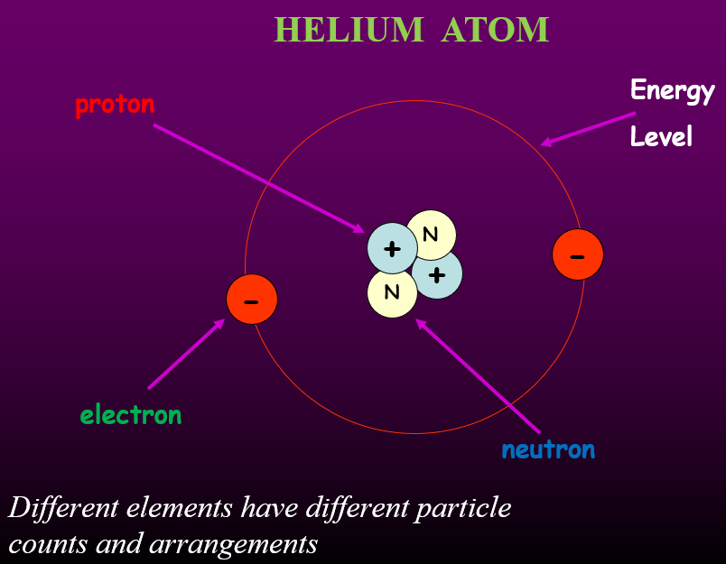

What is the structure of the atom?

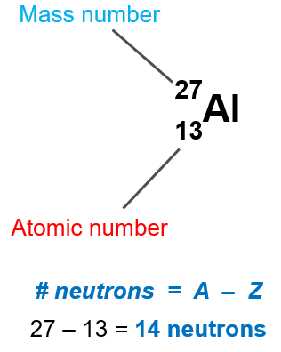

Atomic _____ (*Z*)

* Number of _____ in an atom
* _____ for each element
* Every atom of a given element has the _____ atomic number, and atomic number can be used to _____ an element.

_____ number (A)

* Total number of _____ + _____
* Usually varies from atom to atom
* Aluminum-27

Al-27

27Al

* All atoms of an element have the _____ atomic number, but atoms of the same element can have _____ mass numbers.

N_____ Symbols  
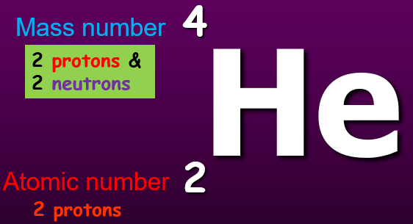

In a neutral atom, the number of _____ = the number of _____.

Isotopes

* _____ are atoms that have the same number of _____ but different numbers of _____. Therefore, they have the same _____ properties.

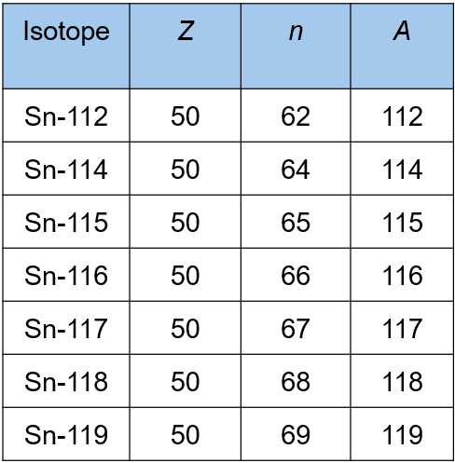

* Neon-20, neon-21, and neon 22 are _____ of neon.

Isotopes of Neutral Atoms

* Atoms of the same _____ with different _____ numbers.
  + Number of _____ are the same
  + Number of _____ are the same
  + Number of _____ are different

Atomic Mass

* An atomic mass unit (_____) is defined as one-twelfth of the mass of a _____ -12 atom.
* The _____ of carbon has been assigned a mass of exactly ___ atomic mass units: 6C12.
* In nature, most elements occur as a _____ of two or more isotopes.
* Each isotope of an element has a fixed _____ and a natural _____ abundance.
* Chlorine exists as chlorine-35 and chlorine-37.
  + Chlorine’s atomic mass on the Periodic Table is 35.453 amu. (*Notice is it not exactly in-between.*)
  + Which isotope is more abundant?
  + In nature there is _____ Cl-35 than _____ Cl-37, therefore, the atomic mass of chlorine, _____ amu, is closer to _____ than to 37.

Calculating Average Atomic Mass

* The average atomic mass is the weighted _____ mass of all _____ of an _____.

Average Atomic Mass

* Abundance of silicon isotopes:
* 92.2297% is from Si-28
* 4.6832% is from Si-29
* 3.0872% is from Si-30
* How do you arrive at a mass of 28.09?
* The weighted average mass reflects both the _____ and the _____ _____ **(%)** of the _____ as they occur in nature.
* _____ the mass of each isotope by its natural abundance and _____ the products.

_____ % (___) + _____ % (___) + _____ % (___) = _____ amu

OR

_____ (___) + _____ (___) + _____ (___) = 28.09 amu

25.82 + 1.36 + 0.93