Heading

Title

**Introduction**

**Purpose**

To identify and describe organisms according to the six-kingdom classification system.

**Discussion**

Classification of living organisms became a science because of the innate need for order and organization. New organisms can be added more easily, and it eliminated the problem of communication between scientists of the same country, different countries, language, culture, etc. To study the diversity of life, biologists use a classification system to name organisms and group them in a logical manner.

Taxonomy is the branch of biology that classifies organisms and assigns each organism a universally accepted name. Scientists use binomial nomenclature, the two**-**name naming system (Genus and species).

The basis of classification is mainly based on two factors: homologous structures and biochemical similarities. Homologous structures include appendages – arms/wings, legs, antennae; organs – heart, brain, lungs; and tissues – nervous, muscle, blood vessels. Biochemical similarities include proteins, carbohydrates, water, DNA, RNA, etc.

Classification involves the establishment of categories from general (broad) to specific (narrow). In particular, the most general categories are domain, kingdom, phylum, class, order, and family. The most specific categories are genus, species, and variety.

Viruses are in a class by themselves as they are technically non-living. All viruses are parasites that harm their host and all viruses require a host to function. Although they can live in a dormant state indefinitely. Viruses are extremely small. Most can be seen only with an electron microscope. A virus is active only when inside a living cell.

The anatomy of a virus:

* 1. Envelope: lipid bilayer derived from host membrane when virus is formed.
  2. Capsid: protein coat that protects the nucleic acid.
  3. Have a nucleic acid core containing either DNA or RNA.

Some viruses replicate themselves immediately, killing the host cell (Lytic). Other viruses replicate themselves in a way that does not destroy the host cell (Lysogenic).

The smallest subviral particles are viroids (circular RNA without protein coat) and prions (misfolded proteins without DNA or RNA). These are harmful within living cells.

**Materials** Worksheet

**Procedures**

Complete the chart related to the six-kingdom classification system.

a. Use the example provided and characteristics as clues to identify each organism.

b. Add to the characteristic column at least one major descriptor.

**Calculations and Data**

|  |  |  |
| --- | --- | --- |
| Kingdom | Example | Characteristics |
|  |  | 1. Strong cell walls 2. no nuclear membrane |
|  |  | 1. Live in extreme environments 2. Anaerobic |
|  |  | 1. Nuclear membrane 2. Lacks complex organ system |
|  |  | 1. Heterotrophic 2. Lacks complex organs |
|  |  | 1. Autotrophic 2. multicellular |
|  |  | 1. Heterotrophic 2. multicellular |

**Conclusion Questions**

1. What broad characteristics do biologist use to group living things into kingdom?

2. Not too long ago, archaebacteria and eubacteria belonged to the same kingdom, Monera. Their appearance is similar – both have similar shapes, are unicellular, and have no nuclear membrane. Explain why biologist may have decided to divide the kingdom into two.

3. Fill in the blanks:

_____ is the classification of living things. _____ classified all organisms as plants or animals. Plants were grouped according to the type of stem they had and animals according to where they lived. The father of modern classification was _____. _____ _____ is used to identify and classify all living organisms based on Latin and a 2-word naming.

4. List the taxonomical sequence in the correct order from general to specific: class, family, genus, kingdom, phylum, order, species.

5. Using the classification system, classify each of the following using the key provided

##### P = Protista F = Fungi

B = Bacteria V = Virus

__ a. Prokaryote cells

__ b. Not made of cells

__ c. Can be animal like or plant like

__ d. Can be multi-cellular and decomposers in communities

__ e. Are all unicellular decomposers in communities

Questions 6 -13 on next page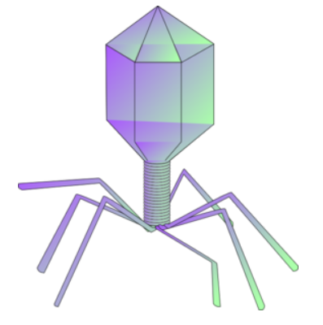

6. A virus consists of

a. RNA or DNA and a cell membrane

b. RNA or DNA and a protein coat

c. RNA and DNA and a protein coat

d. proteins, cell membrane and RNA

7. How do viruses reproduce?

a. divide by mitosis c. sexually, by external fertilization

b. replication outside the host d. inserting DNA into the host cell

8. Retroviruses are DIFFERENT than viruses in that

a. they have RNA instead of DNA c. they are symmetrical

b. they can become dormant d. all of the choices

9. What happens after the virus has been taken up by the cell?

a. it begins making protein c. it inserts into the host DNA

b. it divides d. it switches to infectious mode

10. Which of the following is **NOT** true regarding viruses, prions, and viroids?

a. extremely small c. infectious

b. living d. can be harmful

**Matching**

___ 11. Involves DNA or RNA A. prion

___ 12. Involves RNA only B. viroid

___ 13. Involves bits of protein C. virus