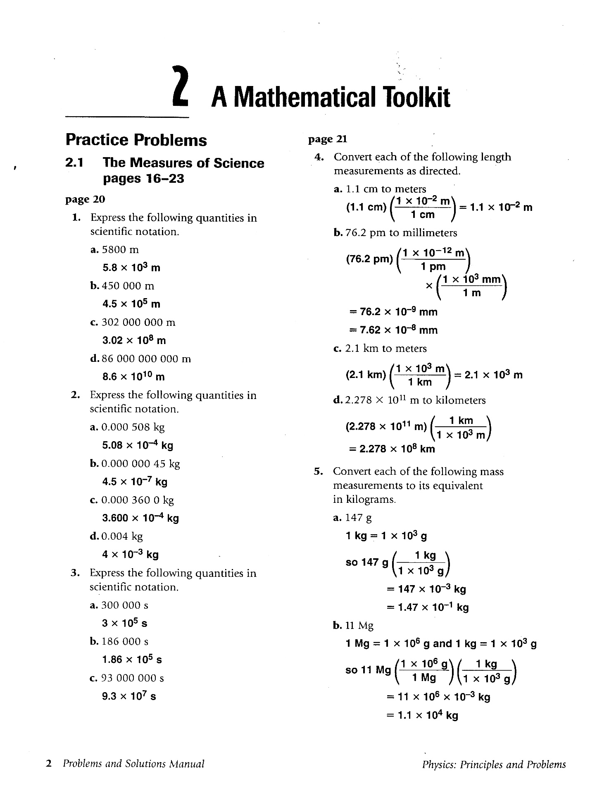

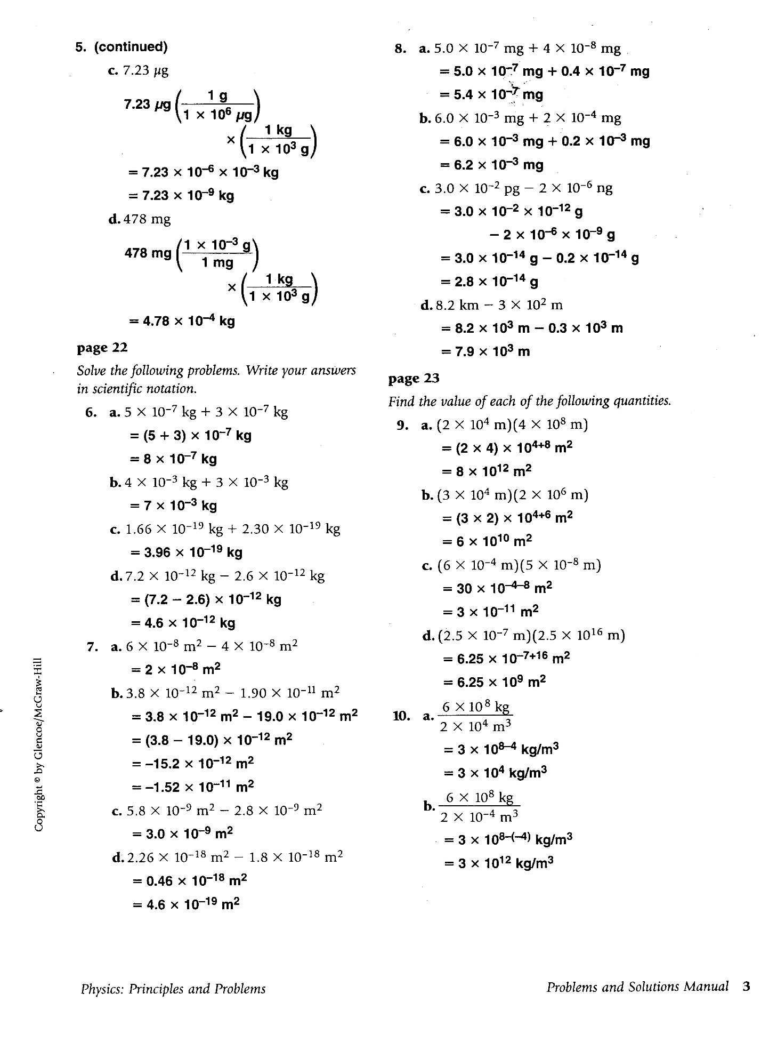

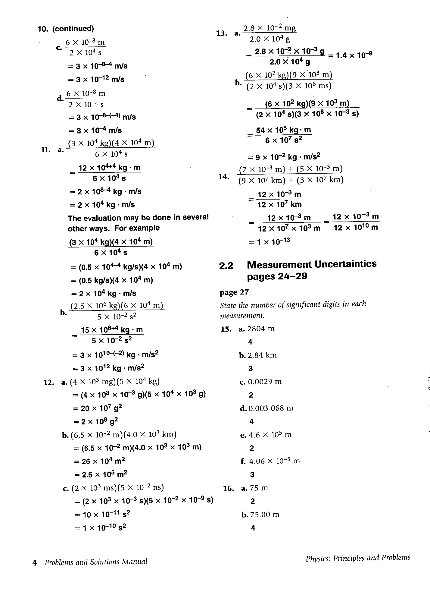

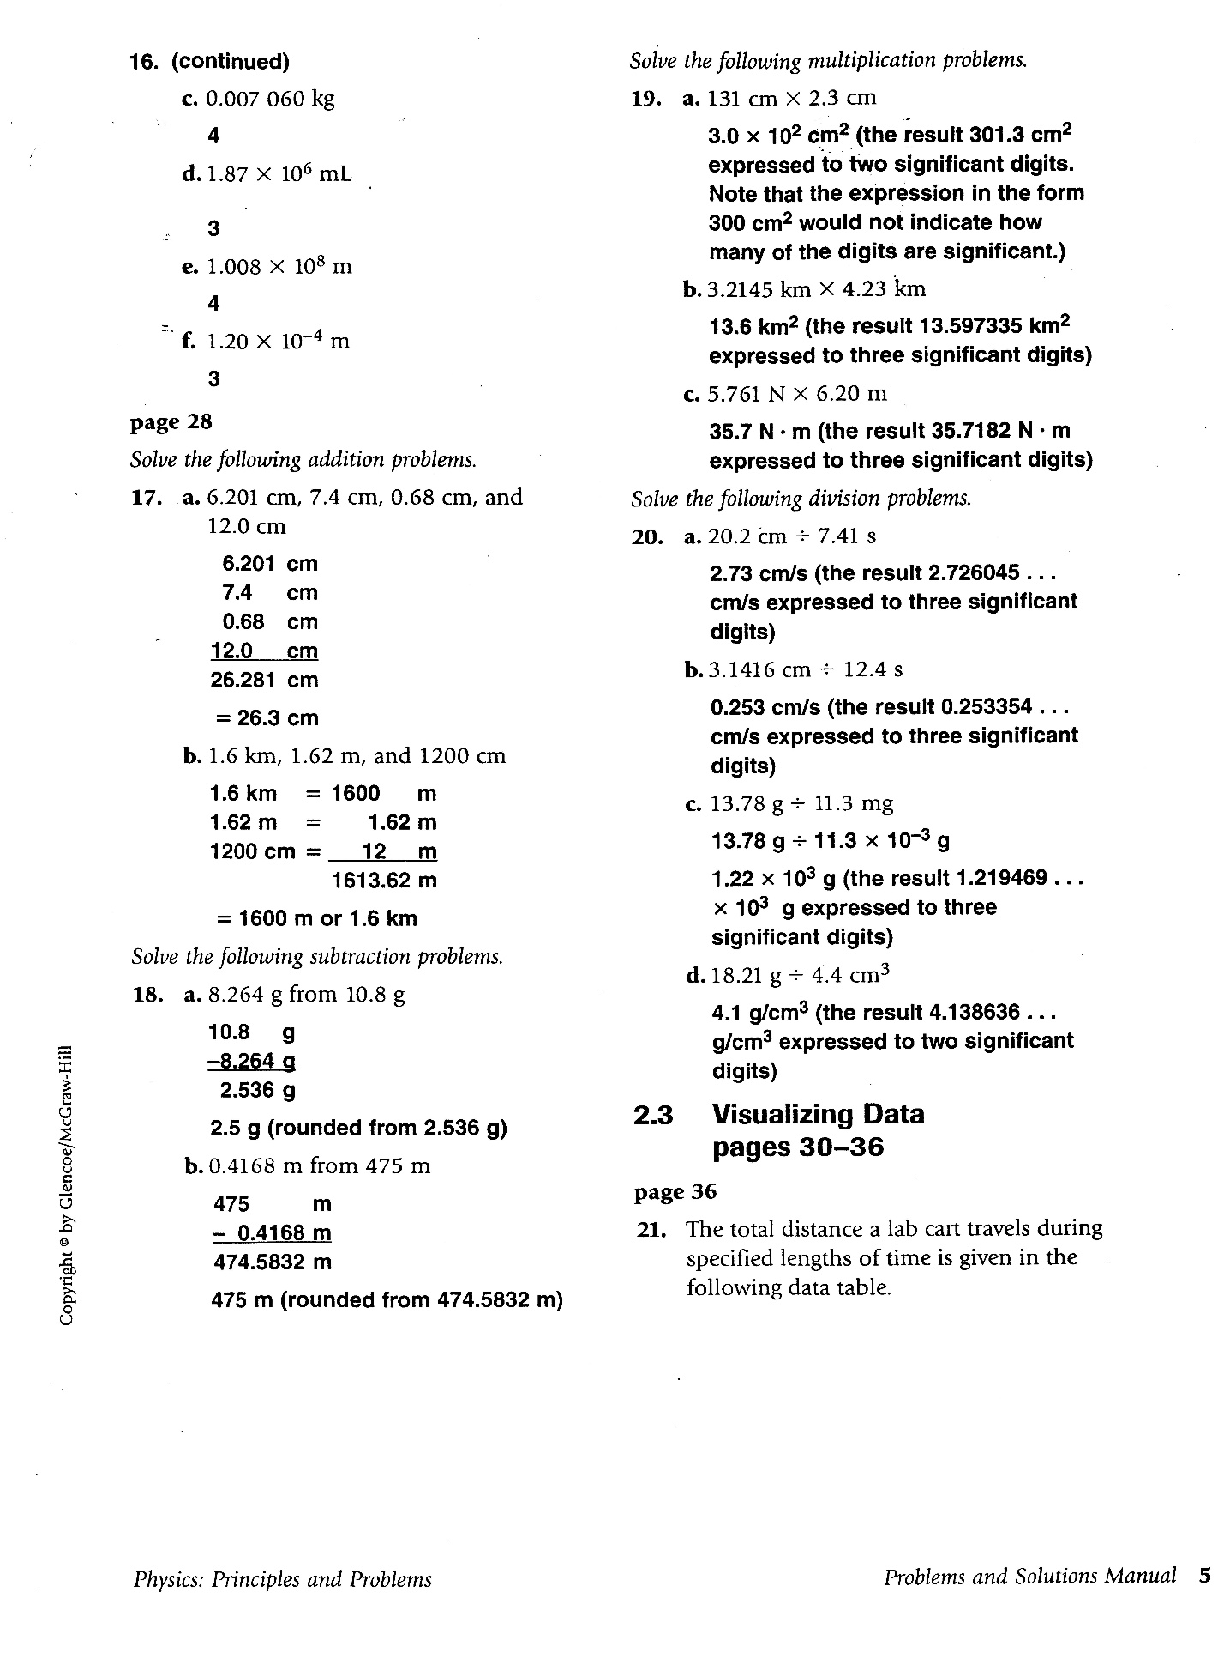

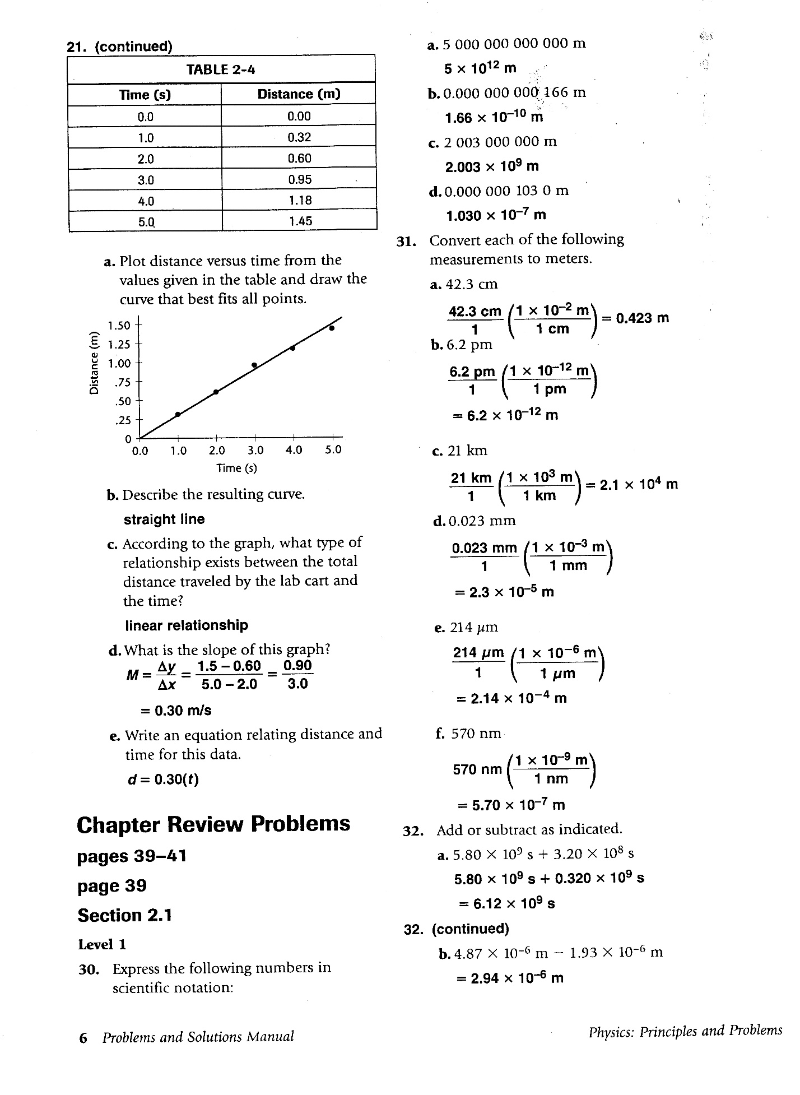

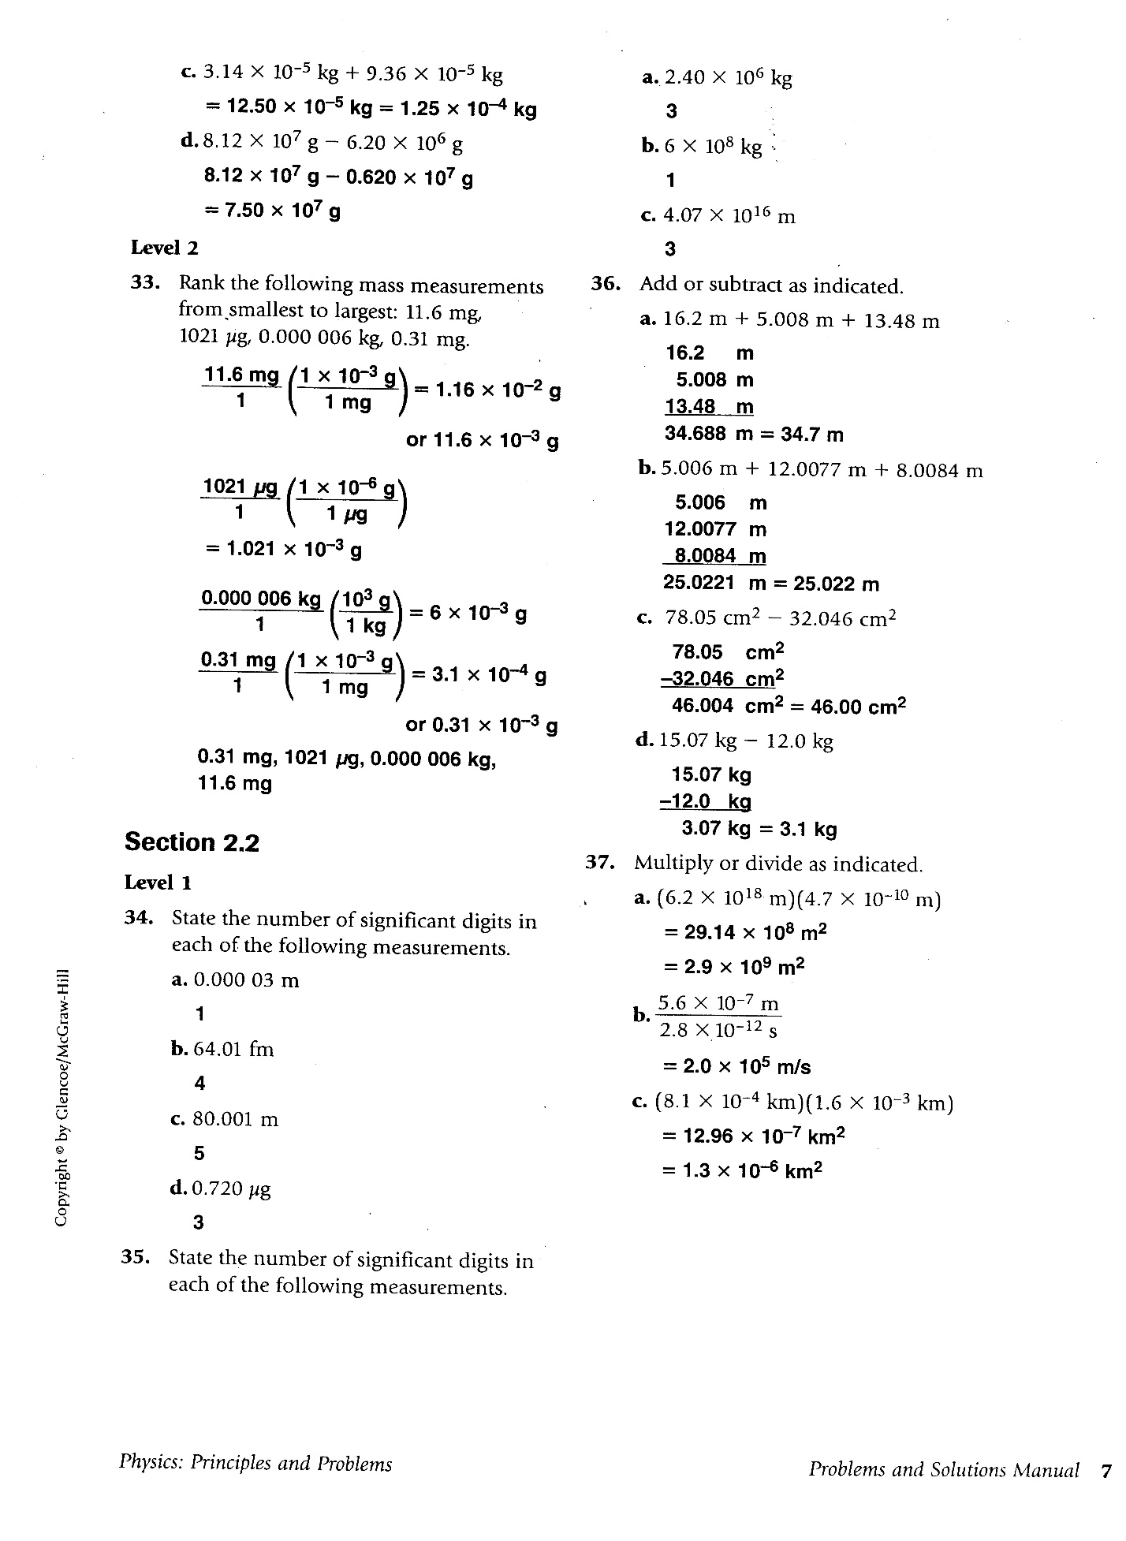

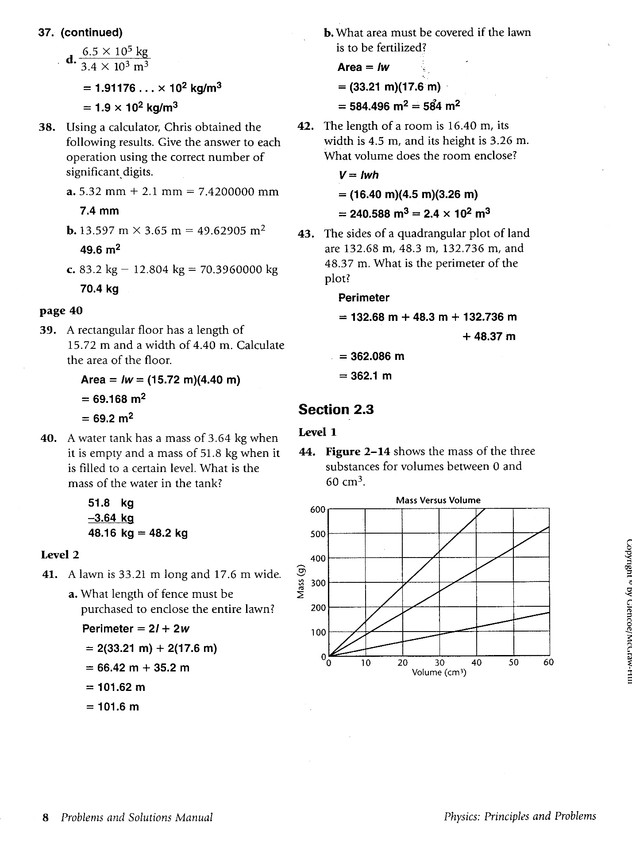

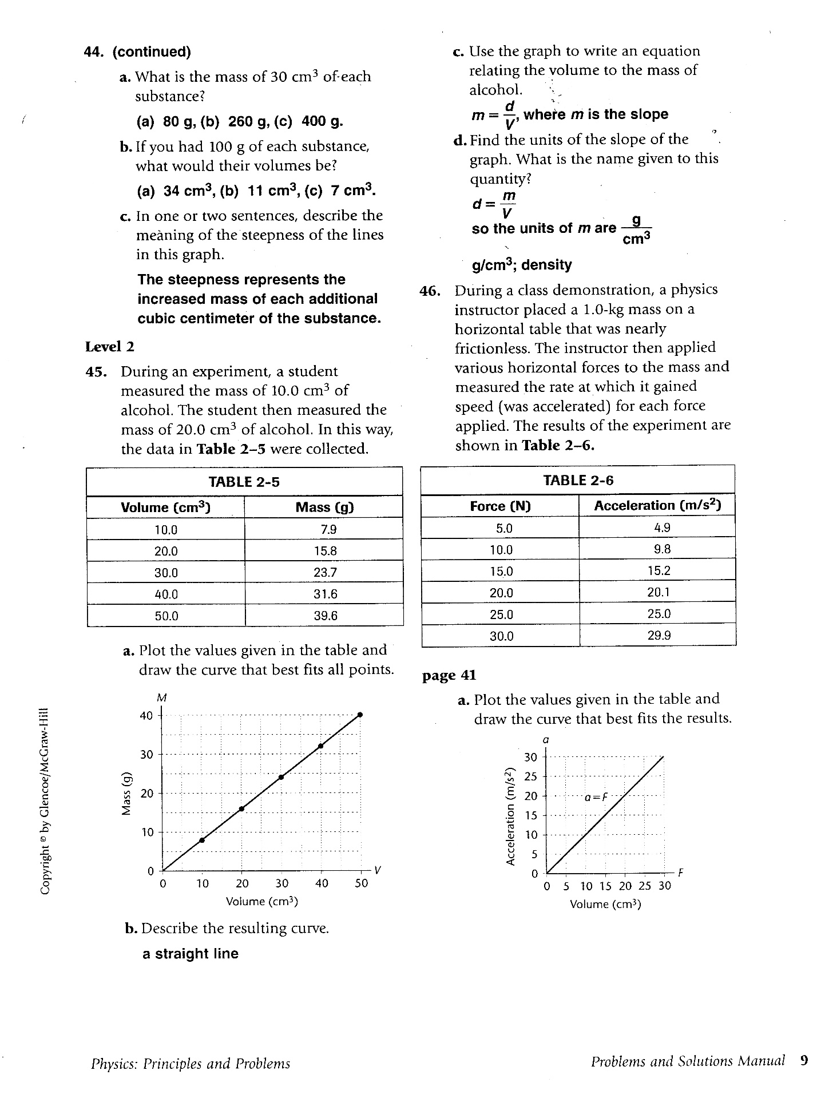

**Appendix B Extra Practice Problems Chapter 2**

11. A cube has an edge of length 5.2 cm. a) Find its surface area; b) Find its volume.

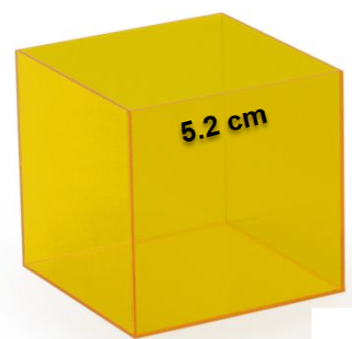 Area of 1 side 🡪 5.2 cm x 5.2 cm = 27.04 cm2

Surface Area of cube (6 sides 🡪 6 x 27.04 cm2 = 162.2 cm2 = 160 cm2 = 1.6 x 102 cm2

Volume = L x W x H = (5.2 cm)3 = 140.6 cm3 = 140 cm2 = 1.4 x 102 cm2

13. HONORS The density of gold is 19.3 g/cm3. A gold washer has an outside radius of 4.3 cm and an inside radius of 2.1 cm. Its thickness is 0.14 cm. What is the mass of the washer?

