Name ___ Date ___

SUN

The Sun is a ____ that energizes our solar system. The power of the sun is derived through ____.

This happens in the core of the sun where the temperature is great enough for ____ Protons to ____ and fuse, producing ____. During this process of fusion, an enormous amount of ____ is released.

* Normal H-He fusion is the most common fusion in the core of stars, but as a star ____ it can fuse to form heavier elements at ____ temperature.
* _____ stars have fused at very high temperatures to create some of the heaviest known elements.
* All heavier elements in the universe are the result of ____ in ____.

The C____

* Temperature of the sun’s core reaches ____ million C, very ___ gas.
* Fusion occurs here.

The R_____ Zone

* ____ the core
* Energy moves ____ in the form of electromagnetic radiation.

The C____ Zone

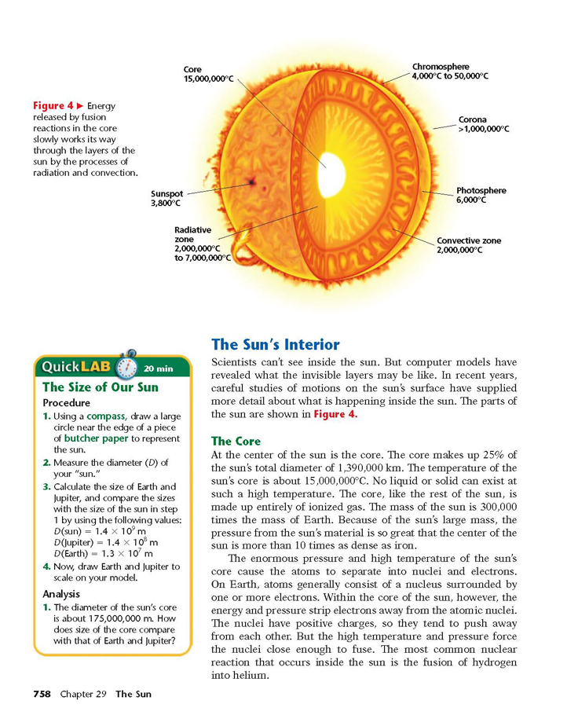

* Surrounding the Radiative Zone where energy is transferred by ____ differences.

The P____

* The “____” of the sun, where energy is radiated mostly in the form of ____ light
* The top of the convective ____, & is made of individual regions called granules.

The C____

* Dense inner ____.

The C___

* ____ atmosphere.

S____

* Sunspots occur as ___, cooler regions on the ____.
* They are ____ in nature, and occur in ____.

Sunspots Occur as a result of the following ____ events:

1. Sun has differential rotation, that is the ____ rotates ____ than the poles.

2. Differential rotation cause the sun’s magnetic ____ to become ____.

3. Where the sun’s magnetic field lines interact, localized magnetic ____ occurs.

4. As a result of localized magnetic force, ____ in that area is blocked. This does ____ allow for warmer material to rise up, & cooler material to sink, so it takes on a darker appearance.

5. Sunspots can lead to solar ____, which can lead to ____ mass ejections, which can lead to ____.

* Sunspots follow a cycle that has a regular pattern of ____ years. That is, every 11 years there is a peak in solar activity.
* When there is a _____, there are ____ sunspots, when there is a low point there are fewer.
* The last peak was about the year ____, and we are currently at a low point.
* As a result of the sunspot cycle, this also plays a role in the visibility of ____.
* During sunspot peaks, there are more solar flares, and coronal mass ejections, causing more solar ____, causing more auroras.

Solar P____

* Solar ____ – outbursts of energy from the ____, often associated with sunspots.
* Solar ____ – large ____ of glowing ____ connecting oppositely charged sunspot fields.
* Coronal Mass Ejections – charged particles that ____ the outer atmosphere, usually from a solar flare.
* ____ – Charged particles from the sun that react with the earth’s magnetosphere (in the upper atmosphere) and create various ____ in the night sky.
* The magnetosphere is more concentrated closer to earth’s magnetic poles, which is why auroras are more often found at ____ latitudes.

Solar D_____

* Charged particles from the sun can also cause disturbances with ____ on the earth. Radio, television, satellite & cell phone communication all use ____ energy to work.
  + Charged particles from the sun cause ____ and can create times when this ____ does not work. This is more of a problem during higher points in the ____ cycle, because there are more charged particles being sent towards earth.

Fate of Our Sun

About ___ billion years from now, the hydrogen fuel in the center of the Sun will begin to ____

* The helium that collected there will gravitationally ____, increasing the rate of hydrogen burning in a shell surrounding the core.
* Our star will slowly bloat into a ___ g___ – eventually ____ the inner planets, including the Earth.

Later, the Sun will shed most of its outer layers, creating a planetary ____, and in time it will reveal itself as a hot ____ d___ star. Nearly ____ percent of all stars in the galaxy will end their lives as white dwarfs.

The H____-R____ diagram

* + Named after it's creators the Danish astronomer Ejnar Hertzsprung (1873-1967) and the American Henry Norris Russell (1877--1957)

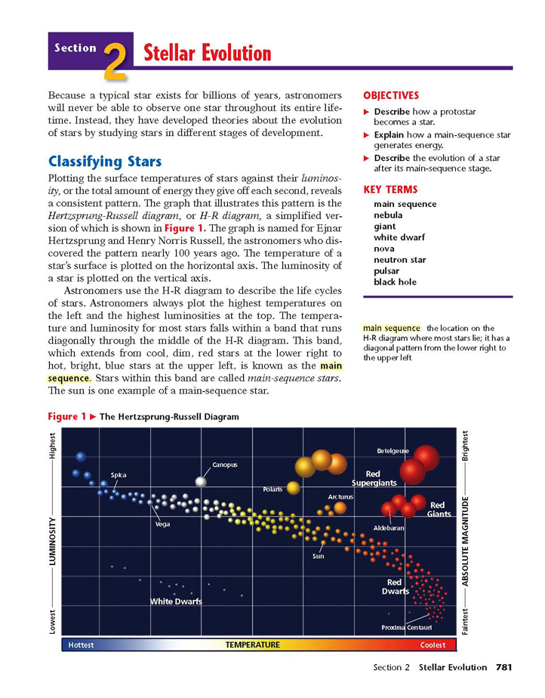

* + Used for classifying _____.

* Stars with ____ mass become w_____ d_______
* Very ____ stars become a ____ Star
* The most massive stars become B___ Holes
* The HR Diagram arranges stars according to _____ (absolute magnitude) and ____ (spectral type).
* Most stars fit into a ____ band which has been called the main ____.

EVOLUTION OF A S____

Stars that have a mass between 0.___ – 5 will become a w___ d___.

Stars that have a mass between ____ – 10 will become a n____ s___.

Stars that have a mass between ____ -100 will become a b___ h___.

A s____mass is equal to that of the Sun: 2 x 1030 kg, about 330,000 Earth masses.

C____

* Constellations are used to help ____ the night sky.
* There are ____ identified constellations.

There are two types of constellations:

C____ – We can see these all year long.

S____ – Only visible during certain times of the year depending on earth’s ____.

E____

* As a result of the earth/moon/sun system, sometimes the Earth, or Moon’s ____ ____our view of the sun, or the moon.
* When this blocking occurs we call this an ____.

S____ eclipse

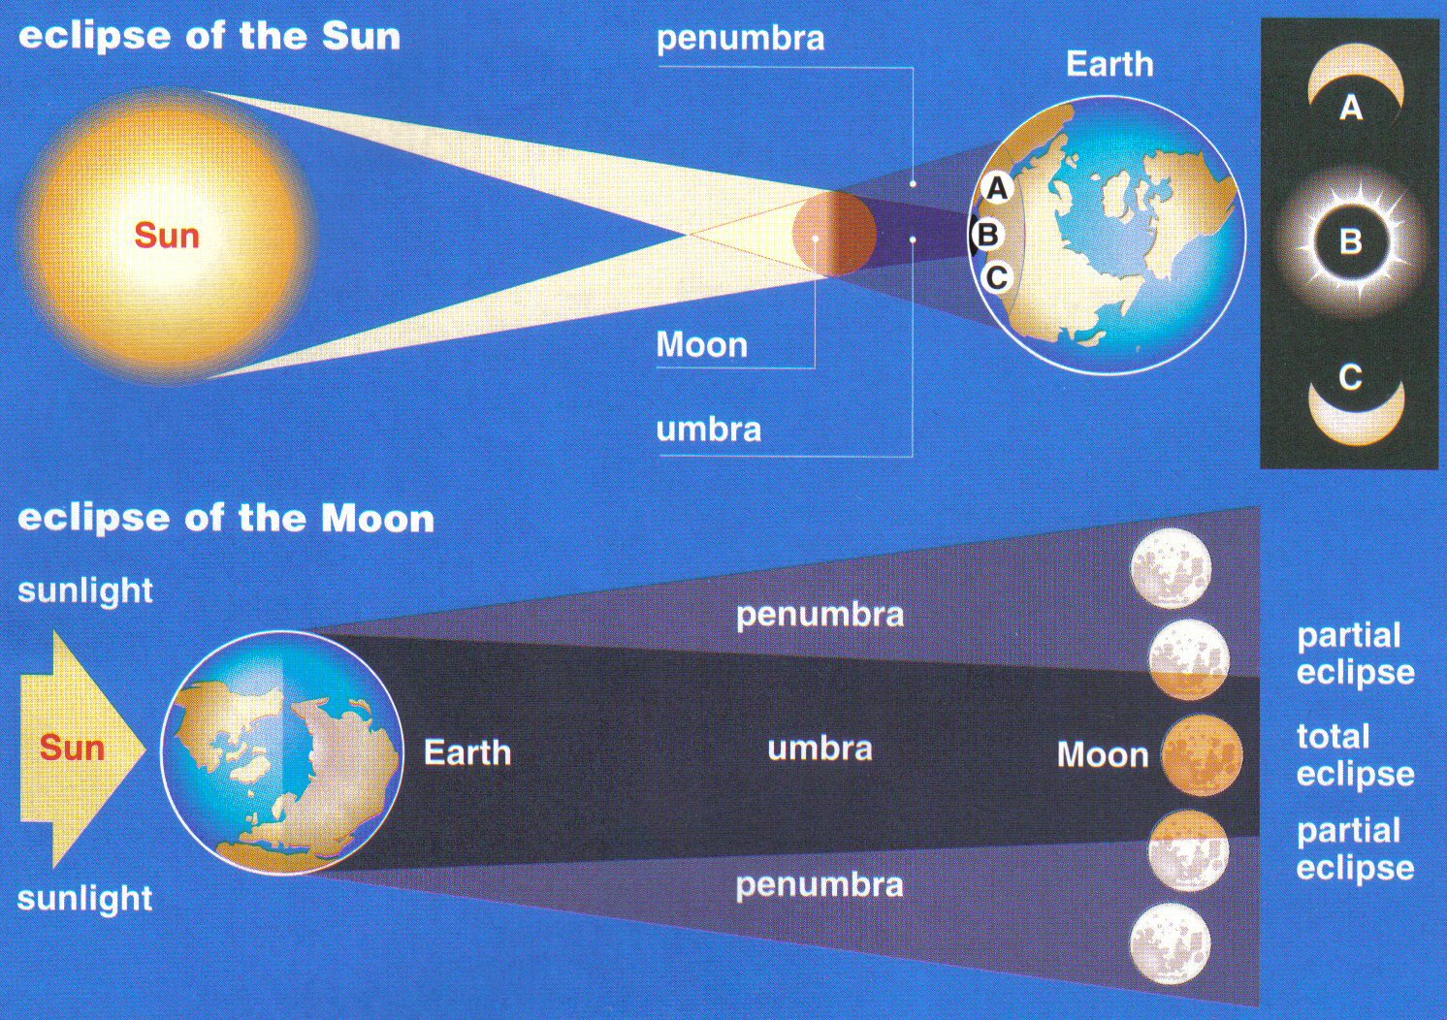

* When the ____ falls into the moon’s shadow, causing the ____ to be blocked.

L____ eclipse

* When the _____ falls into the earth’s shadow, causing the moon to be blocked from our view.

When the _____ comes between the ____ and the ____, there is a Solar Eclipse.



When the ____ comes between the ____ and the ____, there is a Lunar Eclipse.

U____ – true central shadow of an object.

P____ – partial shadow

P____ e___ – when the view is showing the object (moon or sun) in the ____.

T____ eclipse – when the view is showing the object (moon or sun) in the ____.

* Eclipses do not occur every month because the orbital planes of the earth-sun, and earth-moon are off by approximately ___ degrees.
* For this reason the shadows will not always line up.
* ____ eclipses occur ____ frequently than lunar eclipses, but cover less surface area of the earth. Solar eclipses occur approximately ____ times a year.
* An individual location on earth will only have a complete solar eclipse every ____ years.
* ____ eclipses happen approximately ____ a year.

ASTRONOMICAL D____

Because of the size of the universe:

* ____ had to be developed (Refracting & reflecting telescopes)
* New, simpler _____ had to be developed
* The “____” or “Astronomical Unit”, 1 AU, is equal to the average distance between the _____ and the ____ (93 million miles).
* This unit is used mostly within ____ solar system.

Light is part of the EM (____ spectrum)

* All EM waves (including visible light) travel at ___ x 108 meters/second

A L____ Y____ is a Distance

* The light year is a unit of _____, not of time.
* A light year is the distance that light can travel in ____ year.

For even greater distances the p___ can be used. One parsec equals ____ light years

B____ B____

* The theory that the universe began from a point of matter ~ ____ billion years ago.
* The matter ____ (and continues to expand), and was initially very small, and hot, and has since created all other matter and space.

H____'s Law

* Galaxies are moving ____ from each other, proving an ____ universe.

Evidence:

* C___ Microwave B____ Radiation 🡪 Left over energy from the initial expansion of the universe was detected.
* Universe has an abundance of lighter elements. F___ creates heavier elements, and fusion only occurred for a brief time during the “big bang”, which did not create heavy elements, only light ones like ____ and ____.
* R____ S____
* Observations using light waves show that the most galaxies are shifted towards the ____ end of the ____ spectrum.
* This is the ____ wavelength part of the visible spectrum.
* This means that galaxies are moving ____ from us.
* This principle is similar to what happens to ___ waves as an object moves away (The ____ decreases causing a lower pitch) from us.
* This is known as the ____ Effect.

Solar N____ Hypothesis

* The solar system formed from a rotating cloud of ____ and ____.
* Once ____ attraction became great enough the, ____ condensed, & the sun did too.
* Once the ____’s core reached about ____ million C, ____ began.

Earth in Our Galaxy

* Our solar system is part of the ___ W___ Galaxy, which is a ____ galaxy.
* Our solar system is ____ around the core of the Milky Way.
* The Milky Way is thought to be almost as old as the universe at ___ billion years.

ANSWERS

SUN

The Sun is a Star that energizes our solar system. The power of the sun is derived through Fusion.

This happens in the core of the sun where the temperature is great enough for Hydrogen Protons to collide and fuse, producing Helium. During this process of fusion, an enormous amount of energy is released.

* Normal H-He fusion is the most common fusion in the core of stars, but as a star ages it can fuse to form heavier elements at higher temperature.
* Massive stars have fused at very high temperatures to create some of the heaviest known elements.
* All heavier elements in the universe are the result of fusion in stars.

The Core

* Temperature of the sun’s core reaches 15 million C, very dense gas.
* Fusion occurs here.

The Radiative Zone

* Surrounds the core
* Energy moves outward in the form of electromagnetic radiation.

The Convective Zone



* Surrounding the Radiative Zone where energy is transferred by density differences.

The Photosphere

* The “surface” of the sun, where energy is radiated mostly in the form of visible light
* The top of the convective plumes, and is made of individual regions called granules.

The Chromosphere

* Dense inner atmosphere.

The Corona

* Outer atmosphere.

Sunspots

* Sunspots occur as darker, cooler regions on the photosphere.
* They are magnetic in nature, and occur in pairs.

Sunspots Occur as a result of the following sequential events:

1. Sun has differential rotation, that is the equator rotates faster than the poles.

2. Differential rotation cause the sun’s magnetic field to become twisted.

3. Where the sun’s magnetic field lines interact, localized magnetic force occurs.

4. As a result of localized magnetic force, convection in that area is blocked. This does not allow for warmer material to rise up, and cooler material to sink, so it takes on a darker appearance.

5. Sunspots can lead to solar flares, which can lead to coronal mass ejections, which can lead to Auroras.

* Sunspots follow a cycle that has a regular pattern of 11 years. That is, every 11 years there is a peak in solar activity.
* When there is a peak, there are more sunspots, when there is a low point there are fewer.
* The last peak was about the year 2001, and we are currently at a low point.
* As a result of the sunspot cycle, this also plays a role in the visibility of auroras.
* During sunspot peaks, there are more solar flares, and coronal mass ejections, causing more solar wind, causing more auroras.

Solar Phenomena

* Solar Flares – outbursts of energy from the photosphere, often associated with sunspots.
* Solar Prominences – large arches of glowing gas connecting oppositely charged sunspot fields.
* Coronal Mass Ejections – charged particles that leave the outer atmosphere, usually from a solar flare.
* Auroras – Charged particles from the sun that react with the earth’s magnetosphere (in the upper atmosphere) and create various colors in the night sky.
* The magnetosphere is more concentrated closer to earth’s magnetic poles, which is why auroras are more often found at higher latitudes.

Solar Disturbances

* Charged particles from the sun can also cause disturbances with communication on the earth. Radio, television, satellite and cell phone communication all use electromagnetic energy to work.
  + Charged particles from the sun cause interference and can create times when this technology does not work. This is more of a problem during higher points in the sunspot cycle, because there are more charged particles being sent towards earth.

Fate of Our Sun

About 4 billion years from now, the hydrogen fuel in the center of the Sun will begin to run out

* The helium that collected there will gravitationally contract, increasing the rate of hydrogen burning in a shell surrounding the core.
* Our star will slowly bloat into a red giant – eventually engulfing the inner planets, including the Earth.

Later, the Sun will shed most of its outer layers, creating a planetary nebula, and in time it will reveal itself as a hot white dwarf star. Nearly 99 percent of all stars in the galaxy will end their lives as white dwarfs.

The HERTZSPRUNG-RUSSELL diagram

* + Named after it's creators the Danish astronomer Ejnar Hertzsprung (1873-1967) and the American Henry Norris Russell (1877--1957)



* + Used for classifying stars.

* Stars that are low mass will become white dwarfs
* Very massive stars will become a Neutron Star
* The most massive stars will become Black Holes
* The HR Diagram arranges stars according to luminosity (absolute magnitude) and temperature (spectral type).
* Most stars fit into a diagonal band which has been called the main sequence.

EVOLUTION OF A STAR

Stars that have a mass between 0.5 – 5 will become a white dwarf.

Stars that have a mass between 5 – 10 will become a neutron star.

Stars that have a mass between 10 -100 will become a black hole.

A solar mass is equal to that of the Sun: 2 x 1030 kg, about 330,000 Earth masses.

CONSTELLATIONS

* Constellations are used to help map the night sky.
* There are 88 identified constellations.

There are two types of constellations:

Circumpolar – We can see these all year long.

Seasonal – Only visible during certain times of the year depending on where earth is in it’s orbit.

ECLIPSES

* As a result of the earth/moon/sun system, sometimes the Earth, or Moon’s shadow blocks our view of the sun, or the moon.
* When this blocking occurs we call this an eclipse.

Solar eclipse



* When the earth falls into the moon’s shadow, causing the sun to be blocked.

Lunar eclipse

* When the moon falls into the earth’s shadow, causing the moon to be blocked from our view.

When the Moon comes between the Earth and the Sun, there is a Solar Eclipse.



When the Earth comes between the Moon and the Sun, there is a Lunar Eclipse.

Umbra – true central shadow of an object.

Penumbra – partial shadow

Partial eclipse – when the view is showing the object (moon or sun) in the penumbra.

Total eclipse – when the view is showing the object (moon or sun) in the umbra.

* Eclipses do not occur every month because the orbital planes of the earth-sun, and earth-moon are off by approximately 5 degrees.
* For this reason the shadows will not always line up.
* Solar eclipses occur more frequently than lunar eclipses, but cover less surface area of the earth. Solar eclipses occur approximately 3 times a year.
* An individual location on earth will only have a complete solar eclipse every 360 years.
* Lunar eclipses happen approximately twice a year.

ASTRONOMICAL DISTANCES

Because of the size of the universe:

* Instruments had to be developed (Refracting & reflecting telescopes)
* New, simpler units had to be developed
* The “AU” or “Astronomical Unit”, 1 AU, is equal to the average distance between the sun and the earth (93 million miles).
* This unit is used mostly within our solar system.

A Light Year is a Distance

* The light year is a unit of distance, not of time.
* A light year is the distance that light can travel in one year.

For even greater distances the parsec can be used. One parsec equals 3.3 light years

BIG BANG

* The theory that the universe began from a point of matter ~ 15 billion years ago.
* The matter expanded (and continues to expand), and was initially very small, and hot, and has since created all other matter and space.

Hubble's Law

* Galaxies are moving away from each other, proving an expanding universe.

Evidence:

* Cosmic Microwave Background Radiation 🡪 Left over energy from the initial expansion of the universe was detected.
* Universe has an abundance of lighter elements. Fusion creates heavier elements, and fusion only occurred for a brief time during the “big bang”, which did not create heavy elements, only light ones like H and He.
* Red Shift
* Observations using light waves show that the most galaxies are shifted towards the red end of the visible spectrum.
* This is the long wavelength part of the visible spectrum.
* This means that galaxies are moving away from us.

Solar Nebula Hypothesis

* The solar system formed from a rotating cloud of dust and gas.
* Once gravitational attraction became great enough the, planets condensed, & the sun did too.
* Once the sun’s core reached about 10 million C, fusion began.

Earth in Our Galaxy

* Our solar system is part of the Milky Way Galaxy, which is a spiral galaxy.
* Our solar system is revolving around the core of the Milky Way.
* The Milky Way is thought to be almost as old as the universe at 13.2 billion years.