D_____ of Water

The most important solvent to the chemical world is _____ due to its _____ … it is easy to forget the important role of water compared to the role of the solute. For example, milk, orange juice, coffee, tea, soft drinks, etc. etc. all have water as the _____.

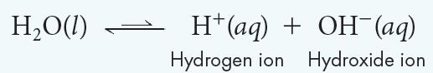

* __ eq of water’s dissociation. 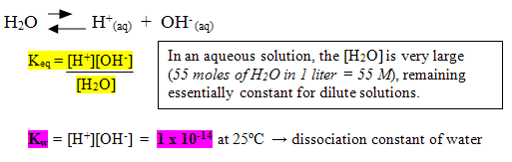
* This means that water only _____ dissociates into ions.
* We can use the same principle as Ksp = [__+][__−] .
* Notice the [H20] is omitted. For aqueous solutions: [H+][OH−] = 1.0 × 10−__
* The product of the concentrations of the hydrogen ions and the hydroxide ions in water is called the ion-product constant for water (*Kw*).

K__ = [H+][OH−] = 1.0 × 10−__

* In pure water at 25 ⁰C, the concentration of hydrogen ions ([___+]) is only 1 × 10−__*M*.
* The concentration of hydroxide ions ([(__)−]) is also 1 × 10−__*M* because the numbers of H+ and (OH)− ions are _____ in _____ water.

The A_____ Concept

* Arrhenius _____: a substance that when dissolved in water increases ___+ (or H+) concentration.
* Arrhenius _____: a substance that when dissolved in water increases (___)− concentration.

**A**_____  **Solutions**

* A substance that _____ the concentration of ___+ (H3O+) ions in solution.
* H+: _____ ion … H3O+: _____ ion

kw = [H+][(OH)-] = 10-14

* In acidic solutions, the hydrogen-ion concentration is _____ than the hydroxide-ion concentration. [__+] > [(___)-]
  + The [__+] is _____ than 1 × 10−___*M*.
  + The [(___)-] is _____ than 1 × 10−___*M*.
* Examples of Acids
  + _____ acid (HCl) …stomach acid
  + _____ acid (H2SO4) … battery acid
  + _____ acid (HCH3COO) … vinegar
  + Nitric acid (HNO3) … explosives, fertilizer
  + Carbonic acid (H2CO3) … soda water
* Not all compounds that contain hydrogen are acids.
  + Only a hydrogen that is bonded to a very _____ element can be released as an ion. Such bonds are highly _____.
* In an _____ solution, hydrogen ions are not present. Instead, the hydrogen ions are joined to water molecules as _____ ions.
* A hydronium ion (__3___+) is the ion that forms when a water molecule _____ a hydrogen ion [H+].
* Chemical and Physical Properties of Acids
  + Have a _____ taste
  + Turn _____ litmus paper _____
  + Turn methyl orange solution red
  + React with carbonates and bicarbonates
  + Are _____ by bases
  + React with metals

**B**_____ **Solutions**

* A substance that _____ the concentration of (___)- ions in solution.
* In basic solutions, the _____ -ion concentration is greater than the hydrogen-ion concentration. [(___)-] > [__+]
  + The [(___)-] is _____ than 1 × 10−___*M*.
  + The [H+] is less than 1 × 10−7*M*.
* Basic solutions are also known as _____ solutions.
* Examples of Bases
  + _____: Al(OH)3
  + Drain Cleaner: Sodium hydroxide (NaOH)
  + Fertilizer/soap: Potassium hydroxide (KOH)
  + Limewater: Calcium Hydroxide Ca(OH)2
* Ionic compounds that _____ into (___)- ions in an aqueous solution.
* Chemical and Physical Properties of Bases
  + Taste _____
  + Are _____
  + Turn _____ litmus paper _____
  + Turn colorless phenolphthalein _____
  + Neutralize _____
  + May react with some metal salts
  + May react with carbon dioxide

Arrhenius Acids and Bases SUMMARY

Arrhenius’ theory defines acids, bases, and salts based on the use of _____. He used observable properties:

* _____ taste sour; _____ taste bitter
* acids/bases conduct electricity (_____)
* strong acids & bases are _____
* _____ turns red in an acid and blue in a base
* indicators change color based on ___

Arrhenius also used the ____-product of water concentrations to define acids [__+], bases [___-] and salts [__+___-].

**pH**

* Expressing hydrogen-ion concentration in molarity (Moles/liter) is often not practical or easy.
* So, rather than focus on [H+], Sorenson suggested that concentration values be expressed as a power of 10 that arises when hydrogen ion concentrations ([H+]) are put in scientific notation.
* pH measures [___+] on a _____ scale.
  + The pH scale works in powers of _____, so each jump in number is a multiple of 10 in concentration.
  + For example, a pH of ___ is 10 times more acidic than a pH of ___.

pH measures [H+] on a logarithmic scale.

* Corresponds to the variation of [H+] related to k___.
* [___+] ranges from 10-1 to 10-14 M
* Avoids the use of small fractions and negative exponents
* Indicates “_____ strength” in a solution

pH = -___10[__+] or pH = -log10[H3O+]

_______

_______

_______

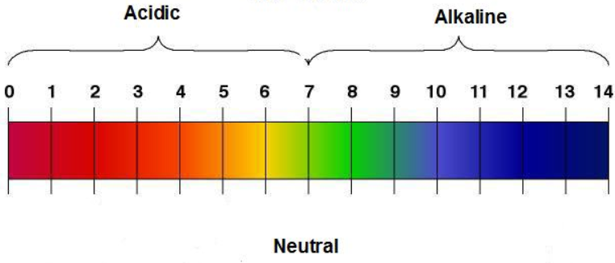

**The pH Scale**

_____: pH _____ 7 [H+] > 1 × 10−7*M* _____ pH indicates greater acidity

_____: pH _____ 7 [OH-] < 1 × 10−7*M* _____ pH indicates greater alkalinity

_____: pH = 7 [H+] = 10−___*M* [OH-] = 10−___*M* [__+] = [___-]

pOH … the “potential” of (OH)- in solution

pOH is a measure of the _____ ion concentration ([OH–]) in an aqueous solution

p____ = –___10[___–]

* pH and pOH are _____ related
* As pH _____, pOH _____
* Acids have _____ pH, _____ pOH
* _____ have high pH, low pOH

pH and pOH pH + pOH = ___

* pH = 5 = -log (10-5) … pOH = 9 = -log (10-9)
* pH = 5 = -~~log (10~~-5) … pOH = 9 = -~~log (10~~-9)
* 5 + 9 = 14

_____ concentrations are described by: kw = [H+][OH-] = 10-14 p__ + p___ = 14

Measuring pH

* A pH _____ can be easier to use than liquid indicators or indicator strips.
* The pH reading is visible in a display window on the meter.
* The color and cloudiness of the solution do not affect the accuracy of the pH value obtained.

**B**_____ **-L**_____  **Acids and Bases**

* A more general definition of acids and bases
* Extends the Arrhenius theory
* Includes other solvents beside _____

An acid-base reaction in which there is a _____ (H+) transfer from one species to another.

* The species which _____ the proton is a B-L _____.
* The species which _____ the proton is a B-L _____.

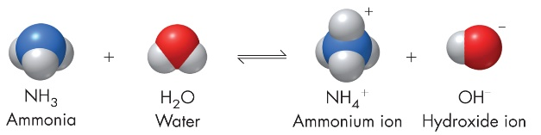

For the f_____ reaction:

* Water donates the H+ … B-L _____
* Ammonia accepts H+ … B-L _____

Bronsted-Lowry proposed that the _____ reaction of an acid/base reaction is also an acid/base reaction.

For the r_____ reaction:

* + Ammonium donates the H+ … B-L _____
  + Hydroxide accepts H+ … B-L _____

Brønsted-Lowry _____ Acid-Base Pairs

* According to the Bronsted-Lowry concept, in every reaction, an acid reacts with a base to form another acid and another base which are _____ of the _____ acid and base.
* _____ means that the acid-base pairs have the same derivation and are distinguished by the presence or absence of a _____ (__+).

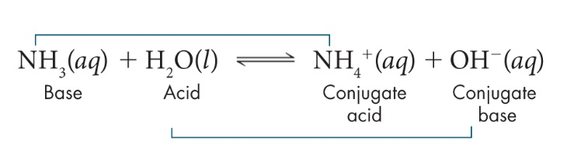

* NH4+ is the _____ acid of the base NH3.
* OH– is the _____ base of the acid H2O.

A_____ Substances

* A substance that can act as either an _____ or a _____ is said to be amphoteric.
* _____ is amphoteric. In the reaction with hydrochloric acid, water _____ a proton and is therefore a _____.
* In the reaction with ammonia, water _____ a proton and is therefore an _____.

Common amphoteric substances include: H2O, HSO4-, HCO3-, HS- [Reference Table L]

  HCO3- (aq) + OH- (aq) 🡪 H2O(aq) + CO3-2 (aq)

____________________

  HF (aq) + HCO3- (aq) 🡪 H2CO3(aq) + F- (aq)

____________________

Notice that bicarbonate can act as an acid (_____ an H+) or a base (_____ the H+).

**L**_____  **Acids and Bases (BONUS)**

* The Arrhenius theory is the most restricted “acid-base” explanation since an acid must possess an H+ ion and a base must possess an OH- ion.
* The Bronsted-Lowry concept extended the acid-base understanding, but can only be applied to reactions involving a proton transfer [an ionizable Hydrogen atom]
* A **Lewis acid** is a substance that can _____ a pair of _____ to form a covalent bond.
* A **Lewis** _____ is a substance that can _____ a pair of electrons to form a covalent bond.
* Note that acids now “accept” rather than “donate” since electrons are opposite protons (H+).

|  |  |  |
| --- | --- | --- |
| Acid-Base Definitions | | |
| Type | Acid Description | Base Description |
| Arrhenius |  |  |
| Bronsted-Lowry |  |  |
| Lewis |  |  |

* C_____ Covalent Bonds
* Any reaction that leads to the formation of a coordinate covalent bond (both e- in the bond are furnished by the same species) is an acid-base reaction.

Lewis Bases

a. All Bronsted-Lowry bases are included, plus a few more.

b. All the bases must possess an unshared pair of _____ which can be _____ to an acid

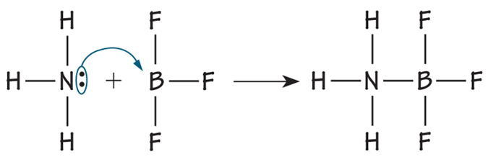

* When a Lewis acid reacts with a Lewis base, the _____ donates a pair of electrons and the _____ accepts the donated pair.

Summary: Acid – Base Theories

Arrhenius

* _____ 🡪 H+ ions _____ scale
* _____ 🡪 (OH)- ions

Bronsted-Lowry

* Acid 🡪 _____ H+ ions _____ acid-base pairs
* Base 🡪 _____ H+ ions

Lewis

* Acid 🡪 _____ electrons most inclusive definition
* Base 🡪 _____ electrons

19B What makes one acid safer than another?

Lemon juice, which contains citric acid, has a pH of about 2.3 which is relatively strong. Yet, most people love lemonade! Battery acid is very dangerous (sulfuric acid: H2SO4 (aq)).

**I**_____

* The foundational concept of Acids and Bases is their ability to _____ in solution.
* _____: acids and bases can conduct _____ due to the presence of free moving _____ which exist because of ionization.
  + i.e. HCl (aq) is a _____ electrolyte (acid)
  + NaOH (aq) is a _____ electrolyte (base)
  + CH3COOH (aq) is a _____ electrolyte (acid)
  + Pure water does _____ conduct electricity

**Strong vs. Weak Acids**

* Acids and bases are classified as _____ or _____ based on the _____ to which they ionize in water.
* In general, a _____ acid _____ ionizes in aqueous solution. Hydrochloric and sulfuric acid are examples of strong acids.
  + HCl(*g*) + H2O(*l*) → H3O+(*aq*) + Cl–(*aq*)
  + H2SO4(s) + 2H2O(*l*) → 2H3O+(*aq*) + SO4–2(*aq*)
* A _____ acid ionizes only _____ in aqueous solution.
* The ionization of acetic acid (CH3COOH), a typical weak acid, is not complete.

D_____ of a _____ acid HX (aq) 🡪 H+(aq) + X- (aq)

* Ionize _____ (___ %) … no reactant remains
* Goes to “_____” (FORWARD rxn favored)
* 100% dissociation, strong _____



Dissociation of a _____ acid HX (aq) H+(aq) + X- (aq)

* _____ ions produced, weak electrolyte
* Favors the _____ reaction
* _____ % dissociation

Acid Dissociation Constant

* The equilibrium-constant expression for any acid: HX (aq) ↔ H+(aq) + X- (aq)
* Ka = [H+][ X-] / [HX]
* The acid dissociation constant (*Ka*) indicates the _____ of _____ produced and which reaction (forward/reverse) is _____.
* Ka = 5.7 x 10-10 (very small) 🡪 _____ acid, _____ ions, _____ reaction
* Ka = 2.4 x 104 (large) 🡪 _____ acid, _____ ions, _____ rxn

_____ acid: is an acid which fully _____ (ionizes) in solution. _____ acids: do not fully _____ (dissociate) in solution.

List some strong acids:

Base Dissociation Constant

* The equilibrium-constant expression for any base:
* NH3 (aq) + H2O  NH4+(aq) + OH- (aq)
* Kb = [NH4+][ OH -] / [NH3]
* Kb = 1.8 x 10-4
* The Base dissociation constant (*Kb*) indicates the amount of ions produced and which reaction (forward/reverse) is favored.
  + Kb = 1.8 x 10-4 (small) 🡪 _____ base, _____ ions, _____ reaction
  + Kb = 7.2 x 106 (large) 🡪 _____ base, _____ ions, _____ rxn

Strong vs. Weak Bases

* Strong bases: like sodium hydroxide or potassium hydroxide which are fully ionized.
* A strong base is a compound that is _____ % split up into metal ions and _____ ions in solution.
* All _____ bases will contain a hydroxide group.
* _____ bases: do not _____ fully into hydroxide ions in solution. E.g. Ammonia NH3

**Strength vs. Concentration**

* The strength of an acid or base is related the degree of dissociation in water to produce ions.
* The _____ tells you about how much of the original acid (solute) is _____ in the solution.
* It is entirely possible to have a concentrated solution of a weak acid, or a dilute solution of a strong acid or base.
* Concentrated and dilute indicate how much of an acid or base is dissolved in solution and refer to the number of moles of the acid or base in a given volume (solute dissoved).
* The words strong and weak refer to the extent of _____ or dissociation of an acid or base (Ka or Kb)… _____ produced

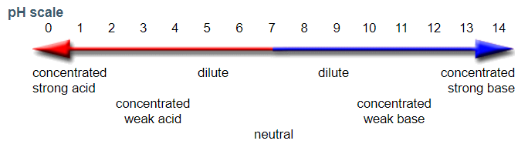

**Acid-Base I**_____

* Either acid-base indicators or pH meters can be used to measure pH.
* An indicator (HIn) is an acid or a base that dissociates in a _____ pH range. Indicators work because their acid form and base form have different _____ in solution.

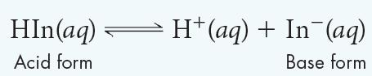

* The acid form of the indicator (HIn) is dominant at low pH and high [H+]. The base form (In−) is dominant at high pH and high [OH−].
* _____ turn blue _____ paper red. Bases turn _____ litmus paper _____.
* Indicator strips were developed to cover a wide range of pH values (e.g. pH or _____ paper).

**Neutralization**

* Neutralization is the complete reaction of a _____ acid with a _____ base to produce a _____ solution.
* A neutral solution has a pH of ___ because it contains _____ concentrations of _____ ions (H+) and _____ ions (OH-). [H+] = [OH-]
* The general equation for an acid base neutralization:

_____ + _____ → _____ + _____

Salt = the anion from an acid and the cation from a base

* A reaction between an acid and a base will go to completion when the solutions contain equal numbers of hydrogen ions and hydroxide ions. This can occur between _____ acids and _____ bases because both dissociate _____.
* The balanced equation provides the correct _____ of moles of acid to _____ of base to produce the neutralization.
* For hydrochloric acid and sodium hydroxide, the mole ratio is 1:1 so equal quantities of the acid and base neutralize. HCl(*aq*) + NaOH(*aq*) → NaCl(*aq*) + H2O(*l*)

Each of the following incomplete reactions are neutralization reactions. What is the formula of the salt formed?

H2SO4 + NH4OH →

NaOH + H2CO3 →

HNO3 + KOH →

H3PO4 + NaOH →

H_____ of a Salt

Show the acid and base used to form each salt in a neutralizing reaction.

K2SO4 →

NaBr →

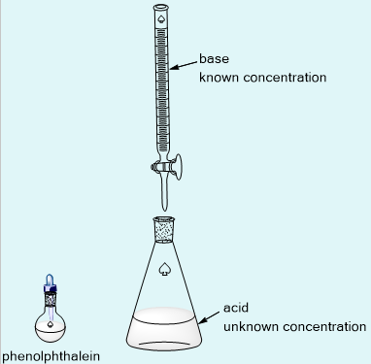

MgCl2 →

(NH4)3PO4 →

Hydrolysis: _____ + _____ 🡪 _____ + _____

_____: Acid + Base 🡪 Salt + Water

**T**_____

* Chemists use a neutralization reaction to determine the _____ of an acid or base.
* The process of adding a measured amount of a solution of _____ concentration to a solution of _____ concentration is called a titration.
* A measured _____ of an acid solution of unknown concentration is added to a flask.
* Several drops of an _____ (phenolphthalein) are added to the solution.
* Measured volumes of a base of known concentration are mixed into the acid until the indicator shows a _____ _____ change.
* Used to determine the composition or concentration of acids and bases in solution.
* Used to _____ mixtures. Used in nearly every laboratory: university, power plants, breweries, etc.
* Titration is one of the most _____ methods of chemical analysis.

E_____ Point

* The point at which _____ occurs.
* The point at which moles of one reactant (acid) have been added in stoichiometric quantity to react completely with the moles of the other reactant (base).
* The indicator chosen for this titration changes color at or near the pH of the equivalence point.
* The point at which the indicator forms a _____ color change is the _____ point of the titration.

Titrations can be done by adding strong acid to strong base or strong base to strong acid.

Adding _____ to _____ Adding _____ to _____

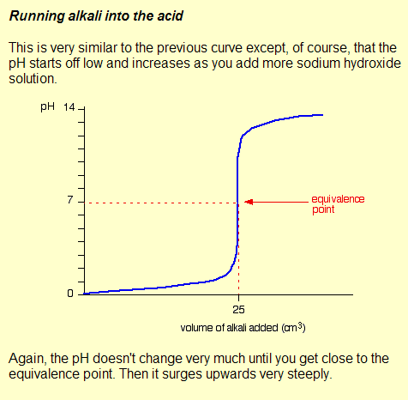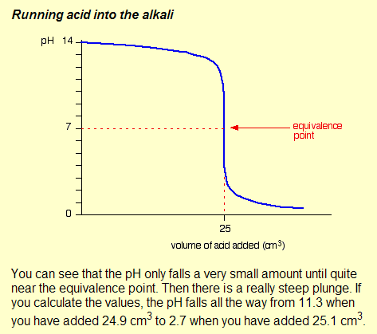

The ___ changes gradually until near the equivalence point where equal moles of acid and base react completely (pH = ___). At the equivalence point pH changes _____.

Titrations can also involve a _____ acid with a _____ base or a _____ acid with a _____ base.

Adding ______ Acid to ______ Base Adding _______ Base to ______ Acid

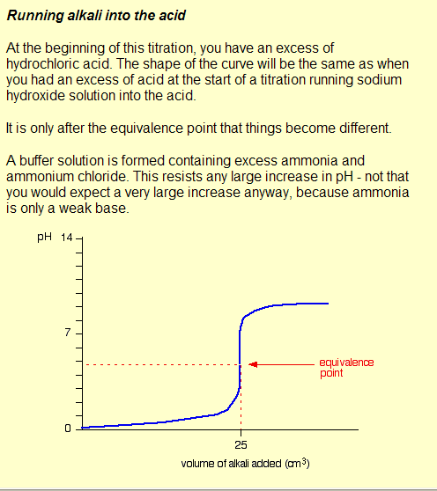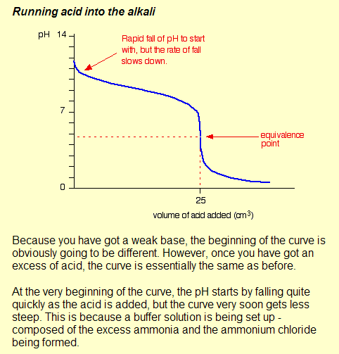

LEFT: _____ (pH _____) RIGHT: _____ (pH _____).

Adding ______ Acid to ______ Base Adding _______ Base to ______ Acid

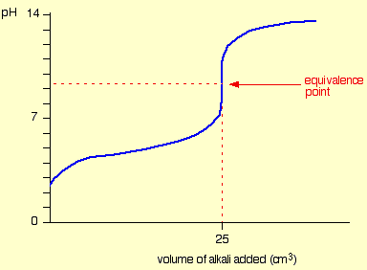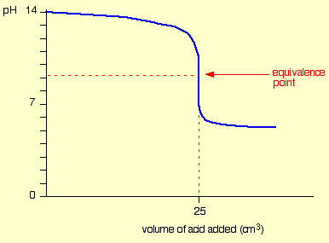

The equivalence point is ___ longer at a pH of 7 as with the _____ acids and _____ bases. At the equivalence point:

LEFT: _____ (pH _____) RIGHT: _____ (pH _____).

Salt Hydrolysis

* Titration depends on neutralization: acid + base 🡪 SALT + water
* The strength of the acids & bases used will determine the type of salt solution produced: acidic, neutral, or basic.
* Ammonium chloride, NH4Cl(*aq*), is acidic (pH of about 5.3).
  + NH4Cl(*aq*) 🡪 NH4(OH)(*aq*), + HCl(*aq*)
  + _____ _____ base _____ acid
* Sodium chloride, NaCl(*aq*), is neutral (pH of 7).
  + NaCl(*aq*) 🡪 HCl(*aq*), + NaOH(*aq*)
  + _____ _____ acid _____ base
* Sodium acetate, NaCH2COOH(*aq*), is basic (pH of about 8.7).
  + NaCH2COOH(*aq*) 🡪 CH3COOH(*aq*) + NaOH(*aq*)
  + _____ _____ acid _____ base
* When a STRONG acid is titrated with a WEAK base, an _____ salt solution is produced. _____ acid + _____ base → Acidic solution
* When a STRONG acid is titrated with a STRONG base, a _____ salt solution is produced. _____ acid + _____ base → Neutral solution
* When a WEAK acid is titrated with a STRONG base, a _____ salt solution is produced. _____ acid + _____ base → Basic solution

Calculating in Titrations

Calculations involving titration is identical to “_____” in molar concentrations (M1V1 = M2V2): Titration is based on the _____ and _____ of the acids and bases involved.

MbVb = MaVa

This calculation can be applied to all concentrations and strengths of the acids and bases (include the _____ factor of a balanced chemical reaction).

**B**_____

A buffer is an [aqueous solution](http://chemistry.about.com/od/chemistryglossary/a/aqueoussoldef.htm) that has a highly _____ [pH](http://chemistry.about.com/od/chemistryglossary/a/phdef.htm).

* If you add acid or base to a buffered solution, its pH will not change significantly.
* Buffers resist _____ in ___.

A buffer is made by mixing a large volume of a _____ acid or weak base together with its _____.

* A weak acid and its conjugate base (salt) can remain in solution without neutralizing each other.
* A weak base and its conjugate acid (salt) do not neutralize.

Buffers cause _____ reactions that will not have much effect on the overall ___ of the buffer solution.

* When hydrogen ions are added to a buffer, they will be neutralized by the base in the buffer.
* Hydroxide ions will be neutralized by the acid.

How Buffers Work

* A _____ solution is better able to _____ drastic changes in pH than pure _____ since water dissociates so little (kw = 10-14).
* A buffer solution contains one component that can react with _____ ions (hydrogen-ion acceptor) and one that can react with _____ ions (hydrogen-ion donor).
* Buffer systems often include _____ substances.

pH too high?

* pH rises because of excess _____ in the blood which reduces the _____ ions.
* 2 H2O + CO2 ↔ H2CO3 + (OH)- → **H3O+** + HCO3-
* Therefore, the _____ generates H3O+ by having carbonic acid dissociate into hydronium ions to _____ the base, favoring the _____ reaction.

pH too low?

* pH drops because of excess _____ in the blood which _____ the hydronium ions.
* 2 H2O + CO2 ↔ H2CO3 + H2O ← H3O+ + HCO3-
* Therefore, the _____ reduces H3O+ by having bicarbonate ions accept hydronium ions to _____ the _____ (_____ rxn favored).

Buffer solutions have their limits.

* Adding too much acid or base will exceed the buffer capacity of a solution.
* The buffer _____ is the amount of acid or base that can be added to a buffer solution before a significant change in pH occurs.
* Buffers work best in environments with specific pH ranges.
  + For _____ solutions, use a buffer with higher pH range (10.01).
  + For _____ solutions, use a buffer with lower pH range (4.01).
  + For _____ solutions, use a buffer with neutral pH range (7.00).