#### Additive Primary Colors

<https://screencast-o-matic.com/watch/crnDYGSpdS> (2:19) OR

<https://screencast-o-matic.com/watch/crnDqJSpU8>

Primary Additive Colors (3:05) … Red, Green, Blue created every other color.

Fill in the chart using the simulation to determine the colors when LIGHT is MIXED at equal intensities:

|  |  |  |  |
| --- | --- | --- | --- |
| **Primary****Additives** | **Red** | **Blue** | **Green** |
| **Red** |  |  |  |
| **Blue** |  |  |  |
| **Green** |  |  |  |
| **R + B + G =** | | | |

#### Subtractive Primary Colors

Fill in the chart using the simulation to determine the colors when **mixing dyes, paint, or ink**:

|  |  |  |  |
| --- | --- | --- | --- |
| **Subtractive Primary Colors** | **Yellow**  **(R + G)** | **Cyan**  **(B + G)** | **Magenta**  **(B + R)** |
| **Yellow (R + G)** |  |  |  |
| **Cyan (B + G)** |  |  |  |
| **Magenta (B + R)** |  |  |  |
| **Y + C + M =** | | | |

#### Complementary Colors

Combining a primary additive with its complement. “**Color Opposites**”

Use the color circles (Red, Blue, and green) to determine complementary colors (color “opposites”).

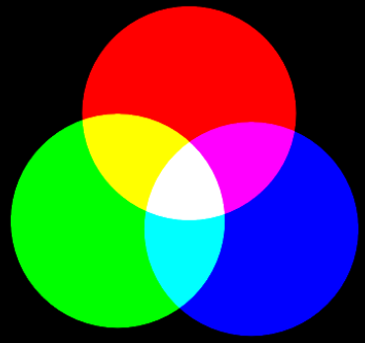

|  |  |  |
| --- | --- | --- |
| **Complementary**  **Colors** | **Complement** | **Result** |
| **Red** |  | White |
| **Green** |  | White |
| **Blue** |  | White |

ANSWERS

#### Additive Primary Colors

Use the simulation to determine the colors when **light is mixed**:

|  |  |  |  |
| --- | --- | --- | --- |
| **Primary****Additives** | **Red** | **Blue** | **Green** |
| **Red** | **red** | **Magenta** | **Yellow** |
| **Blue** | **Magenta** | **Blue** | **Cyan** |
| **Green** | **Yellow** | **Cyan** | **Green** |
| **R + B + G = white** | | | |

#### Subtractive Primary Colors

Use the simulation to determine the colors when **mixing dyes, paint, or ink**:

|  |  |  |  |
| --- | --- | --- | --- |
| **Subtractive Primary Colors** | **Yellow**  **(R + G)** | **Cyan**  **(B + G)** | **Magenta**  **(B + R)** |
| **Yellow (R + G)** | **yellow** | **Green** | **Red** |
| **Cyan (B + G)** | **Green** | **cyan** | **Blue** |
| **Magenta (B + R)** | **Red** | **Blue** | **magenta** |
| **Y + C + M = black** | | | |

#### Complementary Colors

Combining a primary additive with its complement. “Color Opposites”

|  |  |  |
| --- | --- | --- |
| **Complementary**  **Colors** | **Complement** | **Result** |
| **Red** | Cyan (B + G) | White |
| **Green** | Magenta (B + R) | White |
| **Blue** | Yellow (R + G) | White |