# **Purpose:** To investigate reaction rate and factors that affect it.

# **Background Information**

Refer to Class notes.

# **Hypothesis**

If water temperature is increased, then a tablet will dissolve faster because there would be more collisions of particles due to the higher temperature.

# **Materials**: 4 - Alka Seltzer Tablets or some other effervescent tablet

Mass Scale Metric cup Water

Ice Thermometer Heat Source

Glass cup (to be heated)

**Procedures**: WEAR GOGGLES!

1. Obtain ~100 ml of water using a metric measuring cup.

2. Pour the water into the glass cup.

3. Heat the water in the glass cup to the desired temperature. **Be especially carefully with the 100 C as it tends to splash.**

4. Ideally, use the various water temperatures in the data table provided. However, three temperatures are adequate (ice, boiling, in between).

5. When the water temperature is correct, add one tablet to the glass cup with water.

6. Time how long it takes for the tablet to dissolve completely.

7. Repeat the procedures for each water temperature.

Suggestion:

If possible, do the procedure using ice at the same time as working with the other samples (it takes a long time). Begin with the 25 C water, then go to 50 C, to 75 C, and finally to 100 C. Each time, carefully monitor the water temperature by removing the glass cup from the heat source when it reaches the desired temperature.

<http://somup.com/crXjoU39FI> Reaction Rate Vs Temperature & Surface Area (6:50)

## Calculations

Complete the data table below based on your observations:

|  |  |  |  |  |  |
| --- | --- | --- | --- | --- | --- |
| **Water Temperature** | **100 C** | **75 C** | **50 C** | **25 C** | **Ice**  **0 C** |
|  |  |  |  |  |  |
| Time to Dissolve |  |  |  |  |  |

**Graph** of “Volume ∞ Temperature.”

1. Label “Temperature (C)” as the dependent variable … use a range of 0 to 100 C at 5 C intervals

2. Label “Time (minutes)” as the independent variable … use a range of 0 to 10 minutes at 30 second (0:30 minute) intervals.

3. Plot the points from your data table and draw a solid, straight-line that best represents all the points.

|  |  |  |  |  |  |  |  |  |  |  |  |  |  |  |  |  |  |  |  |
| --- | --- | --- | --- | --- | --- | --- | --- | --- | --- | --- | --- | --- | --- | --- | --- | --- | --- | --- | --- |
|  |  |  |  |  |  |  |  |  |  |  |  |  |  |  |  |  |  |  |  |
|  |  |  |  |  |  |  |  |  |  |  |  |  |  |  |  |  |  |  |  |
|  |  |  |  |  |  |  |  |  |  |  |  |  |  |  |  |  |  |  |  |
|  |  |  |  |  |  |  |  |  |  |  |  |  |  |  |  |  |  |  |  |
|  |  |  |  |  |  |  |  |  |  |  |  |  |  |  |  |  |  |  |  |
|  |  |  |  |  |  |  |  |  |  |  |  |  |  |  |  |  |  |  |  |
|  |  |  |  |  |  |  |  |  |  |  |  |  |  |  |  |  |  |  |  |
|  |  |  |  |  |  |  |  |  |  |  |  |  |  |  |  |  |  |  |  |
|  |  |  |  |  |  |  |  |  |  |  |  |  |  |  |  |  |  |  |  |
|  |  |  |  |  |  |  |  |  |  |  |  |  |  |  |  |  |  |  |  |
|  |  |  |  |  |  |  |  |  |  |  |  |  |  |  |  |  |  |  |  |
|  |  |  |  |  |  |  |  |  |  |  |  |  |  |  |  |  |  |  |  |
|  |  |  |  |  |  |  |  |  |  |  |  |  |  |  |  |  |  |  |  |
|  |  |  |  |  |  |  |  |  |  |  |  |  |  |  |  |  |  |  |  |
|  |  |  |  |  |  |  |  |  |  |  |  |  |  |  |  |  |  |  |  |
|  |  |  |  |  |  |  |  |  |  |  |  |  |  |  |  |  |  |  |  |
|  |  |  |  |  |  |  |  |  |  |  |  |  |  |  |  |  |  |  |  |
|  |  |  |  |  |  |  |  |  |  |  |  |  |  |  |  |  |  |  |  |
|  |  |  |  |  |  |  |  |  |  |  |  |  |  |  |  |  |  |  |  |
|  |  |  |  |  |  |  |  |  |  |  |  |  |  |  |  |  |  |  |  |

## A. What relationship is shown between the temperature and the time based on this laboratory? Explain.

## B. What is the relationship between the rate of reaction and temperature? Explain.

## Conclusions

Address the Hypothesis:

1. What effect does temperature have on reaction rate?

2. Why does temperature have such an effect on reaction rate (from question 1)?

3. Give five (5) factors that speed up the rate of a reaction (i.e. the time to dissolve the tablet). Using the Kinetic Theory explain why each speeds up a reaction.

4. Based on the picture below. Which step is the rate determining step? Explain.

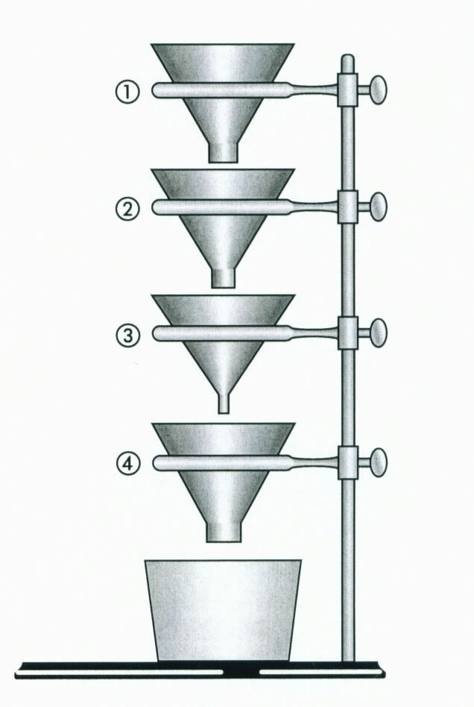

Temperature Versus Time for Reaction Rate

|  |  |  |  |  |  |  |  |  |  |  |  |  |  |  |  |  |
| --- | --- | --- | --- | --- | --- | --- | --- | --- | --- | --- | --- | --- | --- | --- | --- | --- |
|  |  |  |  |  |  |  |  |  |  |  |  |  |  |  |  |  |
|  |  |  |  |  |  |  |  |  |  |  |  |  |  |  |  |  |
|  |  |  |  |  |  |  |  |  |  |  |  |  |  |  |  |  |
|  |  |  |  |  |  |  |  |  |  |  |  |  |  |  |  |  |
|  |  |  |  |  |  |  |  |  |  |  |  |  |  |  |  |  |
|  |  |  |  |  |  |  |  |  |  |  |  |  |  |  |  |  |
|  |  |  |  |  |  |  |  |  |  |  |  |  |  |  |  |  |
|  |  |  |  |  |  |  |  |  |  |  |  |  |  |  |  |  |
|  |  |  |  |  |  |  |  |  |  |  |  |  |  |  |  |  |
|  |  |  |  |  |  |  |  |  |  |  |  |  |  |  |  |  |
|  |  |  |  |  |  |  |  |  |  |  |  |  |  |  |  |  |
|  |  |  |  |  |  |  |  |  |  |  |  |  |  |  |  |  |
|  |  |  |  |  |  |  |  |  |  |  |  |  |  |  |  |  |
|  |  |  |  |  |  |  |  |  |  |  |  |  |  |  |  |  |
|  |  |  |  |  |  |  |  |  |  |  |  |  |  |  |  |  |
|  |  |  |  |  |  |  |  |  |  |  |  |  |  |  |  |  |
|  |  |  |  |  |  |  |  |  |  |  |  |  |  |  |  |  |
|  |  |  |  |  |  |  |  |  |  |  |  |  |  |  |  |  |
|  |  |  |  |  |  |  |  |  |  |  |  |  |  |  |  |  |
|  |  |  |  |  |  |  |  |  |  |  |  |  |  |  |  |  |

Temperature

Time

## A. What relationship is shown between the temperature and the time based on this laboratory? Explain.

## *Inverse proportion. As temperature increases, the amount of time it takes decreases. As temperature decreases, the amount of time it takes increases.*

## B. What is the relationship between the rate of reaction and temperature? Explain.

## *Direct proportion. As temperature increases, the reaction rate increases. As temperature, decreases the reaction rate decreases.*

Sample Results:

|  |  |  |  |  |  |
| --- | --- | --- | --- | --- | --- |
| **Water Temperature** | **100 C** | **75 C** | **50 C** | **25 C** | **Ice**  **0 C** |
|  |  |  |  |  |  |
| **Time to Dissolve** | 0.50 min | 1:45 min | 4:12 min | 8:30 min | 20 min |

## Conclusions

Address the Hypothesis:

**The hypothesis was confirmed. When the water temperature increased from 0 C to 100 C, the tablet dissolved faster (took much less time) because there would be more collisions of particles due to the higher temperature.**

1. What effect does temperature have on reaction rate?

***Temperature is directly proportional to reaction rate of a chemical reaction. The higher the temperature, the faster the rate.***

2. Why does temperature have such an effect on reaction rate (from question 1)?

***Temperature is is the measure of the average kinetic energy (motion) of molecules. The higher the temperature, the faster the particles / molecules move, yielding more collisions. This causes the reaction to go faster.***

3. Give five (5) factors that speed up the rate of a reaction (i.e. the time to dissolve the tablet). Explain why each of these speeds up a reaction.

***Reaction Rate is affected by:***

* ***surface area*** *(increases the collisions and orientation of collisions),*
* ***concentration of reactants*** *(the higher the concentration, the more the collisions),*
* ***temperature*** *(as observed),*
* ***catalysts*** *(lowering the activation energy barrier, yielding an alternative reaction pathway or mechanism ),*
* ***Stirring / Agitation*** *(collisions between reactant particles are more likely to happen).*

4. Based on the picture below. Which step is the rate determining step?



***Step 3 … smallest hole***

***Just like in a relay race for track. The fastest runner is the “anchor” or last leg of the race. The second fastest runner usually leads off (runs first). The slower runner (RATE DETERMINING STEPS) run second and third.***