Observe the items in all 24 squares below in terms of similar characteristics.

Fill in the columns and rows (for the chart you copied) based on a recognizable & sensible pattern of the items. The 2nd row is the category of food.

|  |  |  |  |  |  |  |  |
| --- | --- | --- | --- | --- | --- | --- | --- |
| Radio | Microwave | Infrared | Visible ROY | Visible GBIV | Ultraviolet | x-rays | gamma |
| Meat |  |  |  |  |  |  |  |
|  |  |  |  |  |  |  |  |
|  |  |  |  |  |  |  |  |
|  |  |  |  |  |  |  |  |

What guidelines did you use to make your Periodic Table of Foods? How did you determine “Groups”?

How did you determine “Periods” or “Rows”?

How was the periodic table developed and how is it arranged?

Searching for an Organizing Principle

D_____

* In 1829, a German chemist, J. W. Dobereiner, published a classification system. He grouped known elements into _____, sets of _____ elements with _____ properties.
* One triad consisted of chlorine, bromine, and iodine. They each look different, but have very similar chemical _____.

Dobereiner’s Triads

* When the ___ elements in a triad are put in the order of their atomic _____, the difference in mass between the first and second elements is about the same as the difference in mass between the second and third elements.

N_____’s Law of _____ - John Newlands (1865)

* He arranged the Periodic Table according to _____ atomic _____.
* He established the “Law of _____” 🡪 noticing a repeating pattern of _____ properties every _____ elements on the Periodic table.

M_____’s Periodic Table

* In 1869, the Russian chemist Dmitri Mendeleev produced the _____ orderly arrangement, or periodic table, of all ___ elements known at the time.
* Mendeleev wrote the _____ for each element, along with the _____ and _____ properties.
* Mendeleev arranged the elements in order of _____ atomic _____.
* Mendeleev noticed that _____ properties of elements occurred after “_____” of varying lengths (rows on Periodic Table).
* He established “_____” or “_____” (*columns*) on the Periodic Table, possessing _____ chemical _____.
* Mendeleev predicted properties and masses of _____ elements that he knew existed. (e.g. scandium, gallium, germanium).
* Mendeleev could _____ account for Iodine whose atomic mass was less than Tellurium, but whose chemical properties belonged with Br and Cl’s group .

The Modern Periodic Table

Henry _____ (1887-1915)

* Revised the periodic table to the _____ version.
* Arranged all the elements in order of _____ atomic _____.
* Accounted for variations resulting from _____.

The Modern Periodic Table

* The periodic table of elements is an organized display of the chemical elements.
* In order of _____ atomic _____ (_____)
* Similarities in chemical _____
* Similarities in _____ _____

Metals, Nonmetals, and Metalloids

M_____

* As one goes _____ a _____, the properties of elements become less _____ and more nonmetallic. About ___% of the elements are _____.
* Good _____ of heat and electric current.
* High _____, or sheen … ability to _____ light.
* _____ at room temperature, except for mercury (Hg).
* _____, can be drawn into _____.
* _____, can be _____ into thin sheets without breaking.
* Hard & _____

_____

* Tend to have properties _____ of metals.
* Usually _____ conductors & _____.

_____

* “_____ Elements” that sometimes behave like metals.
* Under other conditions, they may behave like nonmetals.
* _____ is also present as the compound silicon dioxide in glass items and the earth’s crust (*silica*).

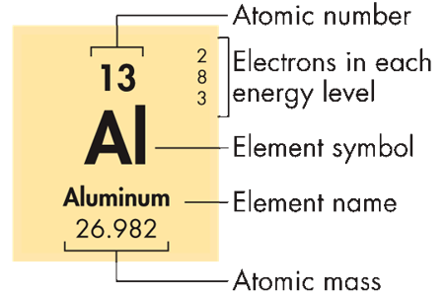

Information for Each Element

Each element’s entry on the periodic table shows:

* Chemical _____
* Element name
* Atomic _____
* Average atomic _____
* _____ _____

_____ Law

* When elements are arranged in order of _____ atomic _____, there is a periodic pattern in their physical and chemical _____.

_____ - _____ rows on the periodic table

* + Indicate _____ energy _____ of _____ electrons (Quantum number 1, ___).
  + Atomic _____ increases from _____ to right across the period.
  + In each period the number of _____ electrons _____ from left to right.
  + Chemical _____ _____ systematically across the periodic table.

_____: _____ or “_____ " on the periodic table

* Elements within a group have the _____ chemical properties
* Groups contain the same number of electrons in outermost level (_____ electrons), which explains why groups have the same properties
* “___” groups 🡪 _____ filling s and p _____ orbitals

“Magic number is “___” … __2 + __6

_____ Metals (Group IA) … s1

* Group 1 or _____
* Easily _____ an electron to form a ___ _____ *in order to gain* _____ *electron configuration*
* Typical properties:
  + Silver in color
  + Soft (can be cut with a knife)
  + Highly _____ with oxygen and water
  + Able to oxidize in air

“Magic number is “8” … s2 + p6 … Is it easier for the metals to _____ ___ electrons to make ___ or to lose ___ electron to have a _____ valence in the next lowest energy _____?

11Na23 neutral cation

+11 p +11 p

-11 e - e

0 +1 charge

_____ _____ Metals (Group IIA) … s2

* Group 2 or _____
* _____ two electrons to form a ___ _____ *in order to gain ideal electron configuration*
* Typical properties:
  + Silver in color
  + More brittle than alkali metals
  + Somewhat reactive
  + Low in density, with low melting and boiling points

“Magic number is “8” … s2 + p6

Is it easier for the metals to gain ___ electrons to make ___ or to lose ___ electron to have a full _____ in the next lowest energy level?

12Mg24 neutral cation

+12 p +12 p

-12 e - e

0 +2 charge

_____ Metals (B Groups)

* Characterized by the presence of electrons in ___ orbitals … E.g. C_____, silver, gold, iron
* Form _____ compounds
* May have unusual properties:
  + Magnetism
  + High conductivity

_____ Transition Metals (___ Groups) … also called _____ -earth elements.

* Characterized by the presence of electrons in ___ orbitals
* L_____: *elements 57-71*
* A_____: *elements 89-103*
* Radioactive (e.g. U-92)
* Present in only trace amounts on Earth

_____ (Group VIIA) … s2 p5

* Group 17 or _____
* Easily _____ an electron to form a ___ _____ *in order to gain ideal electron configuration*
* Typical properties
  + Highly _____ with metals
  + Toxic to organisms
  + Most occur as diatomic molecules (F2, Cl2, Br2, I2)
  + React with metals to form salts

“Magic number is “8” … s2 + p6 … Is it easier for the _____ -metal to _____ ___ electron to make 8 or to lose ___ electrons to have a full valence in the energy level?

17Cl35 neutral anion

+17 p +17 p

-17 e - e

0 -1 charge

_____ Gases (Group VIIIA) … s2 p6

* Group 18 or _____
* Inert gases (nonreactive)  *have ideal electron configuration*
* Typical properties
  + Odorless and tasteless
  + Nonreactive and nonflammable
  + Have extremely low boiling points (i.e. _____)
  + Produce characteristic colors when excited electrically

_____ Rule – Stability of Atoms When Bonding

* The _____ of an atom is associated with electron configuration:
* The _____ number of _____ in outer level is ___e-  [ *s* orbital holds up to ___ e-, *p* orbitals hold up to ___ e-  ]
* 8e- represents a very stable arrangement (noble gas configuration)
* Helium (2He4) has only ___e- but a complete outer shell.
* Atoms tend to combine with other atoms in such a way that each atom has _____ electrons in its _____ shell, giving it the same electron configuration as a _____ gas.

Electron Configurations in Groups

_____ Electrons

* The number of electrons in the _____ occupied _____ _____ (n) level (_____ electrons.)

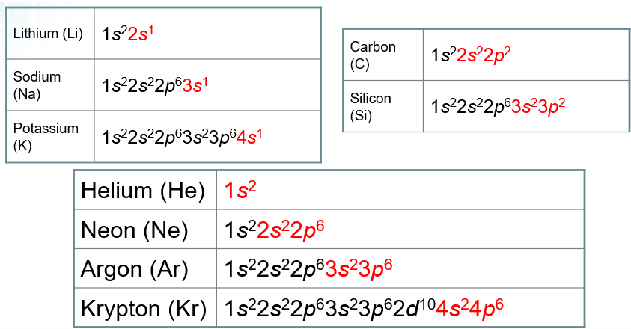

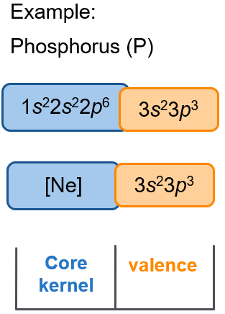

_____ & Valence Electrons in A Groups

* Highest *n* orbitals = _____ electrons
* All other orbitals = _____ electrons (use [Ne])
* _____ number relates to the number of _____ electrons
* _____ gases (group VIII or 18): _____ valence shell

Kernel & Valence Electrons in B Groups

* Notice that valence electrons are still in the _____ “n” s and p orbitals
* Partially filled *___* and *___* orbitals = valence electrons

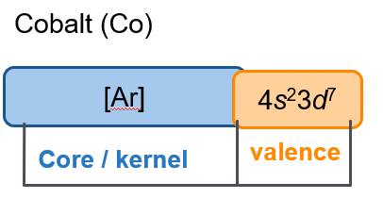

Group “A” & “B” Elements distinguished by sublevels

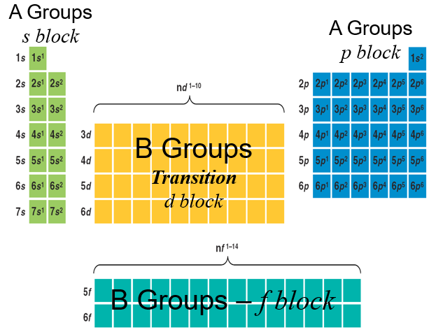

Periodic Trends

Atomic Radii

* This _____ is expressed as an atomic radius, and is one-half of the distance between the nuclei of two atoms of the same element when the atoms are joined. (picometers or 10-12 m)

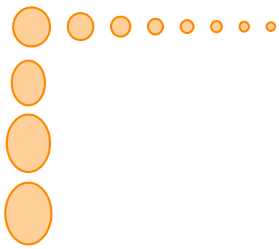

Trends in Atomic _____

* In general, atomic size _____ from _____ to right across a _____ & _____ going down a _____
* Electrons are added:
  + To the _____ energy level across a period (_____ nuclear charge draws them in)
    - E.g. using a larger magnet to pick up metals
  + To a _____ energy _____ down a _____ (the atom is much larger and electrons more energetic)
    - E.g. placing the electrons in a bigger room to accommodate the larger atom

The _____ Effect

* The increase in the number of occupied orbitals _____ _____ in the highest occupied energy level from the _____ of protons in the _____. (e.g. solar eclipse)

Trends of Ionic Radii

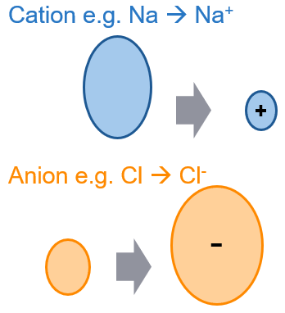

_____ radius is a measure of the size of an ion.

* _____ for _____ across a _____.
  + Groups 1A – 3A elements lose electrons to become cations.
* _____ for _____ across a _____.
  + Groups 4A – 8A elements gain electrons to become anions.
* _____ down a _____.

Ions

* _____, such as Sodium _____ electrons when bonding, giving the sodium ion a net _____ charge (11 protons - 10 electrons). The positive ion is called a cation and is written as Na+. The _____ size is _____ than the atomic size.
* _____, such as chlorine, _____ electrons when bonding, producing an _____ (_____ ion): (+17 p – 18 e-). This is written: Cl-. The _____ size is _____ than the atomic size.
* In general, _____ tend to form _____. _____ tend to form _____.

_____ Energy

* The energy required to _____ an _____ from an atom.
* The tendency to _____ electrons is evidence of _____ character (*to gain ideal electron configuration*).
* Ionization energy _____ across a _____ & _____ down a _____.

Trends in Ionization Energy

* _____ tend to _____ electrons, meaning it takes _____ energy (lower I.E.)
* _____ tend to _____ electrons, meaning it would require _____ energy (higher I.E.)

E_____

* The measure of the electron _____ power (electron _____) of an atom when it bonds with another atom (*to gain ideal electron configuration*).
* A property used to predict Bonding type during a reaction.
  + _____ along a _____ or row
  + _____ down a _____ or family

Trends in Electronegativity

* _____ do not “gain” electrons, meaning _____ electronegativity
* _____ DO gain electrons, meaning _____ electronegativity

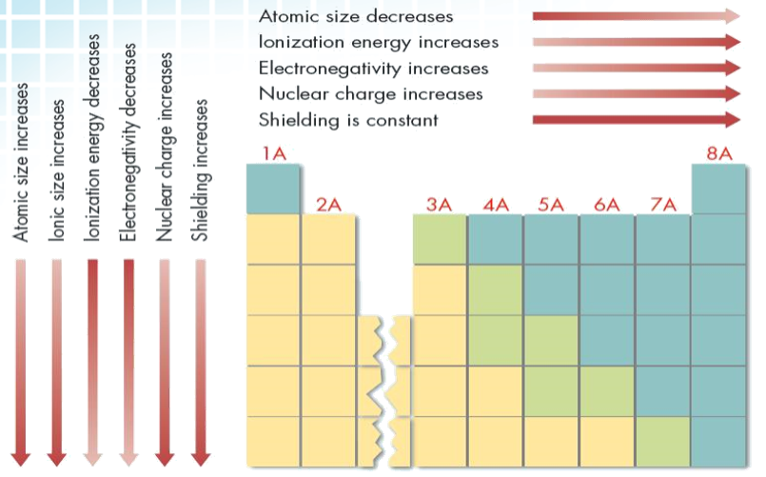

SUMMARY

The Arrangement of the Periodic Table

* The periodic table contains a great deal of information on the elements.
* _____ refer to _____ rows of the periodic table.
* _____ or *families* refer to _____ _____ of the periodic table.
* Cells of the periodic table contain information such as the atomic _____, atomic _____, atomic _____, name of the _____, _____ configuration, and possible _____ numbers.
* Elements can be categorized broadly as _____, _____, or semimetals (_____).

Classifying the Elements

* Groups
* _____ metals: most reactive metals, soft, oxidize quickly
* _____ earth metals: not as reactive as alkali metals, brittle, shiny
* _____ metals: form colored compounds, good conductors of electricity
* _____: most reactive nonmetals
* _____ gases: lowest chemical reactivity, used in lighting
* _____ transition metals: radioactive, used in nuclear power plants