**Poisonous & Invasive Plants 2**

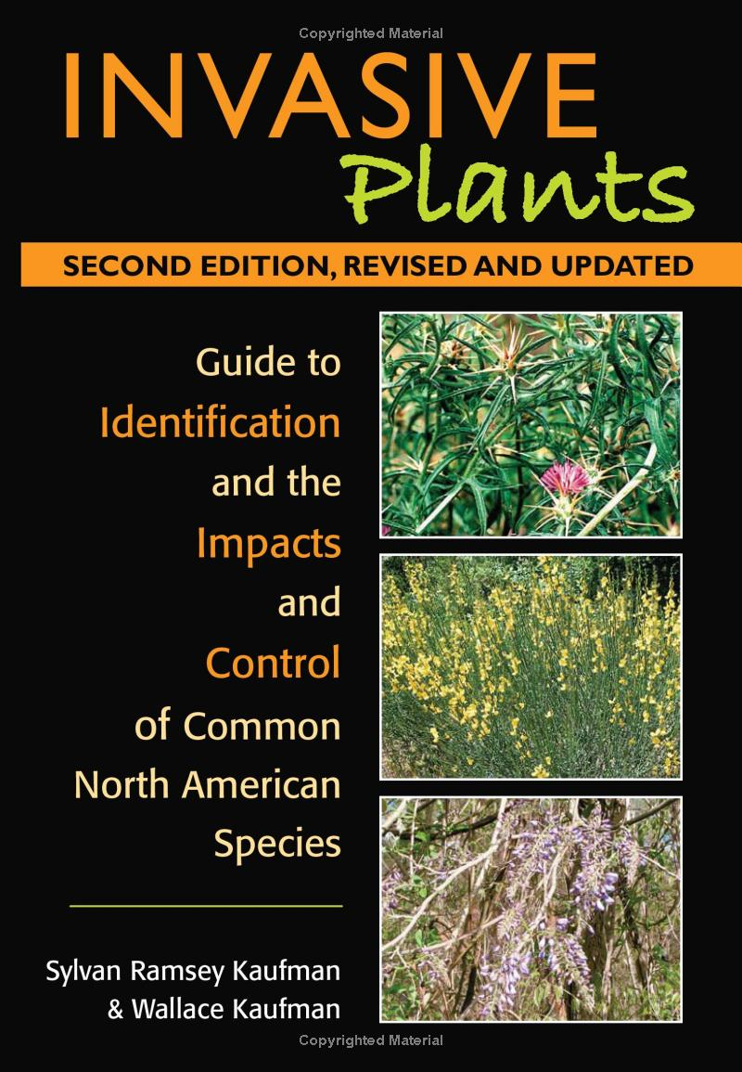

**See** [**https://www.learningctronline.com/courses**](https://www.learningctronline.com/courses) **for Materials and Resources.**

**Topics:**

1. Poisonous & Invasive Plants

**Objectives:**

* + Field Guides
  + Identify Poisonous & Invasive Plants
  + Field Specimen Activity
  + Continue Tree & Poisonous Plant Scrapbook Project

TAKE NOTE

1. Tree & Poison Plant Scrapbook [due in 4 weeks]
2. Complete the Lab: Identifying Poisonous & Invasive Plants using PPT
3. Outdoor Field Identification Activity
4. Quiz: Poison & Invasive Plants Identification
5. Week 4 Devotional (<https://www.learningctronline.com/devotional>)

**Text**: Peterson Field Guide to Edible Wild Plants

**Reference Material: Edible Wild Plants PowerPoint**

**Homework**:

* Review the expectations for the Tree & Poison Plant Scrapbook

**Lab**: Poison & Invasive Plants Identification using PPT

* Complete the lab as directed using the worksheet provided.
* Save the document into your LAB folder in the Projects in Science folder on your desktop.

**Lab**: Outdoor Field Identification Activity

* Complete the lab as directed using the worksheet provided.
* Save the document into your LAB folder in the Projects in Science folder on your desktop.

**TEST: ID** Quiz Poisonous & Invasive Plants (Identification)

1) the academic integrity policy

* Tests must be completed **WITHOUT** referring to books, notes, the internet, people, or any outside resources.
* Students **MAY** use the approved Periodic Tables, approved Reference Tables, or approved equation (formula) sheet (provided by the teacher) along with calculators and scratch paper.
* A guardian should be proctoring the test. Proctoring means to monitor the following:

2) Take the **"in one sitting"**, meaning that once you start the test, you must complete it without interruption.

3) There is a **15-minute time limit** on this test. Please have the proctor write the time taken at the top of your answer sheet with their signature or initials.

4) Proctors should NOT be reading the test or engaging students during the test.

5) Do NOT use RED font. Black font is best.

Supplemental Resources (Optional)

1. Crossword Review Poisonous & Invasive Plants