Describing Matter

* All substances possess either _____ or _____ properties.
* An e_____ property depends on the _____ of matter in a sample.
* e.g. The _____ of an object, a measure of the amount of matter the object contains, is an extensive property.
* The _____ of an object, a measure of the _____ occupied by the object, is an extensive property.
* The volume of a basketball is greater than the volume of a golf ball.
* _____ is also an _____ property; (mass x gravity).
* _____ can be an extensive property when describing how much wire or rope one needs. E.g. 2 m of rope

Describing Matter

* I_____ Properties - help _____ a substance; _____ based on the *amount* of matter.
* Complete the chart:

|  |  |  |  |
| --- | --- | --- | --- |
| Extensive (amount) | Intensive (identification) | General  (both or unknown) | Intensive and/or General |
|  |  |  |  |
|  |  |  |  |
|  |  |  |  |
|  |  |  |  |

Classifying Matter

All matter consists of _____ substances and _____.

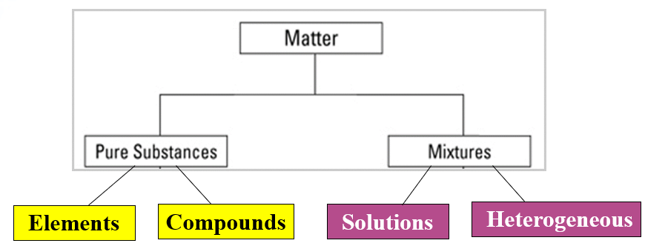

E_____

* _____ substances that _____ be broken down by ordinary chemical means. Elements have a fixed composition because it contains only ___ type of atom.

C_____

* _____ substances made up of _____ or more elements and/or compounds that are _____ combined in a _____ proportion.

M_____

* Substances are classified by “Phases”. Pure substances have only 1 Phase, mixtures have more than ___ phase.
* Mixtures do ___ have uniform composition or properties.
* Each substance (atom/element/compound) in a mixture _____ its own _____. E.g. oil & vinegar
* The term phase is used to describe any part of a sample with uniform composition and properties; also called a “_____”.
* _____ mixture
  + Substances are so _____ distributed that it is difficult to distinguish one substance in the mixture from another. Only ____ boundary or phase.
  + Called “_____”
  + E.g.
  + Solutions can be any _____ of matter (s, l, or g)
  + Substances _____ and form homogeneous mixtures.
  + Particles are too _____ to settle out.
  + Do NOT _____ into layers over time.
  + Cannot be _____ out.
  + No _____ Effect (light passes through a transparent solution _____).
* _____ mixture
  + Appears to have more than _____ phase
  + Having parts with _____ characteristics 🡪 separated by definite _____
  + E.g.

Classifying Matter

* _____ Substances (_____ and _____)
* _____ (_____, _____)

Separating Mixtures

* Most of the things around us are _____.
* To understand, _____, and evaluate substances for the myriads of reasons (medicine, cleanliness, organization, functionality, etc.), we need to _____ mixtures into their _____ components.

Separating _____ Mixtures

* F_____ is a process that separates elements of a heterogeneous mixture based on particle _____.
  + _____ cannot be filtered out.
* M_____: separates mixtures based on the presence of magnetic physical properties.
  + A magnetic substance’s molecules take on a specific _____ (domains), creating magnetic fields with force.
* C_____ separates elements of a mixture based on different _____. E.g. hematocrit (Red blood cell separation) & protein analysis

Separating _____ Mixtures

* D_____, separates _____ in _____ (solutions) based on varying _____ points (intensive physical property).
* E_____ _____ dissolved _____ from the liquid they are dissolved in; also called _____.
* C_____ separates components of a mixture based on their differential migration due to _____. 60% of chemical analysis worldwide is currently done with chromatography.
* E_____
  + Separates components of a mixture based on the differential movement of _____ particles in a liquid or gel under the influence of an electric field. Used for Protein and DNA analysis and in forensics.

_____ Changes

* Separating _____ is based on Physical Change
* Any change that occurs without _____ the chemical composition of a substance
* _____ new substance is formed and the physical & chemical _____ of the constituents remains.
* Physical changes involve a change in outward _____ and arrangement, but _____ in chemical identity.
* Physical changes can be _____ (*putting a puzzle together*) or _____ (*breaking a glass*).
* Physical changes often involve a reversible change from one _____ to another:
  + _____ ↔ _____ ↔ _____

States of Matter

_____

a. _____ shape

b. _____ volume

c. _____ packed molecules

d. Greater _____ than liquids or gases

e. Usually _____ compressible of phases

f. Molecules move slowest of all the phases**Gas** Versus **Vapor**

_____

a. _____ definite shape

b. _____ volume

c. Less tightly packed molecules that take the _____ of the container

d. Lesser density than solids, but greater than gases (usually d ∞ 1/T)

e. Relatively _____ -compressible except for extreme temperatures and pressures

f. Molecules move slower than gases, faster than solids

_____

a. _____ definite shape

b. _____ definite volume

c. Take the _____ and _____ of the container

d. _____ _____ of all phase

e. Compressible

f. Molecules move _____ of all the phases

g. Must consider variables of _____ and _____

Gas Versus Vapor

* A gas is a substance, like oxygen (O2), that exists in the gaseous state at _____ temperature.
* _____ describes the gaseous state of a substance that is generally a _____ or _____ at room temperature, as in water vapor.
* _____ is a high temperature physical state of matter in which atoms lose most of their electrons. Plasma is found in fluorescent bulbs.

Give examples of physical changes:

_____ changes

* _____ the chemical composition of a substance
* produce _____ substances with physical & chemical properties _____ from the constituents. e.g. Sodium (Na) explodes in air, Chlorine gas (Cl2) is lethal; But table salt (NaCl) tastes great!

Give examples of chemical changes:

How can we distinguish chemical change from physical?

Similarities of both physical & chemical changes:

* _____ transfer (e.g. absorbed or released)
* Often a _____ of matter change
* _____ formation* (bubbles form when you boil water or open a carbonated drink [physical], but bubbles* also form when an acid reacts with metal [chemical].
* _____ * (a solid forms in a liquid) rain [physical]; solutions chemically react to form to a precipitate* [chemical]
* _____ change or odor

CHEMICAL CHANGES:

* _____ chemical substances form
* a chemical “_____” occurred
* Combustion

_____ of Mass

* Chemical changes are based on chemical reactions that involve “_____” ↔ “_____”.
* During any chemical reaction [based on a chemical change], the _____ of the products is always _____ to the _____ of the reactants.
* Matter _____ be created or destroyed;
* it can only change form (_____).
* Mass also remains constant for Physical Changes.
* E.g. _____ g or ice melt to form _____ g of liquid water
* The Law of _____ _____ states that in any _____ or _____ change (reaction), mass is conserved.

_____ Proportions

* The mass of any element is given on the Periodic table and never changes in chemistry.
* The mass of a compound, however, is based on a _____ _____ of the _____ that are _____ combined in the chemical reaction that formed that compound.
* For any compound, the _____ of elements _____ in that compound _____ changes.
  + E.g. CO2  contains the elements _____, C, and _____, O, in a fixed proportion of 1:2. [The subscript for Carbon is 1]
* Use the periodic table to find the masses of the elements:

*C🡪* ? O 🡪 ? Total Mass =

* CO2 is always in the ratio of: by_____**.**

Suppose you have a 30.1 g sample of a compound of carbon and hydrogen that decomposes to yield 24.0 g C and 6.1 g H.

You have another compound of carbon and hydrogen with a mass of 67.7 g that decomposes to yield 54.0 g C and 13.7 g H. Is this the same substance as the first sample?

* Ratio of C to H in 30.1 g sample: _____ g / _____ g = _____
* Ratio of C to H in 67.7 g sample: _____ g / _____ g = _____
* The ratios for both samples are almost _____, so one could say they both are the _____ _____.

What if a third compound of carbon and hydrogen has a mass of 80.0 g and decomposes to yield 60.0 g C and 20.0 g H. Is this the same substance as the first sample?

* Ratio of C to H in 80.0 g sample: _____ g / _____ = _____
* Based on the ratio, this compound is a _____ substance from the first two.