**Alternative Energy Resources**



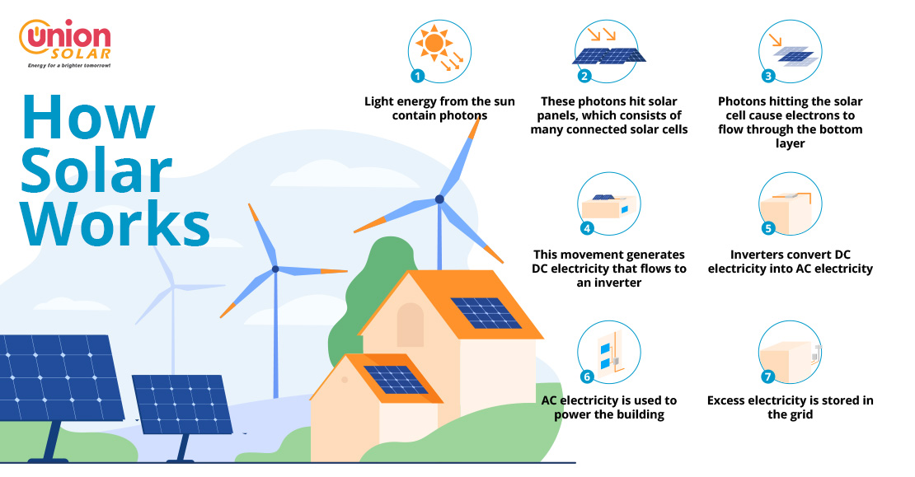

**See** [**https://www.learningctronline.com/courses**](https://www.learningctronline.com/courses) **for Materials and Resources.**

**Topics:**

1. Alternative Energy Resources

**Objectives:**

* + Gain a general knowledge of alternative energy resources and energy conservation.
  + Understand and define the terminology associated with wind, solar, and other alternative energy resources related to electrical production.
  + Understand fracking and its potential as an alternative energy resource.
  + Research “green” energy resources to compare with traditional resources (fossil fuels, hydropower, and nuclear energy).

TAKE NOTE [1 week]

1. Lab Solar Energy
2. Lab Wind Energy
3. Fracking Research Worksheet
4. Project: Go Green
5. Week 23 Devotional (<https://www.learningctronline.com/devotional>)

**Text**:

**Reference Material:**

**Homework**:

* Fracking Research Worksheet

**Lab**: Solar Energy

* Complete the Solar Energy lab using the worksheet provided.
* Save the document into your LAB folder in the Projects in Science folder on your desktop.

**Lab**: Wind Energy

* Complete the Wind Energy lab using the worksheet provided.
* Save the document into your LAB folder in the Projects in Science folder on your desktop.

**TEST:** Project Go Green

Supplemental Resources (Optional)

Solar Energy <http://somup.com/c0XIrbgqSh> (1:54)

Wind Energy <http://somup.com/c0XIrrgqSv> (3:09)

Hydraulic Fracturing (Fracking) <http://somup.com/cZVn0Gkrt5> [6:30]

Fracking Health Concerns <http://somup.com/cZVn0Lkruh> (8:10)

Fracking in Australia <http://somup.com/cZVecckruY> (3:21)