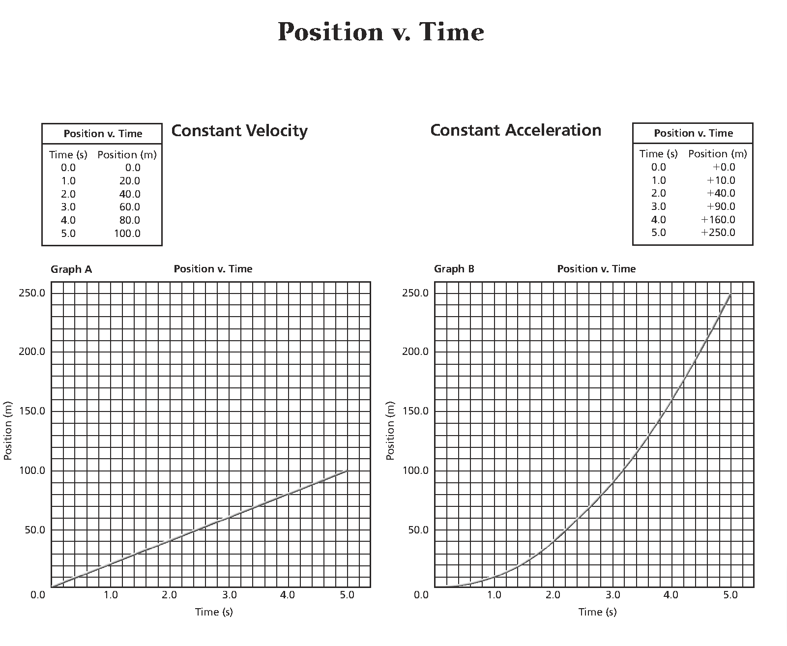

1. On graphs A and B, what is the independent variable? The dependent variable?

2. Which graph represents a linear relationship between the variables? A parabolic relationship?

3. What is the slope of the line in graph A? What does the slope represent?

4. For graph A, what is the total displacement between 3 s and 5 s?

5. Determine the object’s total displacement after 10 s.



6. For graph B, compare the displacement between 0 s and 1 s, with the displacement between 1 s and 2 s. What does this indicate about the velocity of the object?

7. Compare the change in velocity of the objects represented in the two graphs.

8. At what time(s) are both objects at the same position?

9. For graph B, determine the average velocity between 0 s and 3 s?

1. On graphs A and B, what is the independent variable? The dependent variable?

*Position is the dependent variable; time is the independent variable*

2. Which graph represents a linear relationship between the variables? A parabolic relationship?

*Graph A represents a* *linear relationship between the variables while Graph B represents a parabolic relationship.*

3. What is the slope of the line in graph A? What does the slope represent?

*Slope is the area under the curve and can be calculated using ∆y/ ∆x. The slope of the line in Graph A is 20.*

4. For graph A, what is the total displacement between 3 s and 5 s?

*The total displacement from 3 s (60 m) to 5 s (100 m) is 40 m.*

5. Determine the object’s total displacement after 10 s.

*The total displacement after 10 s would need to be extrapolated. Since the slope is 20, the displacement at 10 s would be 200 m.*

6. For graph B, compare the displacement between 0 s and 1 s, with the displacement between 1 s and 2 s. What does this indicate about the velocity of the object?

*The displacement between 0 s and 1 s is 10 m. The displacement between 1 s (10 m) and 2 s (40 m) is 30 m. This indicates that velocity increased between 0 – 1 s and 1 – 2 s.*

7. Compare the change in velocity of the objects represented in the two graphs.

*There was no change in velocity on Graph A. Graph B shows a change in velocity over each second of motion. This is called acceleration.*

8. At what time(s) are both objects at the same position?

*At the origin or time, 0 s, both objects are at the same position. However, as soon as they start moving, the object in Graph B is displaced more than the object in Graph A.*

9. For graph B, determine the average velocity between 0 s and 3 s?

*Average velocity is the total distance over the total time. At 0 s, the distance is zero. At 3 s, the distance is 90 m. v = d / t = 90 m / 3 s = 30 m/s*