**Measurement and Units**

*Use the “Triangle Method” to rearrange 3 variable equations.*

m

v

d

|  |  |  |
| --- | --- | --- |
| **Quantity**  d = m/v  m = d v  v = m/d | **Unit** | **Abbreviation** |
| Time |  | s |
| Length or distance |  | m |
| Area |  | m2 |
| Volume |  | m3 |
| Temperature |  | ° C |
| Mass |  | g, kg |
| Density | mass/volume | g/ml |
| Force |  | N |

Metric prefixes kilo hector deka UNIT deci centi milli

1000 100 10 1 0.1 0.01 0.001

**Motion**

A Force is a push or a pull that produces m____. It is measured in Newtons.

1 Newton = 1 kg∙m/s2

Understand “position versus time” graphs and “Velocity versus time” graphs

Speed = Units are ____

Velocity = Units are ____

Average speed = total distance / total time

Acceleration = Units are ____

The acceleration of g____ = “g” = ____ m/s2

Acceleration is produced by (balanced or unbalanced) force(s)

____ force is the sum of all the forces on an object. In terms of circular motion, ____ force pulls objects towards the ____. Without it, objects would travel ____ to the circular motion.

f____ opposes motion. Give one example of each type of friction:

sliding: static:

fluid: rolling:

Coefficient of friction (u) = Ff / FN

* Freely falling objects only experience g____ (*and air resistance … a form of friction*).
* The distance an object free falls … calculated with: d = _____
* Instantaneous velocity of a freely falling object that hits the ground; calculated with V = ___

**Vectors**

A vector is comprised of (1) a number (_____) WITH (2) a _____. Examples of vectors are: _____ vs distance; _____ vs speed; a_____; f_____.

Vectors in one direction … head to tail addition or subtraction. The sum of two vectors: _____.

The _____ is equal and opposite to the resultant. 2-dimensional diagrams use trigonometry.

For a given right triangle problem, one can find the x and y components as follows:

θ

X

Y

R

**x component** **Xx** = _____

**y component** **Yy** = _____

**Newton’s Laws**

1st → An object resists a change in motion unless an outside force acts upon it → i____.

2nd → The a____ of an object depends on the f____ on it, and its own m____.

Acceleration = Force ÷ Mass  Force = Mass ∙ Acceleration

3rd → Forces come in ____ & ____ pairs. If you push on a wall with a 10 N force, it will push back on you with ___ N, in the opposite direction. If you pull on an object with a 20 N force, you will be pulled with a ___ N force in the _____ direction.

Projectile Motion (2-dimensional motion)

|  |  |  |  |  |
| --- | --- | --- | --- | --- |
| **Free Fall** | **Vertical Free Fall** | **Parabolic** | **Horizontal Cliff fall** | **Trajectory Cliff Fall** |
|  | | |  |  |

dy = Vyt + ½ gt2 dx = Vxt Vx = Vicos@ Vy = Visin@

**Momentum** = m____ ∙ v____ p = mv

The momentum of a 24-kg boulder moving at 3 m/s is ____.

When two or more objects interact (pull, push, crash, etc.), the *total momentum* of the system (all the objects) is conserved.

**Conservation of Momentum** → m1v1 = _____

**Impulse** ___ = ∆___ → increasing impact time, decreases impact force (vice versa)

**Energy**

Energy is sometimes defined as the ability to do w____. Not all energy can be converted into useful work – some will be transformed into h____ (seemingly lost) due to f_____. When you do work on something, you use up energy and give energy to the object.

E and W are both measured in _____ (J)

There are many forms of energy, each of which can be converted into other forms.

K_______= ½(mv2) P________ = mgh Electromagnetic

H____ Sound E__________ Light

E______ G___________

Nuclear Chemical

*Mass (E = mc2), where c = speed of light = 3 x 108 m/s*

P____ Energy PE = mgh PE is greatest at the maximum h____.

K____ Energy KE = ½ mv2 KE is greatest at the maximum v____.

Theoretically, maximum PE = maximum KE, f____ always causes energy to transform to heat.

**Total energy = PE + KE**.

Whenever there is “room to f____”, PE exists. Whenever there is m_______, KE exists.

The work done on an object is equal to the f____ on an object times the d____ it moves in the direction of that force. (If you push North but the object only moves East and West, no work is done.) **Work = _____ ∙ _____** The unit of Work is _____**.**

**Power** is a measure of how fast work is done, or how fast energy is changed.

**Power = ____ / _____**

= Joules / Second = W_____

A motor which does 50 Joules of work in 2 seconds has a power of _____ Watts.

A light bulb which uses 240 Joules of energy in 6 seconds uses ____ Watts of power.

A “rate” is how fast something is done, or how much it changes over a certain time. Rates are usually a quantity divided by time (meters per second = speed, dollars per hour = pay rate, degrees per hour = heating rate.)

Figure out how much w____ is done in each s_____, and you have p_____.

**Machines**

Machines are objects which change the way w____ is done. They do not necessarily make the work “easier”. Neither do they change the amount of work done. They change the direction and/or amount of f_____ that is put it and force that comes out. They also change the direction and/or amount of d_____ that is put in and distance that comes out.

If you gain one thing, you must lose the other!!! If you gain force, you lose d_____ on the other end. If you gain distance, you lose f_____ on the other end.

Work output never equals work input because of energy transformations and heat “loss” (friction). This means that efficiency of machines is never 100%. _____ = useful work o____ / total work i____

The six simple machines are p_____, l_____, i______, wheel and axles, w______, & s______.

**Levers** are categorized based on F = _____ R = _____ & E = _____

1st class (R – F – E): seesaw, 2nd class (F – R – E): wheel barrow, 3rd class (F – E – R): baseball bat

**Pulleys** are based on the number of ropes used. Often the numbers of ropes in the “tackle” = MA

**M**____ **A**____ → indicates the usefulness of a machine

MA = _____ force / _____ force or _____ distance / _____ distance

**Heat, Temperature, Expansion**

Heat incorporates ­­­­_____ and _____ (amount).

Heat flows from _____ to _____. This represents _____.

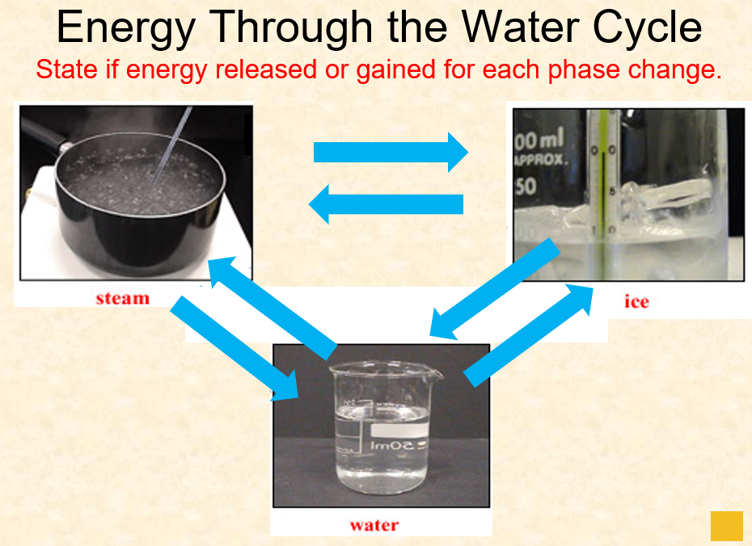

Phase Change Diagrams

* _____ ΔH = +
  + - Heating Curve
    - Heat flows ____ the system from the surroundings
* _____ ΔH = ─
  + - Cooling Curve
    - Heat flows ____ the system into the surroundings

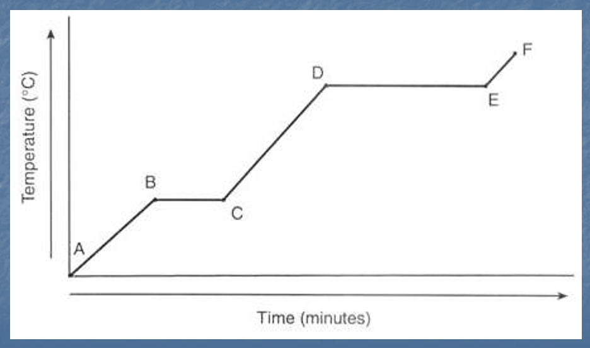

Label the type of phase change diagram.

Label all phases, states of matter, PE, KE

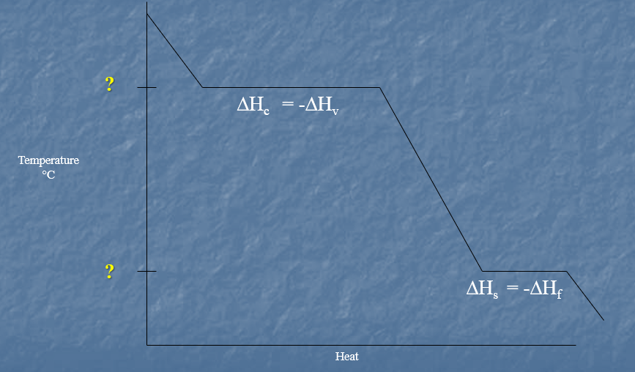

Label the type of phase change diagram.

Label all phases, states of matter, PE, KE

The _____ _____ capacity, or simply the specific heat (C) of a substance, is the amount of heat it takes to raise the temperature of 1 g of the substance 1⁰ C.

* _____ has the second highest specific heat of all liquids.
* _____ generally have low specific heats.
* A _____ is used to measure the specific heat of a substance.
* Equation?

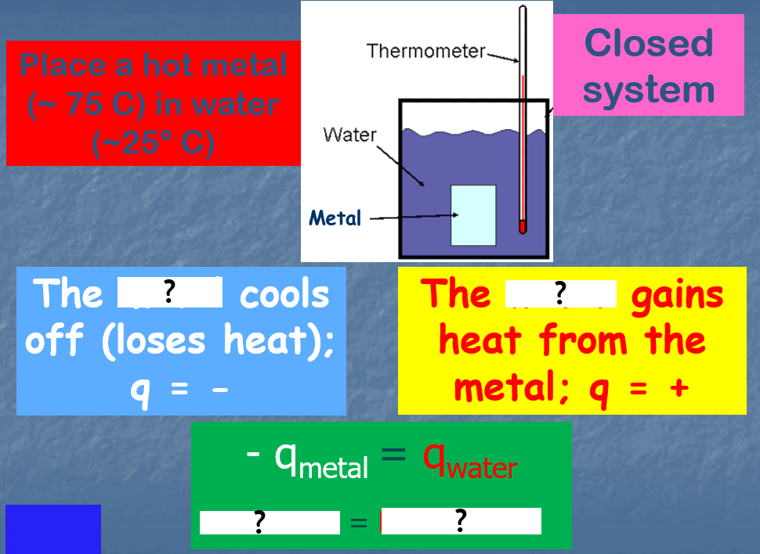

Heat Transfer

Like matter, energy can be transformed from one form to another AND can move from one sphere to another. Thermal (Heat) Energy is transferred in one of three ways:

1. 2. 3.

??

Requires _____ for the transfer. Energy is transferred due to _____ in density or temperature. Causes air, water, land “_____”. The cooler material will ____, warmer material will ____. This is true for heat IN and ON the Earth.

_____ – the transfer of heat by _____ between molecules … requires _____ for the transfer.

* Conduction in gases is slower than in liquids and solids because the particles in a gas collide less often.

A thermal _____ is a material that conducts thermal energy well.

* _____ are good thermal conductors.
* A material that conducts thermal energy poorly is called a thermal _____.
* _____ is a very good insulator. Wool garments and plastic foam cups use trapped air to slow down conduction.

??

Energy that is “given off” by an object AND does _____ require matter for the transfer.

The Earth is most affected by the Sun’s radiation (the heat the Sun gives off (radiates)).

_____ 🡪 The reflectivity of a surface to radiant energy or light.

The higher the albedo the more it ____ radiation.

The temperature increase of a surface depends on albedo. A surface with _____ albedo would not gain as much temperature as a surface with _____ albedo.

The _____ process occurs when air rises or descends. No _____ is added to or withdrawn from air. Air _____ decreases with elevation (as air rises) and therefore _____. The expanding air loses kinetic energy as the molecules slow down, decreasing _____.

x2 + y2 = R2 Pythagorean Theorem … used for right triangles

3

5

4

37

53

1

2

30

60

√3

45

2

√2

√2

@

@

fparallel = mgsin@

f┴= mgcos@

sin A = opp / hyp cos A = adj / hyp tan A = opp / adj

You can break vectors down into their x and y components

To solve for two unknowns, use two equations.

When solving for variables, work with the same variable type: velocity with velocity, distance with distance, etc.

are velocity to distance)

y

x

R

θ

dx = Rcos θ

dy = Rsin θ