Name _______

1. What determines the phenotype (expression) of traits?

2. What type of environmental conditions might trigger a cell to become cancerous?

3. What is the difference between a mutation in a cell and a gene mutation? Are they inherited? Are they expressed?

4. Distinguish changes (e.g. mutations) in chromosome structure and chromosome number. Give the names of each condition.

5. Distinguish mutations in chromosome number for somatic cells versus sex cells. Give specific examples for each.

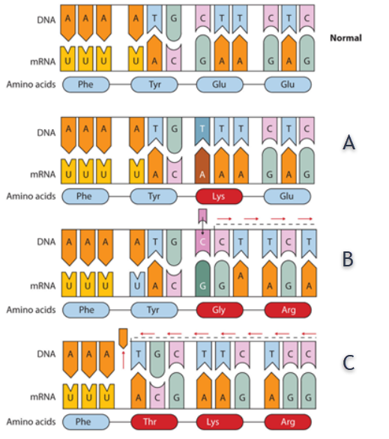

A. What is the mutation? Specifically, what is different?

B. What is the mutation? Specifically, what is different?

C. What is the mutation? Specifically, what is different?

D. How do these mutations affect the protein that is made at the ribosomes?

2. What is a frameshift mutation? Which of the mutations in the previous section are frameshift mutations?

3. List three ways that a DNA mutation can affect a living organism.

A.

B.

C.

4. Using the normal sequence of “ABCDEF”, fill in the following mutations:

AB__EF ABCDCDEF ABEDCF

ABCD EF (two chromosomes) ABCDXYEF

a. deletion

b. duplication

c. inversion

d. translocation

e. insertion

Answers

1. What determines the phenotype (expression) of traits?

***Heredity + Environment = Phenotype or Organism expression of traits. Genetic makeup (genotype) does not necessarily mean that a trait will be expressed.***

2. What type of environmental conditions might trigger a cell to become cancerous?

***Radiation (UV from sunburns; X-rays; Gamma Rays – nuclear); drugs, viruses, chemicals, materials (asbestos).***

3. What is the difference between a mutation in a cell and a gene mutation? Are they inherited? Are they expressed?

***A mutation is simply a change. Therefore, any change in a cell can be considered a mutation and is NOT inherited or passed on to offspring. Tumors, warts, moles.***

***A gene mutation is a change in the DNA and will be inherited or passed onto offspring. However, many mutations involved recessive traits and are masked.***

4. Distinguish changes (e.g. mutations) in chromosome structure and chromosome number. Give the names of each condition.

***Aneuploidy (having one less or one more chromosome) occurs due to nondisjunction during meiosis.***

***Polyploidy results in a 4n, 8n chromosome count rather than the normal 2n. This is observed in cotton, wheat, tobacco, and many types of flowers. Often, this makes plants more vigorous and likely to survive particular environmental or biological conditions. In humans, it is always fatal.***

***Changes in chromosome structure include deletions, substitutions, frameshifts, duplications and translocation. These are serious mutations that can cause severe abnormalities in appearance and health.***

5. Distinguish mutations in chromosome number for somatic cells versus sex cells. Give specific examples for each.

***Somatic cells possess only autosomes. Autosomal aneuploidy is observed with Down Syndrome affecting chromosome pair 21 (trisomy), and Edward Syndrome (trisomy 18), Patau Syndrome (trisomy 13).***

***Sex cell mutation is observed with Klinefelter Syndrome (XXy); Turner Syndrome (XO), Fragile X Syndrome (X-).***



A. What is the mutation? Specifically, what is different?

***Substitution. The G is replaced by A in the mRNA sequence coding for lysine.***

B. What is the mutation? Specifically, what is different?

***Insertion. C C is inserted before the TTT in the DNA sequence, changing the codon.***

C. What is the mutation? Specifically, what is different?

***Deletion. The Adenine is deleted from the DNA sequence, changing the codon.***

D. How do these mutations affect the protein that is made at the ribosomes?

***All of these mutations change the mRNA sequence (codon) and therefore, the amino acid sequence for proteins. Therefore, the protein will be different.***

2. What is a frameshift mutation? Which of the mutations in the previous section are frameshift mutations?

***A frameshift mutation is produced either by insertion or deletion of one or more new bases. Because the reading frame begins at the start site, any mRNA produced from a mutated DNA sequence will be read out of frame after the point of the insertion or deletion, yielding a nonsense protein. In “B” and “C” of the previous section, the DNA, mRNA sequence is shifted to the left.***

3. List three ways that a DNA mutation can affect a living organism.

A. ***no effect***

B. ***most mutations are harmful***

C. ***some mutations are advantageous***

4. Using the normal sequence of “ABCDEF”, fill in the following mutations:

AB__EF ABCDCDEF ABEDCF

ABCD EF (*two chromosomes*) ABCDXYEF

a. deletion **AB__EF**

b. duplication **ABCDCDEF (*can be considered an insertion*)**

c. inversion **ABEDCF**

d. translocation **ABCD EF (*two chromosomes*)**

e. insertion **ABCDXYEF**