Heading

Title

**Introduction**

**Purpose**

To investigate bacteria, protists and fungi.

**Discussion**

Bacteria, Protists, and Fungi cannot be classified as either plants or animals. Each Kingdom will be treated separately in this lab.

**Materials** Video: <https://somup.com/c3j6qEu7Xf> Bacteria Protists Fungi Lab (14:44)

Bacteria

**Discussion**

Bacteria are found almost everywhere – in the air you breathe, in the food you eat, in the water you drink, and even deep in the ocean. They are on your clothes, on your shoes, and on the family dog or cat. A shovelful of soil contains billions of them. There is a huge population of bacteria living within our bodies that are beneficial to us.

For thousands of years, people did not know about bacteria. In the late 1600’s, Antoine Van Leeuwenhoek, a Dutch merchant, used his simple microscope to look at scrapings from his teeth. He observed tiny organisms, but it took another 200 years before bacteria were accepted as living cells.

All bacteria are one-celled organisms, which are “prokaryotic”, meaning they do not have their genetic material in a nucleus. A bacterium is relatively simple in cellular structure, containing cytoplasm surrounded by a cell membrane and cell wall. Genetic material is found in the cytoplasm, not a nucleus. Most bacteria are aerobes (using oxygen for respiration), but some are anaerobes and can live without oxygen. Most bacteria are consumers, obtaining their food from other organisms. Some are producers that use energy from sunlight to make their own food. Some are a special class of consumer called saprophytes which use dead material as a food and energy source. And lastly, some bacteria “fix” nitrogen from the atmosphere into nitrogenous compounds to be used by plants.

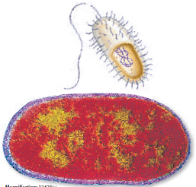

Some bacteria produce a thick wall around themselves when environmental conditions are unfavorable. They are called endospores when they become dormant and can exist in this state for hundreds of years. Two main groups of bacteria (kingdoms) are archaebacteria and eubacteria. Archaebacteria live in harsh environments (salt, extreme heat or cold, acidic) and are named based on the type of environment they live in. While eubacteria exist in less harsh conditions.

In general, bacteria can be identified as having one of three shapes. Sphere-shaped bacteria are called cocci, rod-shaped bacteria are called bacilli, and spiral-shaped bacteria are called spirilaa.

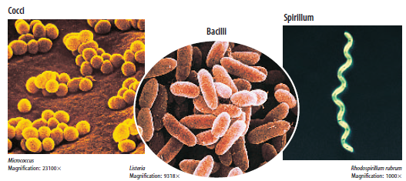

Bacteria can be helpful or harmful. Some bacteria produce chemicals call antibiotics that limit the growth of or kill other bacteria. Streptomycin is an example. Bacteria in our intestines produce vitamin K, which is needed for blood to clot. Harmful bacteria are pathogens that cause disease. Tooth decay is caused by bacteria. Many bacteria produce toxins that negatively affect organisms. Vaccines and sterilization (Pasteurization) can regulate or kill these harmful bacteria.

**Calculations and Data**

Based on the video …

A. What are the steps for making agar?

1.

2.

3.

4.

5.

B. Give a brief description of how to grow bacteria using three surfaces.

C. Sketch or take a screen shot showing the bacterial growth with and without disinfectant.

|  |  |  |  |
| --- | --- | --- | --- |
| Before Disinfectant |  |  |  |
| After Disinfectant |  |  |  |

D. Name the basic type of Bacteria #1?

E. Name the basic type of Bacteria #2?

F. Name the basic type of Bacteria #3?

G. What do all Bacteria have in common?

Protists

**Discussion**

Protists are eukaryotic organisms (DNA is contained in nuclei) that can be unicellular or multi-cellular. They don’t fit into the kingdoms of plants, animals, or fungi, yet, have many similar characteristics. Protists are often classified into three categories: protozoans (animal-like), algae (plant-like), and slime molds (fungus-like).

Protozoans do not possess a cell wall and are classified by how they move: cilia (paramecium), flagella (euglena), or pseudopods (amoeba). They are mostly parasitic and cause many diseases such as malaria, dysentery, typhoid, Trypanosoma (sleeping disease).

Algae do possess a cell wall and are classified by color (green, brown, red, yellow, golden and diatoms) based on the pigment that dominates their composition. Green algae have chlorophyl. Algae is the largest producer of oxygen on earth and are also consumed by many organisms for energy.

Slime molds are either saprophytes (decomposers) or parasites (living off another organism) and usually reproduce using spores like a fungus.

**Calculations and Data**

Based on the video …

A. What are the large green clumps?

B. What phyla of alga was observed?

C. What protozoan was observed that had a stalk to attach to substrates? Which type of protozoa is it?

D. What protozoan was observed at 40X, 400X, 800X and with ProtoSlo? Which type of protozoa is it?

E. What protozoan was observed at 10X, 100X, 400X , 800X and got attached to an air bubble? Which type of protozoa is it?

F. What “elusive” protozoan was observed at 40X, 100X, 400X , 800X? Which type of protozoa is it? What obvious feature was observed in its cytoplasm?

Fungi

**Discussion**

Fungi are multi-cellular heterotrophs (cannot produce their own food) that are also eukaryotic. Unlike plants, they have no specialized tissues and organs such as leaves, roots, xylem and phloem. Fungi reproduce by spores. The visible body and underground structure of a multicellular fungus are made up of long chains of cells called hyphae, that are entwined to form a mass, the mycelium. Mycelia digest, absorb, and transport nutrients for the rest of the fungus.

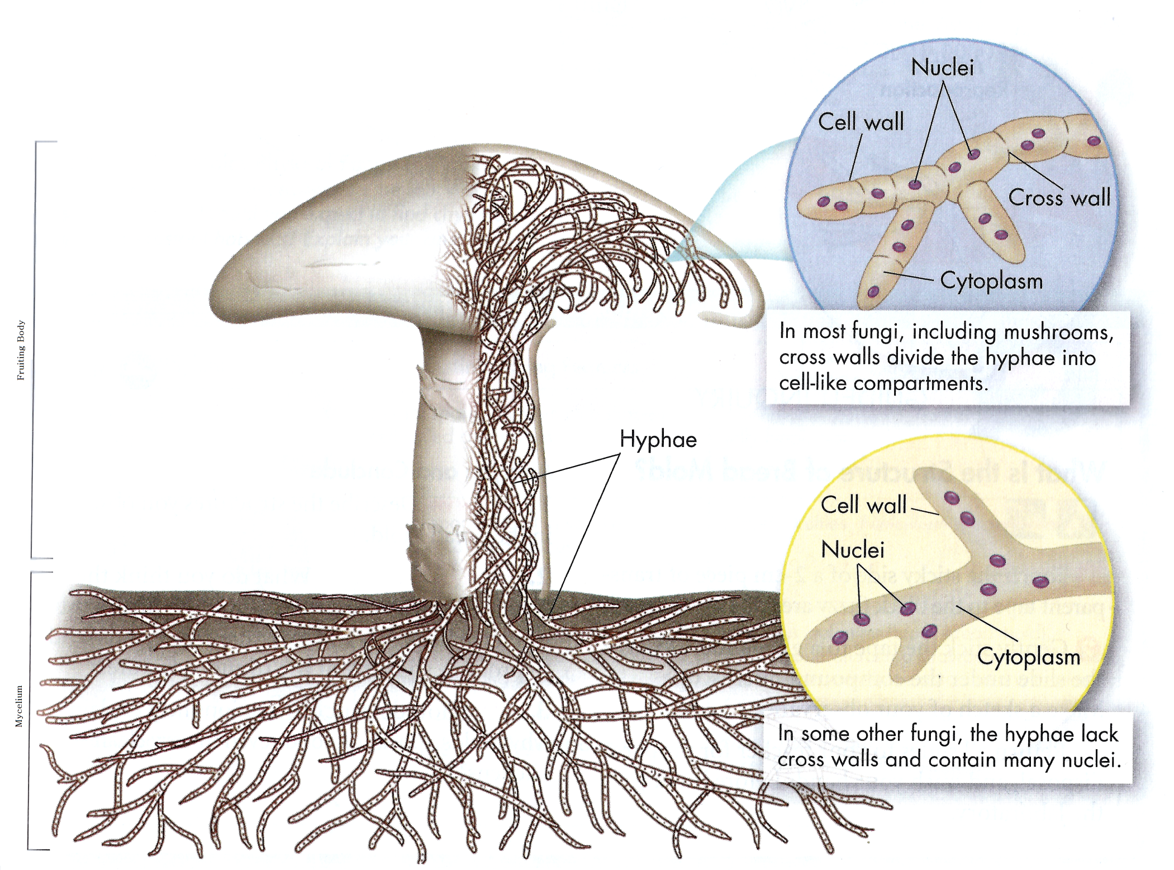

Fungi can reproduce asexually and sexually.

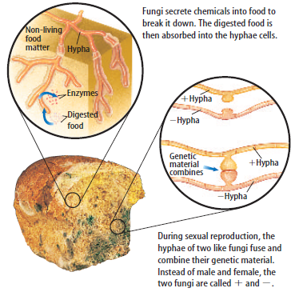

Fungi can be helpful or harmful. Some produce antibiotics (penicillin), others are good for food, and medicines. However, many are destructive, causing disease in plants and animals.

Some fungi grow in close associations with algae or cyanobacterium, called lichens. Lichens play a role in soil formation, releasing acids as part of their metabolism that helps break down rocks. They are sensitive to pollutants so the disappearance of lichens can indicate environmental problems.

Cheese, a traditional food incorporated into many cuisines, is used as an ingredient in cooking or consumed directly as an appetizer or dessert, often with wine or other suitable beverages. Cheese is one of the few foods we eat that contains extraordinarily high numbers of living, metabolizing microbes, leading some participants to say, “Cheese is alive!” The broad groups of cheese-making microbes include many varieties of bacteria, yeast, and filamentous fungi (molds).

**Calculations and Data**

Based on the video …

A. What is the “fuzzy” stuff on fruit, etc.? What is their purpose?

B. What is specimen #1? What phylum is it?

C. What is Fungi specimen #2? What phylum is it? How do they reproduce?

D. Specimen #3 is in the same phylum as specimen 2. What is observed?

E. What is Fungi specimen #4? What phylum is it? What are the asexual spored called?

F. What is Fungi specimen #5? What phylum is it? How do they reproduce?

G. What is Fungi specimen #6? What phylum is it?

**Conclusions**

Fill in the blanks:

**_____** are prokaryotic organisms that in extreme environments. Eubacteria are classified by **_____** and include: **_____**, **_____**, and **_____**. A(n) **_____** can survive without oxygen. A(n) **_____** is a protective structure formed by bacteria which can allow it to remain dormant for years. **_____** can prevent some bacterial diseases. **_____** is a form of sterilization to kill bacteria, especially the disease-causing ones, known as **_____**. A(n) **_____** is an organism that gets nutrition from dead materials.

Protists are classified as fungus-like, **_____**, plant-like, **_____**, and animal-like, **_____**. The protozoa are classified by how they **move**: **pseudopods** (amoeba), **cilia** (paramecium) and **_____** (euglena). Algae are **_____** that provide energy and oxygen. Many protists are harmful.

**_____** grow as a mass of many-celled, threadlike tubes called **_____**. An organism composed of an alga and a fungus is a **_____**. The fungi form an intricate web call **_____** around the roots of plants. The plant provides food for the fungi and the fungi help the plants absorb water and minerals. 90 percent of plants studied have these.

**Questions**

1. Why do Bacteria, Protists and Fungi represent 3 kingdoms?

2. Distinguish a prokaryote and eukaryote. How are Bacteria, Protists and Fungi classified?

3. How are protists classified based on their similarities to plants, animals and fungi?

4. What are the long chains of cells that make up fungi called? What structure do fungi use to reproduce?

**Bibliography**

Biology Course Site, *Class Notes. Week 22*. Learning CTR Online, n.d. Web. 4 Feb. 2024. <[www.learningctronline.com](https://www.pottersschool.org/teacher/)>.

Bacteria, Protist, Fungi. *Lab Handout*, Biology, Week 22. *Learning CTR Online*, n.d. Web. 4 Nov. 2024. <[www.learningctronline.com](https://www.pottersschool.org/teacher/)>.

*Bacteria, Protists, and Fungi: Chapter 12*. 30 pages. <https://in01000714.schoolwires.net/cms/lib07/in01000714/centricity/domain/49/chap12.pdf>

Answers

Bacteria

**Calculations and Data**

Based on the video …

A. What are the steps for making agar?

1. **Add agar, water, stir**

2. **Heat 3 minutes and boil 1 minute**

3. **Cool for 3-5 minutes**

4. **fill petri dishes with prepared agar solution**

5. **cover petri dishes and allow agar to harden**

B. Give a brief description of how to grow bacteria using three surfaces.

**Use a cotton swap and rub along the surface of the cell phone, TV remote, soap dispenser.**

**Rub the “infected” swap on the agar. Use a separate petri dish for each test.**

**Disinfect the surfaces and swap those and rub in separate petri dishes.**

C. Sketch or take a screen shot showing the bacterial growth with and without disinfectant.

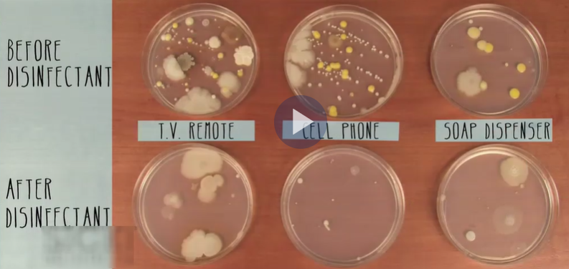

D. Name the basic type of Bacteria #1?

**Spirilla (spiral shaped)**

E. Name the basic type of Bacteria #2?

**Cocci (round shaped)**

F. Name the basic type of Bacteria #3?

**Bacilli (rod shaped)**

G. What do all Bacteria have in common?

**Prokaryotic (no nuclear membrane)**

Protists

**Calculations and Data**

Based on the video …

A. What are the large green clumps?

**Algae**

B. What phyla of alga was observed?

**Diatoms**

C. What protozoan was observed that had a stalk to attach to substrates? Which type of protozoa is it?

**Vorticella, ciliate**

D. What protozoan was observed at 40X, 400X, 800X and with ProtoSlo? Which type of protozoa is it?

**Euglena, flagellate**

E. What protozoan was observed at 10X, 100X, 400X , 800X and got attached to an air bubble? Which type of protozoa is it?

**Paramecium, ciliate**

F. What “elusive” protozoan was observed at 40X, 100X, 400X , 800X? Which type of protozoa is it? What obvious feature was observed in its cytoplasm?

**Amoeba, pseudopod, cytoplasmic streaming**

Fungi

**Calculations and Data**

Based on the video …

A. What is the “fuzzy” stuff on fruit, etc.? What is their purpose?

**Mycelia, reproduction**

B. What is specimen #1? What phylum is it?

***Rhizopus* (bread mold); Zygospore, specialized hyphae**

C. What is Fungi specimen #2? What phylum is it? How do they reproduce?

***Mildew on leaf*; sac fungi; ascocarp (reproduction) … asexual spores**

D. Specimen #3 is in the same phylum as specimen 2. What is observed?

***Cup (sac)* fungi; cloud of spores (conidia)**

E. What is Fungi specimen #4? What phylum is it? What are the asexual spored called?

***Morel*; sac fungi; asexual spores (conidia)**

F. What is Fungi specimen #5? What phylum is it? How do they reproduce?

***shelf* fungi; club fungi with basidium (usually sexual reproduction)**

G. What is Fungi specimen #6? What phylum is it?

***mushroom*; club fungi with basidium (usually sexual reproduction)**

**Conclusions**

Fill in the blanks:

**Archaebacteria** are prokaryotic organisms that in extreme environments. Eubacteria are classified by **shape** and include: **cocci**, **bacilli**, and **spirilla**. A(n) **anaerobe** can survive without oxygen. A(n) **endospore** is a protective structure formed by bacteria which can allow it to remain dormant for years. **Antibiotics** can prevent some bacterial diseases. **Pasteurization** is a form of sterilization to kill bacteria, especially the disease-causing ones, known as **pathogens**. A(n) **saprophyte** is an organism that gets nutrition from dead materials.

Protists are classified as fungus-like, **molds**, plant-like, **algae**, and animal-like, **protozoa**. The protozoa are classified by how they **move**: **pseudopods** (amoeba), **cilia** (paramecium) and **flagella** (euglena). Algae are **producers** that provide energy and oxygen. Many protists are harmful.

**Fungi** grow as a mass of many-celled, threadlike tubes called **hyphae**. An organism composed of an alga and a fungus is a **lichen**. The fungi form an intricate web call **mycorrhizae** around the roots of plants. The plant provides food for the fungi and the fungi help the plants absorb water and minerals. 90 percent of plants studied have these.

**Questions**

1. Why do Bacteria, Protists and Fungi represent 3 kingdoms?

**Bacteria, Protists and Fungi represent 3 kingdoms because they cannot be classified as plants or animals.**

2. Distinguish a prokaryote and eukaryote. How are Bacteria, Protists and Fungi classified?

**Prokaryote and eukaryote describe the types of cells that make up organisms. Prokaryotic cells do NOT have genetic material contained in a nucleus, whereas eukaryotic cells do. Prokaryotic cells are much simpler than eukaryotic cells which often have complex organelles. Bacteria are prokaryotic. Protists and Fungi like plants and animals are eukaryotic.**

3. How are protists classified based on their similarities to plants, animals and fungi?

**Alga are plant-like because they are autotrophs with a cell wall, producing their own food. However, they do not have true tissues or organs like plants.**

**Protozoan are animal-like because they move using cilia, flagella, and pseudopods. Most are unicellular.**

**Slime Molds are fungus-like because they are saprophytic and decomposers.**

4. What are the long chains of cells that make up fungi called? What structure do fungi use to reproduce?

**Hyphae are long chains of cells that make up fungi. Fungi reproduce using spores (asexually or sexually).**