Heading

Title

**Introduction**

*This lab will take FOUR (4) days to complete the procedures. So, get started!*

**Purpose**In this investigation a fresh hen's egg will be used to determine what happens during osmosis and diffusion across membranes.

**Discussion**Transport across the cell membrane can involve an input in energy (active transport) or it may happen spontaneously (passive transport). Passive transport does not require energy, moves from high to low concentration “down” a concentration gradient.

Osmosis is the diffusion of water across a semipermeable membrane, a membrane permeable only to water. The water flows from HIGH water potential or concentration (LOW solute concentration) to LOW water potential or concentration (HIGH solute concentration). This is a form of passive transport (no energy is required).

Tonicity is the relative concentration of solute (particles) OUTSIDE the cell compared with the inside of the cell. Solutions may be hypertonic, hypotonic, or isotonic. A hypertonic solution contains a LOW concentration of water with a HIGH concentration of solute OUTSIDE the cell. A hypotonic solution contains a HIGH concentration of water with a LOW concentration of solute OUTSIDE the cell. An isotonic solution contains the same concentration of water with a same concentration of solute inside and OUTSIDE the cell.

**Hypothesis**

**Materials**

3 Eggs IN THEIR SHELLS Masking Tape Marker

Distilled Water CLEAR Sugar Syrup (e.g. Karo) Vinegar

Clear Cups or Jars Metric Measuring Tape Paper Towels

Paper Pencil

|  |  |
| --- | --- |
| Osmosis in an Egg | http://www.biologyjunction.com/images/chicken_laying_eggs_md_clr1.gif |

**Procedures**

Include THREE pictures in the calculations and Data section.

1. Take a picture of one egg soaking in vinegar.
2. Take a picture of one egg 2 AFTER being soaked in distilled water.
3. Take a picture of one egg 1 AFTER being soaked in syrup.
4. Be sure to place an explanation of what each picture is and its relevance to the lab.

<http://somup.com/c3eir0TvYU> (3:31) Osmosis Using an Egg

**Day 1** http://www.biologyjunction.com/images/Copy_4_of_Bird_hatches3.gif

1. Obtain and label two cups / jars with the word "vinegar" (masking tape works for labeling).
2. Carefully place one raw egg into each of the two cups and cover the eggs with vinegar. You will keep ONE egg separated as the control. DO NOT place it in vinegar.
3. Allow the cups to sit for 24 to 48 hours until the outer calcium shell disintegrates.
4. Take a picture of the eggs soaking in the vinegar.
5. Measure the circumference of the egg NOT PLACED in the vinegar with the measuring tape and record in **Data Table 3**. This will be the original diameter (size).
   1. Be sure to use METRIC units.
   2. If needed, use a string for the circumference and straighten it out to measure with a metric ruler.

**Day 2** http://www.biologyjunction.com/images/Copy_4_of_Bird_hatches3.gif

1. Pour off the vinegar.
2. CARFULLY remove the eggs and gently/quickly rinse them (NOT TOO LONG!) just to remove some of the vinegar.
3. Use a paper towel to GENTLY pat-dry the eggs for measurement.
4. Record the appearance of the eggs in your data table. (**Data Table 1**)
5. Measure the circumference of the eggs with the measuring tape and record in **Data Table 1**. This will be the original diameter (size).
6. Be sure to use METRIC units.
7. If needed, use a string for the circumference and straighten it out to measure with a metric ruler.
8. Rinse the cups thoroughly with distilled water or use two new cups.
9. Label one of the cups with the phrase "Distilled Water" and the other cup “Syrup”.
10. Carefully place one egg into each cup.
11. Cover the egg in the first cup with distilled water and the other egg with CLEAR syrup (in the second cup).
12. Again, you have a third egg that is NOT covered with anything (i.e. control).
13. Allow them to sit for 24 hours.

**Day 3** http://www.biologyjunction.com/images/Copy_4_of_Bird_hatches3.gif

1. **Do NOT** discard the distilled water and syrup yet.
2. Carefully remove the eggs.
3. Record the size and appearance of the eggs in the data table.
4. Measure the circumference of the eggs with the measuring tape and record in the data table (**Data Table 1**). (METRIC)
5. Switch the eggs.
   1. Please the egg that was in the distilled water into the cup with the syrup.
   2. Place the egg that was in the syrup into the cup with the distilled water.
6. Allow them to sit for 24 hours.

**Day 4** http://www.biologyjunction.com/images/Copy_4_of_Bird_hatches3.gif

1. SWITCH the eggs. Please the egg that was in the distilled water into the cup with the syrup. Place the egg that was in the syrup into the cup with the distilled water.
2. Carefully remove the eggs.
3. Record the size and appearance of your egg in **Data Table 2**.
4. Measure the circumference of the eggs with the measuring tape & record in **Data Table 2**. (METRIC)
5. Measure the circumference of the egg NOT PLACED in the vinegar with the measuring tape and record in **Data Table 3**. This will be the final diameter (size).
6. Clean up your work area and put away all equipment.

**Calculations & Data**

**Data Table 1**

|  |  |  |  |
| --- | --- | --- | --- |
| **RESULTS OF OSMOSIS EGG (Days 1-3)** | | | |
|  | **Original Diameter (cm)** | **Final Diameter (cm)** | **Appearance of Egg** |
| **VINEGAR** |  |  |  |
| **Egg 1 in WATER** |  |  |  |
| **Egg 2 in SYRUP** |  |  |  |

Image of egg soaked in vinegar:

There is bubbling around the egg shell as the vinegar disintegrates it.

**Data Table 2**

|  |  |  |  |
| --- | --- | --- | --- |
| **RESULTS OF OSMOSIS EGG (Day 4)** | | | |
|  | **Original Measurement (cm)** | **Final Measurement (cm)** | **Appearance of Egg** |
| **Egg 2 in WATER** |  |  |  |
| **Egg 1 in SYRUP** |  |  |  |

Image of eggs soaked in distilled water & syrup:

**Data Table 3**

|  |  |  |  |
| --- | --- | --- | --- |
| **RESULTS OF OSMOSIS EGG #3 CONTROL** | | | |
|  | **Original Measurement (cm)** | **Final Measurement (cm)** | **Appearance of Egg** |
| **Egg (no solutions)** |  |  |  |

1. Why was the “control” egg included in this experiment?

2. Why was vinegar used in this experiment? (Note: vinegar is made of dilute acetic acid and water).

3. Describe the egg placed in distilled water

(a) What happened to the size of the egg after remaining in distilled water?

(b) Was there more or less liquid left in the cup?

(c) Did water move into or out of the egg? Why?

4. Describe the egg placed in corn syrup.

(a) What happened to the size of the egg after remaining in syrup?

(b) Was there more or less liquid left in the cup?

(c) Did water move into or out of the egg? Why?

**HONORS** Build a **BAR GRAPH** to show how each solution caused a change in the egg’s circumference.

* + Y or Vertical Axis for circumference in cm (Dependent Variable)
  + X or Horizontal Axis for solution type (Independent Variable)
  + Need two bars for each solution: one bar for the egg’s initial measurements and the second bar for its measurement after 24 hours (See Example Below)

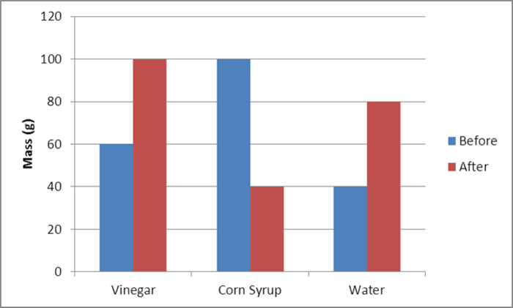

**Circumference (cm)**

**Solution Type**

**Conclusions**

**Address Hypothesis** (*Were the three hypotheses confirmed or not by this experiment? Explain)*

**Analysis** (*Fill in the blanks.)*

**_____** is the relative concentration of solute (particles) **_____** the cell compared with the inside of the cell. Solutions may be hypertonic, hypotonic, or isotonic. A **_____** solution contains a **_____** concentration of water with a **_____** concentration of solute OUTSIDE the cell. A **_____** solution contains a **_____** concentration of water with a **_____** concentration of solute OUTSIDE the cell. An **_____** solution contains the **_____** concentration of water with a same concentration of solute inside and OUTSIDE the cell.

**Questions**

(*Use complete sentences that convey a complete thought. Keep the question numbers, but rewrite the question as a statement.)*

1. When the eggs were placed in distilled water, was this a hypotonic, hypertonic, or isotonic solution? Explain.

2. When the eggs were placed in syrup, was this a hypotonic, hypertonic, or isotonic solution? Explain.

3. Define isotonic solution and explain what would happen to the eggs in terms of their diameter if they were placed in an isotonic solution.

4. Explain the difference between diffusion and osmosis using this experiment.

5. Why are fresh vegetables sprinkled with water at markets?

**Errors**

There are many potential sources of error in this experiment:

1)

2)

3)

**Resources/Bibliography**