**States of Matter Chapter 3**

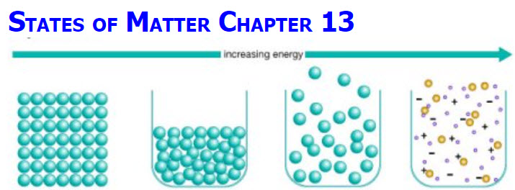



**See** [**https://www.learningctronline.com/courses**](https://www.learningctronline.com/courses) **for Materials and Resources.**

**Topics:**

1. Matter & Change

**Objectives:**

* *Classify Matter as pure substances versus mixtures and explain the main difference among solutions, suspension, and colloids.*
* *Distinguish extensive and intensive Physical properties. Give examples of physical properties.*
* *Explain how mixtures can be separated.*
* *Distinguish chemical versus physical properties and how this can be observed.*
* *Evaluate Accuracy & Precision in Measurements (significant figures).*
* Identify the states of Matter (s, l, g) using kinetic theory.
* Define phases changes of all states of matter and the energy involved for each.
* Understand what happens to a substance’s temperature and a system’s energy (heat) during a phase change.
* Describe the arrangement of molecules and how they change from solid to liquid to gas.
* Distinguish between evaporation and boiling. How are they the same? How are they different?

TAKE NOTE

1. Guided Reading Note-Taking Worksheet (Pearson Text)

1. Pearson Concepts in Action Worksheets
2. Lab: Density (Formal Lab Report) due in 9 days
3. Lab Heating Curve of Water
4. Week 4 Devotional (<https://www.learningctronline.com/devotional>)

Pearson Text Chapter 3: States of Matter pp. 66-97

**Guided Reading Note-Taking Worksheet:**

Complete the worksheet for Chapter 3: States of Matter (3.1 & 3.3).

**Class Notes: PowerPoint or PDF**

**Homework**:

* 3.1 Solid, Liquid, Gas Worksheet from Pearson Concepts in Action
* 3.3 Phase Changes Worksheet from Pearson Concepts in Action
* *Assignments will be “spot checked” during class or submitted via email.*

**Lab**: Density Lab (Formal Lab Report)

Complete the "Density" lab using the Density Lab Worksheet provided.

* This week will go over the Conclusion section.
* You will submit a Formal Lab Report (following the guidelines in the Lab Report Format Document) within 9 days.

**Lab**: Heating Curve of Water

* Perform the lab as directed using the worksheet provided.
* Complete all calculations and data, showing work whenever appropriate.
* Conclusions should be answered in complete sentences that convey a complete thought.
* Save the documents into your LAB folder in the Physical Science folder on your desktop.
* *Assignments will be “spot checked” during class or submitted via email.*

**TEST:** Matter & Change

1) the academic integrity policy

* Tests must be completed **WITHOUT** referring to books, notes, the internet, people, or any outside resources.
* Students **MAY** use the approved Periodic Tables, approved Reference Tables, or approved equation (formula) sheet (provided by the teacher) along with calculators and scratch paper.
* A guardian should be proctoring the test. Proctoring means to monitor the following:

2) The test is composed of 20 multiple choice questions and some written problems.

* The **multiple-choice test must be taken "in one sitting"**, meaning that once you start the test, you must complete it without interruption. (40 minutes)
* Take a short break (5-10 minutes)
* The **written portion of the test must be taken "in one sitting"**, meaning that once you start the test, you must complete it without interruption. (30 minutes)

3) There is a **90-minute time limit** on this test. Please have the proctor write the time taken at the top of your answer sheet with their signature or initials.

4) Proctors should NOT be reading the test or engaging students during the test.

5) Do NOT use RED font. Black font is best.

Supplemental Resources (Optional)

1. Vocabulary Crossword

[**https://screencast-o-matic.com/watch/cYfv3eBO4H**](https://screencast-o-matic.com/watch/cYfv3eBO4H) **Mass of Ice Before and After Melting (0:41)**

[**http://somup.com/cFQ6XCVSht**](http://somup.com/cFQ6XCVSht) **Sublimation of Dry Ice (1:59)**

[**http://somup.com/cFQio2VR7w**](http://somup.com/cFQio2VR7w) **Physical Versus Chemical Properties ctr ... Discussion & "Burning Water" (2:36)**

[**http://somup.com/cFQilMVRKj**](http://somup.com/cFQilMVRKj)**] Physical Versus Chemical Changes LAB ctr (5:01) ... demonstrations (part 1)**

[**http://somup.com/cFX6DGni0X**](http://somup.com/cFX6DGni0X) **Heating Curve of Water (Time Lapse) (1:11)**

<https://screencast-o-matic.com/watch/cq6f2UuDuF> Heating Curve Song (3:20) ... PE, KE, Endo & Exothermic, Graphing Phases (Review).

<http://somup.com/cYhlYZjqAx> Obey Your Parents Ephesians 6:1-2; Pierce My Ear (3:52)