**Wildlife Management:**

**Hunting / Trapping**

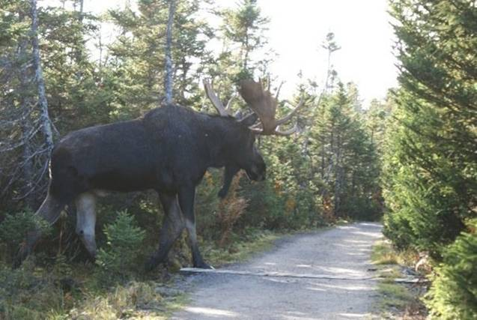

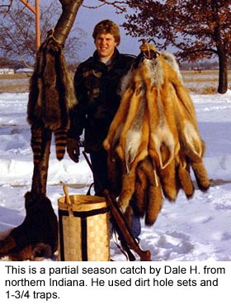

**See** [**https://www.learningctronline.com/courses**](https://www.learningctronline.com/courses) **for Materials and Resources.**

**Topics:**

1. Hunting / Trapping

**Objectives:**

* + Discuss pros and cons of hunting and trapping.
  + Understand the history and usefulness of hunting and trapping.
  + Identify the ethics of hunting and trapping.
  + Recognize types of hunting and trapping and the equipment involved in trapping.

TAKE NOTE

1. Survey: Hunting / Trapping / Fishing
2. Reference Material Worksheet: Trapping
3. <http://somup.com/c3QtrmU7o2> (5:00) A Friendly Look at Grizzly Bears
4. Hunting / Trapping Research Worksheet
5. Wolves (Dorothy McCleer) PPT
6. Quiz Trapping
7. Film Review “Call of the Wild” [2020] (Harrison Ford) or Temple Grandin [2010] (Claire Danes)
8. Week 10 Devotional (<https://www.learningctronline.com/devotional>)

**Text**:

**Reference Material: Trapping**

**Homework**:

* Trapping Reference Material Worksheet
* Hunting / Trapping Research

**Lab**: Hunting / Trapping Research Worksheet

* Complete the worksheet provided using the internet.
* Save the document into your LAB folder in the Projects in Science folder on your desktop.

**Lab**: Film Review

* Obtain the movie “Call of the Wild” [2020, Harrison Ford] or Temple Grandin (2010) [1h 47m] (Claire Danes).
  + Complete the **generic** film review in the course Resources folder.
* Save the document into your LAB folder in the Projects in Science folder on your desktop.

**TEST:** Quiz Trapping

1) the academic integrity policy

* Tests must be completed **WITHOUT** referring to books, notes, the internet, people, or any outside resources.
* Students **MAY** use the approved Periodic Tables, approved Reference Tables, or approved equation (formula) sheet (provided by the teacher) along with calculators and scratch paper.
* A guardian should be proctoring the test. Proctoring means to monitor the following:

2) Take the **"in one sitting"**, meaning that once you start the test, you must complete it without interruption.

3) There is a **40-minute time limit** on this test. Please have the proctor write the time taken at the top of your answer sheet with their signature or initials.

4) Proctors should NOT be reading the test or engaging students during the test.

5) Do NOT use RED font. Black font is best.

Supplemental Resources (Optional)

1. Crossword Review (Trapping)