**Nuclear Power Plants**

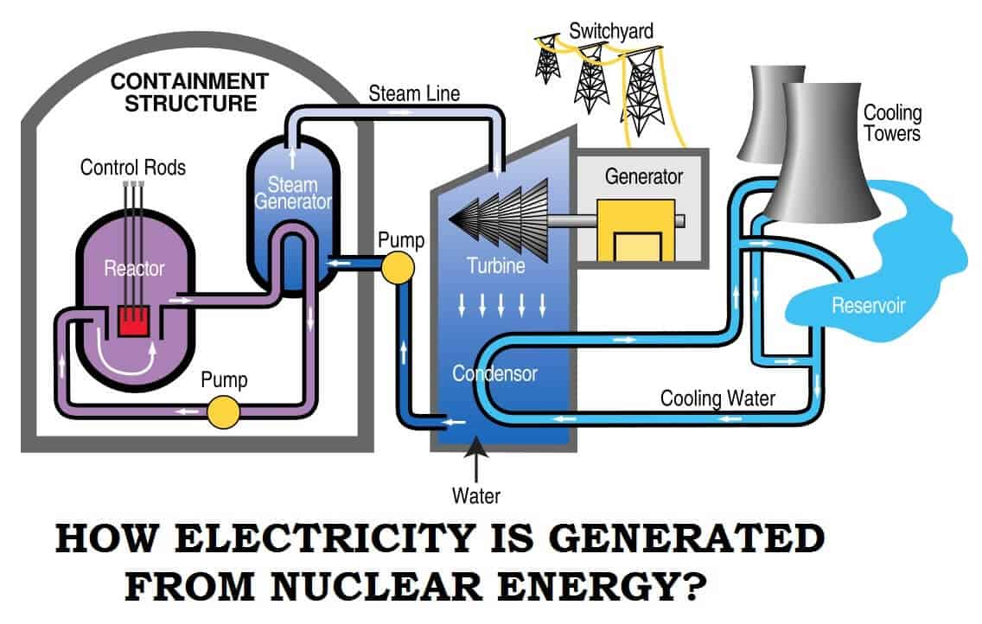

How many nuclear power plants are in the United States, and where are they located? As of August 1, 2023, there were 54 commercially operating nuclear power plants with 93 nuclear power reactors in 28 states.

11,582 megawatts (MW), equal to 12% of total U.S. operating nuclear electricity generation capacity.

Of the 54 operating nuclear power plants, 19 have one reactor, 31 have two reactors, and four have three reactors.

One new reactor—Unit 4, with a planned net summer electricity generation capacity of about 1,117 MW—is nearing completion at the Vogtle nuclear plant in Georgia and is projected to enter service by July 2023. When Unit 4 is operational, Vogtle will be the largest nuclear power plant in the United States, with four reactors and a total 4,536 MW net summer electricity generation capacity.

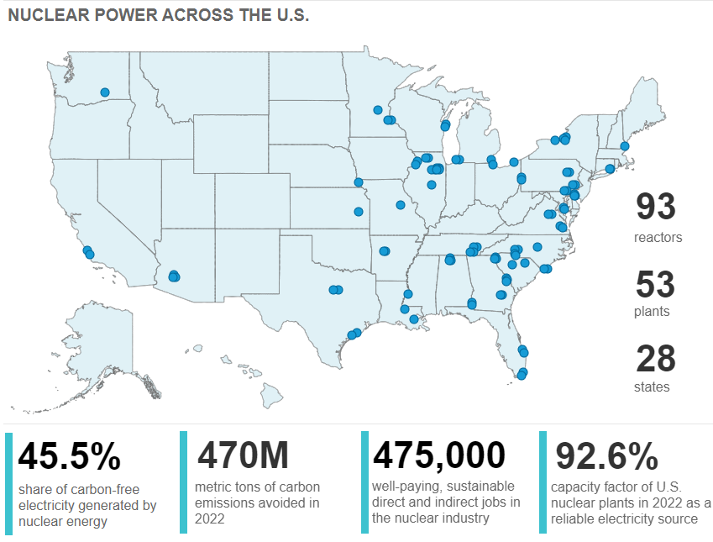

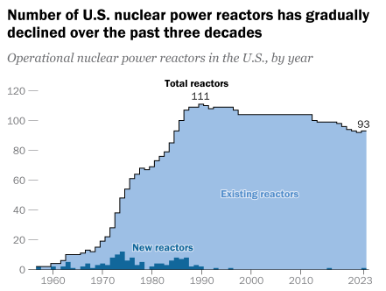

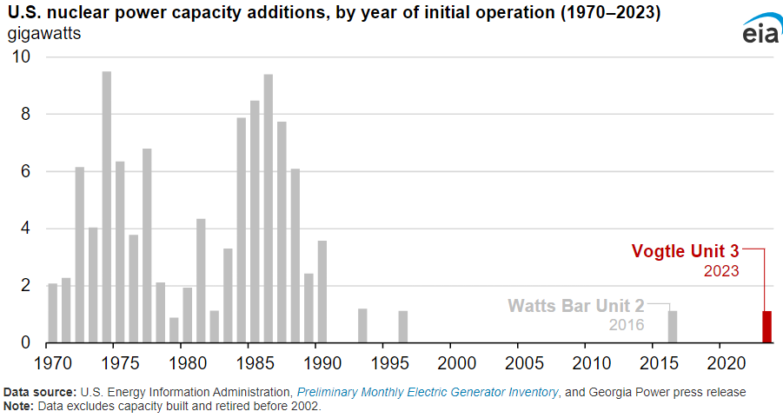

**Waste Disposal**

In the case of nuclear reactors, about 99% of the radioactivity is associated with the fuel. Apart from any surface contamination of plant, the remaining radioactivity comes from 'activation products' such as steel components which have long been exposed to neutron irradiation. Their atoms are changed into different isotopes such as iron-55, cobalt-60, nickel-63, and carbon-14. The first two are highly radioactive, emitting gamma rays, but with correspondingly short half-lives so that after 50 years from final shutdown their hazard is much diminished. Some caesium-137 may also be found in decommissioning wastes.

The nation has over 85,000 metric tons of spent nuclear fuel from commercial nuclear power plants. DOE is responsible for disposing of this high-level waste in a permanent geologic repository but has yet to build such a facility because policymakers have been at an impasse over what to do with this spent fuel since 2010. As a result, the amount of spent nuclear fuel stored at nuclear power plants across the country continues to grow by about 2,000 metric tons a year.

DOE also oversees the treatment and disposal of about 90 million gallons of radioactive waste from the nation's nuclear weapons program.

Transuranic nuclear waste is waste contaminated by nuclear elements heavier than uranium, such as diluted plutonium. The United States has only one deep geologic repository for the disposal of defense-related transuranic waste—the Waste Isolation Pilot Plant (WIPP) near Carlsbad, New Mexico.

Nuclear Waste <http://somup.com/cZnVrBpnvK> (9:13)