# Measurement

* The metric system is the most commonly used system of measurements world-wide. In addition to being used in most other countries it is used in nearly ALL scientific endeavors.



[***http://prezi.com/zc-alvezwvy9/metric-versus-english-measurement/***](http://prezi.com/zc-alvezwvy9/metric-versus-english-measurement/)

## Metric System versus the English System

1. Simplicity
2. The metric system uses ONE unit for each category of measurement
3. Gram (mass), liter (volume), meter (distance)
4. The English system utilizes many different names for each major measurement (*units of mass, volume, distance*)

* Rod, furlong, hand, foot, yard, mile, nautical mile
* Pinch, gill, teaspoon, tablespoon, ounce, cup, pint, quart, gallon, peck, bushel
* Penny, grain, ounce, pound, short ton, standard ton

1. Consistency
2. All metric units are multiple of 10 or utilize decimal placement
3. The English system has no consistency between units

Length – centimeter, meter, kilometer

Weight (Mass) – milligram, gram, kilogram

Volume – milliliter, liter, kiloliter

* *Notice how there is a common element in the units of length and volume*.

1. Units
2. Mass … grams (g)
3. Distance … meters (m)
4. Volume … liters (l)

[Measurement Overview: Metric System, Factor Labeling, Scientific Notation & Uncertainty ctr](http://somup.com/cFQbqeVWXQ) (2:20)  
  
[Metric Units Song](http://somup.com/cF6hIanVSb) (2:51) ... metric units for each category of measurement (m, l, g)  
  
[Metric Progression Song](http://somup.com/cFjtqBV9bc) (1:08) ... learn the metric units  
  
[Metric Progression & Factor Labeling Basics](http://somup.com/cFQj2UVR9h) (4:13)  
  
[Factor Labeling "Thumbs Up / Thumbs Down" Rule](http://somup.com/cFQjoQVR9b) (4:10)  
  
[Factor Labeling Example (negative exponents)](http://somup.com/cFQ6lpVShM) (3:34)

1. Conversions
2. Metric units are inter-converted by moving the decimal place
3. Metric units are expressed by prefixes and exponential notation

* The metric system uses prefixes to adjust a base unit (e.g. meters, liters). Thus, the symbol for the base unit follows the symbol for the prefix.

|  |  |  |
| --- | --- | --- |
| Prefix | Symbol | Example Unit (abbr.) |
| Milli- | m | Millimeter (mm) |
| Centi- | c | Centiliter (cl) |
| Deci- | d | Decigram (dg) |
| Standard Unit | | |
| Deka- | D or da | Dekasecond (Ds) |
| Hecto- | h | Hectofarad (hF) |
| Kilo- | k | Kilojoule (kJ) |

Common Prefixes

1. Metric System Prefixes

|  |  |  |  |
| --- | --- | --- | --- |
| Prefix | Symbol | Numerical Value | Exponent |
|  |  |  |  |
| Tera | T | 1,000,000,000,000 | 1 x 1012 |
| Giga | G | 1,000,000,000 | 1 x 109 |
| Mega | M | 1,000,000 | 1 x 106 |
|  |  |  |  |
| Kilo | k | 1,000 | 1 x 103 |
| Hecto | h | 100 | 1 x 102 |
| Deka | D or da | 10 | 1 x 101 |
|  |  |  |  |
| Standard | **g m l s** | 1 | 1 x 100 |
|  |  |  |  |
| Deci | d | 0.1 | 1 x 10-1 |
| Centi | c | 0.01 | 1 x 10-2 |
| Milli | m | 0.001 | 1 x 10-3 |
|  |  |  |  |
| Micro | u | 0.000001 | 1 x 10-6 |
| Nano | n | 0.000000001 | 1 x 10-9 |
| Pico | p | 0.000000000001 | 1 x 10-12 |
|  |  |  |  |
| Angstrom | A | 0.0000000001 | 1 x 10-10 |

* Demonstrate Decimal place movement for measurements

13 cm = 1.3 dm = 0.13 m = 0.013 Dm = 0.0013 hm = 0.00013 km

123 kl = 0.123 Ml = 0.000123 Gl = 123000 l

1. Metric System Units
2. **Mass**
3. The amount of matter a substance contains
4. The measure of inertia in a substance
5. This value never changes unless the substance changes
6. Grams (g)
7. Triple Beam Balance, Electronic or Analytical Balance
8. **Distance**
9. Dimensions … L W H
10. Meters (m) = *39.13 inches*
11. Calibrations (metric ruler, meter stick, odometer)
12. **Volume**
13. The amount of space a substance occupies or takes up
14. Liters (l)
15. Types of Volume Measurements
16. regularly shaped solids 🡪 cubic volume (L x W x H)
17. volume of a liquid 🡪 direct volume using a graduated cylinder
18. irregularly shaped solids 🡪 water displacement
19. Common conversions
20. 1 ml = 1 cc = 1 cm3



1. 1 l = 1 dm3
2. 1 kl = 1 m3
3. **Density**
4. An object's mass divided by its volume
5. **ρ** = m / V

Soda Pop Cans in a Beaker of water. (1:02) <https://screencast-o-matic.com/watch/cFQ6reqGli>

Density an Intensive Property (1:12) <https://screencast-o-matic.com/watch/cFQi2Cqp7O>

Measuring Density 1: (0:17) <https://screencast-o-matic.com/watch/cFQ6r3qGIz>

Measuring Density 2: (2:57) <https://screencast-o-matic.com/watch/cFQ60NqG0I>

Calculating Density (1:19)

<https://screencast-o-matic.com/watch/cFQ6r2qGlL>

***ρ***

m

*V*

1. Mathematics in Science

#### Scientific Notation // Exponential Notation

1. Scientific Notation is used to simplify very large or small numbers
2. Notation Conventions
3. use a **number** from 1 to 9
4. **exponent** (power) of ten

e.g. 231000

1. assume the decimal follows the last zero & the exponent is 100
2. 2.31000 … move the decimal to the left 5 places
3. 2.31 x 105

[Scientific Notation Overview](http://somup.com/cFQjbdVRRi) (3:31)  
  
[Scientific Notation: Adding/Subtracting](http://somup.com/cFQjFhVRRX) (1:22)  
  
[Scientific Notation: Multiplying/Dividing](http://somup.com/cFQjFoVRR2) (0:58)

1. Inter-converting decimals and exponents
2. increase the number, decrease the exponent

e.g. 6.7 x 104 = 67,000

1. decrease the number, increase the exponent

e.g. 3.82 x 10-3 = 0.00382

* Inversely proportional, indirectly proportional (*Boyle’s Law, Coulomb’s Law*)
* “Thumb Up / Thumb Down”

1. Arithmetic Functions
2. General rule
3. always deal “numbers with numbers” and “exponents with exponents”
4. use scientific notation whenever possible unless instructed otherwise
5. Addition or Subtraction
6. Measurements that are more than TWO decimal places (or exponents) from one another are NOT significant

e.g. car price $21,995 and you only have $21,900

e.g. “give a penny, take a penny” dish

1. Always convert to a common exponent between the numbers you wish to add or subtract … > # < exp or < # > exp

e.g. 4 x 104 + 3 x 101 = 4 x 104 [*ignore the smaller number*]

e.g. 6.4 x 103 + 5 x 102 = 6.4 x 103 + 0.5 x 103 [*convert to the larger #*]

6.9 x 103 [*answer should be in scientific notation*]

1. Multiplication
2. Change all measurements to exponential notation
3. MULTIPLY numbers by numbers and ADD the exponents
4. Place the final answer in scientific notation

e.g. 41,000 x 300 = 4.1 x 104 x 3 x 102 = 12.3 x 106 = 1.23 x 107

1. Division
2. Change all measurements to exponential notation
3. DIVIDE numbers by numbers and SUBTRACT the exponents
4. Place the final answer in scientific notation

e.g. 5,500 / 250 = 5.5 x 103 / 2.5 x 102 = 2.2 x 101

1. If measurements are written in the denominator, it is sometimes easier to change the division problem to a multiplication problem

e.g. 5,500 / 250 = 5.5 x 103 x 2.5 x 10-2 = 2.2 x 101

e.g. 601,000 / 3,370 = 6.01 x 105 x 3.37 x 10-3 = 1.78 x 102

##### Factor Labeling // Dimensional Analysis

1. Equalities
2. State a relationship between two measurement units
3. Examples

1 m = 102 cm 1 kl = 103 l

1 mg = 10-3 g 1 s = 10-6 Ms

1. Conversion Factors
2. Use an “Equality” and change it into a fraction 🡪 anything divided by itself is equal to “1”
3. Examples

1 m = 102 cm 🡪 1 m / 102 cm OR 102 cm / 1m

103 mg = 1 g 🡪 103 g / 1 g OR 1 g / 103 mg

1. “Factor Out” the common units using the proper conversion factor
2. When conversion factors are used properly, ALL undesired units cancel out and the desired unit(s) are left
3. It is usually helpful to convert measurements to the STANDARD whenever units change from a number greater than one to less than one & vice versa

Example: 14 meters = ??? centimeters

Step 1: Identify the conversion factor 

Step 2: Determine whether the number should be greater or less

S*ince 1 meter = 100 cm, 14 meters needs to be a greater number of centimeters.*

Step 3: Multiply by the proper conversion factor [pay attention to units]



* *The 100 comes from the conversion of 1 m = 100 cm.*
* *Since the number has increased as predicted in step 2, we can be rather certain we have applied the conversion correctly.*
* *Notice that “meters” cancelled out and “centimeters” were left … this is factor labeling*

Convert 5 cm to km

Equalities 🡪 1 m = 102 cm 1 km = 103 m

Conversion Factors 🡪 1 m / 102 cm 1 km / 103 m

5 cm (1 m / 102 cm) (1 km / 103 m) = 5 x 10-5 km

1. More difficult conversion examples
2. 1 g / ml to kg / hl

Equalities 🡪 1 kg = 103 g 1 l = 103 ml 1 hl = 102 l

Conversion Factors 🡪 1 kg / 103 g 103 ml / 1 l 102 l / 1 hl

1 g / ml (1 kg / 103 g) (103 ml / 1 l) (102 l / 1 hl)

1 x 10-3  x 103  kg x 102 / 1 hl 🡪 1 x 102 kg / hl

1. 92 cm3 to m3

Equalities 🡪 1 m = 102 cm 1 l = 103 ml 1 hl = 102 l

Conversion Factors 🡪 1 m / 102 cm

92 cm3 (1 m / 102 cm) (1 m / 102 cm) (1 m / 102 cm)

92 m3 / 106  = 92 x 10-6 m3 ➔ 9.2 x 10-5 m3

1. 2000 dm3 to liters

Equalities 🡪 1 dm = 10 cm 1 cm3 = 1 ml 103 ml = 1 l

1 dm3 = 10 cm x 10 cm x 10 cm = 103 cm3

2 x 103 dm3 x 10 cm3 / 1 dm3 x 1 ml / 1 cm3 x 1 l / 103 ml

2 x 103 x 10-3 l = 2 x 103 l

Equalities 🡪 1 l = dm3 2 x 103 l

##### Uncertainty in Measurement

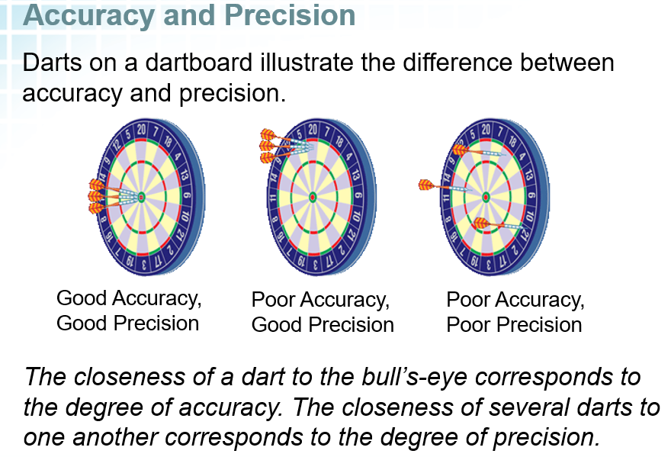

1. Uncertainty in measurement depends on the skill and carefulness of the person and the limitations of the instruments
   * + In common language the terms accuracy and precision are often thought of as interchangeable; however, in the world of science these have different meanings.
2. Precision
3. Usually refers to instrumentation
4. Indicates the reliability or reproducibility of a measurement
5. Examples
6. The following measurements on a thermometer [ 96.9 C, 97.0 C, 97.0 C, 96.9 C] show consistency and high reproducibility and are, therefore, the thermometer readings are considered precise. **Notice they all have the same decimal place.**
7. ***Find the length of an object***

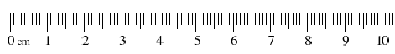

What is the length of the arrow?

* The arrow is beyond the 7 centimeter line
* The arrow is slightly beyond the 6th millimeter line between 7 & 8 cm
* A reasonable estimate for the space between the millimeter lines is 0.2
* A precise measurement could be 7.60 cm
* *Millimeters is the most precise unit shown and 0.1 mm place is the estimate*
* All three digits are significant as part of the measurement.
* the last number of a measurement is an **ESTIMATE**

1. Accuracy
2. Usually refers to people and inaccurate measuring OR to an instrument that may be measuring precisely, but is not accurate (*see example below*)
3. Indicates how close a measurement is to the accepted value
4. Examples
5. The above values of temperature for the boiling point of water are inaccurate … the accepted value at sea level is 100 C
6. People make poor measurements and/or poor estimates; we exaggerate or just plain mis-measure

[Significant Figures: Precision Part 1](http://somup.com/cFQjrRVRSV) (3:28)  
  
[Significant Figures: Precision Part 2](http://somup.com/cFQj0cVRS6) (6:24)

1. Rules for Accuracy and Precision in Measurement
2. The LAST significant figure or digit in a measurement is an ESTIMATE.
3. 123.4**5** *this measurement was to the nearest tenth*
4. 0.00001**2** *this measurement was to the nearest hundred thousandth*
5. The second to the last significant figure in a measurement shows the accuracy (*of the measurer*) and/or the *precision (of the tool used to measure*).
6. Unless instructed otherwise, one should use all the precision possible on a measuring device PLUS ONE ESTIMATE (*one decimal place*). All of these numbers are considered significant (*including the ONE estimate*).
7. **ACTIVITY**

* Use a **Mass Balance** to measure an object
* What is the precision of the balance?
* Convert the measurement into kg, hg, Dg, g, dg

1. **Meter Stick** … shows m, dm, cm and **mm** … estimate in **0.1 mm**
2. **Metric Ruler** … shows cm and **mm** … estimate in **0.1 mm**
3. When using significant figures in calculations, answers must be round off to contain the number of “significant figures” justified by the precision of the measurement.

|  |  |  |  |  |
| --- | --- | --- | --- | --- |
| Number | Sig. Figs. |  | Number | Sig. Figs. |
| 13 | 2 |  | 56098 | 5 |
| .0000013 | 2 |  | 56.098 | 5 |
| 0.009005 | 4 |  | 56098000 | 5 |
| 9.005 | 4 |  | 56098000. | 8 |
| 15.00 | 4 |  | 15.00000000 | 10 |

1. Significant Figures or Significant Digits
2. A scientist uses significant figures for several reasons
3. to decrease the amount of numbers used
4. to indicate the accuracy of measurements obtained
5. to indicate the precision of the measuring tool used
6. RULES for determining which numbers in a measurement are significant
7. All digits (***INTEGERS***) except zero are ALWAYS considered to be significant in a measurement

* 433 🡪 3 sig figs **.**1746 🡪 4 sig figs

1. **Zeros** are significant if they:
2. exist **BETWEEN** two integers

* 502 🡪 3 sig figs **.**12304 🡪 5 sig figs

1. **FOLLOW** a number containing a decimal

* 20**.** 🡪 2 sig figs **.**7000 🡪 4 sig figs

1. Zeros are NOT significant if they:
2. precede a number

* 0.00001 🡪 1 sig fig **.**012. 🡪 2 sig figs

1. follow a number WITHOUT a decimal

* 90,000,000 🡪 1 sig fig **.**0.00000000084 🡪 2 sig figs

1. **Addition** and **Subtraction**
2. Addition and Subtraction maintaining significant figures

a. If numbers are MORE than two multiples of ten from each other, only use the larger number. (*The smaller number is considered negligible or NOT significant.*)

* 1234 + **.**2 = 1234.2 120 + 0.0003 = 120

b. Express the solution with the accuracy of the LEAST precise number (“*the weakest link determines the overall strength*”)

* 12.000 + 142.99078 = 154.99078 🡪 154.991

1.549 x 102 [3 decimal places]

1. Multiplication and Division maintaining significant figures

a. Express the solution using the number of SIGNIFICANT FIGURES in the measurement with the LEAST amount of significant figures

* 10 x 2.3 = 23 🡪 20 [1 SF]
* 1.20 x 102 x 12.000 x 104 = 14.400 x 106 🡪 1.44 x 107 [3 SF]

b. Round up or down to express numbers according to the correct number of significant figures and the correct precision of the measurement

* 35.6 x 0.00234 = (3.56 x 101)(2.34 x 10-3) = 8.3304 x 10-2 🡪 8.33 x 10-2

5. Rules for Measuring Devices & Using Different Prefixes

1. The number of significant figures used depends on the accuracy of the measurer and the precision of the instrument used to measure.
2. Given the following measurements using a meter stick: 1.245 m, 34.0 cm, 97.01 mm, what is the most precise measurement?

* 0.1 mm

1. How could / would we add these same measurements together?

* Convert to a common unit
* Give the answer in the least precise measurement [*mm*]

1. The position of the decimal reveals the precision / accuracy of the measurement.

* 120 m … there is no decimal, therefore, the zero is not significant. The measuring tool was in hm using an estimate of 0.1 hm or 1 Dm.
* 120**.** m … since there is a decimal, now all the numbers, including the zero, are significant. The tool used here measures in Dm and the estimate in 0.1 Dm or m.

6. Significant Figures in Scientific Notation

* 186,000 🡪 3 SF 1.86 x 105 🡪 3 SF
* 1.860 x 105 🡪 4 SF 1.8600 x 105 🡪 5 SF

1. Percent Error
2. Percent error is a mathematical way of showing accuracy and precision
3. % Error = observed value - accepted value x 100%

accepted value

* Accepted or Theoretical Value of the boiling point of water = 100 C
* Observed or Experimental Value = 98.5 C
* (98.5 C - 100 C) / 100 C x 100% = 1.5 % error

##### HONORS

##### Standard Deviation

##### A measure of the amount of variation of a random variable or a data set

##### While the mean identifies a central value in the distribution, it does not indicate how far the data points fall from the center.

##### Higher SD values signify that more data points are further away from the mean. In other words, extreme values occur more frequently. Variability is everywhere.

##### 

##### Calculate the square root of the variance to derive the SD.

##### Standard deviation calculations.

Graphing

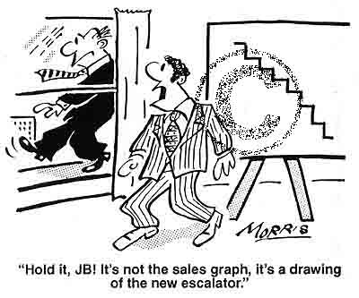

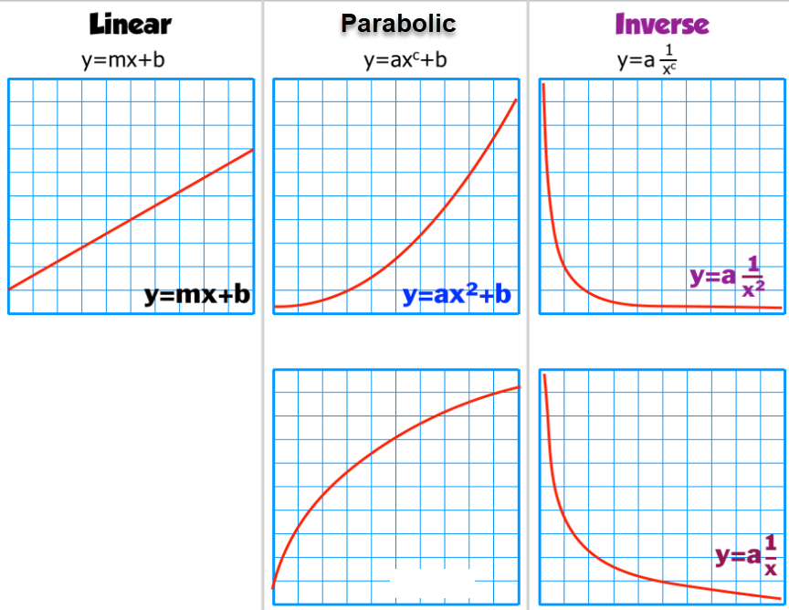

**y2 = ax**

Identifying Graphs

* + A large part of physics is identifying and using relationships between certain physical quantities.
  + Linear Graphs (linear relationship)
    - General Equation: *y =* *kx* + *C*, where *k* and *C* are constants.
    - This is a linear relationship which has a constant slope, meaning that the amount of change between any two points is always the same.
  + Parabolic Graphs (parabolas)
    - General Equation: *y =* *kx2* + *C*, where *k* and *C* are constants.
    - In mathematics, this is often referred to as quadratic.
    - Notice the **kx2** factor. This is an exponential (x2) relationship and always shows a parabolic graph.

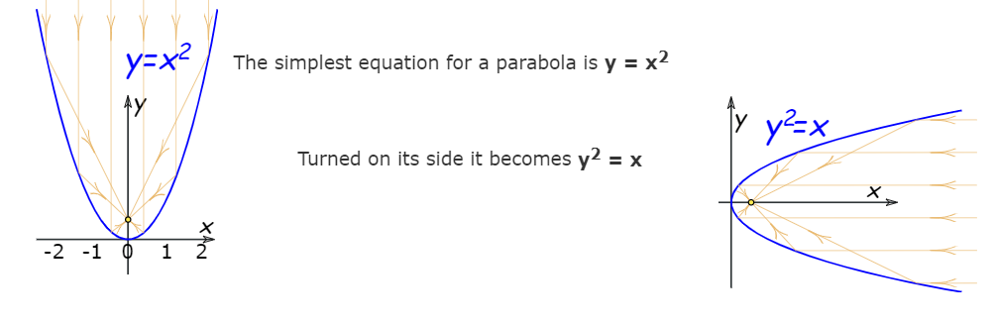

* Hyperbolic Graphs (hyperbolas)
  + - General Equation *y = k/x* + *C*, where *k* and *C* are constants.
    - This is probably the least familiar of these graphs.
    - Notice the **k/x** factor which is a reciprocal relationship (1/x). This always will show a hyperbolic graph due to the “reciprocal” relationship.
* Basic Algebra
  + One Variable Equation Solving
    - Physics involves mathematics, solving single variable equations is important to being able to convey an understanding of various physical relationships.
    - Examples:
      *  
      *  
      *  
  + Pythagorean Theorem
    - One of the key ways physics is studied is through what are known as vectors, the Pythagorean Theorem is used to calculate many vectors.
    - Given any right triangle and the length of two sides, this technique allows the length of the third side to be determined.
    - With shorter sides A and B and hypotenuse C,

B

A

C

the following is always true:

C2 = A2 + B2

* + Basic Trigonometry
    - Another component in dealing with vectors is to utilize angles and the basic trigonometry functions: sine, cosine, and tangent.

sin θ = opposite / hypotenuse

cos θ = adjacent / hypotenuse

tan θ = opposite / adjacent

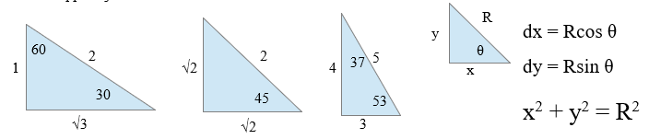

See Physics Equation/Formula Sheet