**Reaction Rate & Equilibrium Chapter 18A**

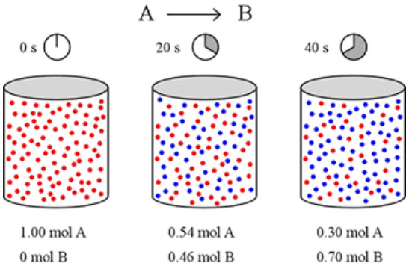

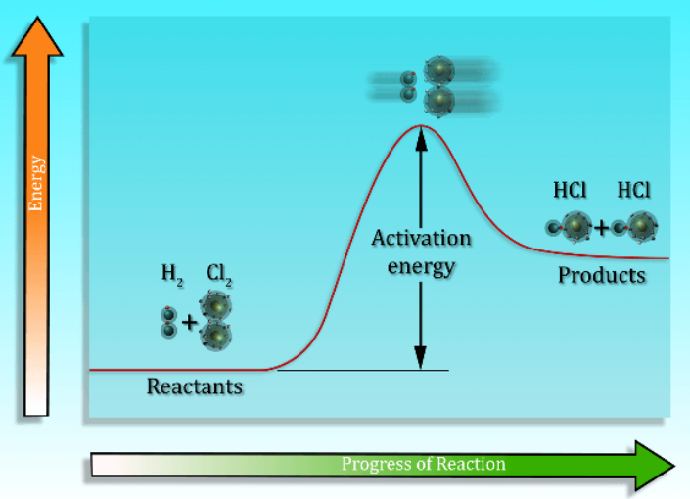

**See** [**https://www.learningctronline.com/courses**](https://www.learningctronline.com/courses) **for Materials and Resources.**

**Topics:**

1. Reaction Rate & Equilibrium

**Objectives:**

1. Explain the concept of reaction rate.
2. Describe collision theory and explain how various factors, including concentration, temperature, and pressure affect the rate of a chemical reaction.
3. Interpret reaction pathways (PE diagrams) to identify exothermic versus endothermic reactions and to define and explain the role of the activation energy in a chemical reaction.
4. Explain what a reaction mechanism is and understand the concept of rate determining step for a reaction.
5. Write equilibrium expressions, distinguishing molar concentrations of reactants and products for reactions.

TAKE NOTE

1. Notes/Study Guide (follow PowerPoint from this week’s class)
2. Test Corrections (Thermochemistry)
3. Lesson Check & Sample Problems or Alternative Worksheet (2 weeks)
4. Lab Quiz: Reaction Rate and Factors that Affect it
5. **HONORS 🡪** Practical application of Reaction Rate or equilibrium
6. Class Song: “There’s No Way to Fail” (Romans 12:9-12)
7. Week 27 Devotional (<https://www.learningctronline.com/devotional>)

**Text**: Chapter 18: Reaction Rate & Equilibrium pp. 592-603; 607-616; 620

Read the assigned pages in the text. Skip the omitted pages.

**Class Notes: PowerPoint or PDF**

**Notes/Study Guide:** Fill in the Chapter 18 worksheet to understand the class notes.

**Homework**: Text

(1) Answer the KEYED **“Lesson Check”** questions at the end of each.

(2) Answer the **“Sample problems”** found in the “Sample Problem” boxes throughout the chapter. An answer KEY is provided for you to use to self-correct your homework problems.

* Put your answers into complete thoughts in a Word document. Do NOT just put the answer, but write a phrase or sentence that you can study from for your tests. Save your work in a WORD document and SAVE into your HOMEWORK folder in the Chemistry folder on the desktop.
* Assignments will be “spot checked” during class or submitted via email.

**Alternate Homework**:

1. Chapter 18 Review Exam (Reaction Rate & Equilibrium)
2. Honors 🡪 practical application of reaction rate or equilibrium (~1 hour)

**Lab**: Reaction Rate and Factors that Affect it

1. Perform the " Reaction Rate and Factors that Affect it " experiment using the worksheet provided.
2. Answers are provided at the end of the document for guidance. Do NOT copy and paste these answers, but write using your own words.
3. Save the document into your LAB folder in the Chemistry folder on your desktop.
4. Study for understanding, and when ready, take the Lab Quiz.
5. You may **NOT** use the worksheet on this lab test.

**TEST:** The test will be given after next week’s lesson.

Supplemental Resources (Optional)

1. Chapter 18 Study Guide Pearson

[Equilibrium Tutorial](http://somup.com/cqeOqQnOxQ) (10:09) Completes Class Notes for this week.  
  
[Flaming Bubbles](https://screencast-o-matic.com/watch/cFe0DXD4w2) (0:38)

<http://somup.com/crXjoU39FI> Reaction Rate Vs Temperature & Surface Area (6:50)

[Rejoice in Hope Romans 12:12; Let Me Love & Not Be Respected](http://somup.com/cYhqoXjzeZ) (5:30)