Flat & Spherical Mirrors Lab

**Purpose** To investigate reflection off a flat mirror and spherical mirrors.

**Materials** Large stainless steel serving spoon

Large Flat Mirror (e.g. bathroom)

## Procedures

### Flat Mirror

1. Look directly into the large mirror (e.g. bathroom).

2. Raise your right hand. Notice which hand raises in the mirror.

3. Stand about 3 feet from the mirror surface. How far into the mirror does it appear you are standing?

4. Complete the data table.

|  |  |
| --- | --- |
| Flat Mirror | |
| Erect or inverted image? |  |
| Regular or reversed image? |  |
| Smaller, same size, larger image? |  |

### Convex Mirror

1. Hold the large stainless steel spoon so that you look into the bowed-out side and can see yourself clearly. Hold it a few inches away from your face.

2. Raise your right hand. Notice which had raises in the mirror.

3. Complete the data table.

|  |  |
| --- | --- |
| Convex Spherical Mirror | |
| Erect or inverted image? |  |
| Regular or reversed image? |  |
| Smaller, same size, larger image? |  |

### Concave Mirror

1. Hold the large stainless steel spoon so that you look into the curved-in side and can see yourself clearly. Hold it a 6-10 inches away from your face.

2. Raise your right hand. Notice which side of the mirror the hand goes up.

3. Complete the data table.

|  |  |
| --- | --- |
| Concave Spherical Mirror (beyond focal point) | |
| Erect or inverted image? |  |
| Regular or reversed image? |  |
| Smaller, same size, larger image? |  |

4. Hold the spoon again so you can see your face clearly. SLOWLY move the spoon closer until you notice the image changes. Stop and record:

5. Repeat procedure 4 but this time continue past the point when the image became blurred. Look closely because you should see another image. You may need to close one eye to see the image. Complete the table again.

|  |  |
| --- | --- |
| Concave Spherical Mirror (inside of focal point) | |
| Erect or inverted image? |  |
| Regular or reversed image? |  |
| Smaller, same size, larger image? |  |

### CALCULATIONS AND DATA

Complete the data tables in the procedure section.

### CONCLUSIONS AND QUESTIONS

1. For the flat mirror, what happens to the incident (incoming) rays?

2. For the flat mirror, what kind of image is produced (*real or virtual*)? Explain your answer.

3. For the convex mirror, what kind of image is produced (*real or virtual*)? Explain your answer.

4. For the convex mirror, where will you always find the image which the reflected light rays produce?

5. For the concave mirror, what happens to the reflected rays (*diverge or converge*)?

6. For the concave mirror, what kind of image is produced (*real or virtual*)? Explain your answer.

7. What characteristic is common for all images in mirrors?

### Flat Mirror

|  |  |
| --- | --- |
| Flat Mirror | |
| Erect or inverted image? | **Erect** |
| Regular or reversed image? | **Reversed** |
| Smaller, same size, larger image? | **Same size and distance from mirror** |

### Convex Mirror

|  |  |
| --- | --- |
| Convex Spherical Mirror | |
| Erect or inverted image? | **Erect** |
| Regular or reversed image? | **Reversed** |
| Smaller, same size, larger image? | **Smaller** |

### Concave Mirror

|  |  |
| --- | --- |
| Concave Spherical Mirror (beyond focal point) | |
| Erect or inverted image? | **Inverted** |
| Regular or reversed image? | **Reversed** |
| Smaller, same size, larger image? | **Smaller** |

4. Hold the spoon again so you can see your face clearly. SLOWLY move the spoon closer until you notice the image changes. Stop and record:

**The clear facial image becomes a big blur.**

|  |  |
| --- | --- |
| Concave Spherical Mirror (inside of focal point) | |
| Erect or inverted image? | **Erect** |
| Regular or reversed image? | **Reversed** |
| Smaller, same size, larger image? | **Magnified** |

### CALCULATIONS AND DATA

Complete the data tables in the procedure section.

### CONCLUSIONS AND QUESTIONS

1. For the flat mirror, what happens to the incident (incoming) rays?

**Incident (incoming rays) hit the mirror surface and reflect back at the same angle at which they hit the mirror. Law of reflection: i = r.**

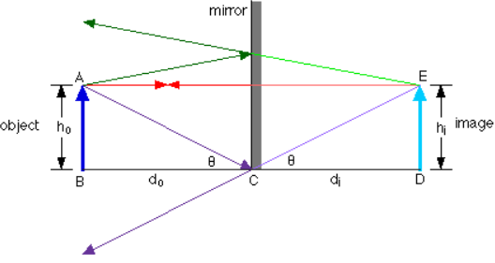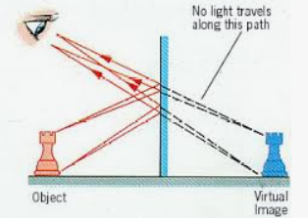

2. For the flat mirror, what kind of image is produced (*real or virtual*)? Explain your answer.

**Flat mirrors usually produce virtual images because the actual light rays are reflected away at the same angle that they entered the mirror. Real images** are produced by **actual light rays** and **light energy**. Virtual images are only seen in our eye, but are not produced by actual light rays and light energy.

3. For the convex mirror, what kind of image is produced (*real or virtual*)? Explain your answer.

**Concave spherical mirrors usually produce virtual images. Real images** are produced by **actual light rays** and **light energy**. Virtual images are only seen in our eye, but are not produced by actual light rays and light energy.

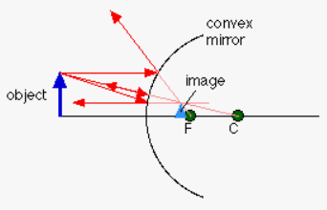

4. For the convex mirror, where will you always find the image which the reflected light rays produce?

**The image is “behind” the mirror (virtual).**

5. For the concave mirror, what happens to the reflected rays (*diverge or converge*)?

**When the object is beyond the focal point, reflected ray converge to form a real image. See the image to the left below.**

**When the object is inside the focal point, reflected ray diverge to form a virtual image. See the image to the right below.**

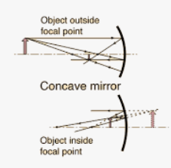 

6. For the concave mirror, what kind of image is produced (*real or virtual*)? Explain your answer.

See answer 5. **Real images** are produced by **actual light rays** and **light energy**. Virtual images are only seen in our eye, but are not produced by actual light rays and light energy.

7. What characteristic is common for all images in mirrors?

**All images are reversed.**